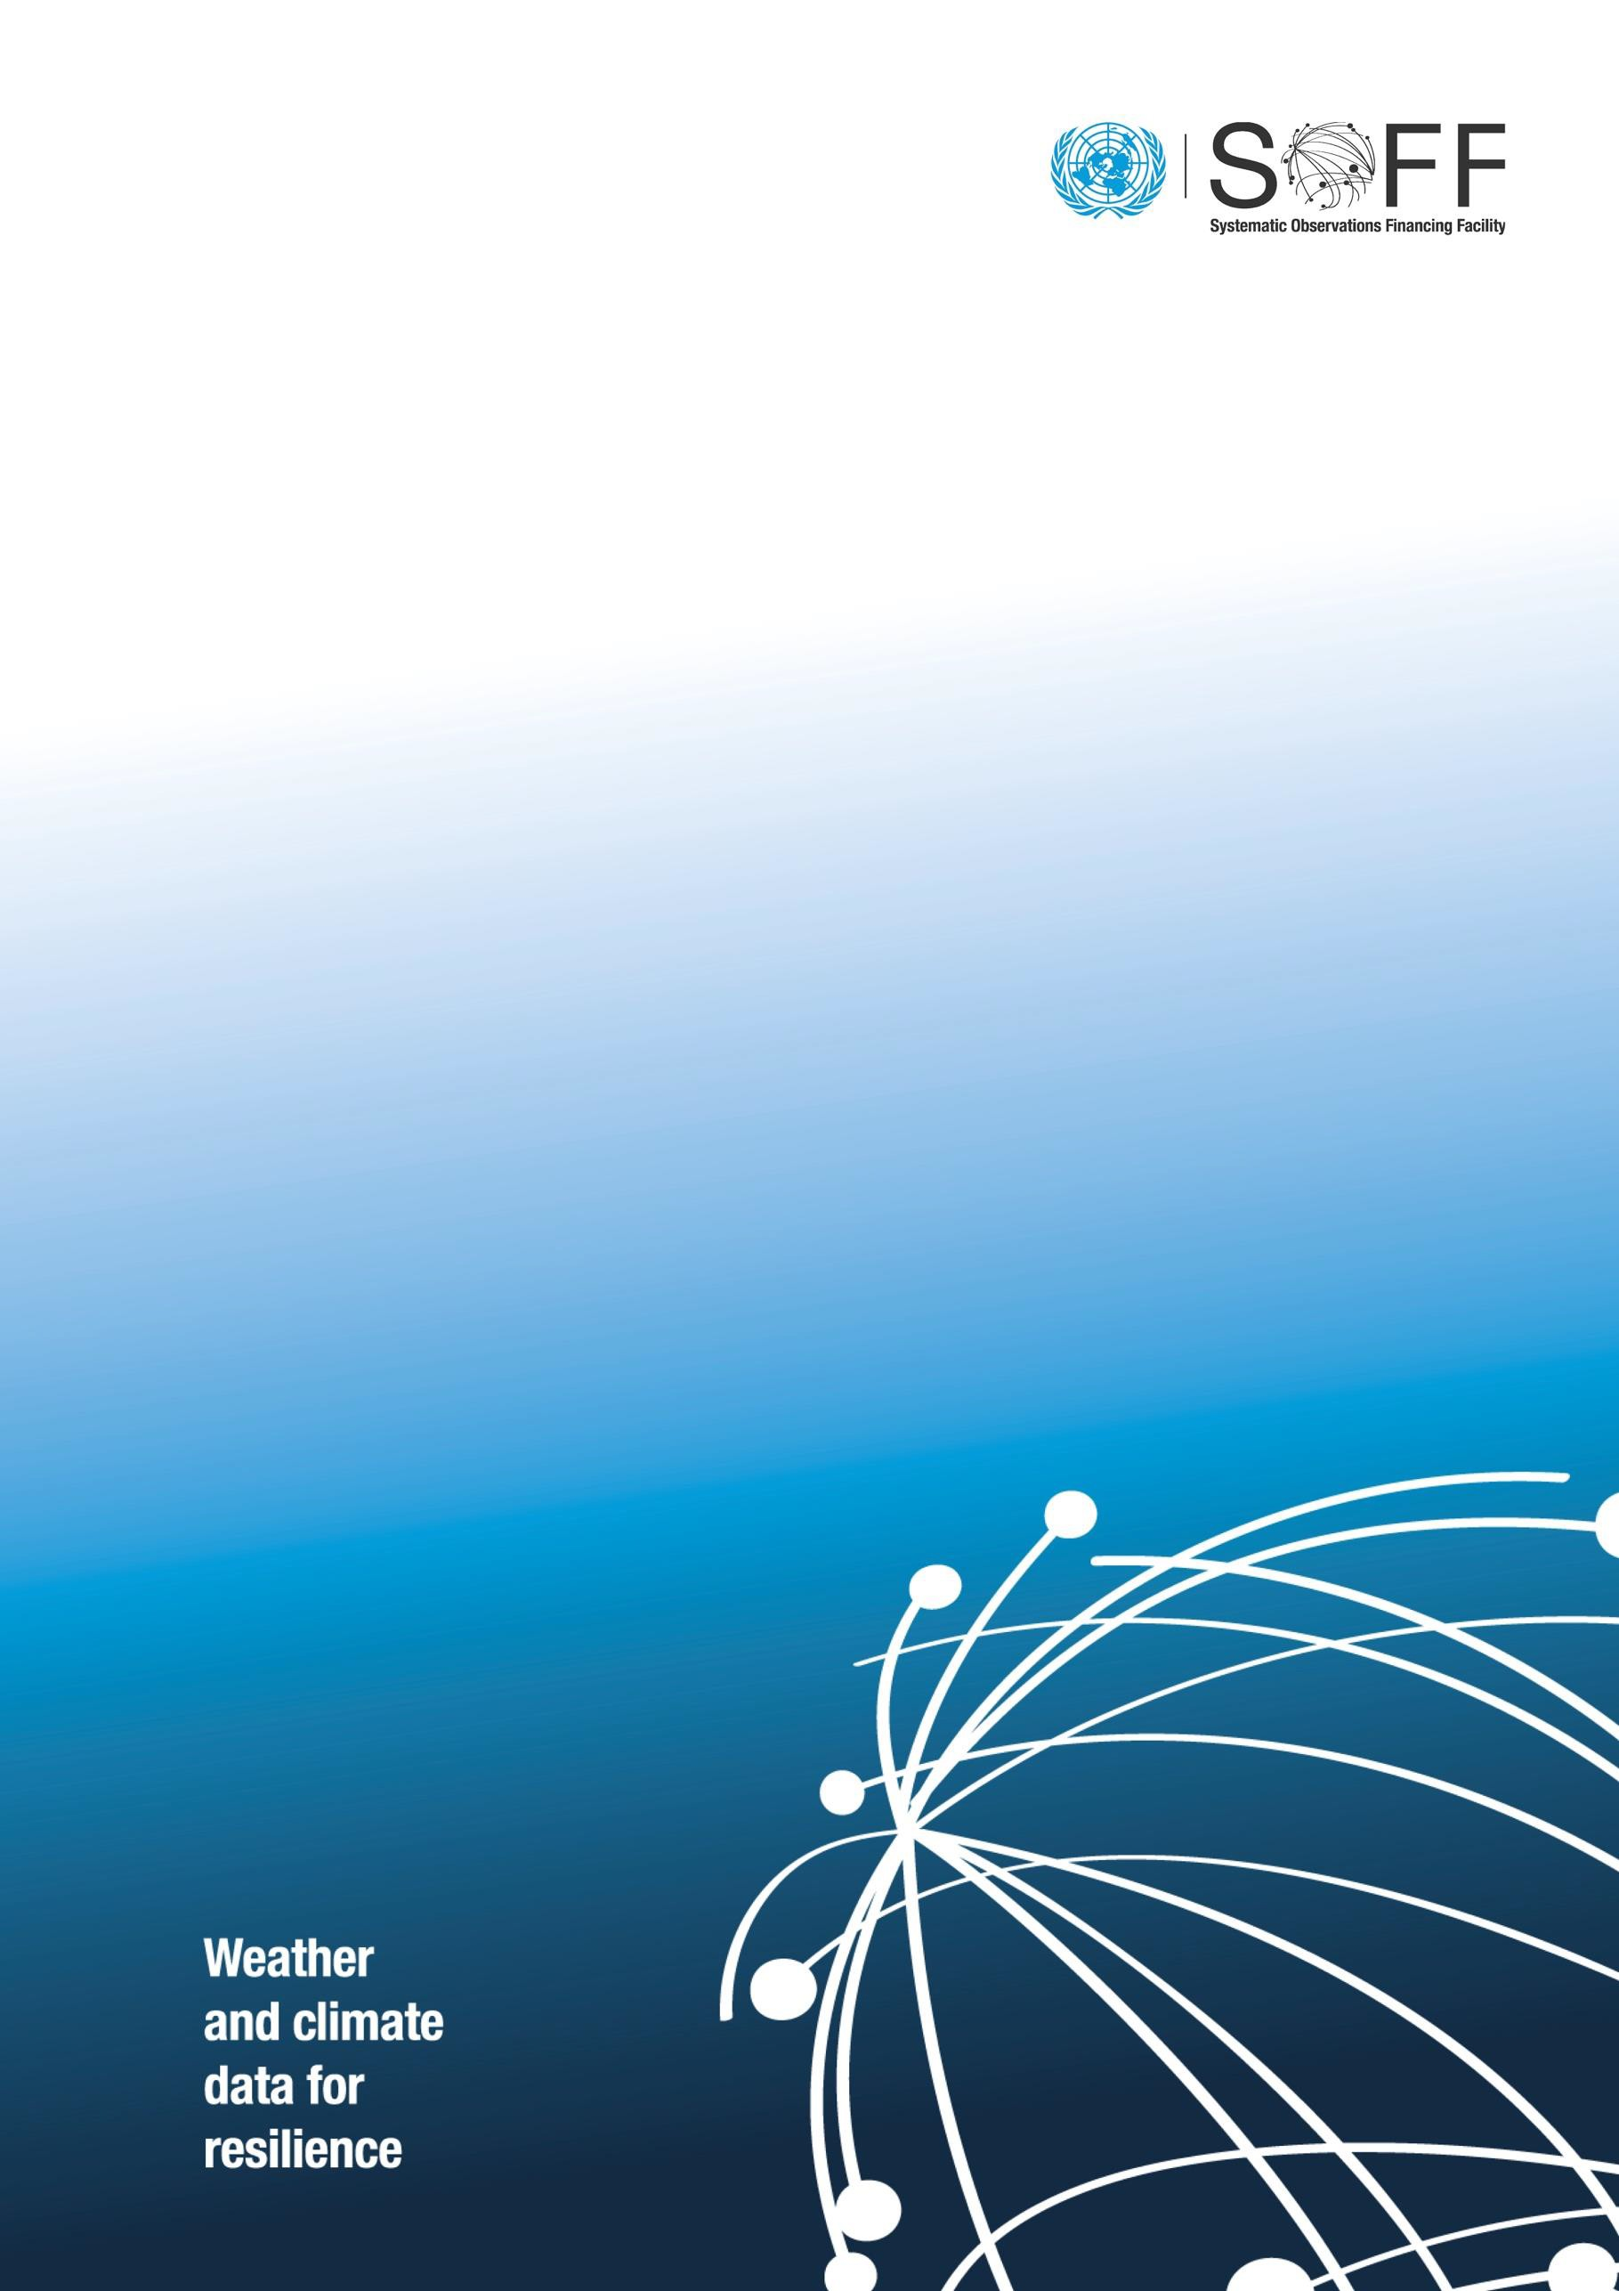

SOFF Readiness Funding Request Template

Version 2.0  
April 2023

Systematic Observations Financing Facility

**SOFF Readiness Funding Request**

*The funding request should be prepared by the SOFF beneficiary country in collaboration with the SOFF peer advisor in coordination with the prospective SOFF Implementing Entity. In case of questions on how to complete this template, please contact the SOFF Secretariat at:* [*soffsecretariat@wmo.int*](mailto:soffsecretariat@wmo.int)*.*

The SOFF Readiness Funding Request template includes the following sections:

1. **Basic information**
2. **SOFF Programming criteria**
3. **Readiness phase outputs, timeline and budget**
4. **Monitoring**
5. **Readiness Phase Risk Management Framework**

The **Assignment Terms of Reference** are included in **Annex 1**.

|  |
| --- |
| **General recommendations to fill in in the template**  **Section 2. Programming criteria:** Please make sure that you provide clear but succint information to relevant to the programming criteria. This is an essential requirement for the submission of the funding request to the Steering Committee.   * **GBON gap and easy fixes:** Please be aware of the limitations of SOFF scope of support. SOFF only supports GBON standard density and surface and upper-air stations over land. However, SOFF does encourage peers and beneficiary countries to during the Readiness phase look at the situation of GBON high-density networks (for those countries that already have them) and marine stations for potential easy fixes opportunities via SOFF support or other future support. We encourage beneficiary countries and peer advisors to ensure that the readiness funding request focuses on the areas of work related to SOFF scope of support to avoid misinterpretations and wrong expectations for the Investment and Compliance phase. For more guidance and details on SOFF scope of support, please see the GBON National Gap Analysis and the GBON National Contribution Plan technical guidance documents.   The information provided on the GBON Gap, and the easy fixes should be high-level, as the details are expected to be scoped out during the Readiness phase. Please avoid excessively detailed information on how many stations to rehabilitate/install.     * **Maximize delivery capacity**: Please clearly state any ongoing or planned activities in the country for which the peer advisor receives funding from other sources. This is a mandatory requirement, as per Assignment Agreement 5.4. If there are none, please explicitly state so.   **Section 3. Budget:** The budget is expected to reflect a strict and careful assessment of the costs for the provision of the advisory services, following a cost-recovery approach and abiding to the eligible expenditure categories according to the Umbrella Agreement. While a budget breakdown is not required in the funding request, the SOFF peer advisor must be in a position to provide copies of all the documents, including budget and costing breakdown, including for audit purposes.  **Section 6: Risk management framework** needs to be carefully developed indicating discrete risks and strong mitigation measures.  **Annex 1: Terms of Reference.** The delivery process needs to be described, including indicative timeline of planned activities, workshops, missions, delivery of the outputs and delivery team. Without this, the funding request cannot be submitted to the SOFF Steering Committee. |

**1. Basic information**

|  |  |
| --- | --- |
| **SOFF Beneficiary Country** | *Please complete* |
| **Country Focal Point** | *[WMO PR or head of NMHS and institution]* |
| **Peer advisor** | *Please complete* |
| **Peer advisor Focal Point** | *Please complete* |
| **Prospective Implementing Entity** | *Please complete* |
| **Prospective Implementing Entity Focal Point** | *Please complete* |
| **Total budget USD** | *Please complete – only lumpsum* |
| **Delivery timeframe** | *Please indicate specific months for the expected start and completion of the activities* |
| **Date of approval** |  |
| Signature SOFF Steering Committee co-chairs (after Steering Committee approval of the funding request) | |

1. **SOFF Programming criteria**

*Please provide below an initial short description of the application of the* [*SOFF programming criteria*](https://alliancehydromet.org/wp-content/uploads/2022/08/Decision-item-1.4.-Programming-criteria.pdf) *in the country.*

**Table 1: Programming criteria**

|  |  |
| --- | --- |
| **Close the most significant data gaps** | *Based on the WMO Global GBON Gap Analysis for the country, please provide a brief summary and initial indications regarding the GBON gap in the country.* |
| **Target easy fixes** | *Based on the WMO Global GBON Gap Analysis, please provide initial indications on the opportunities for rehabilitation and improvement of potential GBON stations in the country.* |
| **Maximize delivery capacity** | *Outline the capacity of the peer advisor and the prospective Implementing Entity to deliver SOFF support efficiently and effectively in the country.* ***State any ongoing or planned activities in the country for which the peer advisor receives funding from other sources.*** *If none, please explicitly state so.* |
| **Create leverage** | *Provide initial indications on opportunities for complementarity of SOFF with previous, ongoing and planned operations by the SOFF Implementing Entities and other funds.* |
| **Sub-regional gains** | *Provide initial indications on opportunities to create economies of scale and optimize the design of the observing networks through multi-country/sub-regional SOFF implementation e.g. existing sub-regional cooperation or opportunities for sub-regional procurement and operations and maintenance.* |
| **Ensure country balance** | *Indicate if the country is a Small Island Developing State, a Least Developed Country, an ODA-recipient country, a Fragile and Conflict-affected State.* |

1. **Readiness phase outputs, timeline and budget**

The Terms of Reference for the development of the SOFF Readiness phase outputs (see Annex I) provide more detailed information. They also summarize the roles and responsibilities, as stated in the [SOFF Operational Manual](https://alliancehydromet.org/wp-content/uploads/2022/11/Decision-item-2.2-Adoption-of-the-SOFF-Operational-Manual.pdf), of the beneficiary country, the peer advisor, the prospective Implementing Entity and WMO Technical Authority for the delivery of the Readiness phase outputs.

The budget for the development of the SOFF Readiness phase outputs by the SOFF peer advisor shall be a lump-sum, fixed cost amount. It shall be calculated using a cost-recovery approach based on the peer advisors’ standard cost recovery rates.

*Please indicate the expected time required to deliver the Readiness outputs and the total budget. See example below.*

**Table 2: outputs, timeline and budget**

|  |  |  |  |  |  |  |
| --- | --- | --- | --- | --- | --- | --- |
| **Outputs** | **Timeline** | | | | | |
| **Month 1** | **Month 2** | **Month 3** | **Month 4** | **Month 5** | **Month 6[1]** |
| **National GBON  Gap Analysis** |  |  |  |  |  |  |
| **GBON National Contribution Plan** |  |  |  |  |  |  |
| **Country Hydromet Diagnostic (on demand)** |  |  |  |  |  |  |
| **Total budget USD[2]** | *Please indicate only a lumpsum figure, no breakdown required* | | | | | |

**4. Monitoring**

The beneficiary country and peer advisor shall notify the SOFF Secretariat on any delays that may impede the timely delivery of the Readiness phase outputs. If the assignment takes more than six months, the SOFF peer advisor shall submit semi-annual progress reports to the SOFF Secretariat (form to be provided by the SOFF Secretariat) stating the delivery status of the outputs.

The Readiness phase completion will be monitored by the peer advisor and the SOFF Secretariat using the following country-level Results Framework for the Readiness phase.

**Table 3: Result framework**

|  |  |  |
| --- | --- | --- |
| **Outputs** | **Indicator** | **Target** |
| 1. **GBON National Gap Analysis** | GBON gap established and reviewed (Y/N) | GBON gap analysed and reviewed by WMO Technical Authority |
| 1. **GBON National Contribution Plan** | GBON national contribution plan developed (Y/N) | GBON national contribution plan developed and reviewed by WMO Technical Authority |
| GBON National Contribution Plan includes gender considerations (Y/N) | GBON National Contribution Plan includes gender considerations |
| 1. **Country Hydromet Diagnostic (on demand)** | Country Hydromet Diagnostic developed (Y/N) | Country Hydromet Diagnostic developed |

1. **Evaluation**

An evaluationfrom both, the beneficiary country and the prospective Implementing Entity on the quality of support received by the peer advisor will be conducted at the end of the Readiness phase and the peer advisor’s assignment (form to be provided upon completion of the Readiness phase by the SOFF Secretariat).

1. **Readiness Phase Risk Management Framework**

*Please provide a brief description of the contextual, institutional, and programmatic risks that might hinder the effective delivery of the Readiness phase outputs.*

**Table 3: Risk Management Framework**

|  |  |  |  |
| --- | --- | --- | --- |
| **Risk category** | **Description** | **Probability** | **Mitigation action** |
| **Contextual risks**  Risks related to conflicts, safety and political insecurity jeopardizing the delivery of the Readiness phase outputs | *Please indicate specific risks* | *Please indicate:*  *Rare*  *Unlikely*  *Possible*  *Likely*  *Very likely* | *Please indicate specific mitigation actions for each risk* |
| **Institutional risks**  Risks related to the beneficiary country's institutions participation in the Readiness phase activities |  |  |  |
| **Programmatic risks**  Risks related to country ownership of the Readiness phase outputs |  |  |  |

**Annex 1. Assignment Terms of Reference for the development of the SOFF Readiness phase outputs**

1. **Purpose and scope**

The purpose of this Assignment is to provide SOFF peer advisory services by [*peer advisor name]* to [*SOFF beneficiary country*] to develop the outputs of the SOFF Readiness phase as described in section 3 of these Terms of Reference.

The provisions defined in the Terms of Reference are based on the [SOFF Operational Manual](https://alliancehydromet.org/wp-content/uploads/2022/11/Decision-item-2.2-Adoption-of-the-SOFF-Operational-Manual.pdf), in particular Section 4.4 on Operational Partners and Section 4.5.1 on the Readiness phase.

1. **Roles and responsibilities**

**Beneficiary country National Meteorological and Hydrological Service**

* Is responsible for implementing the activities of the Readiness phase with the support from the peer advisor and the prospective Implementing Entity.
* Prepares the Assignment Terms of Reference following the standard Terms of Reference provided by the SOFF Secretariat, in collaboration with the peer advisor and in coordination with the prospective Implementing Entity.
* Submits the funding request for the SOFF Readiness phase support using the standardized template provided by the SOFF Secretariat.
* Is responsible for collaborating with the peer advisor to provide all the necessary information and participate in and facilitate the national activities the peer advisor needs to conduct in order to develop the Readiness phase outputs.
* Confirms receipt of the peer advisors’ report with the Readiness phase outputs and provides comments on the outputs as needed.

**Peer advisor**

* Is accountable to the beneficiary country.
* In dialogue with the beneficiary country, provides independent technical advice, analysis and recommendations to support the beneficiary country in implementing the activities of the Readiness phase.
* Develops the Readiness phase outputs and is responsible for their quality and timely delivery. Communicates regularly with the beneficiary country and the Implementing Entity.
* Engages with the civil society, including on the identification of stakeholders of relevance for GBON implementation.
* Submits the final report with the Readiness phase outputs to the country for comments and to the prospective Implementing Entity for feedback.
* Submits the final report including the beneficiary country’s comments and the prospective Implementing Entity’s feedback to the SOFF Secretariat.
* Notifies the SOFF Secretariat and the prospective Implementing Entity of any delays that may impede the timely delivery of the outputs, and for assignments for which the delivery takes more than six months submits a semi-annual progress report.

**Implementing Entity**

* Participates in the Readiness phase activities and collaborates with the beneficiary country and the peer advisor to ensure a common understanding of the Readiness phase outputs and that they address the technical needs for the design and implementation of the Investment phase.
* Contributes to the definition of the Terms of Reference and provides feedback on the outputs delivered by the peer advisor.
* Based on its experience in the beneficiary country, supports the work of the peer advisor, e.g. by sharing its knowledge and facilitating access to the network of relevant stakeholders.

**WMO Technical Authority**

* Provides basic technical support to the beneficiary country, peer advisor, and prospective Implementing Entity on GBON regulations.
* Is responsible for the technical screening of the draft GBON National Gap Analysis and the draft GBON National Contribution Plan against the GBON regulations.
* Is responsible for establishing and administering the pass-through mechanism for contracting and funding of the technical assistance provided by the peer advisors.

**SOFF Secretariat**

* Facilitates communication, coordination and collaboration between the beneficiary country, the peer advisor, the prospective Implementing Entity and WMO Technical Authority.
* Reviews the Readiness funding request, including the Terms of Reference, for compliance and consistency with the information requirements in the template and provides feedback as needed. Transmits the funding request to the SOFF Steering Committee for its decision.
* Confirms receipt of the peer advisors’ report with the Readiness phase outputs.
* Organizes exchange of knowledge and experiences and captures lessons learned.

1. **Readiness phase outputs**

The peer advisor should perform the following tasks following the technical guidance and using the templates provided in the operational guidance documents for each one of the outputs. A summary of the key steps and modules to be conducted for each output is presented below.

* 1. **GBON National Gap Analysis**

The GBON National Gap Analysis defines the gap between the mandatory requirements of the GBON regulations and the existing country surface and upper-air networks. In other words, it serves as the basis for identifying the number of observing stations that need to be installed or rehabilitated to comply with the mandatory requirements of the GBON regulations.

To develop the GBON National Gap Analysis, the following steps should be followed

* **Step 1** – Country information from the GBON Global Gap Analysis
* **Step 2** – Analysis of existing GBON stations and their status against GBON requirements
* **Step 3** – GBON Gap Analysis results
* **Step 4** – Country endorsement for integration of the GBON National Gap Analysis into the GBON National Contribution Plan
  1. **GBON National Contribution Plan**

The GBON National Contribution Plan identifies the infrastructure, human and institutional capacity needed to achieve a progressive target toward GBON compliance, including the sustained operation and maintenance of the national GBON observing network.

To develop the GBON National Contribution Plan, the following modules should be completed

* **Module 1. National target toward GBON compliance:** Establishment of a progressive national target toward GBON compliance
* **Module 2. GBON business model and institutional development**: public-private business model as appropriate; partnerships, institutional and financial arrangements needed to operate and maintain the observing network
* **Module 3. GBON infrastructure development**: Appropriate investments needed to increase or improve the observing network and its Information and Communication Technology (ICT) infrastructure
* **Module 4. GBON human capacity development**: Human technical and managerial capacities required to operate and maintain the observing network
* **Module 5. Risk Management:** Operational risks of the observing network and required mitigation measures
* **Module 6. Transition to SOFF Investment phase:** Support the beneficiary country and the Implementing Entity in preparing the Investment phase funding request (template provided by the SOFF Secretariat).
  1. **Country Hydromet Diagnostics**

The Country Hydromet Diagnostic (CHD) complements the GBON National Gap Analysis and the GBON National Contribution Plan. It is a standardized, integrated and operational tool and approach for diagnosing National Meteorological Services across the meteorological value chain, their operating environment, and their contribution to high-quality weather, climate, hydrological and environmental information services and warnings. Its assessment serves as a basis for investments beyond SOFF, across the whole value chain, by the SOFF Implementing Entity and other development partners.

The peer advisor should **assess the 10 CHD elements** with its respective indicators following the matrix provided in the CHD guidance document.

* Governance and institutional setting
* Effective partnerships to improve service delivery
* Observational infrastructure
* Data and product management and sharing policies
* Numerical model and forecasting tool application
* Warning and advisory services
* Contribution to climate services
* Contribution to hydrological services
* Product dissemination and outreach
* Use and national value of products and services

To develop the Country Hydromet Diagnostic, the following **steps** should be completed.

* Stage 1 – Information gathering. As input, the WMO Monitoring Evaluation Risk and Performance unit will provide available country data structured along the CHD elements and their indicators (performed remotely)
* Stage 2 – Validation and analysis (performed in-country if feasible)
* Stage 3 – Closure

1. **Delivery process**

The peer advisor in collaboration with the beneficiary country and in coordination with the prospective Implementing Entity should establish the specific activities and consultations needed to complete the outputs. The development of the outputs should include the following:

* Collaboration arrangements between the beneficiary country and the peer advisor, including at least one country visit, unless the country context does not allow it *[please outline]*
* Coordination arrangements with the prospective Implementing Entity *[please outline]*
* In-person or virtual consultation meetings with relevant national and international stakeholders and partners *[please outline]*
* Delivery partners that support the peer advisor in the delivery of the outputs, as applicable *[please outline]*
* Peer advisor delivery team and focal point *[please outline]*
* Timeline for the development of the outputs *[please outline]*

1. **Reporting and completion**

**Reporting.** For assignments for which the delivery of advisory services takes more than six months, the SOFF peer advisor shall submit a semi-annual progress report to the SOFF Secretariat (form to be provided by the SOFF Secretariat).

**Completion**

* **Step 1.** The peer advisor submits the draft GBON National Gap Analysis and the GBON National Contribution Plan reports to WMO Technical Authority and, as applicable, the draft Country Hydromet Diagnostics to the Monitoring Evaluation Risk and Performance unit of the WMO Secretariat. The draft reports have to follow the templates provided in the SOFF operational guidance documents.
* **Step 2.** WMO Technical Authority screens the draft GBON National Gap Analysis and the draft GBON National Contribution Plan to ensure consistency with the GBON regulations. The WMO Monitoring Evaluation Risk and Performance unit screens the draft Country Hydromet Diagnostics and provides feedback for revisions as needed.
* **Step 3.** The peer advisor submits the report with the Readiness phase outputs for beneficiary country and prospective Implementing Entity feedback.
* **Step 4.** The peer advisor finalizes the report for confirmation of receipt by the beneficiary country and, as needed, beneficiary country comments. Following beneficiary country receipt of the report, the peer advisor submits the report, including beneficiary country’s comments and the prospective Implementing Entity’s feedback, to the SOFF Secretariat.
* **Step 5.** The SOFF Secretariat confirms the satisfactory receipt of the report and informs the country and the prospective Implementing Entity accordingly. The SOFF Secretariat authorizes WMO to proceed with the release of the final payment and informs the SOFF Steering Committee of the completion of the SOFF readiness phase.

1. **Signatures**

By signing this document, the beneficiary country, peer advisor and the prospective Implementing Entity agree with the provisions stated in this Terms of Reference.

|  |
| --- |
| **Beneficiary country** |
| **Peer advisor** |
| **Prospective Implementing Entity** |

1. It is expected that the assignment is completed within six months. If more time is required for exceptional circumstances, please add additional months to the table.
2. Eligible expenditures are limited to: Staff and consultants; Consultations, national technical workshops, and communications; Travel and transportation costs; Other incidental expenditures.