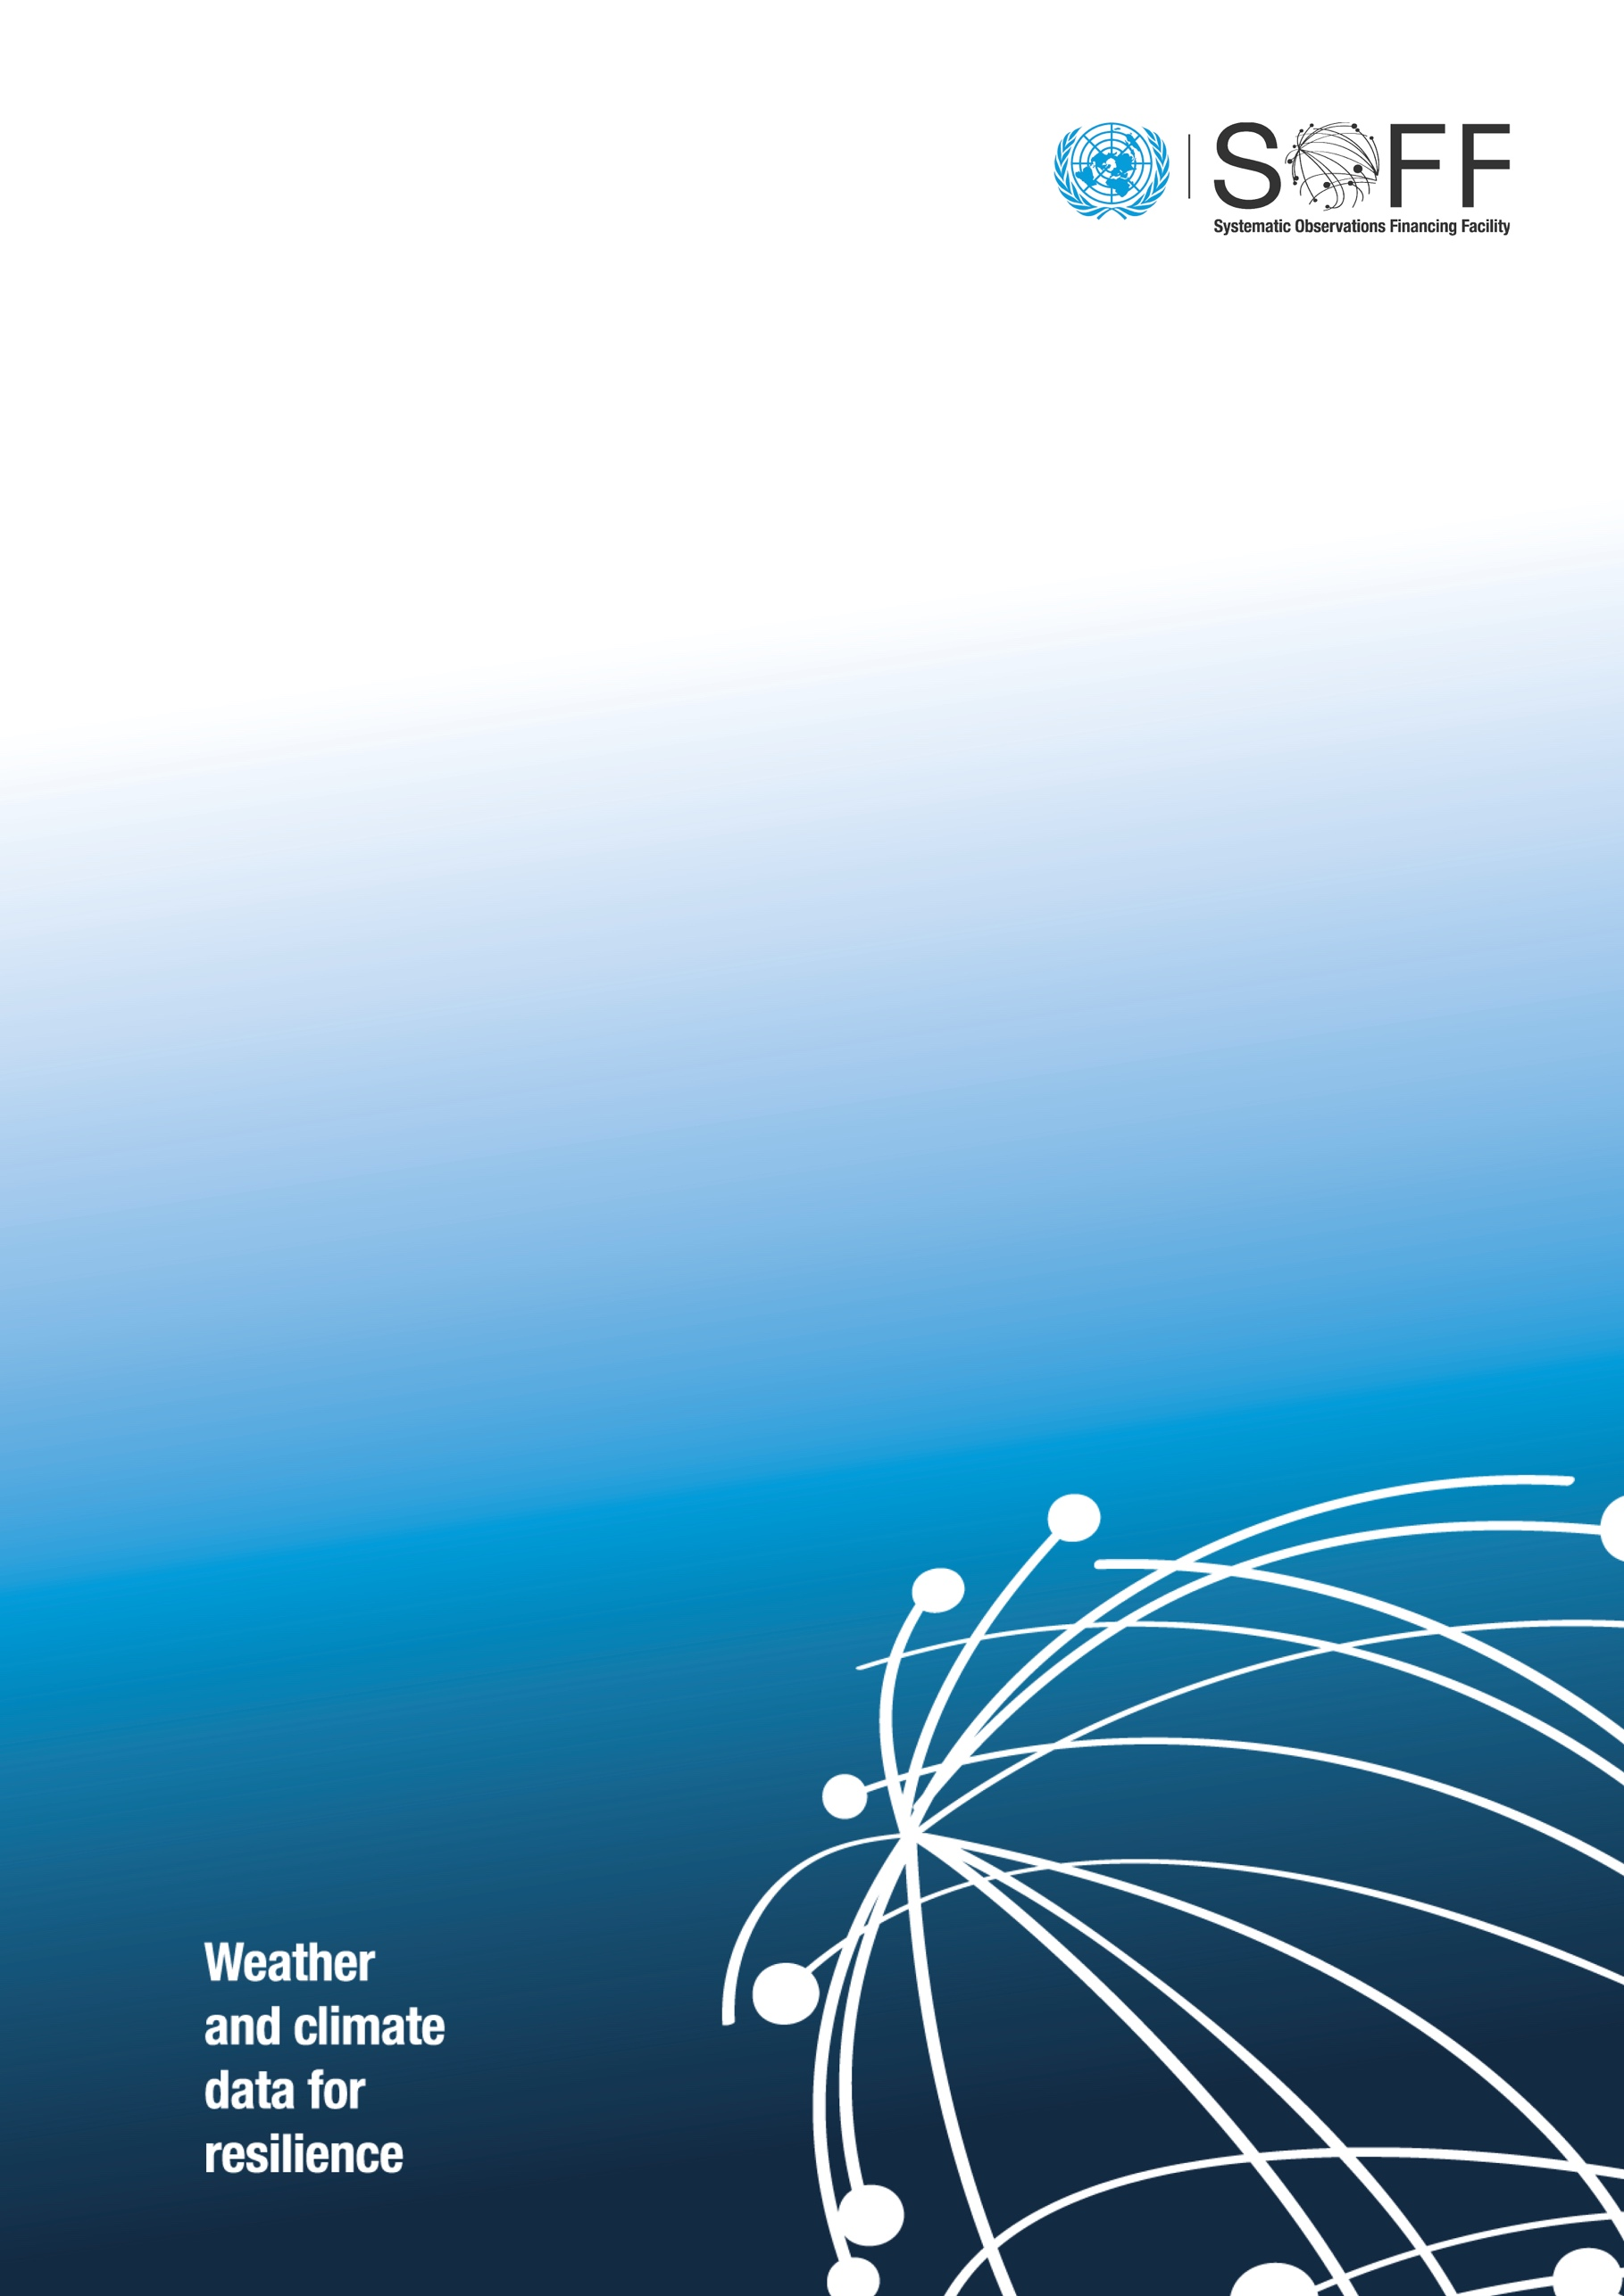
SOFF UNMPTF Gateway: Guidance for Implementing Entities

  - Systematic Observations
Financing Facility

Table of contents
SOFF UNMPTF Gateway: Guidance for Implementing Entities 3
Fund Management Platform (FMP) Project Creation 4
1. General Information 4
1.1. Contacts 5
1.2. Description 5
1.3. Universal Markers 5
1.4. Optional Markers 6
1.5. Fund Specific Markers 6
1.6. Geographical Scope 7
1.7. Participating Organizations and their Implementing Partners 7
1.8. Programme and Project Cost 7
1.8.1 Manage Budget Requested 7
Step 2.a Please select the SOFF Implementing Entity for the current project and add the Investment phase budget excluding the Peer Advisory fee. 8
1.8.2 Manage Tranches 8
1.8.3 Manage Other Sources 9
1.9. Thematic Keywords 9
1.10. Programme Duration 9
1.11. Comments for review process 9
2. Narrative 9
3. SDGs 10
4. RBM 10
4.1. Outcomes 11
4.2. Manage Indicators 14
4.2.1 Signature Indicators 14
4.2.2 Imported Fund Outcome/Output Indicators 14
4.2.3 Project Indicators 17
5. Risk Management 18
6. Budgets 18
6.1. Budgets by UNSDG Categories: Overall 18
6.2. Results Based Budget 20
7. Work Plan 20
8. Documents 21
9. Workflow 22

SOFF UNMPTF Gateway: Guidance for Implementing Entities

The MPTFO Gateway v2 is a partner-centred integrated platform that includes, among other “Fund Management Platform” functionalities. These will reduce the operational risk and management cost and will allow for easy and rapid access to information including:

- Grant management system
- Online management of call for proposals
- Results-based management system
- Marker system in place, allowing better tracking, i.e., GEM
- Dashboard for effective and efficient monitoring of results and reporting
- Fund and detailed project programmatic and financial recording and reporting

The platform also provides a Partners Gateway section that provides:
- Comprehensive information about pooled funding
- Tools for data analysis
- Information on MPTF portfolio (Funds, JP, regions, countries, partners, etc.)
- Access to results

Fund Management Platform (FMP)

The FMP integrates the main Fund’s management processes:
- Online project application and approval
- Project funding
- Monitoring and reporting

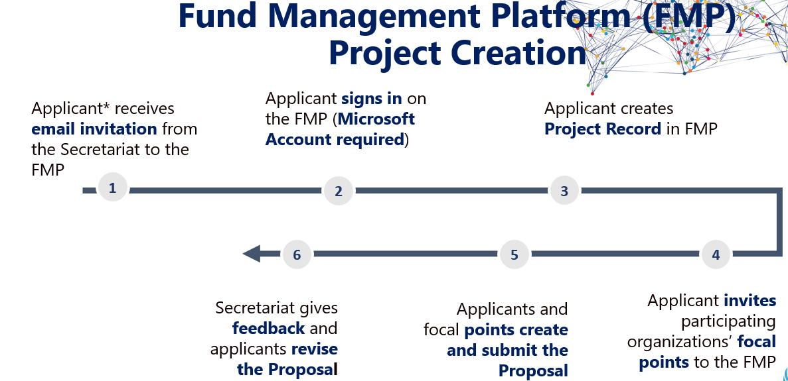

Fund Management Platform (FMP) Project Creation
Please click on Create Project to start creating the Investment funding prodoc in the Gateway.
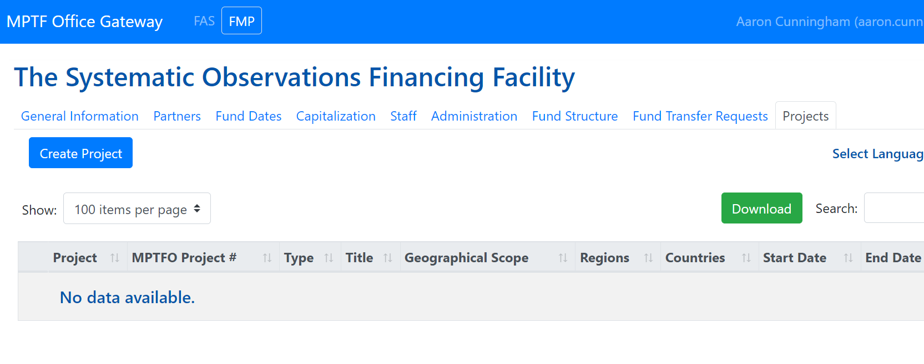

General Information
Please enter the information as outlined in the funding request.
Fund: MPTF_00281: The Systematic Observations Financing Facility
Title: SOFF [Country name] Investment Phase
Anticipated Start Date: Please enter.
Duration (In months): Please enter.
Description: Please enter a brief description of the proposal.
Don’t forget to click  before !

Contacts
Add contacts from the 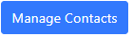button. Use the Search Contacts box for existing contacts or add new ones with  .
This section is for any additional contact focal points who can collaborate jointly to prepare the proposal in the platform.
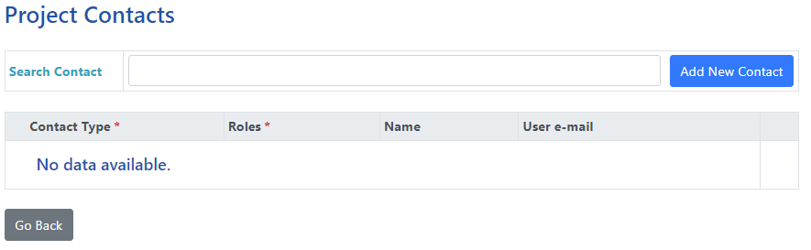

Description
Please provide a short description of the project which will appear on the SOFF UNMPTF Gateway website - Systematic Observations Financing Facility (undp.org) .
The description should include overview of the project including its objectives.

Universal Markers
For Gender Marker, please select:
GEM1 - The Key Activity contributes to GEWE in a limited way.
The Risk marker should be aligned with the Environmental and Social Safeguards risk rating given to the project through the implementing entity.
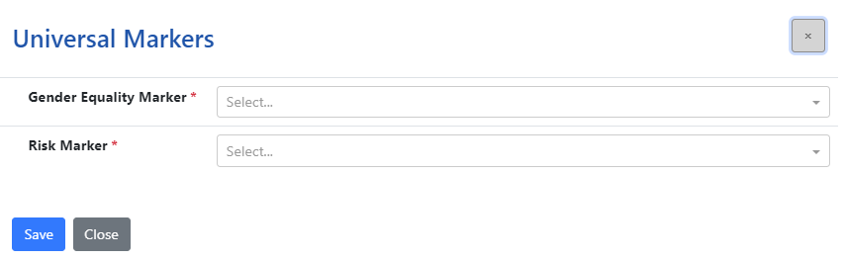

Optional Markers
Please select the most relevant.
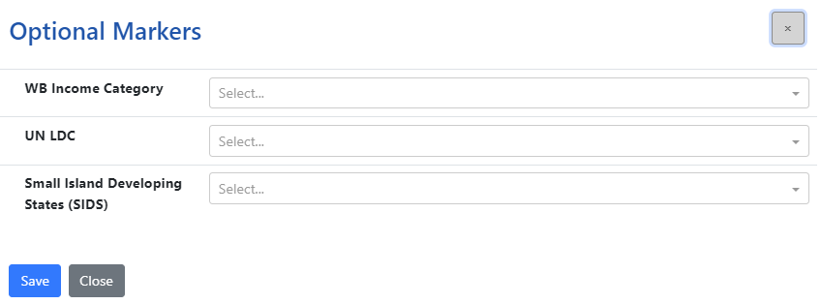

Fund Specific Markers
Please select the relevant responses to all fund specific markers.
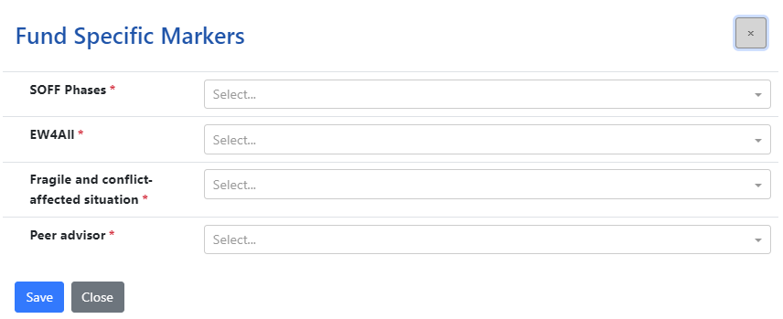

Geographical Scope
Please select the most relevant under Geographical Scope and Region(s).
Please ignore Name of the Region
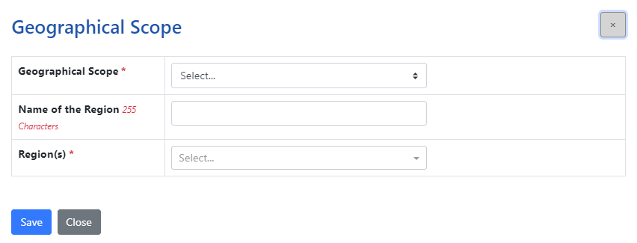

Participating Organizations and their Implementing Partners
Please select SOFF Implementing Entity for the current project, WMO and any other organizations that maybe relevant. WMO should be included for all SOFF projects as the budget for peer advisories services will be allocated to the peer through the WMO passthrough mechanism.

Programme and Project Cost

Manage Budget Requested
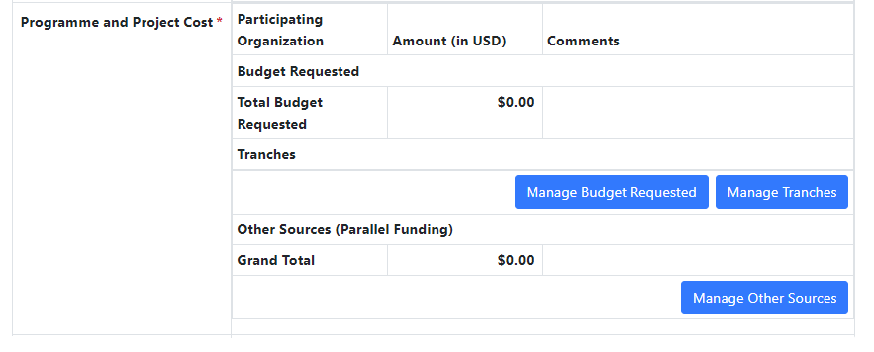
Step 1: Click 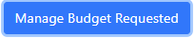 and then .
Step 2: All participating organizations entered under 1.9 should appear in the drop-down menu.
Step 2.a Please select the SOFF Implementing Entity for the current project and add the Investment phase budget excluding the Peer Advisory fee.
Step 2.b Please select WMO and add the Peer Advisory fee + 7% of the Peer Fee.
For example: if the Peer Advisory fee is USD 100’000, then 7% of 100’000 = 7000.
Therefore, total budget under WMO will be 100’000+7’000 = USD 107’000.
Don’t forget to click before 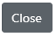!

Manage Tranches
Step 3: Click 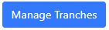to add the tranches. Under Tranche Type, select Percentage. The sum should add up to 100% to save the selection.
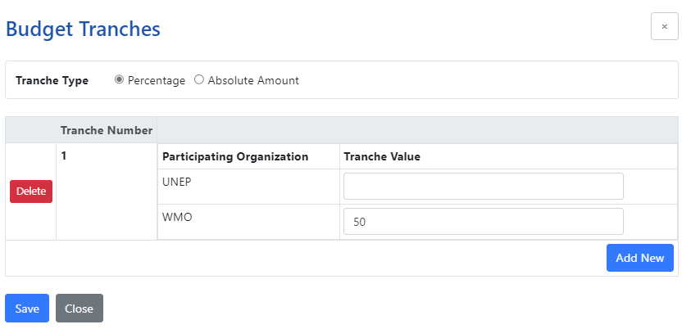
XXXXX
Tranche Number 1
SOFF Implementing Entity: Enter the percentage for the first tranche.
WMO: Please enter ‘ 33.33% ’ under Tranche Value i.e one third (1/3) .
Click  to add more tranches.
Tranche Number 2
SOFF Implementing Entity: Enter the percentage for the second tranche.
WMO: Please enter ‘ 33.33% ’ under Tranche Value i.e one third (1/3) .
Tranche Number 3
SOFF Implementing Entity: Enter 0
WMO: Please enter ‘ 33.34% ’ under Tranche Value i.e one third (1/3) .
Don’t forget to click before !

Manage Other Sources
Please add any other additional fundings that are complimentary to SOFF investments.

Thematic Keywords
Please ignore.

Programme Duration
Please enter duration of investment request.

Comments for review process
For SOFF secretariat to input upon successful submission of the funding request in the platform.

Narrative
Please input text from the SOFF Investment Funding Request Section 2, Section 3 and Section 5 into their respective sections.
Please ensure all information from the funding request is added including the GBON National Contribution target table.
Under section ‘Create leverage’- please add the following table to showcase relevant investments from the 5 multilateral climate funds and corresponding funding amount:
 | Adaptation Fund | Climate Investment Fund | CREWS | GCF | GEF
[Country Name]

Don’t forget to click after each entry before moving on to the next one!

SDGs
Please select all SDGs indicated in the figure below and add the suitable contributions to the SDGs.
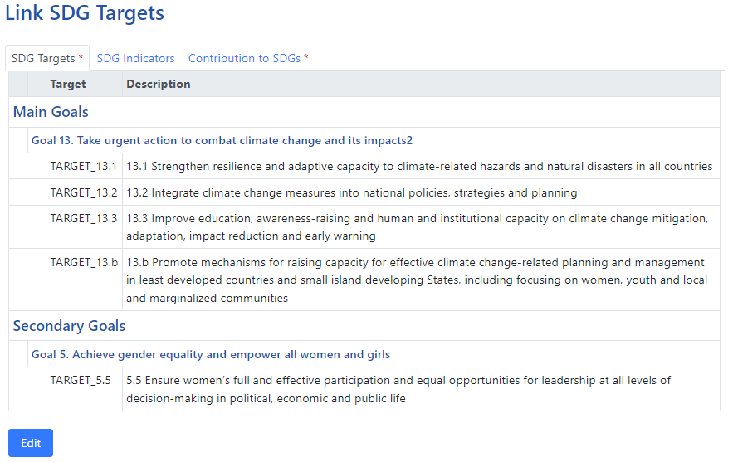

RBM
Please ensure this section is aligned with the SOFF investment funding request section 4 “Investment Phase Outputs and Budget”.
The indicated outputs/outcomes in the investment request template are already programmed in the Gateway.
Please note that the gateway uses only the term Outcomes within this section as compared to SOFF Investment Phase Funding Request which refers to Outputs 1 and 2 (see below table).
SOFF Investment Phase Funding Request. | UNMPTF Gateway
Output 1: | Outcome 1:
Output 2: | Outcome 2:
Outcome: | Outcome 3:

Outcomes
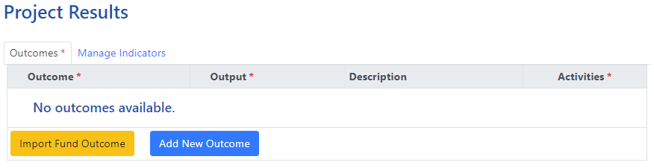
Step 1: Click 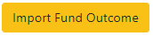and select the SOFF Investment outcomes from the drop-down menu and click 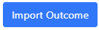 .
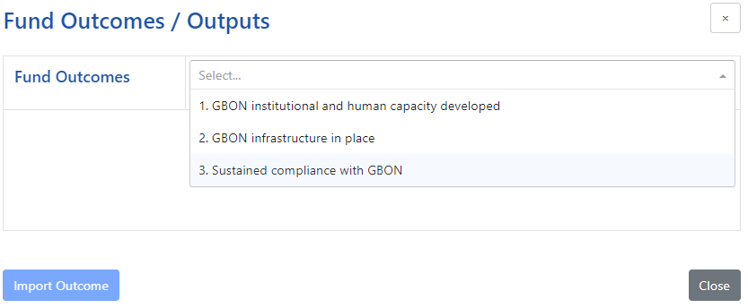
Step 2: Click 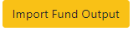and select the outputs under each outcome and click 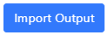.
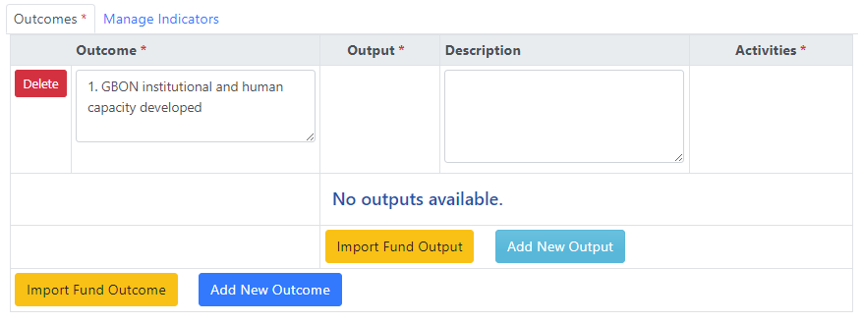
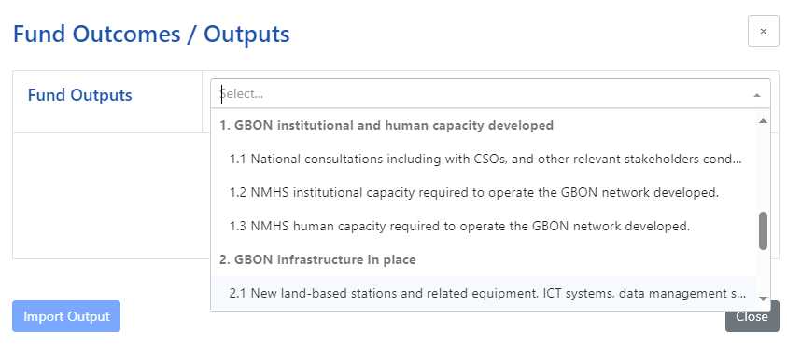
Step 3: Click and add the Main activities from Section 4. Investment Phase Outputs and Budget of the SOFF Investment Phase Funding Request.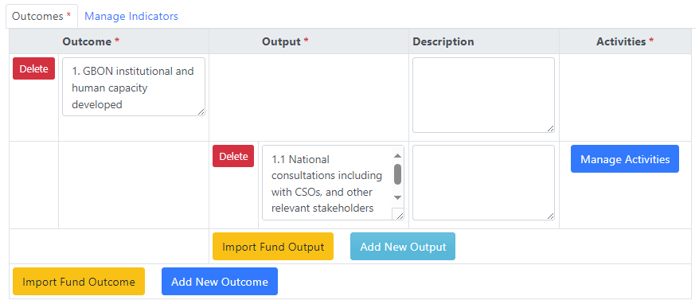 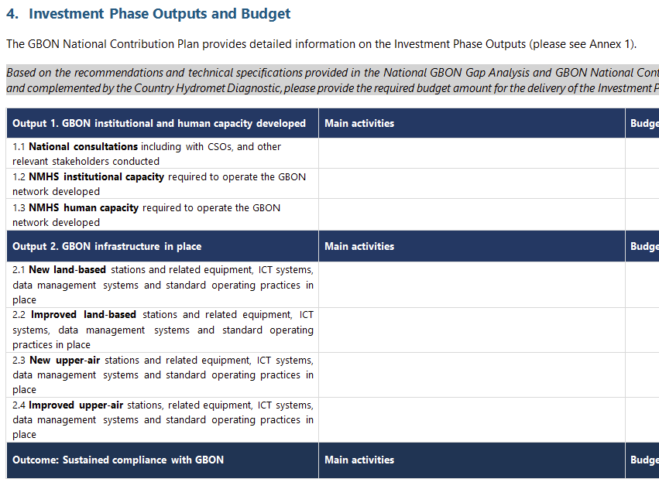
Please complete for all 3 outcomes and their respective outputs based on the SOFF Investment Phase Funding Request.

Manage Indicators
Please include all indicators from the SOFF investment funding request section 6 “Investment Phase Monitoring and Reporting”.
SOFF will not indicate any indicators as signature indicators.
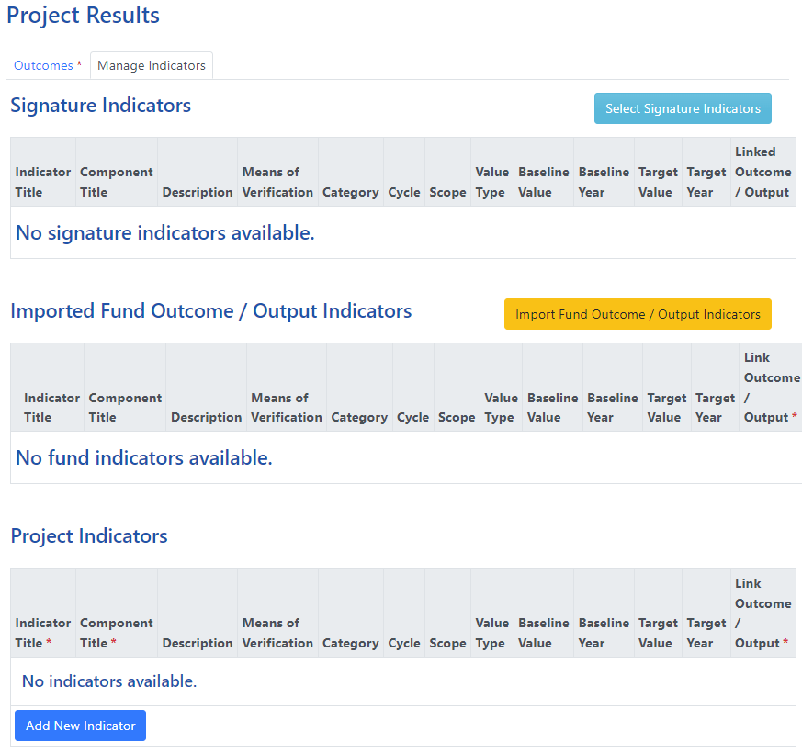

Signature Indicators
Please Ignore.

Imported Fund Outcome/Output Indicators
Step 1: Click 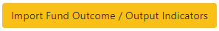 and select all relevant indicators and then 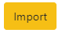.
Note: This section only considers indicators under the Output 2 and Outcome of the SOFF Investment Funding request.
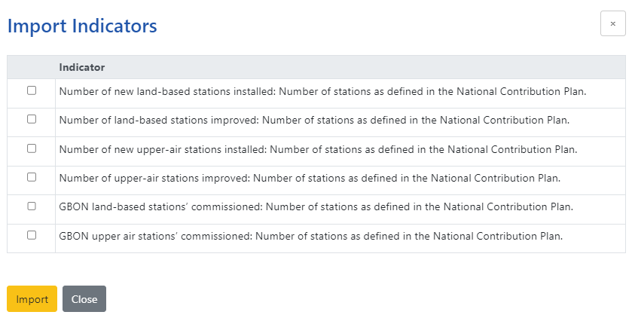
Step 2: Under each indicator, choose the right options (refer table below) to reflect the details from Section 6. Investment Phase Monitoring and Reporting SOFF Investment Phase Funding Request.
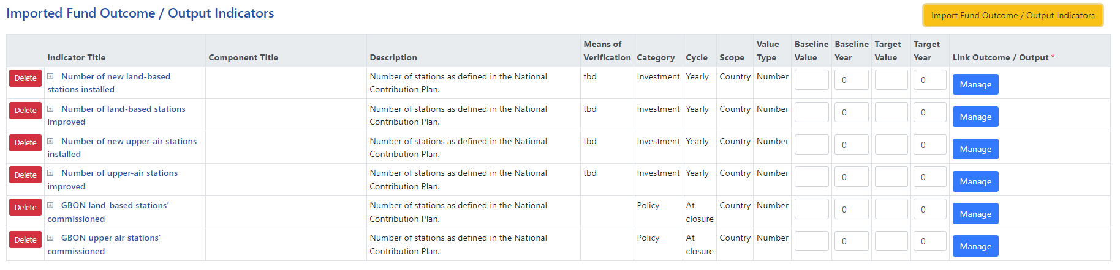

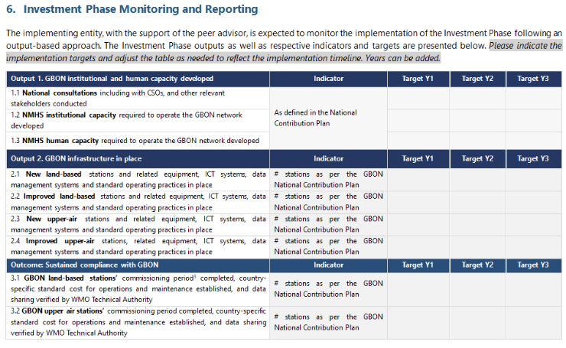
Imported Fund Outcome/Output Indicators | Indicator Title | Choose relevant indicators from the drop-down menu
Imported Fund Outcome/Output Indicators | Component Title
Imported Fund Outcome/Output Indicators | Description | Number of stations as per the National Contribution Plan.
Imported Fund Outcome/Output Indicators | Means of Verification | Annual or Quarterly reports
Imported Fund Outcome/Output Indicators | Category | Choose the most relevant
Imported Fund Outcome/Output Indicators | Cycle | At closure
Imported Fund Outcome/Output Indicators | Scope | Choose the most relevant
Imported Fund Outcome/Output Indicators | Value Type | Choose the most relevant
Imported Fund Outcome/Output Indicators | Baseline Value | - 0 if no stations currently existing (New stations)  - X if X number of stations are already existing (Improved stations)
Imported Fund Outcome/Output Indicators | Baseline Year | Year of start of project
Imported Fund Outcome/Output Indicators | Target Value | Total target as per the NCP
Imported Fund Outcome/Output Indicators | Target Year | Year of end of project
Imported Fund Outcome/Output Indicators | Link Outcome/Output | Link to the correct outcome/output
Step 3: Link each indicator to the relevant outcome/output by clicking 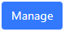
Don’t forget to click before !

Project Indicators
Please add all indicators under Output 1 on Section 6. Investment Phase Monitoring and Reporting of the SOFF Investment Phase Funding Request and link it to the relevant outcome/output as done above.
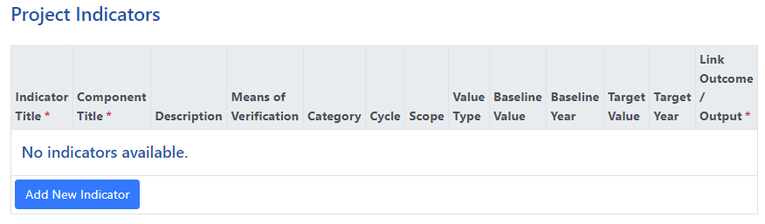
Please include gender as a component of all the project indictors.
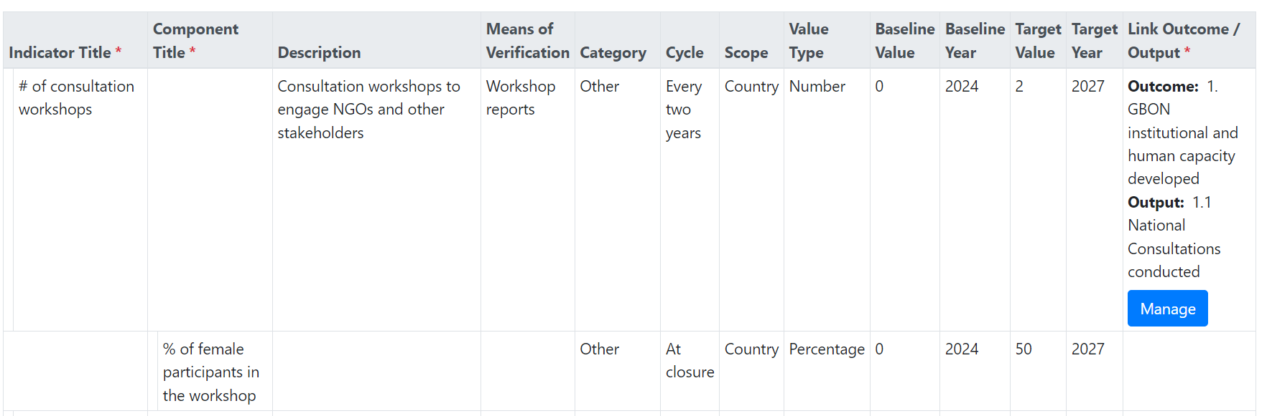
Don’t forget to click before !

Risk Management
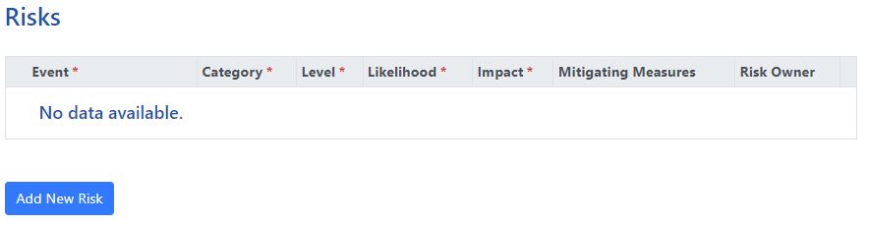
Please enter all the risks listed under Section 7. Investment Phase Risk Management Framework of the SOFF Investment Phase Funding Request.

Budgets

Budgets by UNSDG Categories: Overall
Please enter budget from the table under Section 4. Investment Phase Outputs and Budgets of the SOFF Investment Phase Funding Request.
Please note 7 % Implementing Entity (IE) fee is automatically calculated under budget line 8. Therefore, the budget lines 1 to 7 should not include the IE fee.
Peer Advisory fee must also be included under the WMO column. 7% of Peer fee that goes to WMO is automatically calculated and therefore the total Peer fee will appear higher (i.e. 1.07 x Peer fee).
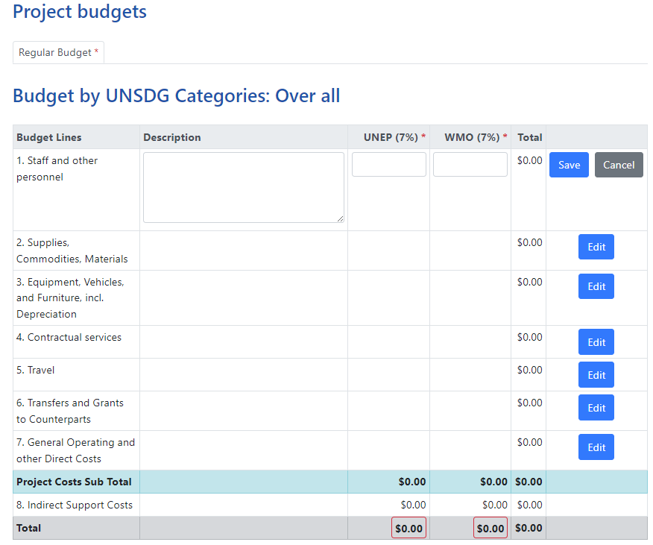
XXX
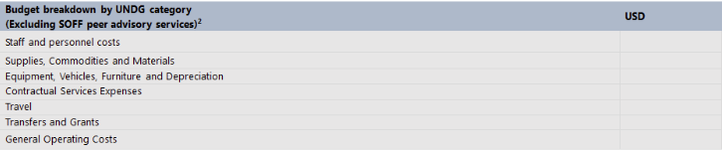
Don’t forget to click after each entry!

Results Based Budget
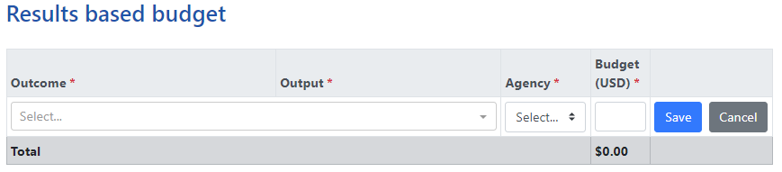
Please select each Outcome and Output from the drop-down menu and enter their respective budget from Section 4. Investment Phase Outputs and Budgets of the SOFF Investment Phase Funding Request.
Please include Peer Advisory fee under the most appropriate Outcome.
Please ignore Budget per Gender (GEWE) table.
Don’t forget to click after each entry!

Work Plan
Please mark the correct target years for each activity based on Section 6. Investment Phase Monitoring and Reporting of the SOFF Investment Phase Funding Request.
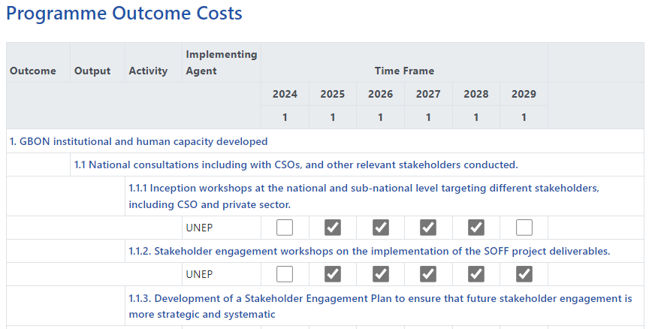
XXX
XXX
Don’t forget to click eachtime!

Documents
Please upload the following documents:
- Peer Advisors Terms of Reference, in accordance with the template provided in Annex 1
- Three Readiness outputs
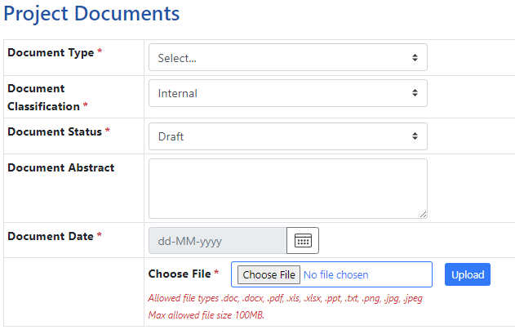

Workflow
Ensure all sections are filled – any missing section will be indicated with X
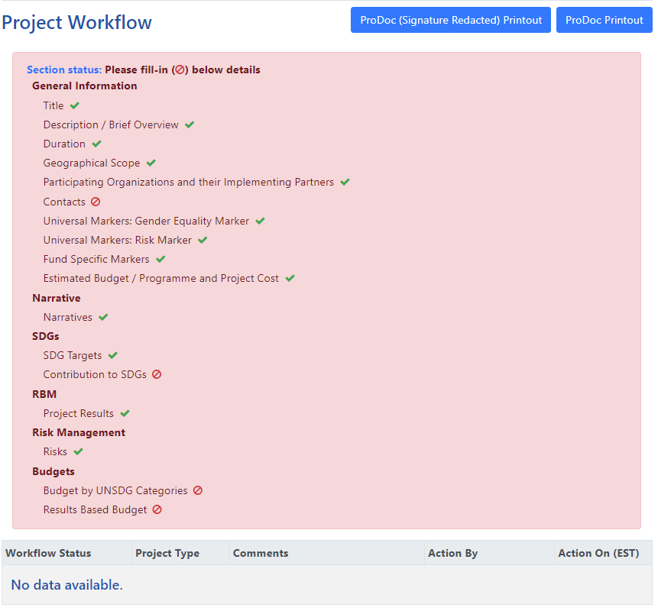
Once all information is uploaded correctly, the Workflow will turn green and [Submit] button will appear.
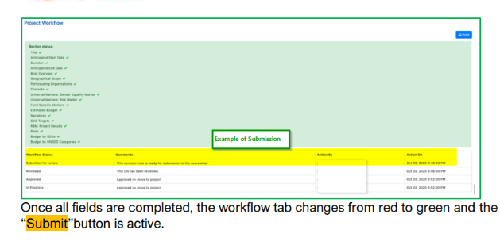

Annex 1: Terms of Reference for the provision of technical advisory services during the SOFF Investment Phase
This Terms of Reference describe the provision of technical advisory services by [peer advisor name] to [SOFF beneficiary country] to contribute to the delivery of the SOFF Investment Phase outputs as described in Section RBM of the SOFF UNMPTF Gateway
Output | Indicator  (Please copy the indicators from the Investment Funding Request) | Activities conducted/Contributions  (One indicator allows more than one activity/contribution from peer advisors) | Implementation plan
Output |  |  | Y1 | Y2 | Y3 | Y4 | Y5
1.1 National consultations, including with CSOs and other relevant stakeholders conducted | Add indicator as per approved funding request | Specify activities relevant to the output
 | Add indicator as per approved funding request | Specify activities relevant to the output
 | Add indicator as per approved funding request | Specify activities relevant to the output
1.2 NMHS institutional capacity required to operate the GBON network developed | Add indicator as per approved funding request | Specify activities relevant to the output
 | Add indicator as per approved funding request | Specify activities relevant to the output
 | Add indicator as per approved funding request | Specify activities relevant to the output
1.3 NMHS human capacity required to operate the GBON network developed | Add indicator as per approved funding request | Specify activities relevant to the output
 | Add indicator as per approved funding request | Specify activities relevant to the output
 | Add indicator as per approved funding request | Specify activities relevant to the output
2.1 New land-based stations and related equipment, ICT systems, data management systems and standard operating practices in place | # of new stations installed as per the GBON National Contribution Plan | Specify activities relevant to the output
2.2 Improved land-based stations and related equipment, ICT systems, data management systems and standard operating practices in place | # of stations improved as per the GBON National Contribution Plan | Specify activities relevant to the output
2.3 New upper air stations and related equipment, ICT systems, data management systems and standard operating practices in place | # of new stations installed as per the GBON National Contribution Plan | Specify activities relevant to the output
2.4 Improved upper air stations and related equipment, ICT systems, data management systems and standard operating practices in place | # of stations improved as per the GBON National Contribution Plan | Specify activities relevant to the output
3.1 GBON land-based stations’ commissioning period completed, country-specific standard cost for operations and maintenance established, and data sharing verified by WMO Technical Authority | # of stations commissioned as per the GBON National Contribution Plan | Specify activities relevant to the output
3.2 GBON upper air stations’ commissioning period completed, country-specific standard cost for operations and maintenance established, and data sharing verified by WMO Technical Authority | # of stations commissioned as per the GBON National Contribution Plan | Specify activities relevant to the output

