SOFF UNMPTF Gateway: Guidance for Implementing Entities

Systematic Observations   
Financing Facility

Table of contents

SOFF UNMPTF Gateway: Guidance for Implementing Entities 3

Fund Management Platform (FMP) Project Creation 4

1. General Information 4

1.1. Contacts 5

1.2. Description 5

1.3. Universal Markers 5

1.4. Optional Markers 6

1.5. Fund Specific Markers 6

1.6. Geographical Scope 7

1.7. Participating Organizations and their Implementing Partners 7

1.8. Programme and Project Cost 7

1.8.1 Manage Budget Requested 7

*Step 2.a Please select the SOFF Implementing Entity for the current project and add the Investment phase budget excluding the Peer Advisory fee.* 8

1.8.2 Manage Tranches 8

1.8.3 Manage Other Sources 9

1.9. Thematic Keywords 9

1.10. Programme Duration 9

1.11. Comments for review process 9

2. Narrative 9

3. SDGs 10

4. RBM 10

4.1. Outcomes 11

4.2. Manage Indicators 14

4.2.1 Signature Indicators 14

4.2.2 Imported Fund Outcome/Output Indicators 14

4.2.3 Project Indicators 17

5. Risk Management 18

6. Budgets 18

6.1. Budgets by UNSDG Categories: Overall 18

6.2. Results Based Budget 20

7. Work Plan 20

8. Documents 21

9. Workflow 22

# SOFF UNMPTF Gateway: Guidance for Implementing Entities

The MPTFO Gateway v2 is a partner-centred integrated platform that includes, among other “Fund Management Platform” functionalities. These will reduce the operational risk and management cost and will allow for easy and rapid access to information including:

* Grant management system
* Online management of call for proposals
* Results-based management system
* Marker system in place, allowing better tracking, i.e., GEM
* Dashboard for effective and efficient monitoring of results and reporting
* Fund and detailed project programmatic and financial recording and reporting

The platform also provides a Partners Gateway section that provides:

* Comprehensive information about pooled funding
* Tools for data analysis
* Information on MPTF portfolio (Funds, JP, regions, countries, partners, etc.)
* Access to results

Fund Management Platform (FMP)

The FMP integrates the main Fund’s management processes:

* Online project application and approval
* Project funding
* Monitoring and reporting

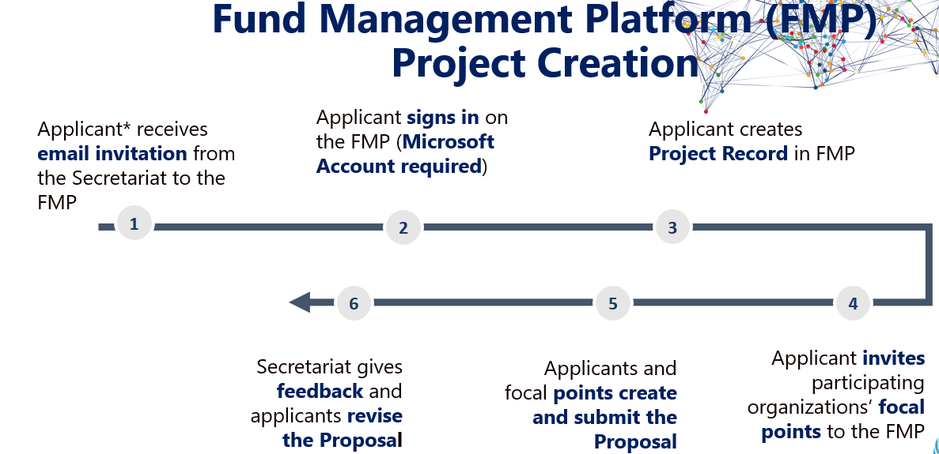

# Fund Management Platform (FMP) Project Creation

*Please click on* ***Create Project*** *to start creating the Investment funding prodoc in the Gateway.*

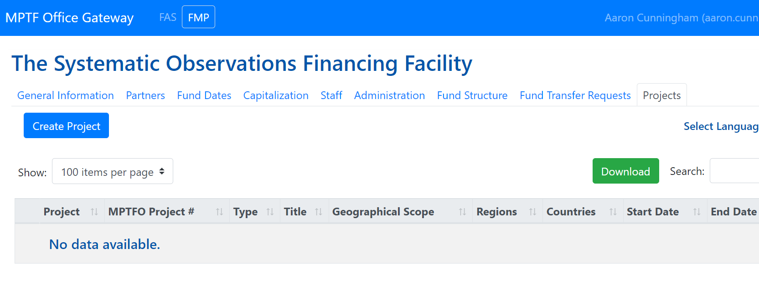

# General Information



*Please enter the information as outlined in the funding request.*

**Fund:** MPTF_00281: The Systematic Observations Financing Facility

**Title:** SOFF[*Country name*] Investment Phase

**Anticipated Start Date:** *Please enter.*

**Duration (In months):** *Please enter.*

**Description:** *Please enter a brief description of the proposal.*

*Don’t forget to click  before* !

## Contacts

*Add contacts from the* *button. Use the* **Search Contacts** *box for existing contacts or add new ones with*  *.*

*This section is for any additional contact focal points who can collaborate jointly to prepare the proposal in the platform.*

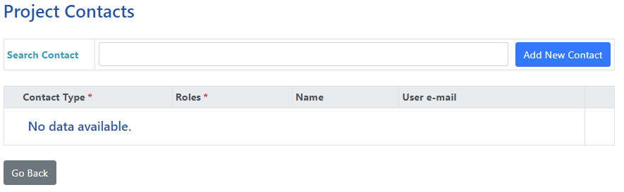

## Description

*Please provide a short description of the project which will appear on the SOFF UNMPTF Gateway website -* [*Systematic Observations Financing Facility (undp.org)*](https://mptf.undp.org/fund/sof00) *.*

*The description should include overview of the project including its objectives.*

## Universal Markers

*For Gender Marker, please select:*

**GEM1 - The Key Activity contributes to GEWE in a limited way.**

*The Risk marker should be aligned with the Environmental and Social Safeguards risk rating given to the project through the implementing entity.*

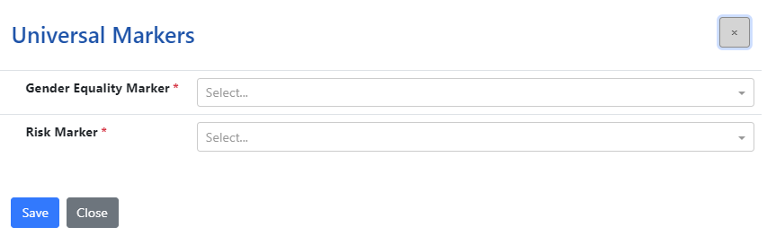

## Optional Markers

*Please select the most relevant.*

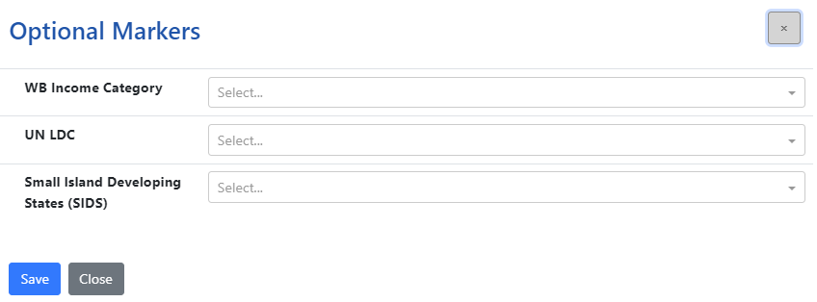

## Fund Specific Markers

*Please select the relevant responses to all fund specific markers.*

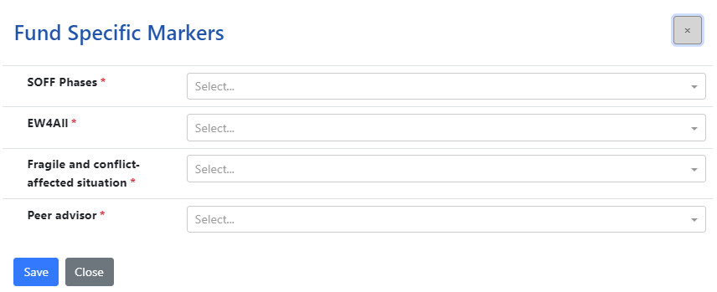

## Geographical Scope

*Please select the most relevant under* **Geographical Scope** *and* **Region(s).**

*Please ignore* **Name of the Region**

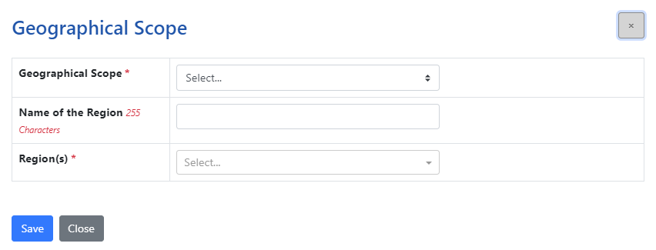

## Participating Organizations and their Implementing Partners

*Please select SOFF Implementing Entity for the current project, WMO and any other organizations that maybe relevant. WMO should be included for all SOFF projects as the budget for peer advisories services will be allocated to the peer through the WMO passthrough mechanism.*

## Programme and Project Cost

### Manage Budget Requested

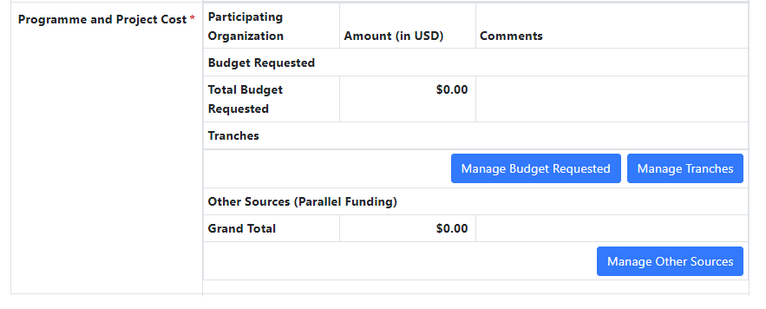

*Step 1: Click  and then .*

*Step 2: All participating organizations entered under* ***1.9*** *should appear in the drop-down menu.*

*Step 2.a Please select the SOFF Implementing Entity for the current project and add the Investment phase budget excluding the Peer Advisory fee.*

*Step 2.b Please select WMO and add the* ***Peer Advisory fee + 7% of the Peer Fee.***

***For example: if the Peer Advisory fee is USD 100’000, then 7% of 100’000 = 7000.***

***Therefore, total budget under WMO will be 100’000+7’000 = USD 107’000.***

*Don’t forget to click  before* !

### Manage Tranches

*Step 3: Click to add the tranches. Under* **Tranche Type***, select* **Percentage.** *The sum should add up to 100% to save the selection.*

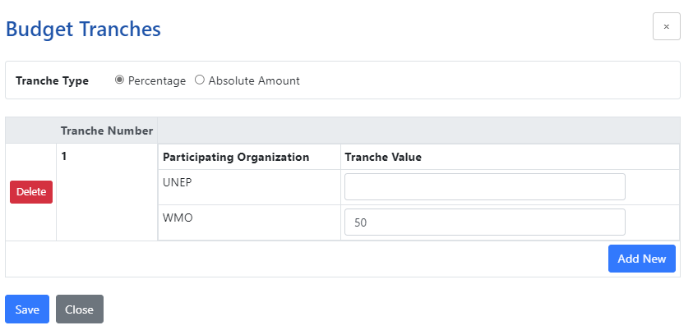

XXXXX

**Tranche Number 1**

***SOFF Implementing Entity:*** *Enter the percentage for the first tranche.*

***WMO:*** *Please enter ‘ 33.33% ’ under Tranche Value i.e one third (1/3) .*

*Click*  *to add more tranches.*

**Tranche Number 2**

***SOFF Implementing Entity:*** *Enter the percentage for the second tranche.*

***WMO:*** *Please enter ‘ 33.33% ’ under Tranche Value i.e one third (1/3) .*

**Tranche Number 3**

***SOFF Implementing Entity:*** *Enter 0*

***WMO:*** *Please enter ‘ 33.34% ’ under Tranche Value i.e one third (1/3) .*

*Don’t forget to click  before* !

### Manage Other Sources

*Please add any other additional fundings that are complimentary to SOFF investments.*

## Thematic Keywords

*Please ignore.*

## Programme Duration

*Please enter duration of investment request.*

## Comments for review process

*For SOFF secretariat to input upon successful submission of the funding request in the platform.*

# Narrative

*Please input text from the SOFF Investment Funding Request* **Section 2***,* **Section 3** *and* **Section 5** *into their respective sections.*

*Please ensure all information from the funding request is added including the* ***GBON National Contribution target table.***

*Under section* ***‘Create leverage****’- please add the following table to showcase relevant investments from the 5 multilateral climate funds and corresponding funding amount:*

|  |  |  |  |  |  |
| --- | --- | --- | --- | --- | --- |
|  | ***Adaptation Fund*** | ***Climate Investment Fund*** | ***CREWS*** | ***GCF*** | ***GEF*** |
| ***[Country Name]*** |  |  |  |  |  |

*Don’t forget to click  after each entry before moving on to the next one!*

# SDGs

*Please select all SDGs indicated in the figure below and add the suitable contributions to the SDGs.*

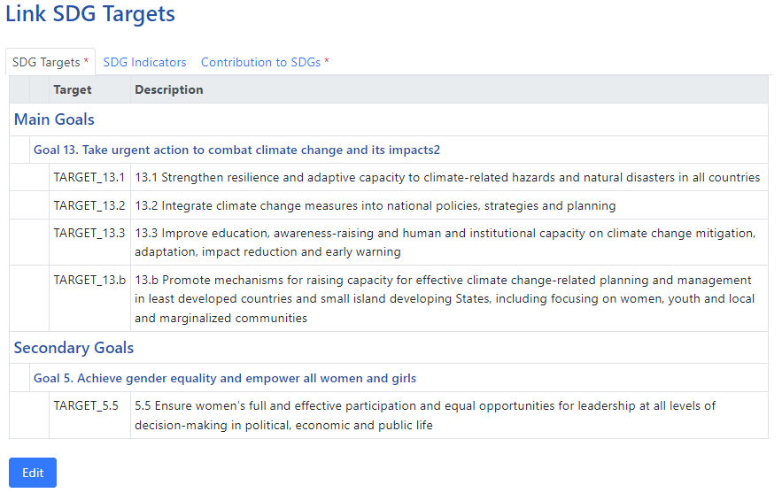

# RBM

*Please ensure this section is aligned with the SOFF investment funding request section 4 “Investment Phase Outputs and Budget”.*

*The indicated outputs/outcomes in the investment request template are already programmed in the Gateway.*

*Please note that the gateway uses only the term* **Outcomes** *within this section as compared to SOFF Investment Phase Funding Request which refers to Outputs 1 and 2 (see below table).*

|  |  |
| --- | --- |
| **SOFF Investment Phase Funding Request.** | **UNMPTF Gateway** |
| **Output 1:** | **Outcome 1:** |
| **Output 2:** | **Outcome 2:** |
| **Outcome:** | **Outcome 3:** |

## Outcomes

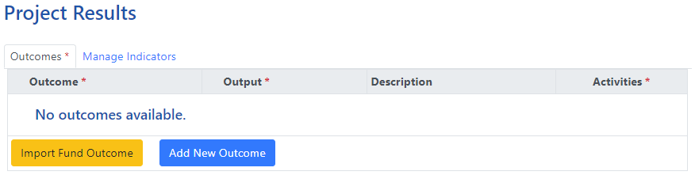

*Step 1: Click and select the SOFF Investment outcomes from the drop-down menu and click*  *.*

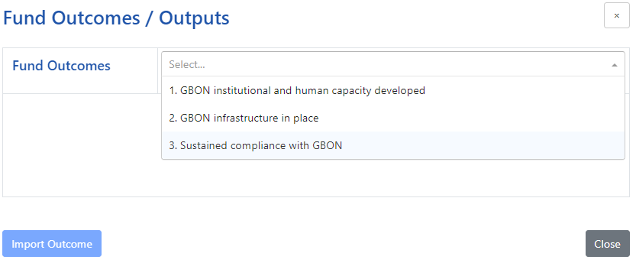

*Step 2: Click and select the outputs under each outcome and click* *.*

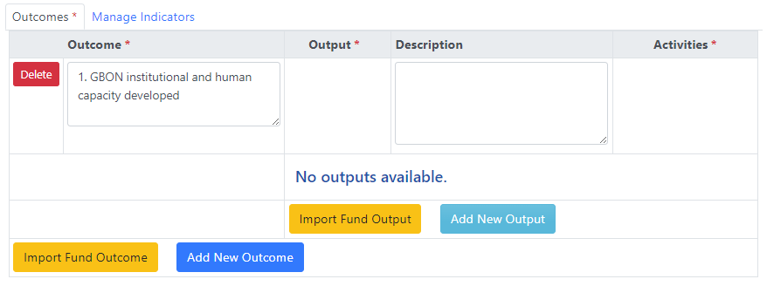

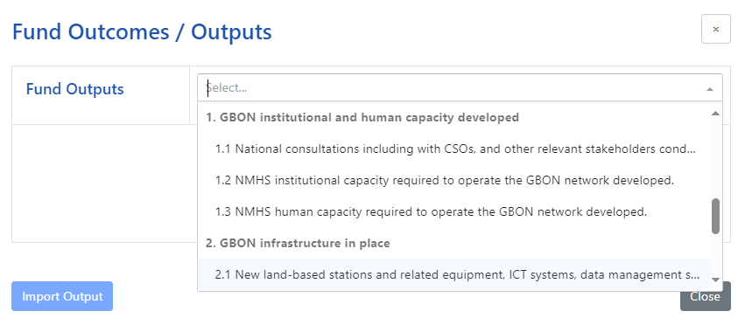

*Step 3: Click* *and add the* **Main activities** *from* **Section 4. Investment Phase Outputs and Budget** *of the SOFF Investment Phase Funding Request.*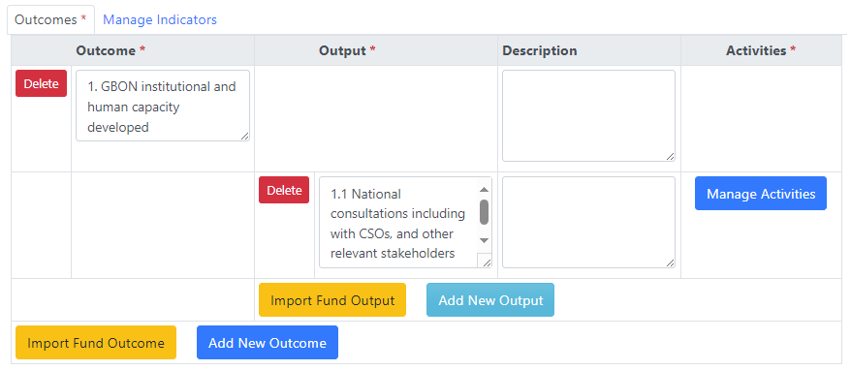 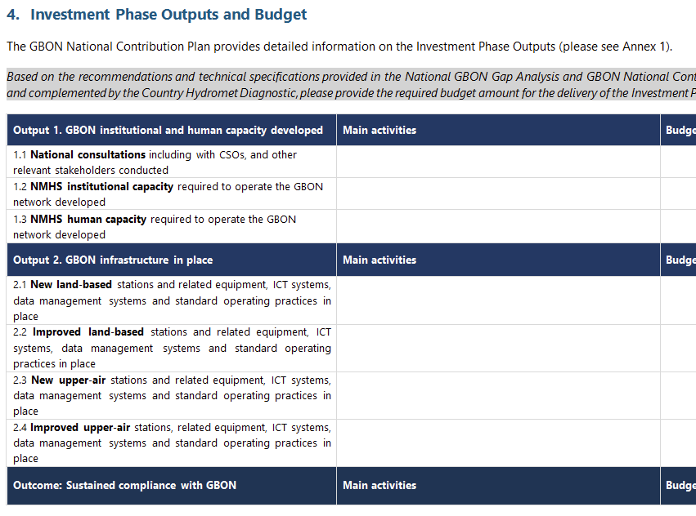

***Please complete for all 3 outcomes and their respective outputs based on the SOFF Investment Phase Funding Request.***

## Manage Indicators

Please include all indicators from the SOFF investment funding request section 6 “Investment Phase Monitoring and Reporting”.

**SOFF will not indicate any indicators as signature indicators.**

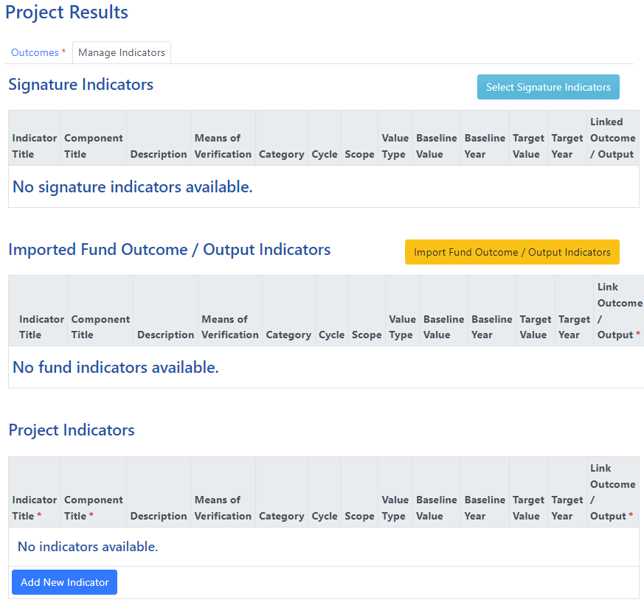

### **Signature Indicators**

*Please Ignore.*

### **Imported Fund Outcome/Output Indicators**

*Step 1: Click  and select all relevant indicators and then .*

*Note: This section only considers indicators under the* ***Output 2*** *and* ***Outcome*** *of the SOFF Investment Funding request.*

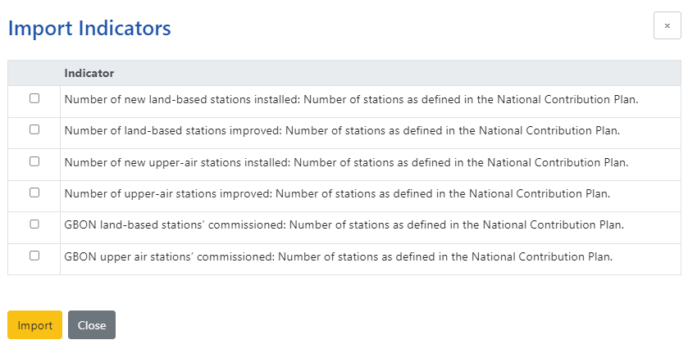

*Step 2: Under each indicator, choose the right options (refer table below) to reflect the details from* **Section 6. Investment Phase Monitoring and Reporting** *SOFF Investment Phase Funding Request.*

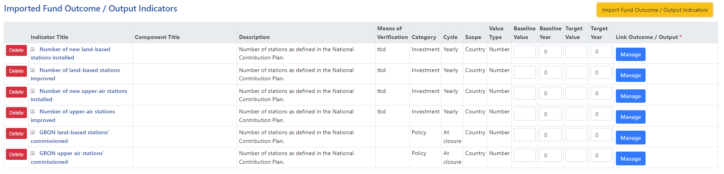

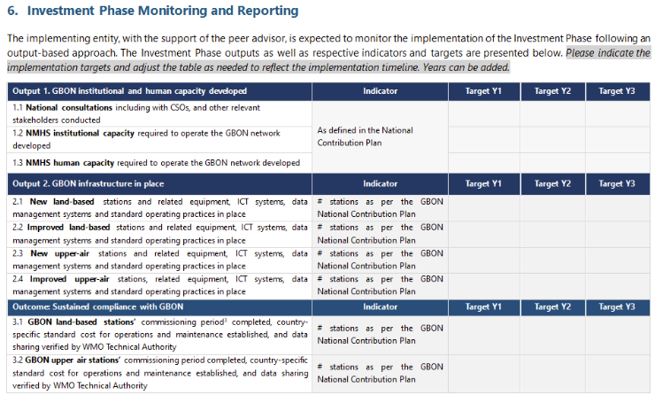

|  |  |  |
| --- | --- | --- |
| **Imported Fund Outcome/Output Indicators** | **Indicator Title** | Choose relevant indicators from the drop-down menu |
| **Component Title** |  |
| **Description** | *Number of stations as per the National Contribution Plan.* |
| **Means of Verification** | *Annual or Quarterly reports* |
| **Category** | Choose the most relevant |
| **Cycle** | *At closure* |
| **Scope** | Choose the most relevant |
| **Value Type** | Choose the most relevant |
| **Baseline Value** | * 0 if no stations currently existing (New stations) * X if X number of stations are already existing (Improved stations) |
| **Baseline Year** | Year of start of project |
| **Target Value** | Total target as per the NCP |
| **Target Year** | Year of end of project |
| **Link Outcome/Output** | Link to the correct outcome/output |

*Step 3: Link each indicator to the relevant outcome/output by clicking* 



*Don’t forget to click  before* !

### **Project Indicators**

*Please add all indicators under* **Output 1** *on* **Section 6. Investment Phase Monitoring and Reporting** *of the**SOFF Investment Phase Funding Request and link it to the relevant outcome/output as done above.*

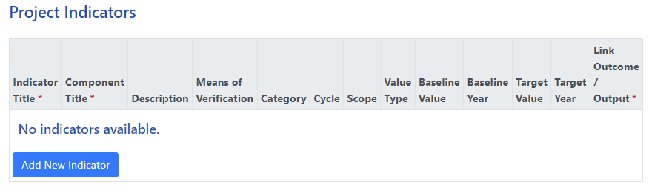



***Please include gender as a component of all the project indictors.***

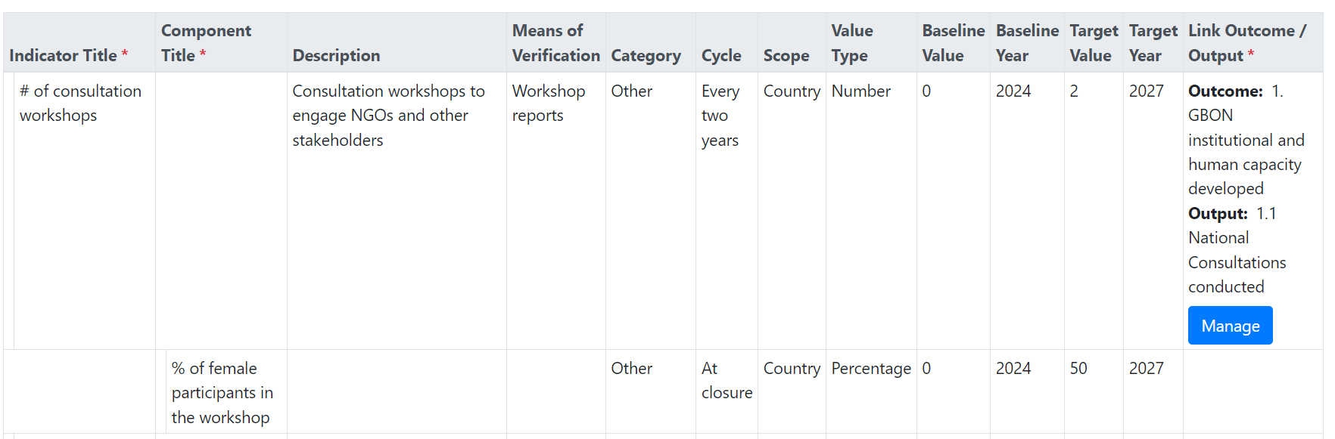

*Don’t forget to click  before* !

# Risk Management

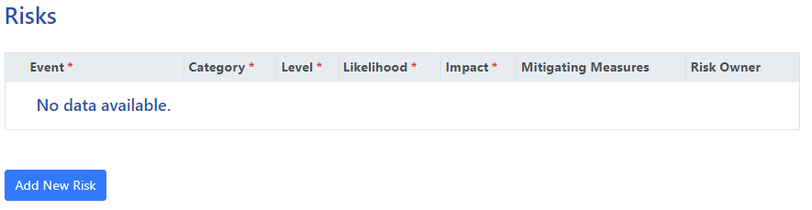

*Please enter all the risks listed under* **Section 7. Investment Phase Risk Management Framework** *of the**SOFF Investment Phase Funding Request.*

# Budgets

## Budgets by UNSDG Categories: Overall

*Please enter budget from the table under* **Section 4. Investment Phase Outputs and Budgets** *of the**SOFF Investment Phase Funding Request.*

***Please note 7 % Implementing Entity (IE) fee is automatically calculated under budget line 8. Therefore, the budget lines 1 to 7 should not include the IE fee.***

***Peer Advisory fee must also be included under the WMO column. 7% of Peer fee that goes to WMO is automatically calculated and therefore the total Peer fee will appear higher (i.e. 1.07 x Peer fee).***

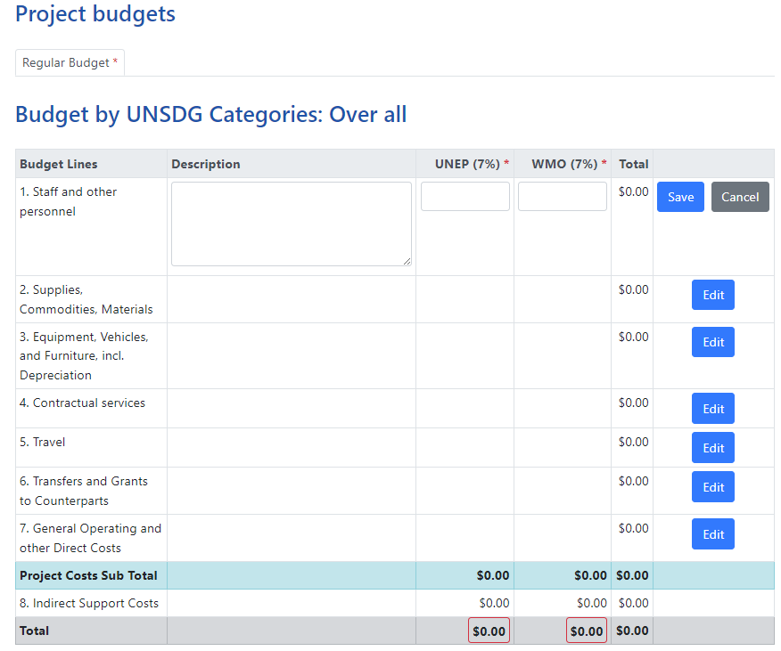

XXX

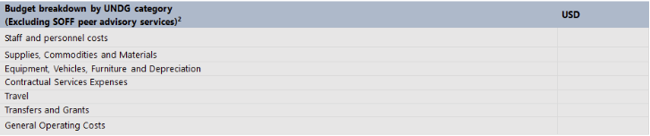

*Don’t forget to click  after each entry!*

## Results Based Budget

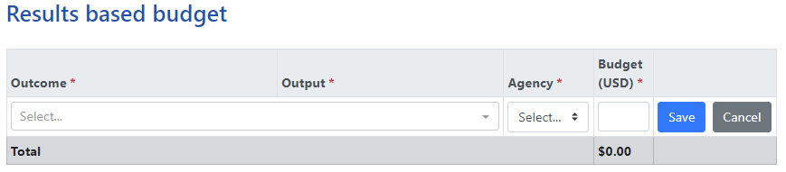

*Please select each* **Outcome** *and* **Output** *from the drop-down menu and enter their respective budget from* **Section 4. Investment Phase Outputs and Budgets** *of the**SOFF Investment Phase Funding Request.*

***Please include Peer Advisory fee under the most appropriate Outcome.***

*Please ignore Budget per Gender (GEWE) table.*

*Don’t forget to click  after each entry!*

# Work Plan

*Please mark the correct target years for each activity based on* **Section 6. Investment Phase Monitoring and Reporting** *of the**SOFF Investment Phase Funding Request.*

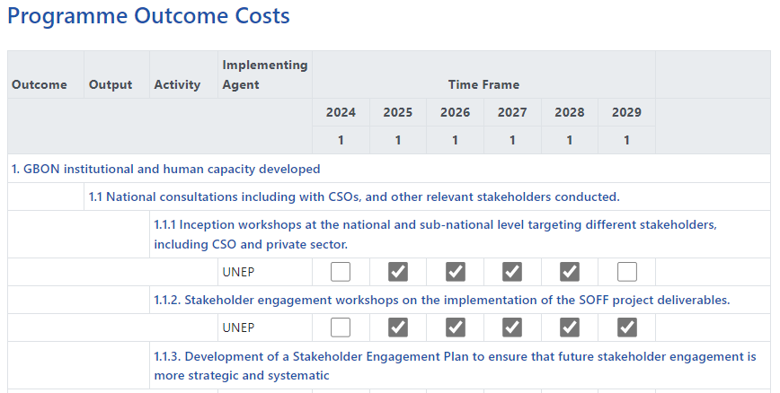

XXX

XXX



*Don’t forget to click  eachtime!*

# Documents

*Please upload the following documents:*

* *Peer Advisors Terms of Reference, in accordance with the template provided in Annex 1*

1. *Three Readiness outputs*

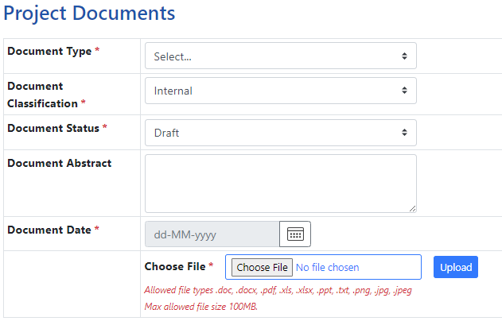

# Workflow

*Ensure all sections are filled – any missing section will be indicated with* X

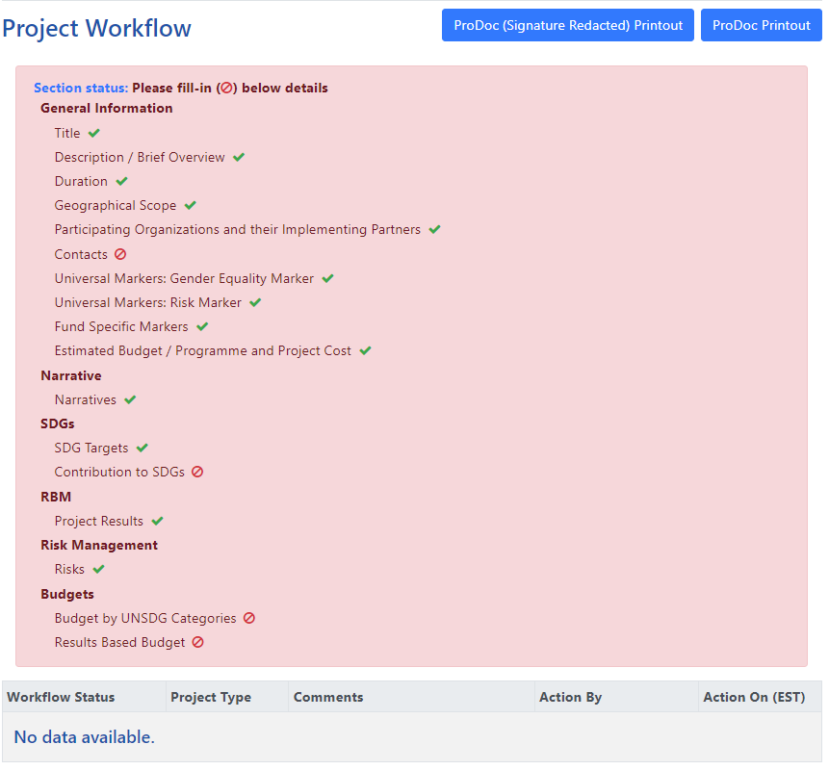

*Once all information is uploaded correctly, the Workflow will turn green and* ***[Submit]*** *button will appear.*

Annex 1: Terms of Reference for the provision of technical advisory services during the SOFF Investment Phase

This Terms of Reference describe the provision of technical advisory services by [peer advisor name] to [SOFF beneficiary country] to contribute to the delivery of the SOFF Investment Phase outputs as described in Section RBM of the SOFF UNMPTF Gateway

| Output | Indicator  (*Please copy the indicators from the Investment Funding Request*) | Activities conducted/Contributions  (One indicator allows more than one activity/contribution from peer advisors) | Implementation plan[1] | | | | |
| --- | --- | --- | --- | --- | --- | --- | --- |
| Y1 | Y2 | Y3 | Y4 | Y5 |
| 1.1 National consultations, including with CSOs and other relevant stakeholders conducted | Add indicator as per approved funding request | Specify activities relevant to the output |  |  |  |  |  |
| Add indicator as per approved funding request | Specify activities relevant to the output |  |  |  |  |  |
| Add indicator as per approved funding request | Specify activities relevant to the output |  |  |  |  |  |
| 1.2 NMHS institutional capacity required to operate the GBON network developed | Add indicator as per approved funding request | Specify activities relevant to the output |  |  |  |  |  |
| Add indicator as per approved funding request | Specify activities relevant to the output |  |  |  |  |  |
| Add indicator as per approved funding request | Specify activities relevant to the output |  |  |  |  |  |
| 1.3 NMHS human capacity required to operate the GBON network developed | Add indicator as per approved funding request | Specify activities relevant to the output |  |  |  |  |  |
| Add indicator as per approved funding request | Specify activities relevant to the output |  |  |  |  |  |
| Add indicator as per approved funding request | Specify activities relevant to the output |  |  |  |  |  |
| 2.1 New land-based stations and related equipment, ICT systems, data management systems and standard operating practices in place | # of new stations installed as per the GBON National Contribution Plan | Specify activities relevant to the output |  |  |  |  |  |
| 2.2 Improved land-based stations and related equipment, ICT systems, data management systems and standard operating practices in place | # of stations improved as per the GBON National Contribution Plan | Specify activities relevant to the output |  |  |  |  |  |
| 2.3 New upper air stations and related equipment, ICT systems, data management systems and standard operating practices in place | # of new stations installed as per the GBON National Contribution Plan | Specify activities relevant to the output |  |  |  |  |  |
| 2.4 Improved upper air stations and related equipment, ICT systems, data management systems and standard operating practices in place | # of stations improved as per the GBON National Contribution Plan | Specify activities relevant to the output |  |  |  |  |  |
| 3.1 GBON land-based stations’ commissioning period completed, country-specific standard cost for operations and maintenance established, and data sharing verified by WMO Technical Authority | # of stations commissioned as per the GBON National Contribution Plan | Specify activities relevant to the output |  |  |  |  |  |
| 3.2 GBON upper air stations’ commissioning period completed, country-specific standard cost for operations and maintenance established, and data sharing verified by WMO Technical Authority | # of stations commissioned as per the GBON National Contribution Plan | Specify activities relevant to the output |  |  |  |  |  |

1.