WEATHER CLIMATE WATER | 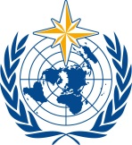  World Meteorological Organization  EXECUTIVE COUNCIL  Seventy-Eighth Session  10 to 14 June 2024, Geneva | EC-78/INF. 3.1(2)
Submitted by:
Secretary-General
2.IV.2024

PILLAR 2 RAPID ASSESSMENT: HAZARD MONITORING AND FORECASTING
[Version for TCC-PAC. The document is being proofread for EC-78]

Background

- The launch of the Early Warnings for All (EW4All) Initiative saw a sharp increase in the demand for monitoring data, particularly on the capacity of the 30 countries selected for coordinated assistance. Whereas the WMO Monitoring and Evaluation System provided useful insights into global and regional trends, the information lacked the granularity required to inform technical assistance planning and infrastructure investments.

- To facilitate these processes and establish a baseline on capacity, WMO undertook a two-pronged approach involving: (a) the development of a rapid assessment methodology for appraising the monitoring and forecasting capacity of the 30 countries, including for specific priority hazards; and (b) the conduct of Country Hydromet Diagnostics (CHD) in all 30 countries as part of the Systematic Observations Financing Facility (SOFF) Readiness Phase. The former tool provides a detailed view on the countries’ capacity for early warnings; the latter offers a big picture perspective on the National Meteorological and Hydrological Services (NMHS) operating environment and contribution to weather, climate, hydrological and environmental services and warnings.

- The two methodologies are aligned to each other and the self-reported data that feeds the Rapid Assessment is being validated through the peer advisors conducting CHDs in-situ as well as through the WMO Regional Offices and project managers.

Purpose

- The purpose of the Pillar 2 Rapid Assessment is to inform the planning stage of the EW4All Initiative through baseline data and analysis. It is also intended to identify the areas with the biggest capacity gaps so that technical assistance and investments could be better targeted.

Methodology

- The Rapid Assessment methodology is aligned with the elements and maturity levels of CHD as well as with the Pillar 2 Implementation Strategy. It is also based on relevant components of the Multi-Hazard Early Warning System (MHEWS) Checklist, CDEMA Checklist and the Climate Risk and Early Warning Systems (CREWS) Custom MHEWS Indicators. It is structured along the following seven elements of the hydrometeorological value chain:

(i) Legal framework and institutional mechanisms of the NMHS
(ii) Observation infrastructure
(iii) Hazard monitoring capacity
(iv) Use of remote-sensing data
(v) Use of numerical weather prediction (NWP) models and forecasting tool application
(vi) Impact-based forecasting capacity, and
(vii) Warning services and early warning system operations

- Important enabling environment factors are also considered, such as the existence of legislation, governance mechanisms and financial as well as technological capabilities.

- The data collection is conducted by means of WMO-led structured interviews with the Permanent Representatives of the respective country and designated NMHS staff. A detailed questionnaire composed of 74 questions is used, which has been designed to collect both quantitative and qualitative data on the seven elements. As a first step, respondents are requested to select five priority hazards from the WMO Catalogue of Hazardous Events. For these, hazard-specific information is further collected in the course of the interview (see example in Figure 1).

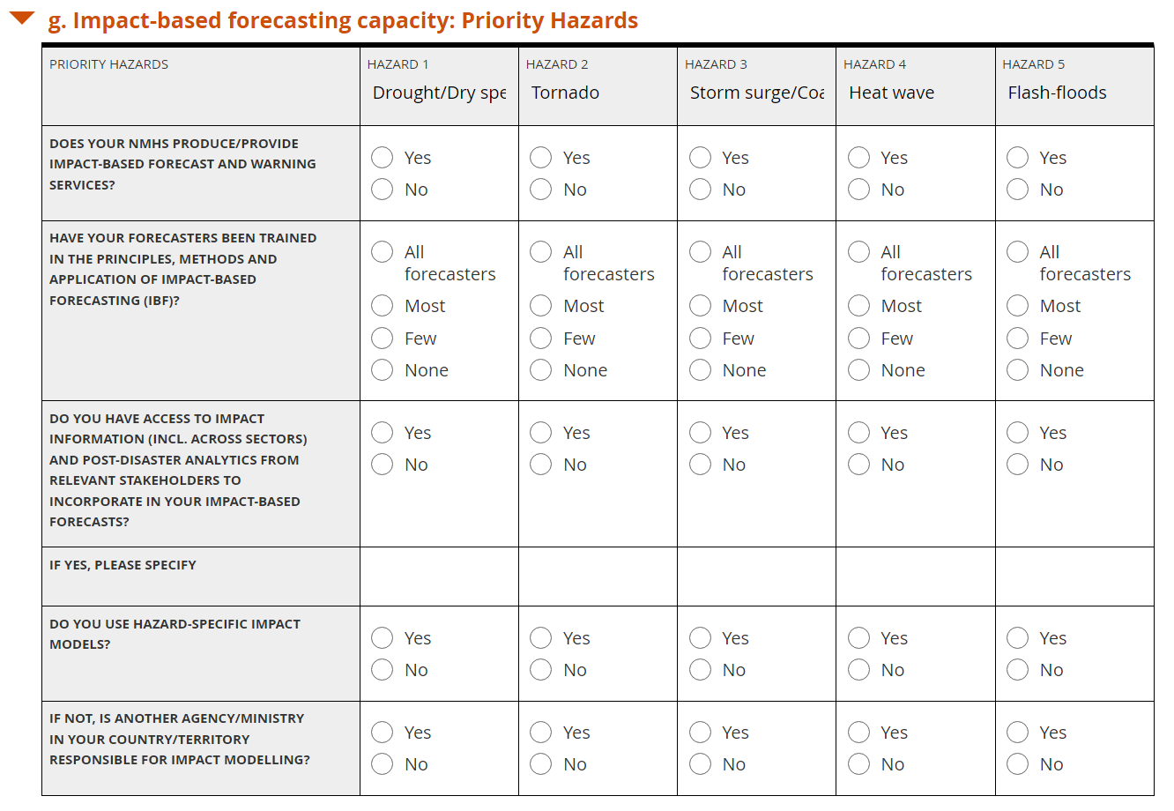

Figure 1 Example of hazard-specific data collected

- The Rapid Assessment questions are weighed based on the criticality of the criteria addressed for the delivery of early warnings, the objectivity of the data, and the clarity of the concepts. Once collected, each response is coded (e.g. 0=criteria not met, 0.25=starting to be met, 0.5=partially met, 0.75=mostly met, 1=criteria fully met) and a capacity level calculated (a) per element and (b) for the Rapid Assessment as a whole. This level is then converted to a scale of 1 to 5 to establish the overall capacity of the country, where five represents advanced capacity and one represents no or less than basic capacity. For each country, a scorecard is developed (see Figure 2) presenting the overall capacity level with an executive summary detailing the status and needs of the NMHS as well as colour-coded bars indicating the level of each element of the value chain assessed.

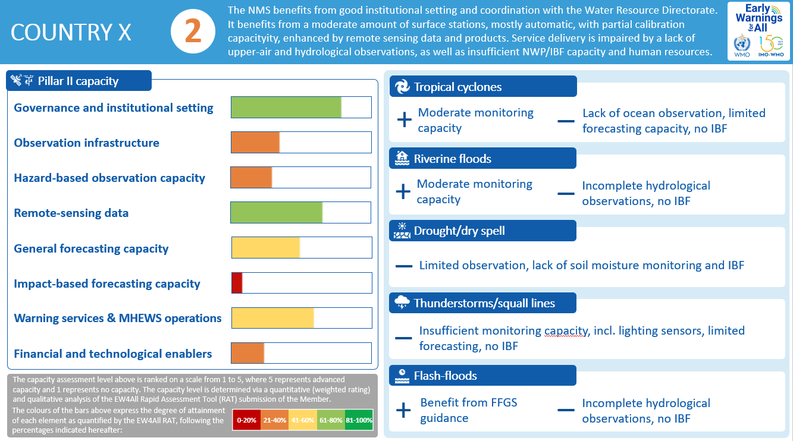

Figure 2: Example scorecard

- The five priority hazards identified by the NMHS are presented on the right-hand side of the scorecard. Whereas considerably more detailed data is required to be able to assess the monitoring and forecasting capacity of a country for specific hazards, the Rapid Assessment proved useful in detecting overall strengths and weaknesses in countries’ ability to tackle them.

Data Validation

- A three-step data validation process is followed to ensure the accuracy and reliability of the analysis:

- Data completeness and relevance. In the course of the data collection interviews, the WMO Secretariat is able to clarify questions, explain terminology, apply common benchmarking, minimize any incorrect data feed, and avoid any missing values. Data that is not readily available or requires verification is provided by the NMHS at a later point. Though more time-consuming and labour-intensive than a survey, the interview approach is believed to increase the reliability and validity of the data.

- Data verification. Once the dataset is complete, it is shared with the WMO Regional Offices and/or project managers working with the respective country to alert of any potential inconsistencies or inaccuracies.

- Data validation. As a last step, the data is provided to the peer advisors conducing CHDs as part of the SOFF Readiness Phase. They validate the accuracy of the data during in-situ visits and interviews, thus contributing to the quality and reliability of the WMO Monitoring System. Adjustments to a country’s scorecard are possible based on this final validation step of the process.

Implementation Status

- Since June 2023, the Rapid Assessment has been applied to 41 Members, including the 30 initial EW4All focus countries, eight Members from RA VI (based on a request from the Management Group), and three more Members. The data from seven more countries is undergoing analysis.

- Presented as the at-a-glance scorecards illustrated in Figure 2, the Rapid Assessment results provide substantive analysis that is being used in the creation of the national Early Warnings for All roadmaps. The results are also provided to the EW4All partners and funding institutions for consideration in their investment decisions.

Results

- Figure 3 presents the aggregate results of the Rapid Assessment, which show that almost a quarter of the 30 countries operate with less than basic monitoring and forecasting capacity for their priority hazards, while over half rely on basic monitoring and forecasting to support their early warning systems.

Figure 3: Pillar 2 capacity levels, 30 initial countries selected for EW4All
coordinated assistance (WMO, 2023)

- Impact-based forecasting is the area with the biggest deficiencies in human resources, training, technical solutions and access to vulnerability and impact data. Hazard monitoring is another area where NMHS face considerable challenges, with basic to less than basic observations for certain priority hazards, lack of automation of the infrastructure network, and inadequate capacity to perform appropriate maintenance, calibration, and quality control of stations and instruments.

- The full aggregate results are available in Early Warnings for All in Focus: Hazard Monitoring and Forecasting, an analytical brief which summarizes the Rapid Assessment outcomes and draws attention to important gaps and trends.

- The country analysis and underlying data are available on the Early Warnings for All Dashboard, the centralized data portal of the Initiative (see MHEWS Country Capacity). Bringing together data from all partners, the dashboard presents selected monitoring indicators structured along three categories:

(a) Global indicators: metrics that capture the Initiative’s impact on the availability of end-to-end, people-centred multi-hazard early warning systems.

(b) Implementation indicators: metrics intended to measure implementation of the Initiative’s pillar implementation strategies as well as key elements of the enabling environment.

(c) Country capacity indicators: baseline data on the early warning capacity of the roll-out countries, currently only available for Pillar 2 based on the Rapid Assessment.

Limitations

- The Rapid Assessment methodology has proven useful in informing the planning stage of the EW4All Initiative and in establishing a baseline on country capacity. Its broader application and upscaling could potentially be slowed down by lack of sufficient resources to conduct the relatively labour- and time-intensive interviews and analysis. The data validation could also be affected by resource availability, given its dependency on the conduct of CHDs through SOFF.

Next Steps

- Transfer the know-how to the Regional Offices. The capacity for applying the Rapid Assessment methodology, particularly with respect to data collection and interviews, is currently being built in the Regional Offices. This will facilitate the upscaling of the assessment and improve the data availability.

- Scale up to more WMO Members. The Secretariat plans to progressively increase the number of Members with Pillar 2 Rapid Assessments from 30 to 60 in 2024 and up to 100 Members by the end of 2025. Two mechanisms will be used to this end: (i) upon demand (as requested by the Regional Associations and Members, particularly those joining EW4All implementation) and (ii) through the SOFF Readiness Phase. Data availability on a larger sample of Members will allow broader regional analysis, thematic reports and better-informed insights on global needs and gaps. It will also establish an important baseline for measuring progress in country capacity (i.e. moving from red to orange to yellow and ultimately green).

- Expand beyond Pillar 2. Co-chaired by WMO and the United Nations Office for Disaster Risk Reduction (UNDRR), the EW4All Monitoring and Evaluation (M&E) Working Group plans to replicate the methodology to the other three pillars of the Initiative. Pillar 1 has successfully tested its applicability and is currently working on fine-tuning the weights assigned.

- Develop an Early Warning System (EWS) Maturity Index. The EW4All M&E Working Group is also initiating work on the development of a maturity index, based on the WMO Rapid Assessment methodology and the minimum core capabilities established by the four pillars.

_____________

The CHD has been developed by the Alliance for Hydromet Development under WMO leadership and with the guidance of a multi-party Working Group. It is based on a peer approach where advanced NMHSs from both developed and developing countries undertake the diagnostics, following the standardized methodology. CHD provides a maturity assessment of NMHS operations along 10 elements of the hydrometeorological value chain. Behind each element sit various indicators, which are informed by data sources and by direct interviews and observation for validation purposes.
Multi-hazard Early Warning Systems: A Checklist (wmo.int)
EWS Toolkit - Multi-hazard Early Warning Systems: A Checklist (cdema.org)
Multi-hazard early warning system custom indicators & methodologies for computation | UNDRR
The SOFF Steering Committee has approved funding for the readiness phase of 60 beneficiary countries, including all 30 countries initially selected for coordinated assistance under EW4All. One country has a CHD funded a separate project.
Antigua and Barbuda, Bangladesh, Barbados, Cambodia, Chad, Comoros, Djibouti, Ecuador, Ethiopia, Fiji, Guatemala, Guyana, Haiti, Kiribati, Lao People’s Democratic Republic, Liberia, Madagascar, Maldives, Mauritius, Mozambique, Nepal, Niger, Samoa, Solomon Islands, Somalia, South Sudan, Sudan, Tajikistan, Tonga, Uganda.
Albania, Armenia, Bosnia and Herzegovina, Georgia, Jordan, North Macedonia, Republic of Moldova, Ukraine.
Cabo Verde, Timor-Leste and Vanuatu.
Burkina Faso, Côte d’Ivoire, Mali, Nigeria, Republic of Tanzania, Senegal and Trinidad and Tobago.

