|  |  |  |
| --- | --- | --- |
| WEATHER CLIMATE WATER | **World Meteorological Organization**  **EXECUTIVE COUNCIL**  **Seventy-Eighth Session** 10 to 14 June 2024, Geneva | **EC-78/Doc. 3.1** |
| Submitted by: Chair TCC with PTCs, C/RB and PRAs  4.IV.2024  **DRAFT 1** |

**AGENDA ITEM 3: WMO contribution to the EW4All Initiative**

**AGENDA ITEM 3.1: WMO contribution to the EW4All Initiative**

# WMO ROADMAP FOR THE EARLY WARNINGS FOR ALL INITIATIVE

*[Version for TCC-PAC. The document is being proofread for EC-78]*

|  |
| --- |
| **Summary** |
| **Document presented by:** TCC Chair  **Strategic objective 2024–2027:** Objective 1.1 Strengthen national  multi-hazard early warning/alert systems and extend reach to better  enable an effective response to the associated risks  **Financial and administrative implications:** Within the parameters of the Strategic and Operating Plans 2024–2027.  **Key implementers:** SERCOM, INFCOM, Research Board, Regional Associations, TCC, supported by the Secretariat  **Timeframe:** 2024-2027  **Action expected:** Coordinated actions across the organization, its constituent bodies and its partners to further the goal of Early Warnings for All by 2027 |

# General considerations

### Background

1. The nineteenth session of WMO Meteorological Congress through [Resolution 4 (Cg-19)](https://library.wmo.int/idviewer/67177/61) *-* United Nations Early Warnings for All initiative requested Executive Council to oversee progress on WMO’s contribution to the EW4All Initiative as a matter of highest priority and to ensure coordination and consolidation of all relevant WMO activities under the EW4All umbrella.

2. On the margins of Cg-19, the WMO Secretariat’s Monitoring, Evaluation, Risk and Planning (MERP) Office initiated a process within the subset of 30 countries to establish a baseline on capacity. MERP undertook a two-pronged approach involving: (a) the development of a rapid methodology for appraising the monitoring and forecasting capacity of the 30 countries, including for specific priority hazards (see INF 3.1(2)); and (b) the conduct of Country Hydromet Diagnostics (CHD) in all 30 countries as part of the [SOFF Readiness Phase](https://un-soff.org/operations/#phases). The former tool provides a detailed view on the countries’ capacity for early warnings; the latter offers a big picture perspective on the National Meteorological and Hydrological Services (NMHS) operating environment and contribution to weather, climate, hydrological and environmental services and warnings. In addition, the EW4All Monitoring and Evaluation (M&E) Working Group chaired by WMO and United Nations Office for Disaster Risk Reduction (UNDRR) developed (i) [a theory of change](https://wmoomm.sharepoint.com/sites/wmocpdb/Planning%20%20Monitoring/Forms/AllItems.aspx?id=%2Fsites%2Fwmocpdb%2FPlanning%20%20Monitoring%2FMonitoring%20and%20Evaluation%2FEarly%20Warnings%20for%20All%20%28EW4All%29%2FTheory%2Dof%2DChange%5FEW4All%5FFINAL%2Epdf&parent=%2Fsites%2Fwmocpdb%2FPlanning%20%20Monitoring%2FMonitoring%20and%20Evaluation%2FEarly%20Warnings%20for%20All%20%28EW4All%29&p=true&ga=1) for the Initiative, which lays out the results chain consisting of impacts, outcomes, intermediary outcomes and illustrative outputs and (ii) [a M&E framework](https://wmoomm.sharepoint.com/sites/wmocpdb/Planning%20%20Monitoring/Forms/AllItems.aspx?id=%2Fsites%2Fwmocpdb%2FPlanning%20%20Monitoring%2FMonitoring%20and%20Evaluation%2FEarly%20Warnings%20for%20All%20%28EW4All%29%2FEW4All%2DOutcomes%2DOutputs%2DIndicators%5Fupdated%5F14Feb2024%2Epdf&parent=%2Fsites%2Fwmocpdb%2FPlanning%20%20Monitoring%2FMonitoring%20and%20Evaluation%2FEarly%20Warnings%20for%20All%20%28EW4All%29&p=true&ga=1) with a range of indicators at all levels. A monitoring plan is currently being developed to ensure that data from reliable sources is readily available.

3. The Executive Council through its [Resolution 7 (EC-77)](https://library.wmo.int/idviewer/66333/17) - Subsidiary bodies of the Executive Council delegated the role of coordinating the technical bodies of the Organization (technical commissions, the Research Board, and other relevant bodies) and the regional associations to the Technical Coordination Committee (TCC). The TCC’s mandate is to coordinate the technical bodies with the regional associations to ensure that the technical work of the Organization is properly guided by the needs and priorities identified by Members.

4. At its first meeting (17-19 October 2023), the TCC considered a proposed outline for a draft implementation plan developed by the Secretariat as the basis for the development of a WMO-wide implementation plan to guide WMO coordinated contribution to the EW4All Initiative and the development of regional action plans. The TCC agreed on the development of such a WMO-wide implementation plan, complemented by regional plans, with the aim of submitting a related recommendation to the seventy-eighth session of the Executive Council (EC-78). The TCC also provided guidance to technical commissions, requesting the identification of proposed priority activities that could be considered for the EW4All initiative; and to the regional associations for their review and regional prioritization based on regionally- and sub-regionally relevant identified hazards.

5. At its first update meeting on 23 November 2023, TCC took note of the categorization of priority hazards by each region, whereas at the second update meeting on 15 December 2023 it considered a consolidated narrative list of proposed priority activities compiled by the Secretariat, reflecting the ongoing or planned priority activities carried out by the technical commissions and the Research Board, as presented in the annex.

6. The consolidated narrative list of proposed priority activities, revised by the respective Management Groups of the technical commissions and the Research Board, was then circulated in January 2024 to seek feedback from Members on what should be considered a WMO priority activity for the EW4All initiative. By 3 March 2024, the deadline for feedback from Members, 39 replies were received.

7. The draft zero of the WMO Implementation Plan was presented to TCC at the third update meeting on 21 February 2024. Having considered it, TCC agreed to move forward with the further development of a draft Resolution for EC-78, articulating over the vision for the WMO contribution to the EW4All and providing a Roadmap to guide technical commissions, the Research Board, regional associations and other subsidiary bodies of the Executive Council in the implementation of priority activities for the EW4All Initiative.

8. The proposed draft Resolution reflects the indications given by the TCC on 21 February about its structure and was further reviewed at the fourth update meeting of TCC on 22 March 2024.

# DRAFT RESOLUTION

## Draft Resolution 3.1/1 (EC-78)

## WMO Roadmap for implementation of the Early Warnings for All Initiative

THE EXECUTIVE COUNCIL,

**Recognizing**:

1. That the objectives and ambitions of the United Nations Early Warnings for All initiative (EW4All) are fully aligned with the purpose of the organization as outlined in Article II of the WMO Convention,
2. The fundamental role of NMHSs as the official and authoritative providers of early warnings for hydrometeorological and climatological hazards,
3. That it is the primary responsibility of Members to establish multi-hazard early warning systems and that commitments of the Members to the establishment and development of early warning systems are integral to the initiative,
4. That the multi-hazard early warning systems value cycle is built on the collaborative efforts of national and international stakeholders inclusive of multilateral and bilateral development partners in the public, private, and academic sectors,

**Recalling**:

1. [Resolution 4 (Cg-19)](https://library.wmo.int/idviewer/67177/61) - EW4All, requesting Executive Council to oversee progress on WMO’s contribution to the EW4All Initiative as a matter of highest priority and to provide advice and direction to ensure there is coordination and consolidation of all relevant WMO activities under the EW4All umbrella,
2. [Resolution 1 (EC-77)](https://library.wmo.int/idviewer/66333/9) – WMO Contribution to EW4All, requesting inter alia Regional Associations, Technical Commissions and Research Board, under the guidance of the Executive Council, to consolidate all their relevant activities under the EW4All umbrella and report back to EC,
3. [Resolution 7 (EC-77)](https://library.wmo.int/idviewer/66333/17) - Review of subsidiary bodies of the Executive Council, re-establishing the Technical Coordination Committee, and requesting it to focus on coordination of the WMO contributions to EW4All,
4. Decision 4.5(2)/1 (SERCOM-3), see INF 3.1(2), requesting SERCOM subsidiary bodies to refer to the WMO Roadmap for EW4All to guide the future development of SERCOM contributions to EW4All,
5. Draft Decision 7.1/1(INFCOM-3), endorsing the list of priority activities of INFCOM contributing to EW4All and draft Recommendation 7.1/1 (INFCOM-3), recommending to the Executive Council the adoption of the Action Plan for infrastructure components contributing to EW4All,

**Welcoming**:

1. The launching of the EW4AllExecutive Action Plan 2023–2027 by the United Nations Secretary-General at the twenty-seventh session of the Conference of the Parties of the United Nations Framework Convention on Climate Change (UNFCCC/COP 27) in Sharm El-Sheikh, Egypt in November 2022,
2. The ongoing efforts of the technical commissions, Research Board, regional associations and subsidiary bodies of Executive Council in furthering this initiative,
3. The contributions of Members, development agencies, multilateral organizations, and global climate funds (like the Green Climate Fund) towards mobilizing and allocating funds to support implementation of EW4All in Members most in need,
4. The alignment and acceleration of the work of the Systematic Observations Financing Facility (SOFF), the Climate Risk and Early Warning Systems (CREWS) initiative, and Multilateral Development Banks to support the goals of EW4All,

**Acknowledging**:

1. That WMO Congress designated EW4All as the highest priority in the WMO Strategic Plan 2024–2027; and as such should be clearly reflected in the activities and work programmes of the technical commissions, Research Board and the regional associations,
2. The role of the Technical Coordination Committee thus far in coordinating the technical and scientific work of the organization, in particular the technical commissions, Research Board, Regional Associations and relevant EC panels, towards the development of a high-level Roadmap for EW4All activities,
3. The role of the Policy Advisory Committee in providing strategic guidance for the collective and collaborative engagement of the Organization and its Members with a range of stakeholders,
4. The broad extent of the organization’s activities under the banner of EW4All and the need to clarify the accountabilities and responsibilities of the constituent and additional bodies (technical commissions, Research Board and Regional Associations), as well as the subsidiary bodies of Executive Council,
5. That some EW4All activities, such as resource mobilization, engagement with United Nations (UN) partners and extrabudgetary projects, fall outside of the remit of TCC according to its approved Terms of Reference, but still require the oversight of Executive Council,

**Noting**:

1. The list of priority hazards and proposed priority activities arising from consultation with the technical commissions, Research Board and Regional Associations provided in the annex,
2. The feedback on the proposed priority activities from Members through the regional offices, as presented [here](https://wmoomm.sharepoint.com/:x:/s/Services/EfEGLwlhL6dGtpXJNIewGdsBokBvaC63aYYCdUAroAAikQ?e=rghMjk&wdLOR=cC4B274EC-DCBF-4943-A378-E06E1C2CDB3F),
3. The decision of SERCOM-3 to follow guidance of TCC on the implementation of priority activities in relation to its workplan,
4. The ongoing consultation with regional associations, Members and partners through EW4All regional and national launch workshops (19 national EW4All workshop launch/consultations conducted), driving the development of national and regional action plans/roadmaps,
5. The recommendation of the Technical Coordination Committee on the overall approach taken for the development of the EW4All Roadmap and composed of two connected and coherent parts:

(a) Part I covering technical and scientific activities within the Terms of Reference of the Technical Coordination Committee, including activities of the technical commissions, Research Board, Regional Associations,

(b) Part II covering the broader organizational activities which are managed on a day-to-day basis by the Secretariat, particularly coordination with other UN entities and capacity development at the regional, sub-regional and national levels,

**Endorses** the latest version of the EW4All Roadmap, presented in its current form in INF 3.1 and encourages the TCC to now maintain and update the Roadmap as a “living document”, building on the list of priority hazards and priority activities as presented in the annex;

**Decides**:

1. To renew the assignment of responsibility for overall ongoing coordination at the global and regional level of technical aspects of the WMO contribution to the EW4All initiative to TCC, including voluntary cooperation projects contributing to the EW4All initiative;
2. To delegate authority for the ongoing development and evolution of the EW4All Roadmap to the TCC;

**Requests:**

1. The technical commissions and the Research Board, in close coordination, to use the Roadmap to guide their respective EW4All related implementation activities and include EW4All as a standing agenda item in each session throughout the next financial period;
2. The Regional Associations to establish regional arrangements needed for the successful implementation of the Roadmap and lead the monitoring and evaluation of EW4All related implementation activities, based on the M&E framework developed by the EW4All Monitoring and Evaluation Working Group, and include EW4All as a standing agenda item in each session throughout the next financial period;
3. The Secretary-General:

(a) To take all necessary actions to mobilize and allocate the resources necessary to support technical commissions, Research Board, Regional Associations, as well as Secretariat activities contributing to the overall WMO contribution to the EW4All initiative;

(b) To coordinate with UNDRR and other partners to help ensure a coordinated approach with other initiatives contributing to early warnings;

(c) To promote coordination and alignment of SOFF, CREWS, and the WMO extrabudgetary portfolio along with contributions of Members, development agencies, multilateral organizations, and global climate funds (like the Green Climate Fund) Multilateral Development Banks to the EW4All through the Alliance for Hydromet Development;

(d) To enhance communication on WMO contribution to the EW4All initiative, including through an overarching communication strategy;

(e) To continue working on a coordinated monitoring approach with the Initiative’s partners, track progress and further enhance the performance indicators and tools;

**Invites** Members, in consultation with their respective regional associations, to continue to provide feedback to the technical commissions and the Research Board, on the priority activities described in the EW4All Roadmap;

**Urges** Members to support the successful implementation of the Roadmap within their national context;

**Invites** Members to call on all stakeholders from public, private and academic sectors and civil society to contribute to EW4All;

**Invites** partners to continue to collaborate in the implementation of the EW4All.

See EC-78/INF. 3.1(1) and INF. 3.1(2) for more information.

__________

Annex: 1

_______

Note: This resolution replaces [Resolution 1 (EC-77)](https://library.wmo.int/viewer/66333/download?file=1327_EC-77_en.pdf&type=pdf&navigator=1), which is no longer in force.

## Annex to draft Resolution 3.1(1)/1 (EC-78)

## Narrative on the consolidated list of proposed priority activities for consideration by Members in relation to the Early Warnings for All Initiative

*[Submitted by P/SERCOM, P/INFCOM and C/RB to the follow up meeting on 15 December 2023 to the first session of 2023 of the Technical Coordination Committee; further revised by SERCOM Management Group, INFCOM Management Group and the Research Board]*

### Introduction

1. At its first meeting from 17 to 19 October 2023 in Geneva, the Technical Coordination Committee (TCC) was informed of the initial tentative list of priority activities ([Doc. 3.2 TCC-1](https://meetings.wmo.int/TCC/Session%20Documents/Lists/Session/By%20Agenda/TCC-1(2023)%20-%20Doc.%203.2%20List%20of%20priority%20activities%20of%20TCs%20and%20RB.docx)), over the short-, medium- and long-term, to be included in the work programmes of the technical commissions, for consideration of their Management Groups (MGs) and submission to their next sessions (third session of the Services Commission (SERCOM-3), from 4 to 9 March 2024; third session of the Infrastructure Commission (INFCOM-3), from 15 to 19 April 2024).
2. TCC took note of the initial tentative list of priority activities of the technical commissions to be reviewed by the respective MGs and submitted to the sessions in 2024, as well as those of the Research Board. TCC further noted challenges for regional associations (RAs) to provide feedback to technical commissions based on Members’ needs so that the priority activities could be revised as needed.
3. Therefore, agreeing on the horizons as:
   1. “Short-term” should be referred to 2024;
   2. “Midterm” to 2025 (Cg-Ext(2025));
   3. “Long-term” to 2027 (final deadline of the Early Warnings for All (EW4All) initiative).

TCC also recommended with reference to the EW4All initiative that a finalized consolidated list of priority activities should be finalized as soon as possible, in view of the approval of the work programmes of the two technical commissions, to be adopted at their next sessions. This consolidated list should reflect contributions from RAs and their subsidiary bodies and be based on a consolidated list of ongoing or planned activities under the technical commissions’ subsidiary bodies.

### Methodology to produce the consolidated list

1. The presidents of the technical commissions, INFCOM and SERCOM, together with the Chair of the Research Board and the respective Secretariat coordinators, assembled initially through consultations with the relevant focal points a list of planned or ongoing activities that could be contributing to theEW4All initiative. This list was compiled against the major priority hazards defined by the RAs and articulating over the different elements of the end-to-end value cycle of hydrometeorological infrastructure and services for disaster risk reduction (DRR).

### Priority hazards

1. For what concerns the priority hazards, the initial list proposed by TCC at its first meeting was refined following the virtual meeting of 22 November with the list of priority activities presented by the RAs. The mapping of the activities was initially conducted based on the categorization of hazards by the TCC-1 (flash floods, drought/dry spells, heatwaves, riverine floods, tropical cyclones, thunderstorms/squall lines) to which were added three additional categories (non-hazard specific/multi-hazard; emerging hazards; and hazard categorization).

|  |  |  |
| --- | --- | --- |
| ***Priority issues identified at TCC-1***  ***(From 17 to 19 October 2023)*** | ***Priority hazards types1 based on RAs inputs (22 November 2023)*** | ***Primary linkage2 with first column*** |
| 1. Non-hazard specific/multi-hazard (generic/structural) | Extreme cold | 9 |
| 1. Standardization of hazards identification | Prolonged dry spells and drought | 4 |
| 1. Flash floods | Mid/high latitude storms/cyclones | 3–5 |
| 1. Drought/dry spells | Flooding (all types) and coastal inundation | 3–5–6 |
| 1. Riverine floods | Heatwaves | *8* |
| 1. Tropical cyclones | Thunderstorms/squall lines | 7 |
| 1. Thunderstorms/squall lines (lightning and severe convective winds) | Tropical & extra-tropical storms/cyclones | *6* |
| 1. Heatwaves |  |  |
| 1. Emerging hazards3 |  |  |

*1 Hazard types likely to result in multiple and in some cases linked and cascading impacts.*

2 *All hazard types of link to issues 1 & 2.*

3 *Currently ‘Emerging hazard list’ explicitly includes cryosphere, tsunami (geophysical & meteo), volcanic & air quality.*

1. The table below summarizes the priority hazards assessments by RA for each WMO region.



### Priority activities

1. The compilation of the activities that could be prioritized as a contribution to the EW4All initiative has been performed through different iterations with relevant focal points of the subsidiary bodies of the technical commissions and the Research Board. They have been collected by ten different categories (below table, second column) depicting the overall value cycle of hydrometeorological services, ranging over the following elements of the value cycle merged into six categories (in the third column):

|  |  |  |
| --- | --- | --- |
| a. | Global observation of variables | Data and observation |
| b. | International exchange of data (both observation and products) |
| c. | Global numerical weather prediction (NWP) | NWP |
| d. | Limited area NWP (particularly of interest for hydrological hazards) |
| e. | Other activities (research focused) | Research |
| f. | Nowcasting | Forecaster added value |
| g. | Local data processing, forecast, guidance products (requiring human intervention) |
| h. | Impact- and risk-based forecasts and warnings | Dissemination and communication |
| i. | Warning dissemination |
| j. | Support to decision making | Decision support |

1. The collected ongoing or planned activities allowed a first depiction (provided [here](https://wmoomm.sharepoint.com/:x:/s/wmocpdb/EW1-4uiP8jNKsgxEFWLxwHYBDQT7WvJc5kzGcPj9DN0Cvg?e=HucRCS&ovuser=eaa6be54-4687-40c4-9827-c044bd8e8d3c%2Cdmazo%40wmo.int&clickparams=eyJBcHBOYW1lIjoiVGVhbXMtRGVza3RvcCIsIkFwcFZlcnNpb24iOiIyNy8yNDAyMDExOTMwNyIsIkhhc0ZlZGVyYXRlZFVzZXIiOmZhbHNlfQ%3D%3D) with alphanumeric codes assigned to each activity) of the proposed prioritized activities for each type of hazard. Moreover, it was decided to link these tables to a narrative description of the consolidated value cycle for each priority hazard, as per the following sections. A synthesis graphical representation is provided for each priority hazard. Colour codes for each activity depicted in the synthesis graphical representation indicate with green dots the short-term activities (2024), with yellow the medium term (2025) and with red the long-term activities (2027). The synthesis graphs are provided in high resolution [here](https://meetings.wmo.int/SERCOM-3/_layouts/15/WopiFrame.aspx?sourcedoc=%7b10B761C6-C496-4B23-B80A-843952221CC7%7d&file=SERCOM-3-INF04-5%282%29-DRAFT-ZERO-IMPLEMENTATION-PLAN-EW4ALL_en.pdf&action=default).

1 – Non-hazard specific and/or multi-hazard

1. Many of the required actions to support Members’ development and operation of early warnings systems (EWSs) are non-hazard specific and/or respond to requirements of multi-hazards.
2. The gap analysis of observing capabilities through the support provided by Systemic Observations Financing Facility to the Global Basic Observing Network (GBON) implementation provides essential information on the gaps of observing infrastructure to support EW4All (**A1.1**). The expansion of the scope of GBON is an important activity to allow GBON to monitor a wider range of hazards (**A1.2**), while this should be considered as a continuous effort for years. Satellite data and products are the available monitoring tool and actions to ensure Members’ access to sufficient satellite data and products are urgent and high priority (**A1.3**). In the longer term, GBON compliance monitoring (**A1**) and follow up would be an essential activity for continuous enhancement of observing capability.
3. The WMO Information System (WIS) has been developed and operated primarily for the international data exchange required for global NWP and climate monitoring. The new WIS 2.0 technical framework, guided by principles of adopting open standards and Web technologies, makes international, regional, and national data sharing simple, effective, and inexpensive. The implementation of WIS 2.0 (**B1.1**), therefore, is the essential contribution to the EW4All initiative through the drastic improvement of data exchange capability supporting the whole value cycle of early warning services. As part of the evolution of WIS2.0, technical solutions to process large-volume data, especially satellite and model outputs, close to the data, without moving it, need to be explored (**B1.2**), because this is an increasingly relevant need to sustain the mechanism for monitoring, forecasting, and producing warnings for hazards. The development of methods to monitor and assess the use of WMO Integrated Processing and Prediction System (WIPPS) products (**B1**) is also considered a necessary action to further enhance the support of WIPPS to EWS.
4. Products of global NWP models are provided by the World Meteorological Centres (WMCs) and used through various Regional Specialized Meteorological Centres (RSMCs) (**C1.1**) and national meteorological and hydrological centres through the cascading forecasting process, which are continuously enhanced through the updates of mandatory/recommended products from RSMCs for global NWP (**C1.2**). A series of actions to enhance the WIPPS considered as priority includes the establishment of a new WIPPS activity for Climate Reanalysis and designation of new RSMCs (**C1.3**), update of WIPPS Web Portal (**C1.4**), articulation of the requirements on graphical products (**C1.6**), collection of good practice of discovery metadata for NWP products (**C1.7**), WIPPS pilot project on the provision of high-resolution data as initial and lateral boundary conditions (LBCs) (**C1.8**), Collect available training materials from WMCs and consolidate as education on the access and use of WIPPS products (**C1.9**), identification of user requirements on the training and identify gaps (**C1.10**). WIPPS Rolling Review of user Requirements process (**C1.5**) is being developed as an institutional mechanism to enhance WIPPS, through the demonstration planned in 2024–2025. Several WIPPS pilot projects are considered relevant to EWS, including the provision of high-resolution as LBCs (**C1.3**).
5. Products of limited area NWP models are also provided through the Severe Weather Forecasting Programme (SWFP) and the Tropical Cyclone Programme (TCP) frameworks (**D1.1**), as support for national warning services. Enhancement of the framework is planned through the update of the mandatory/recommended products from RSMCs for limited area NWP (**D1.2**) and Identification, demonstration, and designation of potential RSMCs for limited area NWP (**D1.3, D1. D1.1**).
6. Several activities across the Research Board and research programmes are contributing to non-specific and/or multiple hazards. The World Climate Research Programme (WCRP) Explaining and Predicting Earth System Change Lighthouse Activity takes major steps toward the delivery of an integrated capability for quantitative observation, explanation, early warning, and prediction of Earth System change on global and regional scales, with a focus on multi-annual to decadal timescales (**E1**). Additionally, the Research Board’s Sowing Seeds of Innovation Workshop Series will continue to organize workshops in partnership with regions focused on regional hazards (**E1.1**). The Horizon EU Mediterranean and pan-European forecast and Early Warning System against natural hazards (MedEWSa) project will address multiple hazards by providing novel solutions to help protect citizens and infrastructure and enhance disaster response mechanisms across the Europe-Mediterranean-North African region (**E1.3**). Finally, the International Telecommunication Union (ITU)/WMO/UNEP Focus Group on artificial intelligence (AI) for Natural Disaster Management (**E1.4**) is exploring the potential of AI to support data collection and handling, improving modelling across spatiotemporal scales, and providing effective communication.
7. In the area of local data processing, forecast, guidance products, the train-the-trainers focused on access, processing, visualization, and interpretation of satellite data (**G1.1**) is a high priority activity to enhance the capability of nowcasting. Storm surges forecasting also plays an important role in the field of multi-hazard EWS (MHEWS), as storm surges (besides having a high impact on navigation) are often occurring at the same time with heavy thunderstorms or tropical cyclones, hence having a combined impact with riverine flooding (**G1.2**)
8. Support in the production of multi-hazard impact-and risk-based forecast and warnings (IBFWS) would be provided to Members through the IBFWS training workshops, expansion of IBFWS eCourse for priority hazards, and IBFWS online Ecosystem and competencies (**H1.1**). Hazardous Event Tracking System and tools will be developed in partnership with UNDRR and United Nations Development Programme (UNDP), and Members will be supported for the WMO Cataloguing Hazardous Weather, Climate, Water, and Space Weather Events (WMO cataloguing of hazardous weather, climate, water and space weather events (CHE)) with the aim that all Members use unique ID for cataloguing events in the long-term (**H1.2**).
9. Support on warning dissemination tools will also be continued through the implementation of Common Alerting Protocol (CAP) to make sure that all Members have the capacity to disseminate warnings in CAP format in the long-term (**I1.1**). For this purpose, e-learning courses and CAP editor tool will be integrated into WIS 2.0, and the WMO Register of Alerting Authorities (RAA) will be incorporated into the technical regulations in addition to updating of RAA interface (**I1.2**). Additionally, the World Weather Research Programme (WWRP) Progressing EW4All Oriented to Partnerships and Local Engagement (PEOPLE) project (2024–2028) will recognize the elements of an effectively expanded EWS and analyse the structural and social processes, considering cultural, knowledge systems and governance dimensions, needed to support effective warning dissemination as well as decision making (**I1.3**).
10. As the ultimate objective of EWSs, decision making support is continued through the Global Multi-hazard Alert System (GMAS) with the enhancements of the SWFP support framework, establishment of CAP Helpdesk, development of CAP warnings Application Programme interface and aggregation of Members’ warnings via the Severe Weather Information Centres (SWIC) and other platforms (**J1.1**). The WMO Coordination Mechanism to support humanitarian activities (WCM) continues to provide regular advice to humanitarian agencies, and it will be further strengthened through the delivery of global hydrometric situational awareness infographics with humanitarian partners and inclusion of introductory trainings for humanitarians, as well as introductory trainings for WMO Members on the role of humanitarian agencies, their functioning, and requirements (**J1.2**). WMO-UNDRR Centre of Excellence for Disaster and Climate Resilience (CoE) continues to support Members, and five additional solution packages will be developed including for heat (**J1.5**). Guidance on Business Continuity Management and necessary training material will be developed to sustain MHEWS, and it will be tested in EW4All supported countries (**J1.6**). DRR related standards and technical regulations will be developed/updated and published (**J1.7**).

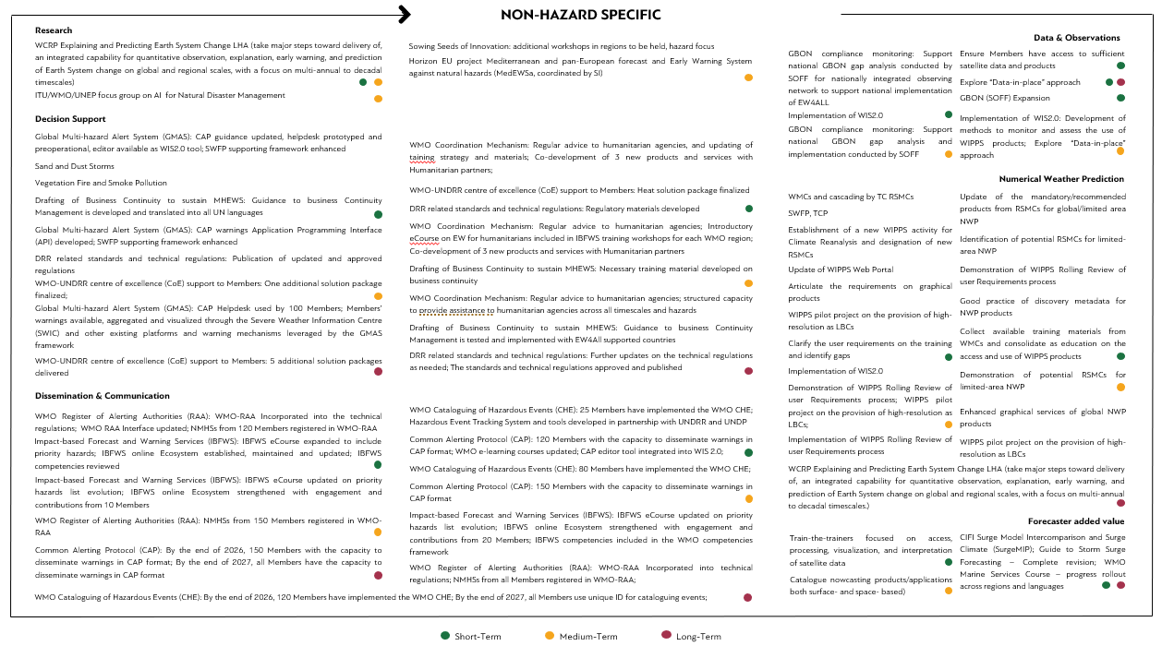

2 – Hazard identification

1. In each WMO Region, and in Antarctica, the Regional Basic Observing Network (RBON) represents a subset of WMO Integrated Global Observing System (WIGOS) stations selected for global exchange (**A2**). The RBON consists of surface-based observing stations, typically used in combination with space-based and other surface-based observing components of WIGOS. The network capabilities respond to observational user requirements at the national, regional and global levels, as identified by the WIGOS [Rolling Review of Requirements (RRR)](https://community.wmo.int/en/rolling-review-requirements-process-2023-version) process. Defined by the[*Manual on the WMO Integrated Global Observing System*](https://library.wmo.int/records/item/55063-manual-on-the-wmo-integrated-global-observing-system?offset=2)(WMO-No. 1160) (section 2.2.4 and Appendix 2.3), the purpose of the RRR process is to provide a systematic and transparent process to support the high-level design and evolution of the [WIGOS](https://community.wmo.int/en/activity-areas/WIGOS) aligned with its [Vision in 2040](https://community.wmo.int/en/vision2040). User requirements for the observing geophysical variables in support of the activities across the WMO Application Areas (AAs) are collated in a comprehensive, systematic, technology free and quantitative way in the [WMO Observing Systems Capability Analysis and Review (OSCAR)/Requirements database](https://space.oscar.wmo.int/observingrequirements). A [WMO Application Areas (AA](https://space.oscar.wmo.int/applicationareas)) is an activity involving the direct use of observations that allows NMHSs or other organizations to render services related to weather, climate and water, and other environmental events, contributing to public safety, socioeconomic well-being and development in their respective countries. The concept of WMO AAs is used to describe a homogeneous activity for which it is possible to compile a consistent set of observational user requirements agreed upon by community experts working in this area.
2. The international community has been working for decades to standardize hazard and impacts information to understand better risks and how they change over time at the national, regional, and global levels. Impacts are typically recorded by the national disaster management agency (or other mandated agency) in terms of mortality and morbidity, loss of, and damage to, physical assets, and associated economic damages and losses. Attribution is then made to the associated hazard in consultation with national services that have the mandate for documenting the hazard, such as the NMHS. NMHSs and other relevant national scientific and technical agencies have an opportunity to catalogue hazardous events to provide authoritative information on each hazard event and associated larger-scale phenomena. Implementation of the WMO-CHE (**J2**) will provide the foundation for strengthening understanding of hazards, their impacts (and their changes over time) with scalability to the larger physical processes. The WMO-CHE is not intended to be a real-time database but a scientific (climate) record of hazardous events. When implemented, the WMO-CHE methodology (approved by WMO [Resolution 12 (Cg-18)](https://library.wmo.int/idviewer/56690/64), and whose implementation plan has been endorsed through [Resolution 12 (EC-76)](https://library.wmo.int/idviewer/66258/293)), will provide an authoritative data source of the magnitudes, durations, locations, timing, and frequency of hazardous events. By implementing the WMO-CHE, WMO Members will enable new possibilities for the development of impact-based warnings, risk analysis based on empirical hazardous event data, research, and more systematic and scalable hazard and impact data, which could benefit Members and other stakeholders in the loss and damage community. The purpose of this CHE implementation plan is to provide information on what needs to be put in place in terms of guidelines, infrastructure, procedures, and capacity that will help to operationalize the WMO-CHE. Partnering with DRR institutions and the private sector is crucial to realizing WMO-CHE's full benefits; therefore, the CHE implementation plan includes mechanisms to leverage this collaboration. The collaboration is currently moving towards the development with UNFCCC and UNDRR of a new system based on [DesInventar](https://desinventar.net/) that has been in existence since 1994, interoperable with the WMO Catalogue of Hazardous events which will provide authoritative records of weather, climate, and water-related hazardous events at the national and regional levels.

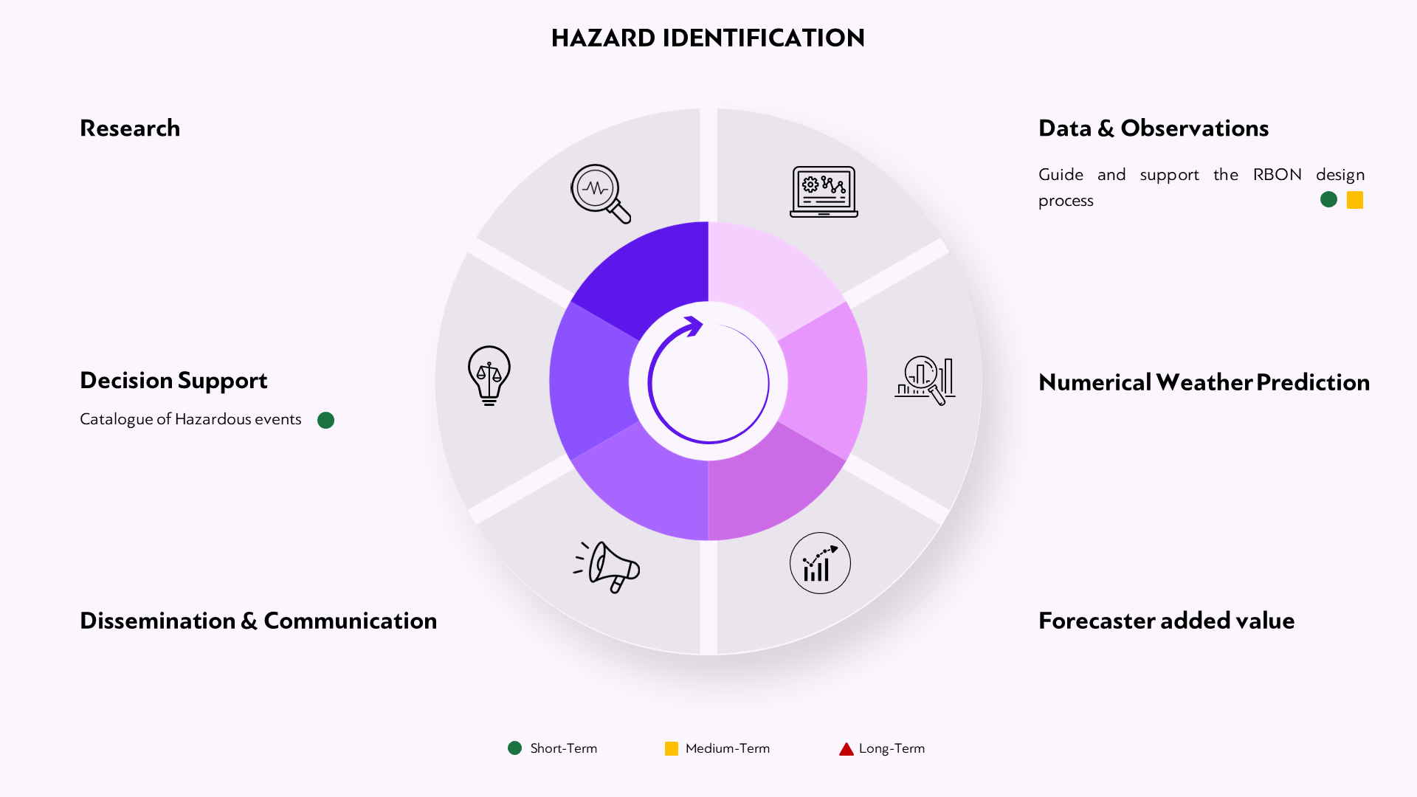

3 – Flash Floods

1. Flash floods have a different character than river floods – notably, short timescale and occurring in small spatial scales – which make the forecasting of flash floods a different challenge than flood forecasting approaches.
2. Satellite data plays a significant role in flash flood forecasting due to its ability to provide a global perspective on weather patterns, precipitation, soil moisture and snow cover area, and are used together with available radar and gauge data to obtain bias-corrected estimates. This data, coupled with gauge information, is crucial in deriving accurate estimates after bias correction. WMO technical commissions are actively engaged in developing guidelines for leveraging satellite data in flood forecasting and specifying product necessities (**A3**).
3. The exchange of reliable and standardized observations related to flash floods is crucial for effective EWSs. The WMO Hydrological Observing System (WHOS) supports hydrological data providers and users with free and easy access (**B 3.1**).
4. The regional centres of the Flash Flood Guidance System (FFGS) (**B 3.2**) access global in situ gauge observations through the WMO Global Telecommunications System (GTS) or the more recent WIS. Despite the method used to exchange data, the real-time sharing of critical observational data like streamflow discharge or radar data among nations poses a significant challenge. Many countries face restrictions related to national security, hindering the widespread access, and sharing of such data through systems. There is a pressing need for coordinated action at the national level to develop and implement policies that enable data sharing, particularly for purposes such as safeguarding lives and minimizing property damage through initiatives like the FFGS.
5. By integrating observational data and hydrological models alongside high-resolution limited area NWP models customized for particular regions, forecasters can enhance their capability to anticipate and monitor localized weather conditions, thereby improving flash flood forecasting. The Regional Specialized Hydrologic Centres (RSHCs) responsible for flash flood forecasting (**D3**) will aid NMHSs in creating flash flood products and generating forecasting information, facilitating the availability of these varied products through the WIS or an alternative web-based platform.
6. Research on end-to-end EWSs is invaluable for advancing the effectiveness, reliability, and adaptability of these systems. It drives innovation in the development of new technologies and methodologies, such as the integration of AI or machine learning. However, integrating AI into flash flood management requires robust data infrastructure, collaboration among stakeholders, such as focus group on AI between ITU, WMO and UNEP (**E.3.3**) and continuous refinement of AI models based on real-world feedback and experiences.
7. In the next intersessional period, the Integrated Prediction of Precipitation and Hydrology for Early Actions (InPRHA) will focus on minutes to days, and the advancement of warning strategies associated with multi-hazards, including flash floods (**E 3.1**), while the Horizon EU project MedEWSa (**E 3.2**) will provide novel solutions to ensure timely, precise, and actionable impact-and finance forecasting, and EWS that support the rapid deployment of first responders to vulnerable areas.
8. Nowcasting data with high temporal and spatial resolutions enables forecasters to track rapidly evolving weather phenomena, such as convective storms, and predict flash floods in small, vulnerable areas. A catalogue of nowcasting products and applications (**F 3.1**) that will be available to Members through the RSHCs and RSMCs (**F 3.2, F 3.3**) will assist them in preparing more accurate and timely forecasts.
9. The primary purpose of the FFGS is to provide real-time guidance products and forecasts pertaining to the threat of potential flash floods (**G 3.1**). Developing flash flood guidance products and forecasts is also supported by the WMO Community of Practice for Flood Forecasting and Warning (**G 3.2**), allowing Members and organizations to exchange experiences towards the development and adoption of the best available, sustainable, and tailored end-to-end EWSs.
10. Impact-based forecasting (IBF) and EWS play a pivotal role in mitigating the effects of flash floods, marking a significant stride in DRR. Efforts to reinforce or establish IBFWS for flash floods can be supported through the utilization of Guidelines on IBF tailored for floods and droughts, coupled with relevant training materials (**H 3.1**). Additionally, the Community of Practice for Flood Forecasting (**H3**) and Guiding Principles for engaging the private sector in supporting flood and drought related EWS and risk management (**H 3.2**) stand as invaluable resources. These resources are designed to assist Members by furnishing exemplary practices and a comprehensive roadmap for the development or enhancement of IBF systems.
11. Facilitating the seamless exchange of warning data among diverse agencies engaged in disaster response and the wider public, are the Guidelines on communication concerning hydrological information regarding forecast outcomes and associated risks (**I3**). Additionally, the ongoing support from the Associated Programme on Flood Management (APFM) HelpDesk on Integrated Flood Management (**I 3.2**) further enhances this collaborative effort.
12. To complete the comprehensive value chain, WMO remains committed to consistently aiding decision makers. This support is channelled through a range of activities and initiatives, including but not limited to the APFM HelpDesk on Integrated Flood Management (**J 3.1**), Guidelines focusing on transboundary flood risk management (**J 3**), the Horizon EU project MedEWSa (**J 3.2**), and participation in the ITU/WMO/UNEP Focus Group addressing AI for Natural Disaster Management (**J 3.3**).

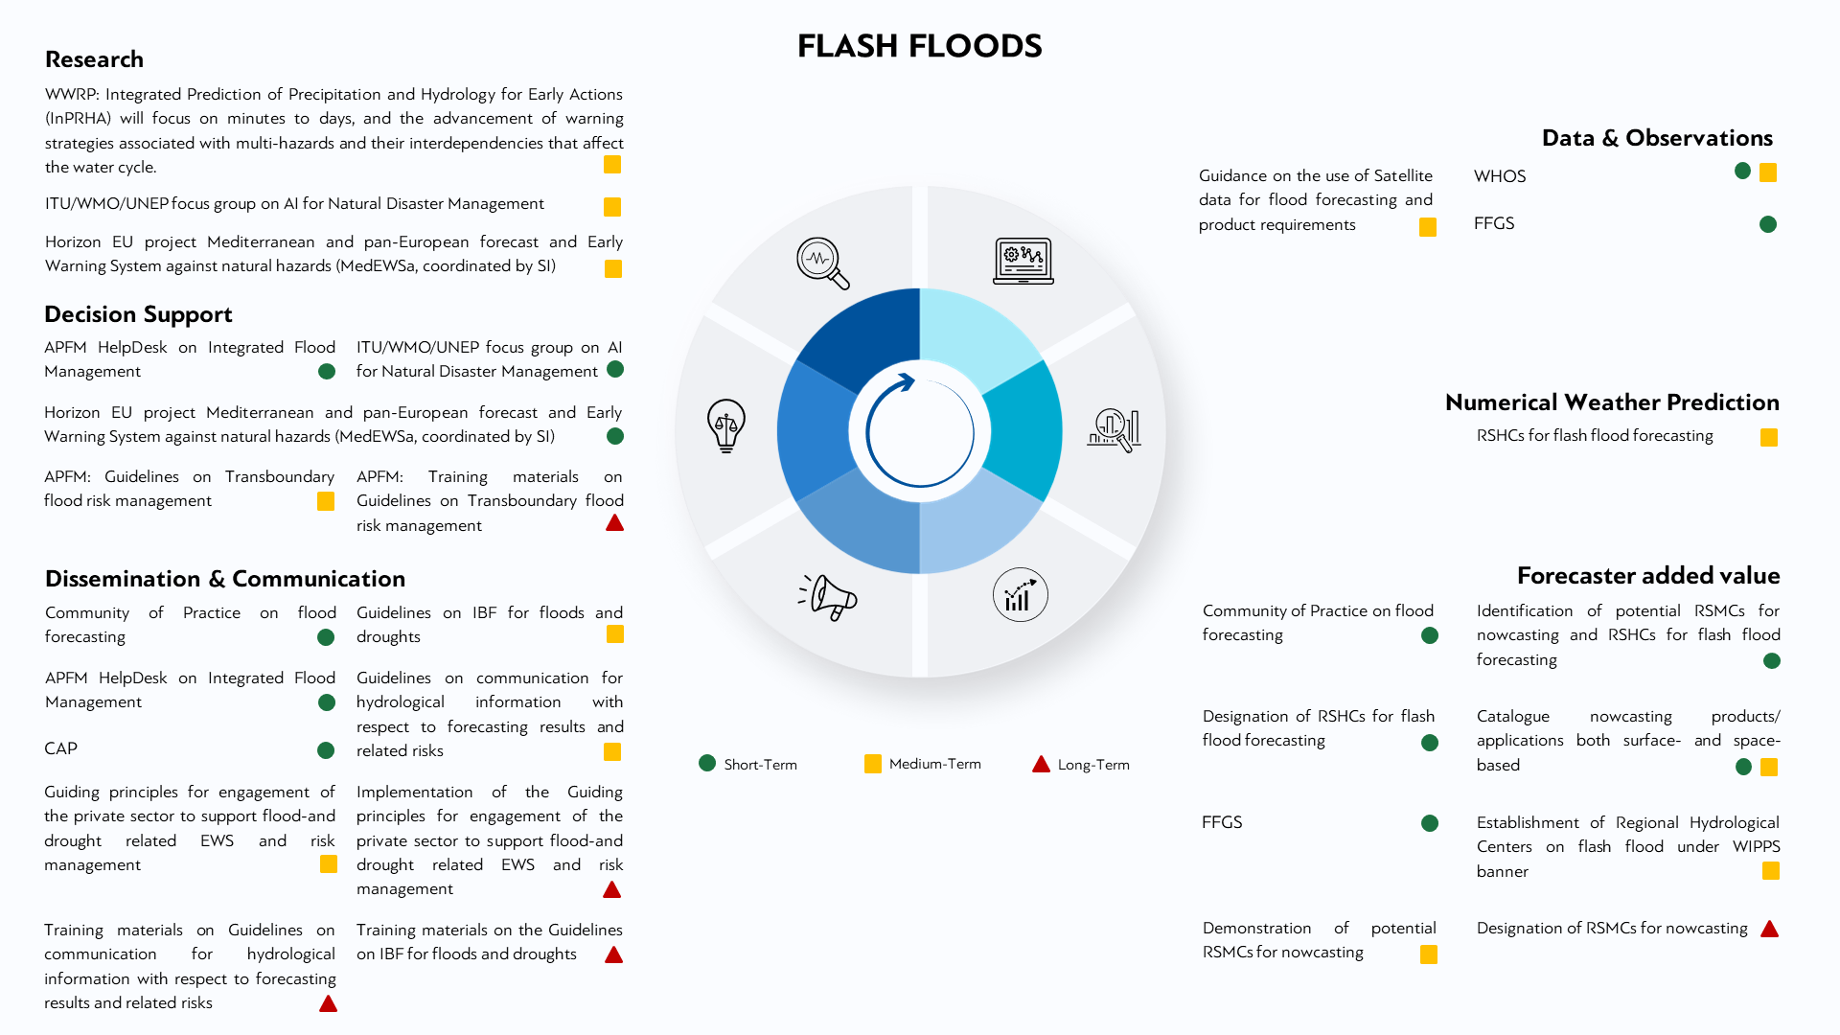

#### 4 – Droughts/Dry spells

1. Droughts are a normal part of the climate, and they can occur in any climate around the world. Droughts are one of the more costly natural hazards on a year-to-year basis and their impacts are significant and widespread, affecting many economic sectors and people at any one time.
2. Drought can be easily monitored because the slow onset of the drought events allows time to observe changes in precipitation, temperature and the overall status of surface water and groundwater supplies in a region.
3. Currently, nationally integrated observing network to be sufficient to monitor and forecast severe weather. The use of satellites to estimate precipitation is very useful for drought monitoring especially in areas with sparse ground-based stations (**A4**). Data from the WMO Space-based Weather and Climate Extremes Monitoring (SWCEM) project has been used to some countries to aid in developing drought monitoring products.
4. With regards to the international exchange of observations and products, the Hydrological Status and Outlook System (HydroSOS) can contribute the possible establishment of Global/Regional Centres on Drought Monitoring (**B4** and **F4**) as well.
5. For Global NWP, there will be updates on several recommended drought indictors and indices to WMO Members for SERCOM-3. The identification and provision of drought indictors and indices for specific impacts will be ongoing process through 2027 (**C4.1**). The same will be done for the identification and designation of RSHCs for snow cover prediction (**C4.2**). For limited area NWP, the Regional Climate Centres will continue to provide monitoring and forecasting products as needed.
6. Starting in 2024, other research will focus on improving operational products, sub-seasonal prediction skills and understanding sources of predictability to communicate appropriate actions under uncertainty and determine where forecasts will or will not exhibit skill for extreme weather such a floods and droughts in s2s timescales. This is the WWRP SAGE Project: Sub-seasonal to seasonal Applications for Agriculture and Environment (SAGE) (**E4.1**).
7. In addition, from 2024 to 2025, there will be the Horizon EU project MedEWSa coordinated by WMO Science and Innovation Department (**E4.2**). In 2025, Research will also look at the ITU/ WMO/UNEP focus group on AI for Natural Disaster Management (**E4.2**).
8. For nowcasting, local data processing, forecast, and guidance products identification needs to be done for the potential establishment of RSMCs/Regional/Global Drought Monitoring and Forecasting Centres (**F4** and **G4.1**). In addition, HydroSOS can contribute as well as the Dynamic Water resources Assessment Tool (DWAT) (**G4.2**). Training for Members will be needed for National Drought EWS (**G4.3**). In the midterm, there is the possibility of establishing Regional Hydrological Centres on seasonal to sub-seasonal forecasting under WIPPS banner (**G4.1**) which can contribute to drought monitoring and forecasting (**G4.2**).
9. To produce IBFWS, HydroSOS (**H4.1**) can possibly contribute and improved climate and hydrological prediction services will be needed (**H4.3**). The World AgroMeteorological Information Service (WAMIS-www.wamis.org) and the Integrated Drought Management Programme (IDMP) website can assist in disseminating drought products and information (**H4.2** and **I4**). Of course, training will be needed for Members to develop National Drought Plans and Policies (**H4.4**). In 2025 and beyond, guiding principles for engagement of the private sector to support flood and drought related EWS and risk management will be developed (**H4.1**) as well as a framework for evaluating the gaps and needs with respect to national drought forecasting and EWSs (**H4.2**). Based on the work of SC-AGR, Guidelines on Flash drought will be developed (**H4.3**).
10. For warning dissemination, work needs to be done in the strengthening the IDMP HelpDesk on Integrated Drought Management (**I4.1**) and CAP standards will need to explore if they can be extended to drought warnings and alerts (**I4.2**). In 2025, several guidelines will be produce including on communication for hydrological information with respect to forecasting results and related risks (**I4.1**) and on Communicating Drought Information (**I4.2**). In 2027, training materials related to Guidelines on communication for hydrological information with respect to forecasting results and related risks will need to be developed (**I4**).
11. To conclude the end-to-end value chain, the IDMP HelpDesk on Integrated Drought Management (**J4.1**) and HydroSOS (**J4.2**) will be able to provide support to Members through 2027. There will also be the Horizon EU project MedEWSa (**J8.2**). For 2025 and beyond, Guidance for water use, allocation and accounting in the Water Energy Food Ecosystems nexus will be developed across SC-AGR, SC-HYD and SG-REN.

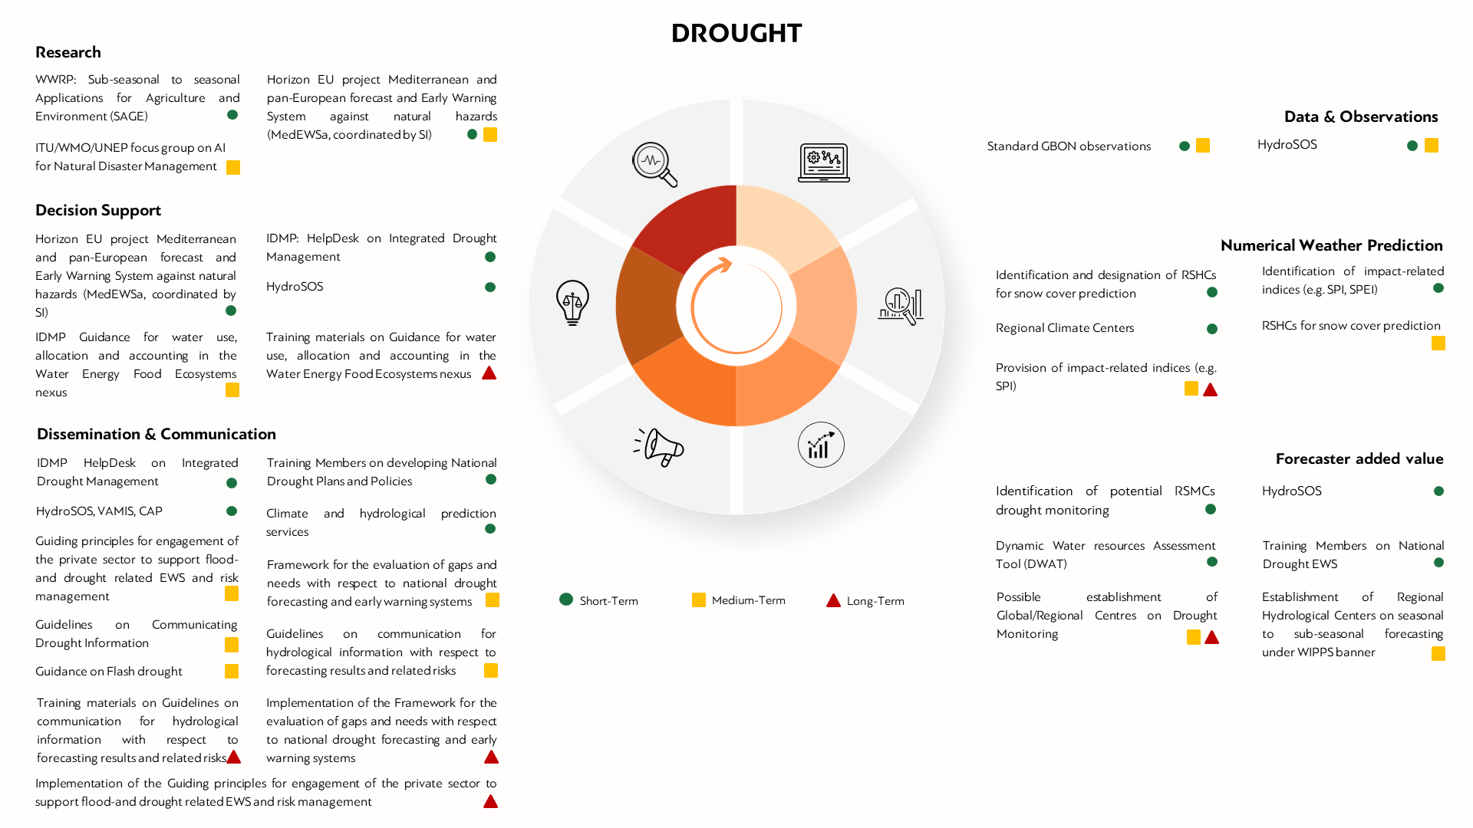

#### 5 – Riverine Floods

1. Every river basin having different characteristics, the approach to riverine flood forecasting cannot be the same for other hazards, where local applications might be the result of downscaling of global models.
2. Observations are needed at the local basin scale, and as indicated in the [*Guide to Hydrological Practices*](https://library.wmo.int/records/item/35804-guide-to-hydrological-practices-volume-i?offset=1) (WMO-No. 168), a minimum density for the observation network is needed to allow proper monitoring and flood forecasting. In line with the WMO Vision and Strategy for Hydrology and its related plan of action, WMO Technical Commissions will focus on the development of guidance on observation network density requirements for flood forecasting (**A5.3**). At the same time, recognizing the added value of satellite data, guidance will also be developed on product requirements and the use of satellite data for flood forecasting (**A5.2**)
3. WMO has been assisting Members since the early 1990s with the improvement of hydrological data observing networks: the WMO Hydrological Cycle Observation System (WHYCOS) has been implemented in all regions with the purpose of promoting hydrological observations, and through voluntary contribution projects often assisting Members in expanding their existing hydrological observation network (**A5.1**).
4. It is essential, especially for transboundary basins, that data be standardized and shared among riparian countries, or countries sharing the same basin in an upstream/downstream relation. For this purpose, the WHOS acts as a broker for hydrological data, converting it in WaterML format and therefore making data available as a hydrological component of WIS 2.0 to those countries willing to share hydrological data (**B5.1**).
5. To further support data sharing, but also contributing to the expansion of hydrological observation networks through innovative low-cost technologies, the Global Hydrometry Support Facility (HydroHub) is supporting through a HelpDesk approach the development of hydrological observation networks and the promotion of WHOS, while at the same time regularly launching calls for innovation to identify alternative ways of measuring hydrological variables (**B5.2**)
6. NWP remains an essential input to hydrological modelling, and the GDPFS/WIPPS RSMCs play a great role in making NWP available to local flood forecasters (**C5.1**). Moreover, the expansion of WIPPS capabilities will entail soon the creation of RSHCs, acting as a hub or repository of know how to assist Members in the application of flood forecasting techniques (**C5.2**). At the same time, consideration will be given to innovative technologies (e.g., AI based) to contribute to global hydrological modelling (**C5**), as well as to cataloguing available nowcasting products and applications, both surface-based and space-based and making them available through the RSHCs (**F5**). Research will play a major role in exploring these new technologies, in close collaboration with other partners such as ITU and UNEP (**E5.2**).
7. Since SERCOM-2, WMO has made available to Members an inventory of models and platforms for flood forecasting (**G5.2**). Models and platforms included in this inventory must meet a set of criteria, such as being operationally used and free of charge. The inventory is open to additional models and platforms, and it will be supported by a Community of Practice on flood forecasting, through which practitioners will be able to exchange experiences and solutions (**G5.1**) aimed at producing impact-based and risk-based forecasts and warnings. Guiding principles will also be developed to clarify the engagement of the private sector to support flood and drought risk management and EWSs (**H5.1**). This will include also specific interaction such as riverine flooding and storm surges, already combined in the Coastal Inundation Forecasting Initiative (CIFI) (**H5.2**). Besides advancing on the application of standard communication such as CAP applied also to hydrological hazards (and collecting good practices and case studies from those Members that have already started applying CAP to the dissemination of alerts related to hydrological hazards), IBF Guidelines, supported by Guidelines on communication for hydrological information with respects to forecasting results and related risks, are also going to be developed in the next intersessional period (**I5**).
8. To conclude the end-to-end value chain, WMO will also continue providing access to know how and guidance material through the HelpDesk on Integrated Flood Management (IFM), particularly focusing on the support to decision makers, and providing guidance to NMHSs and other stakeholders (academia, NGOs, IOs, the private sector) on integrated approaches to flood management, revamping its series of IFM Tools on those topics of particular relevance to the EW4All initiative (such as the Guidelines on transboundary flood risk management – **J5**). The HelpDesk will also act as an entry point to collect needs from Members and catalyse expertise through its network of Support Base Partners for the development of bankable project proposals, to be submitted to various donors, including research-based calls such as the EU Horizons (**J5.2**).

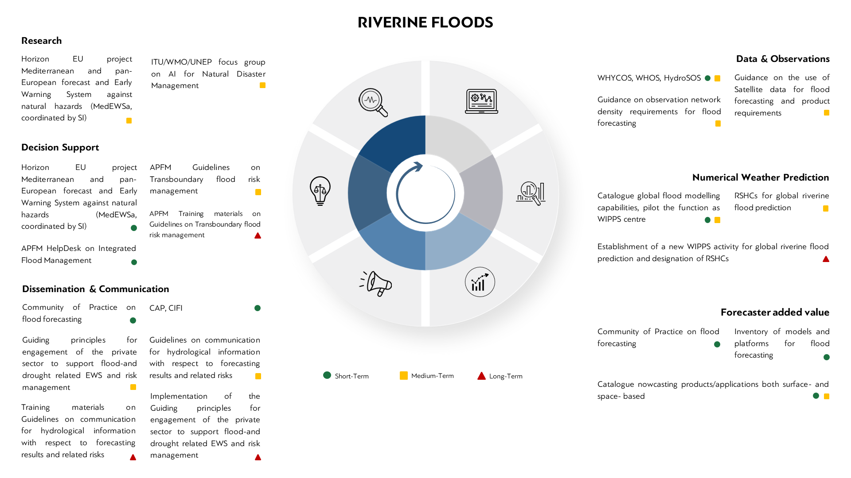

#### 6 – Tropical Cyclones

1. The Tenth session of the International Workshop on Tropical Cyclones ([IWTC-10](https://community.wmo.int/en/meetings/tenth-international-workshop-tropical-cyclones-iwtc-10)), quadrennial forum gathering the whole tropical cyclone community, provided [recommendations](https://wmoomm.sharepoint.com/:b:/s/Services/EeXe7w1kYZFOuh1_70bqVGcBr60BowJeBFWvVaRlRE5Psg?e=3UvMTe) covering the full value chain. Those recommendations were endorsed by the Advisory Group on Tropical Cyclones and approved by the Standing Committee on DRR and Public Services.
2. Coordination to ensure continual access to crucial data such as satellite data and products, atmospheric (radar, automated weather stations, etc.) and oceanographic (such as buoys, etc.) data. At the regional level, this coordination is made through the [Tropical Cyclone Operational Plans](https://community.wmo.int/en/tropical-cyclone-operational-plans) (**A6.2**). Those Operational Plans are updated regularly during the tropical cyclone regional bodies sessions. (**B6**, **I6.1**).
3. RSMCs for tropical cyclone forecasting (RSMC TC) and associated NMHSs will be prepared to exchange data through WIS 2.0 (see **Non-hazard specific sheet**, case **B1.1**).
4. NWP remains an essential input to tropical cyclone forecasting. WIPPS RSMCs make NWP and Numerical Ocean Wave Prediction available for the tropical cyclone community at large (research and operations). The provision of tropical cyclone vortex parameters critical to forecast operations is being redefined to become “core” data (**C6.1**). Additional parameters regarding the tropical cyclone environment are being made “recommended” (**C6.1**). Those parameters concerned both deterministic and ensemble numerical prediction systems. NWP products are also important at the local level for regional components such as SWFP or CIFI (**D6.2** and **D6.3**)
5. Further research into explainable and validated AI/Machine Learning techniques is recommended to address components in the tropical cyclone analysis and forecast process (**E6**).
6. To make better use of ensemble NWP data and further develop the impact-based forecasting (**H6**) approach to support better risk-based decisions, the Tropical Cyclone – Probabilistic Forecast Products (TC-PFP) are being rolled-out (**E6.1**). This project involved the Research Board (WWRP), SERCOM (AG-TC) and INFCOM (ET – Operational Weather Forecasting System). This 3-phased project addresses tropical cyclone formation and position, tropical cyclone intensity and structure, tropical cyclone-related rainfall and storm surge and continues to make important research progress.
7. TC forecasting and warning workshops are being implemented in RSMCs TC as per the TC Forecaster competency framework ([*Compendium of WMO Competency Frameworks*](https://library.wmo.int/records/item/56877-compendium-of-wmo-competency-frameworks) (WMO-No. 1209)) (**G6.3**). Training workshops are also organized under the framework of CIFI and the WMO Marine Services Course (**G6**).
8. Collaboration and coordination between the RSMCs TC and RSMCs for regional severe weather forecasting (RSMC SWF) will be improved further in the respective common sub-regions, and synergies with CIFI, FFGS and SWFP will also be continued as feasible and appropriate in support of EW4All initiative and MHEWS interoperability at regional and national levels.
9. RSMCs TC and RA V Tropical Cyclone Warning Centres provide regional forecasts on tropical cyclone track and intensity, and information on tropical cyclone-related hazards (wind, rainfall, storm surge) every 6 hours to the associated NMHSs, which oversee national forecasting and warnings (**F6**, **G6.1**). The forecast lead time is being gradually expanded to 7 days for some centres (**F6**). All centres have developed guidance on IBF products and oversee further developing them (**H6**). Members will continue to be supported in the use of CAP for dissemination of warnings related to tropical cyclones and associated hazards.
10. The coordinated standard operation procedures at the regional level are ensured through the above-mentioned tropical cyclone regional bodies sessions (**I6** and **I6.1**). Regarding warning dissemination, Members are encouraged to use the CAP (**I6.2**). To encourage the Members to establish national coordination procedures and mechanisms, a Guide was developed and is being published (WMO Guide for NMHSs in support of national MHEWS). An implementation plan will be developed to move forward with this Guide (2025)) (**J6**).

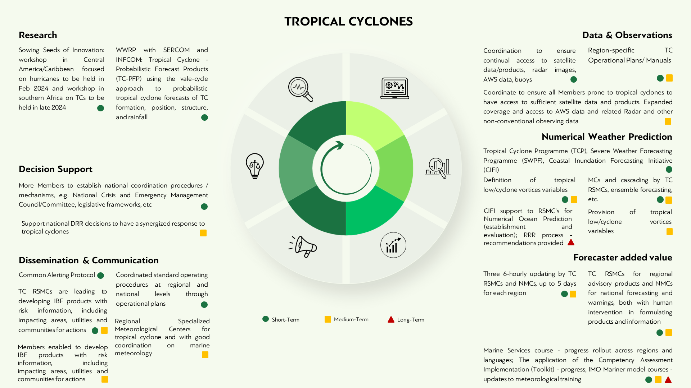

#### 7 – Thunderstorms and squall lines

1. Thunderstorms and squall lines are one of the major hazards for many countries and various socioeconomic sectors including aviation. The monitoring and prediction of thunderstorms and squall lines (which are associated with lightning, heavy precipitation, hail, strong winds and dust storms due to downdraft, and occasionally tornadoes and/or waterspouts) generally require nowcasting systems and techniques comprising mainly high-resolution observations (including in situ, radar and satellite-based) and convective permitting NWP models’ analysis and forecast fields.
2. WMO has been assisting its Members on improving nowcasting techniques and services including especially for thunderstorms and related hazards since last many years. In 2017, [*Guidelines for Nowcasting Techniques*](https://library.wmo.int/records/item/55666-guidelines-for-nowcasting-techniques) (WMO-No. 1198) was published. In recent years, RSMCs for nowcasting (RSMCs Nowcasting (NWC)), limited area deterministic NWP & limited area ensemble NWP (RSMCs Limited-Area Model (LAM)), and regional severe weather forecasting (RSMCs severe weather forecasting (SWF)) have been added to the network of RSMCs as part of the [*Manual on the WMO Integrated Processing and Prediction System*](https://library.wmo.int/records/item/35703-manual-on-the-wmo-integrated-processing-and-prediction-system)(WMO-No. 485) to provide numerical outputs, various derived products and indices including instability indices and severe weather guidance products. In 2023, [*Guidelines for Satellite-based Nowcasting in Africa*](https://library.wmo.int/records/item/58348-guidelines-for-satellite-based-nowcasting-in-africa?offset=3) (WMO-No. 1309), and [*Guidelines on High-resolution NWP*](https://library.wmo.int/records/item/66217-guidelines-on-high-resolution-numerical-weather-prediction?offset=1) (WMO-No. 1311) have also been published. An online training on nowcasting tools using EUMETSAT satellite products was organized for all Members in Africa in October 2023.
3. Considering the importance of high-resolution observations in monitoring of thunderstorms/squall lines and associated hazards, WMO will continue to assist its Members to have integrated observing network nationally to monitor thunderstorms and forecast severe weather in support of EW4All initiative (**A7**). Exchange of observations and products will be improved through various programmes and initiatives including through SWFP (**B7**). RSMCs for Numerical Ocean Prediction and Numerical Wave Prediction will also be established and evaluated as feasible (**B7.2**).
4. Nowcasting products and services will be improved through cataloguing nowcasting products and applications both surface- and space-based (**F7.1**) and by identification of more potential regional centres for nowcasting to provide indices and guidance products for thunderstorms/squall lines and related hazards (**F7.2**). Later, such regional centres may become RSMCs NWC after demonstration of their capabilities in the long-term (**F7.2**).
5. Members doing limited area deterministic NWP including RSMCs LAM will be coordinated and supported including through SWFP to improve their capacities to run fine high-resolution models resolving thunderstorms (**D7**). RSMCs SWF will cascade the relevant information and additional products from WMCs, RSMCs LAM and RSMCs NWC to the Members. “Cascading forecasting process” will continue to be further strengthened and expended as feasible (in 2023, Djibouti, Mauritania and Somalia have already joined) in support of EW4All initiative to cover those countries and sub-regions not yet covered by establishing more regional SWF centres which then potentially can become RSMCs SWF as part of WIPPS (**C7**). With contributions from RSMCs LAM and RSMCs NWC, and support from the satellite operating centres (e.g., EUMETSAT, CMA, IMD, JMA, NOAA, etc.) RSMCs SWF will provide improved guidance products to the Members involved (**G7.1** and **G7.2**) to support impact-based forecast and warning services (**H7**) and dissemination of warnings through CAP.
6. To improve meteorological forecast and warning dissemination including for thunderstorms over the METAREAS within the Global Maritime Distress and Safety System (GMDSS), Iridium SafetyCast (a mobile satellite service) will be implemented across all METAREAS.
7. To facilitate research into operations to improve nowcasting products and early warning services, co-production of satellite-based nowcasting and NWP services will be tested by working with the relevant development partners and universities through various projects as feasible, for example, WWRP through the UK-funded Weather and Climate Information Service – Early Warnings for Southern Africa Programme (WISER – EWSA) to improve early warnings of storms in Southern Africa (**E7.1**). WWRP and SERCOM/SC-AVI, in collaboration with other partners through “Aviation Research Development Project Phase 2 (AvRDP2)” are working to develop, demonstrate and quantify the benefits of improvements to the forecasting of significant convection and associated hazards to enhance early warnings for aviation. The project will leverage advances in meteorological observing, nowcasting and forecasting research to enable the delivery of risk-based, hazard impact information services that fully meet aviation users’ needs (**E7.2**).

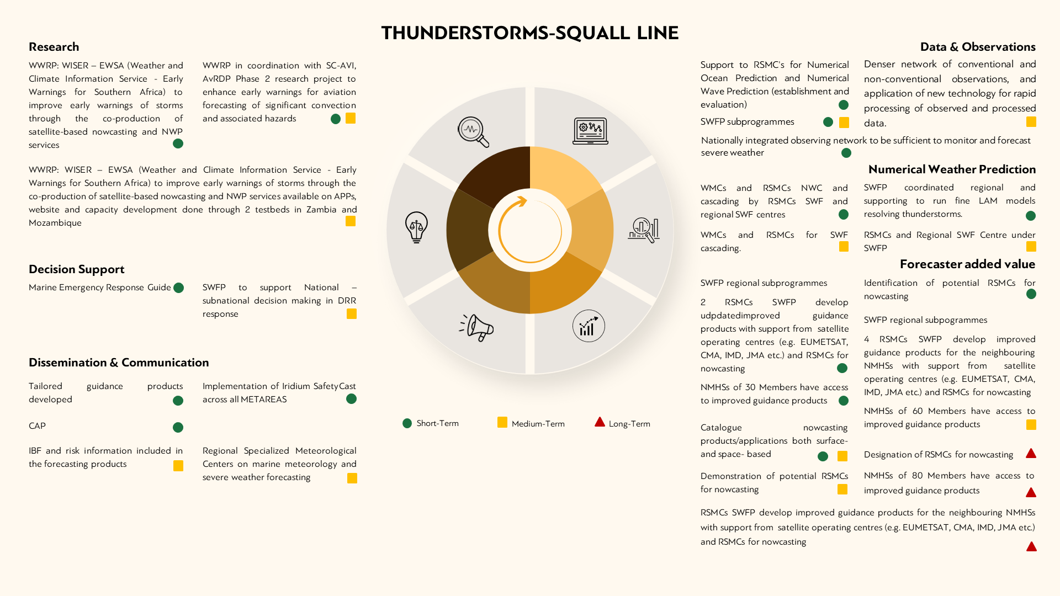

#### 8 – Heatwaves

1. Meteorological heatwaves are the consequence of (definition) local cumulative excess heat over a sequence of unusually hot days and nights. As a severe weather intensity phenomenon, most heatwaves are low intensity, supporting normal community capacity and practices to manage heat. Less frequent severe-intensity heatwaves are hazardous for vulnerable people and require warning services, while rarer extreme heatwaves require protective measures for healthy people and their supporting infrastructure. Heatwave-intensity services are complemented by other extreme heat services including assessments of temperature extremes and human thermal heat-stress.
2. Currently, nationally integrated observing networks are needed to monitor and forecast heatwaves as a severe weather phenomenon at synoptic scale. However, a denser network of conventional temperature, and non-conventional thermal observations, and application of new technology for rapid processing of observed and processed data require development **(A8.2)**. The maximum and minimum temperatures are needed for indicator data and heatwave-intensity indices. Temperature needs to be coupled with wind speed, humidity, radiation, and pressure for thermal indices (**A8.1**).
3. With regards to the international exchange of observations and products, 30-year extreme heat hazards climatologies are needed for:
   1. Temperature indicators,
   2. Thermal indices,
   3. Heatwave-intensity indices (**B8**).
4. For Global NWP, there needs to be identification of impact-related indices for heatwave-intensity and thermal indices (**C8.1**). In collaboration with SC-MMO and SC-CLI, the [*Climate Data Management System Specifications*](https://library.wmo.int/records/item/51447-climate-data-management-system-specifications?offset=1) (WMO-No. 1131) and in collaboration with SC-DRR and SC-ESMP, the WIPPS Manual need to be revised. In 2025, there will work on impact-related indices (e.g. Heatwave-intensity index, Thermal Indices and Temperature indicators via the Extreme Heat Services Roadmap) (**C8**). In the longer term, the provision of impact-related indices (e.g., Heatwave-intensity index) will need to be done on a regular basis (**C8.1**).
5. For limited area NWP, there needs to be improved resolution of humidity and wind fields for thermal indices (**D8**). In 2024/25, there will be work on a Joint Group on Earth Observation (GEO)/WMO/Global Heat Health Information Network (GHHIN) Global Heat Resilience Service which aims to integrate remote and local data at city scale for urban planners and managers (**D8**).
6. Other research will focus on the US National Integrated Heat Health Information Service (NIHHIS) and GHHIN projects supporting best practice and urban initiatives. In addition, there will be the Horizon EU project MedEWSa coordinated by WMO Science and Innovation Department (**E8.1**). Research will also look at the ITU/WMO/UNEP focus group on AI for Natural Disaster Management (**E8.2**). In 2025, WWRP Urban Prediction project will develop applications (such as thermal heat-stress) and will evaluate sub-kilometre modelling techniques for vulnerable urban communities to advance the concept of digital cities as a companion to initiatives like Digital Earth and Digital Twins (**E8.1**).
7. For nowcasting, identification needs to be done of the potential RSMCs for global/ Regional centres of excellence on Heat in developing and supporting products and training the trainer for extreme heat products suite (**F8**).
8. With regards to local data processing, forecast, guidance products, training Members on Heatwaves and Heat Health; Guidance on EWS Development is needed from now until 2027. Also, training is need on temperature-indicator, thermal and heatwave-intensity principles and the interpretation and use of the new Handbook on Extreme Heat Indicators and Indices (**G8**). The heatwaves and heat health guidance material will be finalized in 2024 (**G8.2**) coupled with Training Members on Extreme Heat Services and the Handbook on Extreme Heat Indicators and Indices (**G8.1**).
9. To produce impact- and risk-based forecast and warnings, there needs to be Training for Members on good practices for all impacted sectors, including health. In addition, related to above, 30-year extreme heat hazards climatologies needs to be completed for: a. temperature, b. thermal indices and c. heatwave-intensity indices required for development of impact-based forecast and warning codesign projects (**H8.1**). The SWFP regional subprogrammes also need to develop RSMCs SWF cascade of WMC’s extreme heat products and indices to NMHSs as/when available and to develop specific guidance products for compound (other) hazard services. There needs to be Training for Members on good practices for engagement with health and all other heat-impacted essential service sectors (**H8.1**).
10. For warning dissemination, work need to be done with CAP to identify the temperature, thermal and heatwave-intensity components of an extreme heat warning service (**I8.1**), and training in multi-hazard linkages between drought, dust, heatwave, fire, smoke, and flash flood. There also needs to be training in CAP for temperature, thermal and heatwave-intensity extreme heat warnings (**I8.2**). Relevant national arrangements need to be developed in 2024/25 to support management of extreme heat services (**I8.3**). By 2027, Guidelines need to be developed on communicating severity classes for impact-based heatwave-intensity warnings. A guide on codesign of hazard/impact studies supports the inclusion of impact-based forecast and warning services (IBFW) in local heat action plans (**I8**).
11. To conclude the end-to-end value chain, WMO will also continue to work with partners on the GHHIN/WMO and (NIHHIS/NOAA) support (**J8.1**). In addition, there will be the Horizon EU project MedEWSa) (**J8.2**) and the ITU/WMO/UNEP focus group on AI for Natural Disaster Management (**J8.3**). In the long-term the partnership with GHHIN, NIHHIS, and GEO needs to continue (**J8.3**).

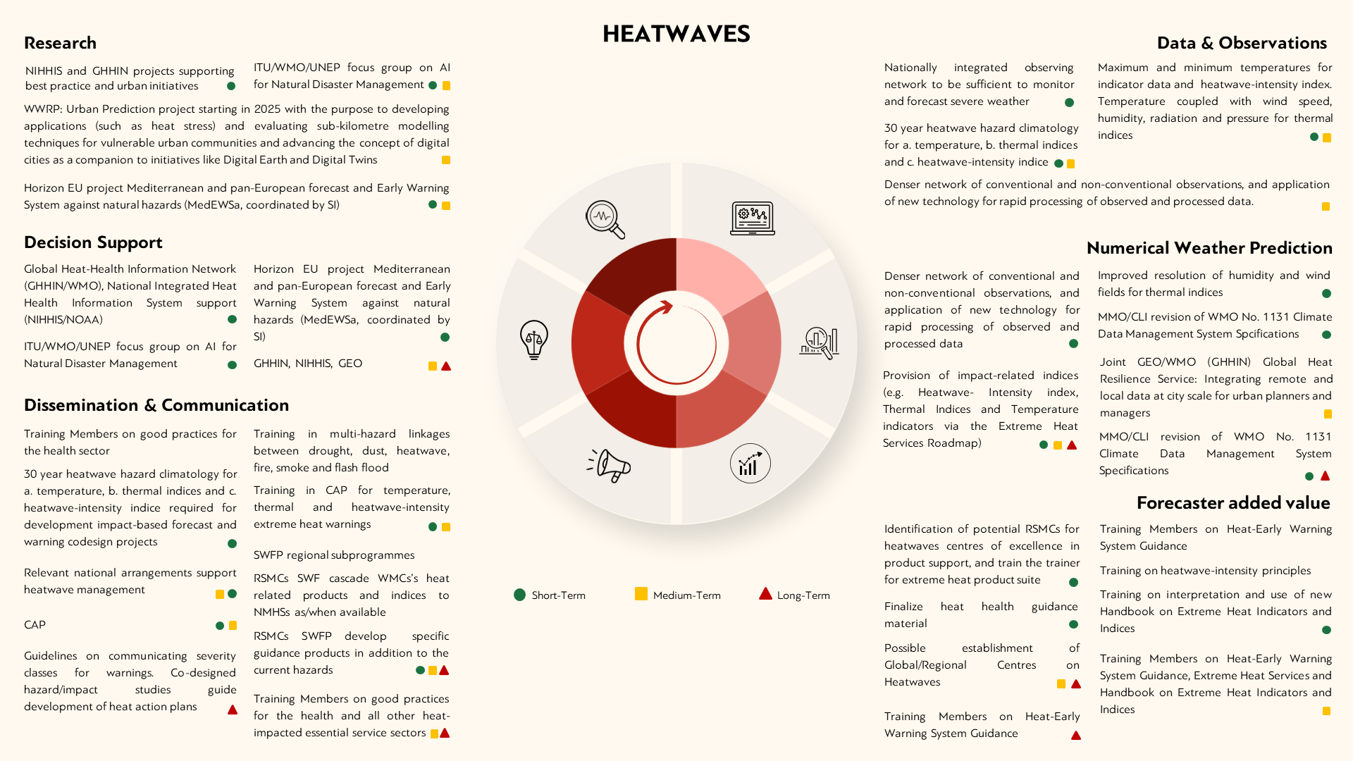

#### 9 – Emerging hazards

1. Addressing the needs of monitoring of, and EWSs for emerging hazards is a specific request made by [Resolution 4 (Cg-19)](https://library.wmo.int/idviewer/67177/61), including such as those due to changes in the cryosphere.
2. The first action to integrate emerging hazards into the system would be the publication of the currently available gap analysis on cryosphere-related hazards, and cross-reference with the hazard type list of the WMO-CHE (**A9**), in addition to emerging hazards identified by RAs as priority hazards (**G9.1**).
3. Pilot of recommendations of the Third Pole Regional Climate Centre (TPRCC) Network (**A9**) can be considered as the next step, through establishing their operational capabilities to deliver the mandatory functions in each of the functional areas for the domain of their responsibility, and establishing a Regional Climate Outlook Forum (RCOF) for the Third Pole region as a user interface platform, which is a mechanism to understand user requirements and identify gaps. The additional action is to address the crucial research and development areas identified for the region with high priority, including development of downscaling methods for outputs from regional and global climate models tailored to Third Pole region; monitoring, seasonal prediction and risk assessment on special climatic events over Asian High Mountain regions; monitoring and prediction information on cryosphere-related disasters; regional projection over Asian High Mountain regions to assist development of adaptation strategies. Building on the success of the WWRP Polar Prediction Project, the new Polar Coupled Analysis & Prediction for Services (PCAPS) project (2024–2028) aims to improve Earth System models, and evolving climate in the Arctic and Antarctica regions by using novel observations and data assimilation to predict impacts relevant to local inhabitants (**E9.1, H9.1, J9.2**).
4. Establishment of Regional Hydrological Centres on snow cover prediction under WIPPS banner (**G9**, **J9**) is also under consideration to support the local data processing, forecast and provision of guidance products, as well as decision making to respond to hazards related to snow.
5. As actions for marine hazards, WMO is consolidating its position and making efforts to support Members working in tsunami and meteotsunami (**G9.2**), including the International Maritime Organization (IMO) Mariner model courses, updates to meteorological training, implementation of Iridium SafetyCast across all METAREAS, and the development of guidance materials on meteotsunami.
6. Another work package to address other types of emerging hazards, especially in supporting decision making, is the guidance for water use, allocation and accounting in [the Water Energy Food Ecosystems Nexus](https://international-partnerships.ec.europa.eu/policies/climate-environment-and-energy/water-energy-food-ecosystem-nexus_en) (**J9**), which highlights the interdependence of water, energy and food security and ecosystems – water, soil, and land – that underpin that security, and identifies mutually beneficial responses that are based on understanding the synergies of water, energy, and agricultural policies.
7. Finally, vegetation fires and the impact on smoke pollution, sand and dust storms and their impact not only at the ground level (on agriculture and public health), but also for aviation and land transportation, are among the emerging hazard on which it is planned to focus on the next intersessional period. WMO through the Global Atmosphere Watch (GAW) is leading the activities of forecasting and early warning of the UN Coalition for combating sand and dust storms, supporting the development of early warning advisories related to atmospheric composition (including air quality) smoke plumes and dust storms and contributing to the establishment of RSMCs for wildfires (**E9.1**, **E9.2**). This will be done scaling up and leveraging efforts from SWFP, through the Sand and Dust Storm Warning Advisory and Assessment System (SDS-WAS) which falls under GAW (**D9**), and possibly expanding it into a Severe Vegetation Fires Warning Advisory and Assessment System (SVFS-WAS)

