Photo Instructions

SOFF wants to give visibility to countries, and what they are achieving together with peer advisors and Implementing Entities.
These photos are vital to tell a story of what’s happening in countries. The SOFF Secretariat is using those photos for Action Reports, social media posts, the website, or country news and stories.

Ask
- min. 4 photos of people and stations, both landscape and portrait format
  - at work: people interacting with equipment
  - Stations: wide-angle of the station in the landscape
  - at work: people in the office
  - posed: group photo
- nice to have: 1 Video in Landscape
  - 10 second video of local experts with equipment in the field,
e.g. see bottom right photo – that would be great to have live footage from

See tips for a good photo or video in the Annex below.

Sharing & Copyright
Please share material you have taken incl. copyright information with soffsecretariat@wmo.int, or directly with Pauline (ptrepczyk@wmo.int, the Communications Officer at the SOFF Secretariat).

You can attach photos directly in the email. If you have too many or too big files, we recommend using WeTransfer as a free service.

Copyright normally is either the person who took the photo, or the organization the photographer works for. When you share the photos with the SOFF Secretariat, please indicate how the Secretariat is allowed to use the material, or if there are any restrictions.

If you take photos of individuals, please make sure to get their approval for the photo and the photo to be shared. When sharing a photo with the Secretariat, please also include the names of the individuals (ideally also their role, position and organization).

The SOFF Secretariat would like to encourage capturing the entire diverse team working on SOFF Operations. Along with the SOFF Gender Action Plan, SOFF promotes women leadership in hydromet governance, which ideally would also be reflected in photos.

Example Photos
Inspiration here: https://www.flickr.com/photos/worldmeteorologicalorganization/sets/72157649296433237/

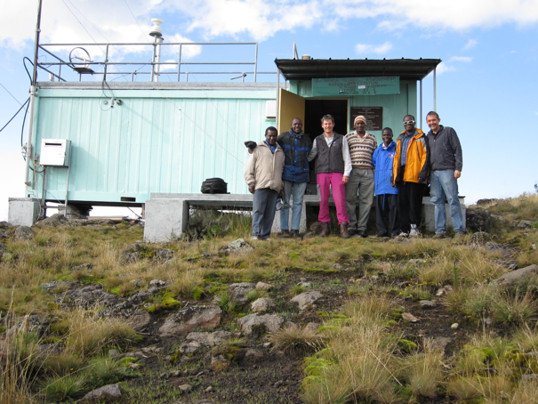  Group photo with landscape/building around it makes it possible to crop or use for background in communication material | 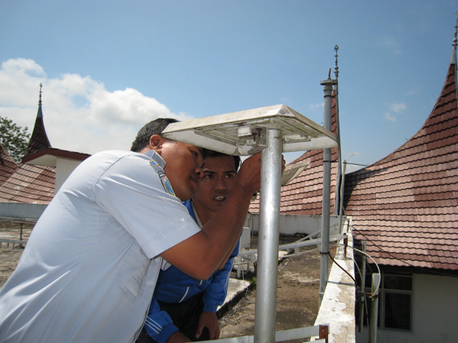  “Action shot” of experts interacting with a station
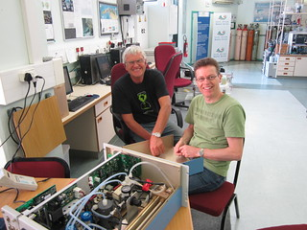Experts at work in the office | 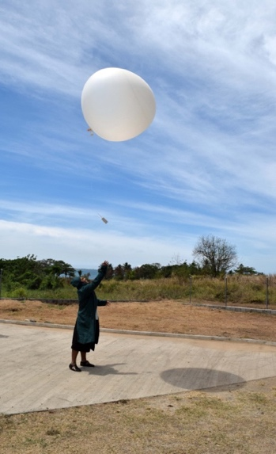  “Action shot” with upper-air station
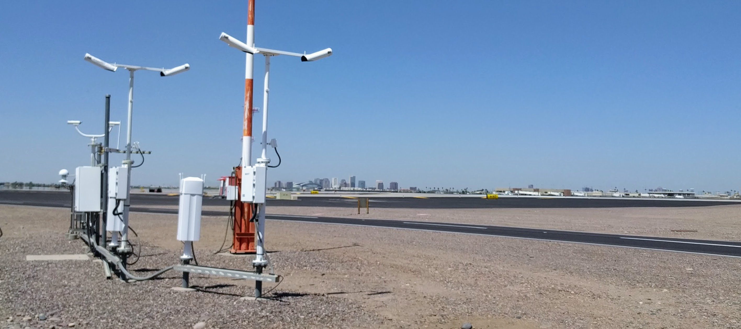Whole station with landscape, makes it possible to crop for various uses, like website, social media or brochures | 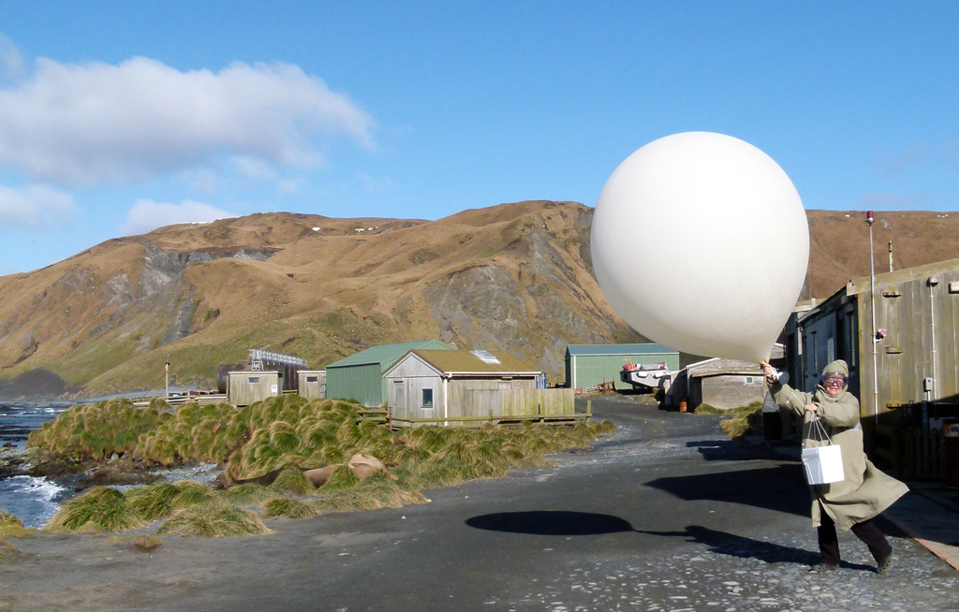Motion, perfect for videos

Tips for a good photo

Do | Don’t / Avoid
Use rule of thirds  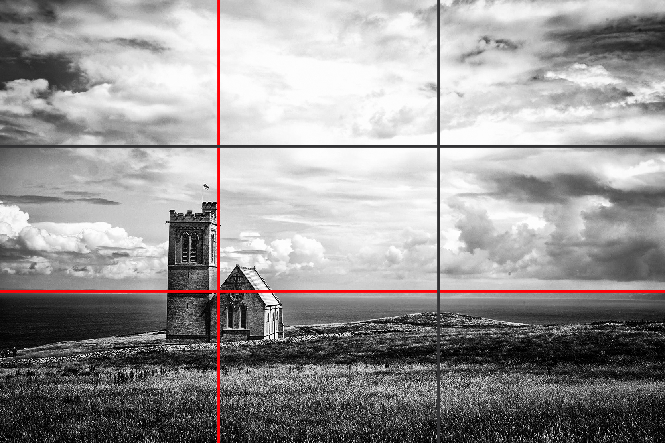  People  - Whole body or above the hips  - Ensure they are engaging with the station naturally (e.g., maintaining equipment, observing readings).  - Capture the entire diverse team contributing  Weather Station  - Show the landscape and environment around the station (e.g., mountains, fields, coastline)  Light  - Take photos in natural light, preferably in the morning or late afternoon  Camera  - Height of the camera should be just below eye level  - Use the highest resolution possible (avoid compressed images).  - Keep the camera steady (use a tripod or a firm grip)  - Should be level to the ground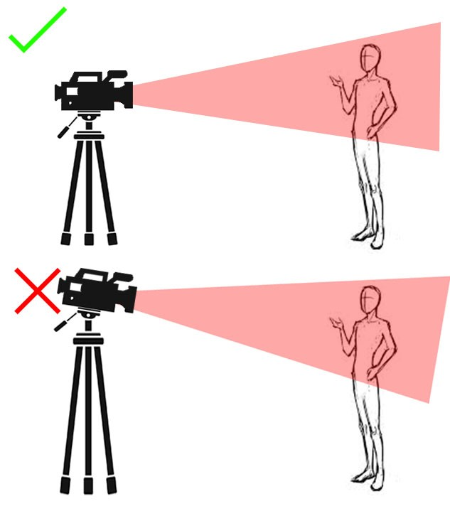 | People  - Cut off body parts  - Head should not touch the frame  - cluttered backgrounds that distract from the main subject  - staged, stiff poses—people should be interacting with the station naturally (exception: Group Photos)  - people blocking key parts of the station  Weather Station  - cropping parts of the station  - trees, fences, or objects obstructing the view of the station  Light  - harsh direct lights, like midday sunlight (causes strong shadows and overexposed highlights)  - flash can create unnatural reflections  Camera  - Blurry, pixelated, or low-resolution images  - Digital zoom reduces image quality  - Angle from above or below
If in doubt
- Step a few steps back if possible: photos can be cropped afterwards, but background cannot be added
- Take several photos, and choose the best one afterwards: People can blink, not be ready, or the lighting might not work

