Caribbean Early Warnings Using the Potential Tropical Cyclone (PTC) Advisory

1. Module 1: Introducing the PTC Advisory Product

1.1 CREWS PTC Advisory Course
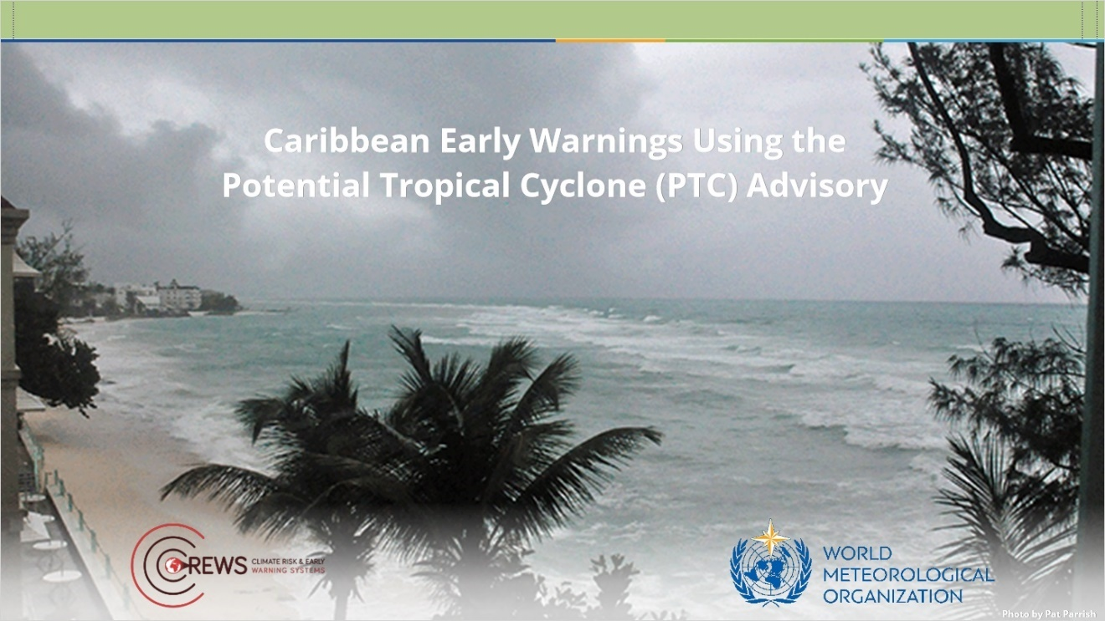
Notes:

zoom1 (Slide Layer)
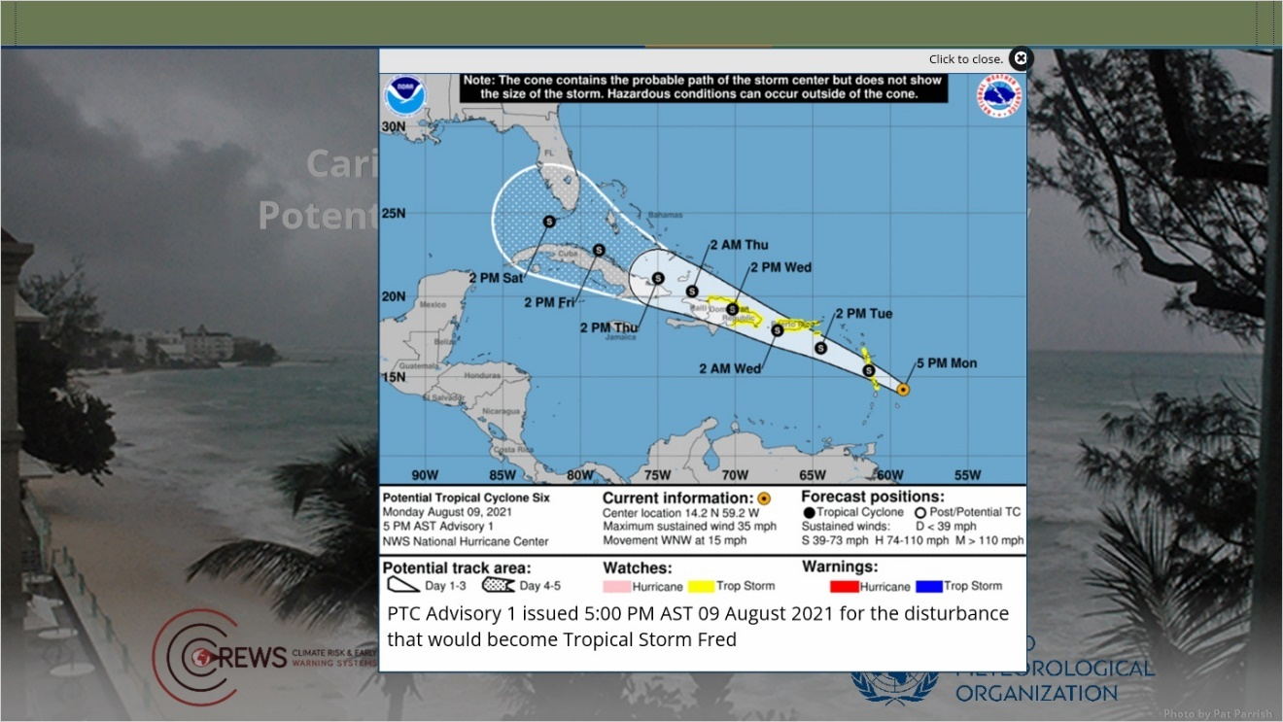

zoom2 (Slide Layer)
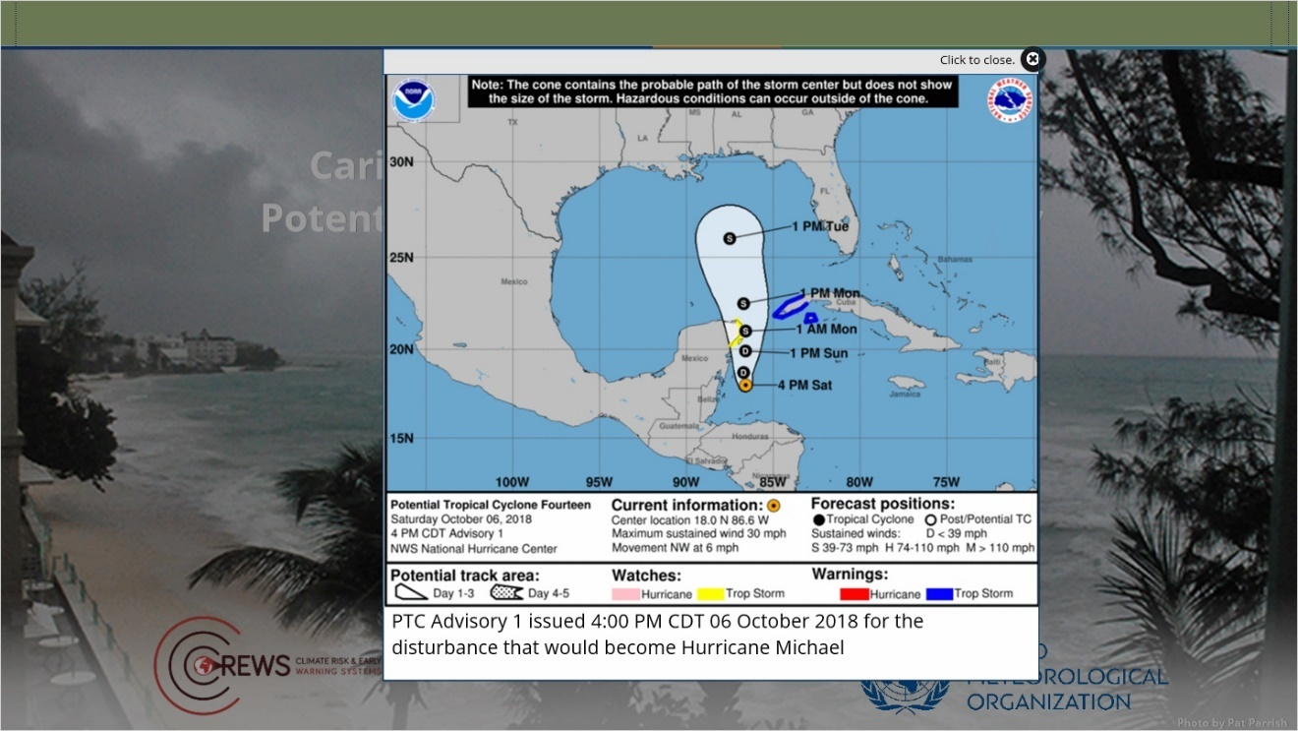

1.2 Module Overview
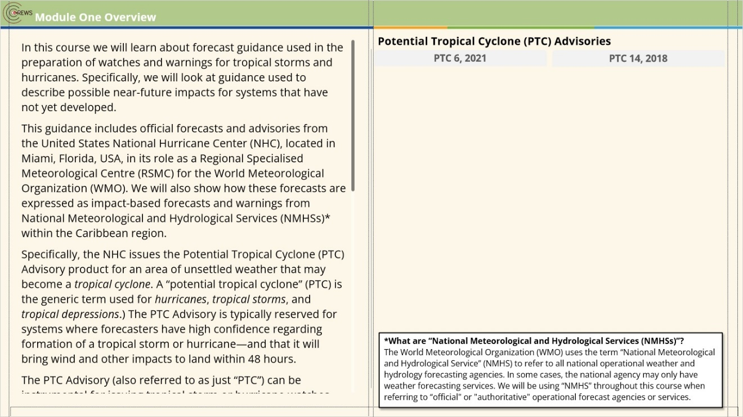
Notes:
In this course we will learn about forecast guidance used in the preparation of watches and warnings for tropical storms and hurricanes. Specifically, we will look at guidance used to describe possible near-future impacts for systems that have not yet developed.
This guidance includes official forecasts and advisories from the United States National Hurricane Center (NHC), located in Miami, Florida, USA, in its role as a Regional Specialised Meteorological Centre (RSMC) for the World Meteorological Organization (WMO). We will also show how these forecasts are expressed as impact-based forecasts and warnings from National Meteorological and Hydrological Services (NMHSs)* within the Caribbean region.
Specifically, the NHC issues the Potential Tropical Cyclone (PTC) Advisory product for an area of unsettled weather that may become a tropical cyclone. A “potential tropical cyclone” (PTC) is the generic term used for hurricanes, tropical storms, and tropical depressions.) The PTC Advisory is typically reserved for systems where forecasters have high confidence regarding formation of a tropical storm or hurricane—and that it will bring wind and other impacts to land within 48 hours.
The PTC Advisory (also referred to as just “PTC”) can be instrumental for issuing tropical storm or hurricane watches within 48 hours of the arrival of tropical-storm-force winds, and warnings within 36 hours of tropical-storm-force winds. With the issuance of a PTC, the NHC begins generating a suite of detailed guidance about the expected track, intensity, and timing.
The course is organised as follows:
Module 1: Introducing the PTC Advisory Product
Module 2: Tools for Assessing Potential impacts
Module 3: Effectively Communicating Potential Impacts
We will start this module with a review of some important terminology that will assist you with using official forecast products. Then, we will do an activity that demonstrates why the PTC may be useful for those in emergency management and disaster preparedness.
Although this course is aimed primarily at professionals working in emergency management and disaster preparedness within the Caribbean region, it may be useful for others as well. Weather forecasters, university faculty and students, media personnel, government workers, and others working in public safety in areas prone to tropical storms and hurricanes may all benefit from taking this course.
Click Next to continue.
References:
For Potential Tropical Cyclone (PTC) Advisories and other tropical weather products see:
National Hurricane Center, NOAA/NWS https://www.nhc.noaa.gov/
Regional Specialized Meteorological Centres https://severeweather.wmo.int/v2/rsmcs.html

zoom1 (Slide Layer)
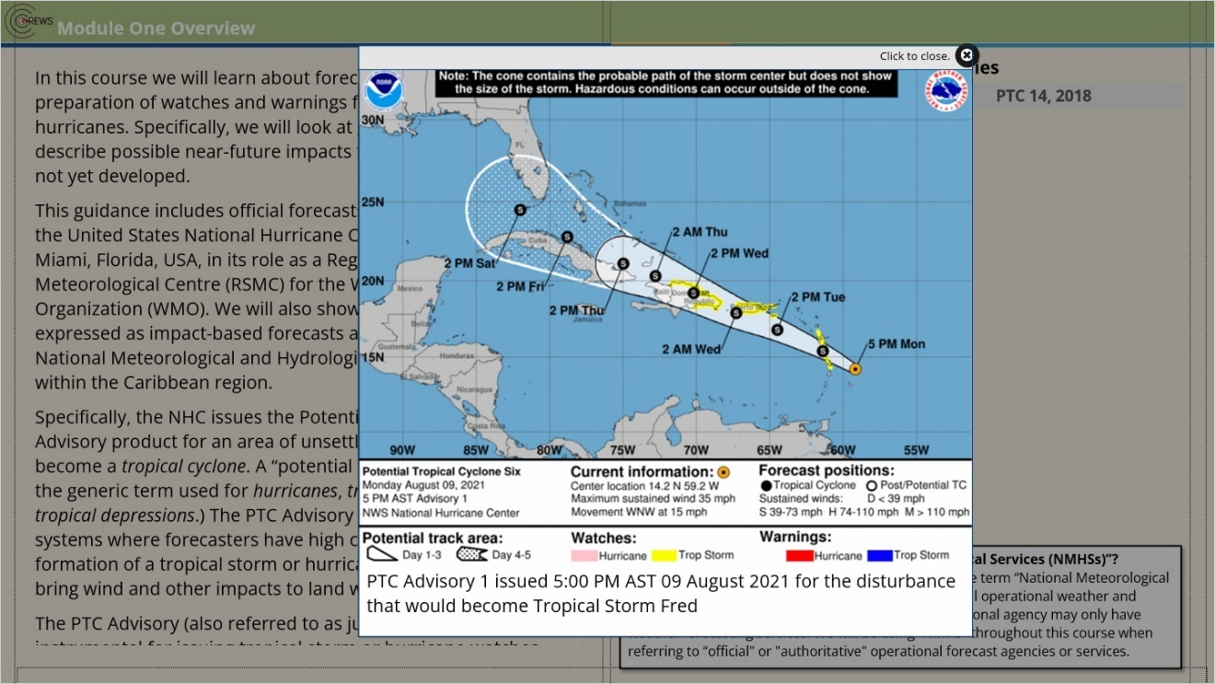

zoom2 (Slide Layer)
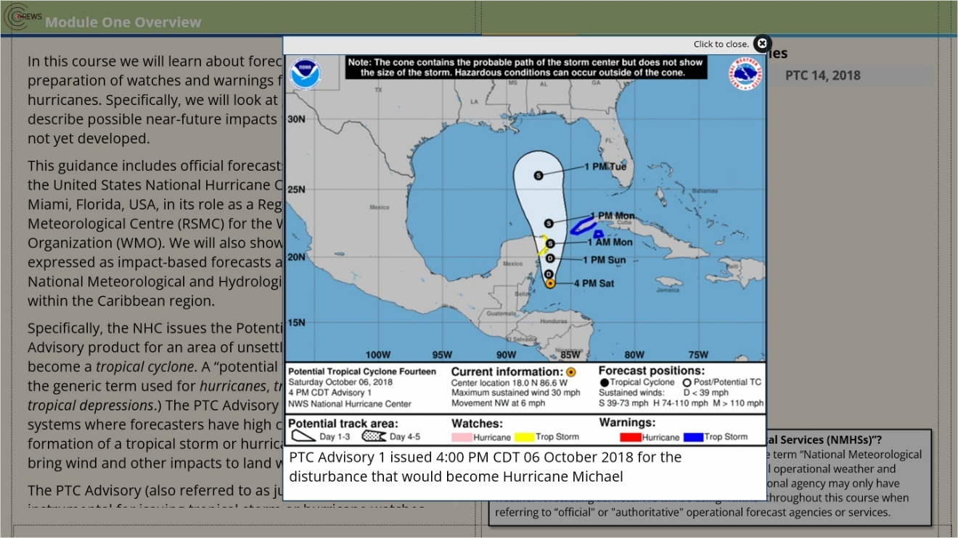

1.3 Tropical Cyclones
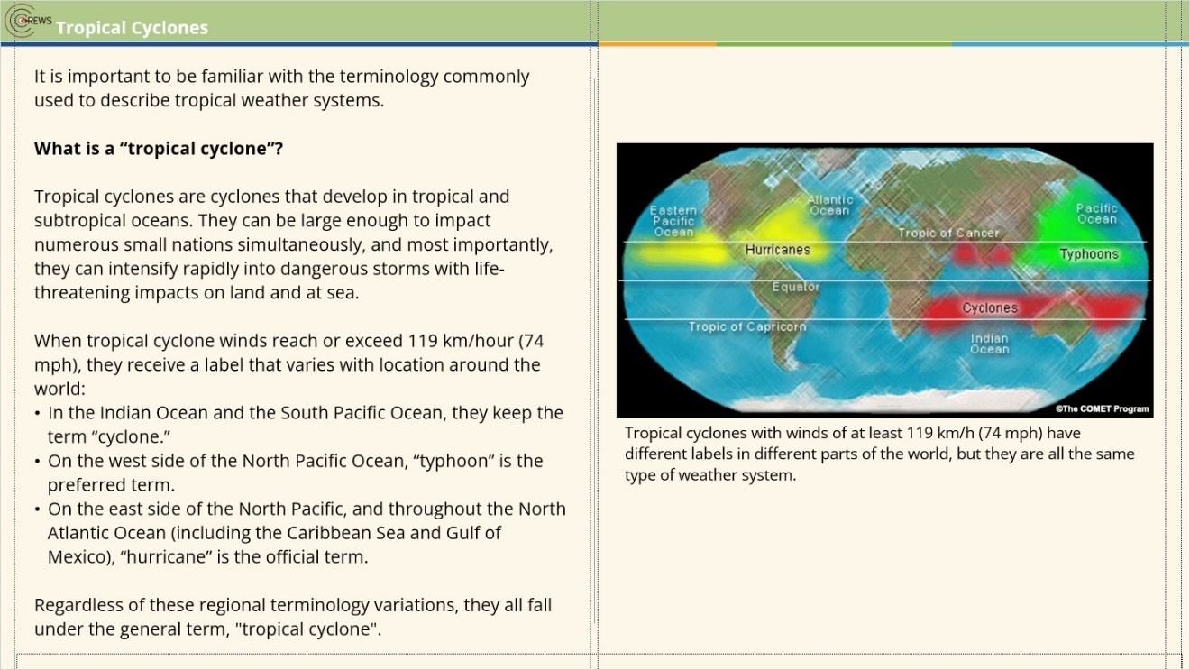
Notes:

Item 02 (Slide Layer)
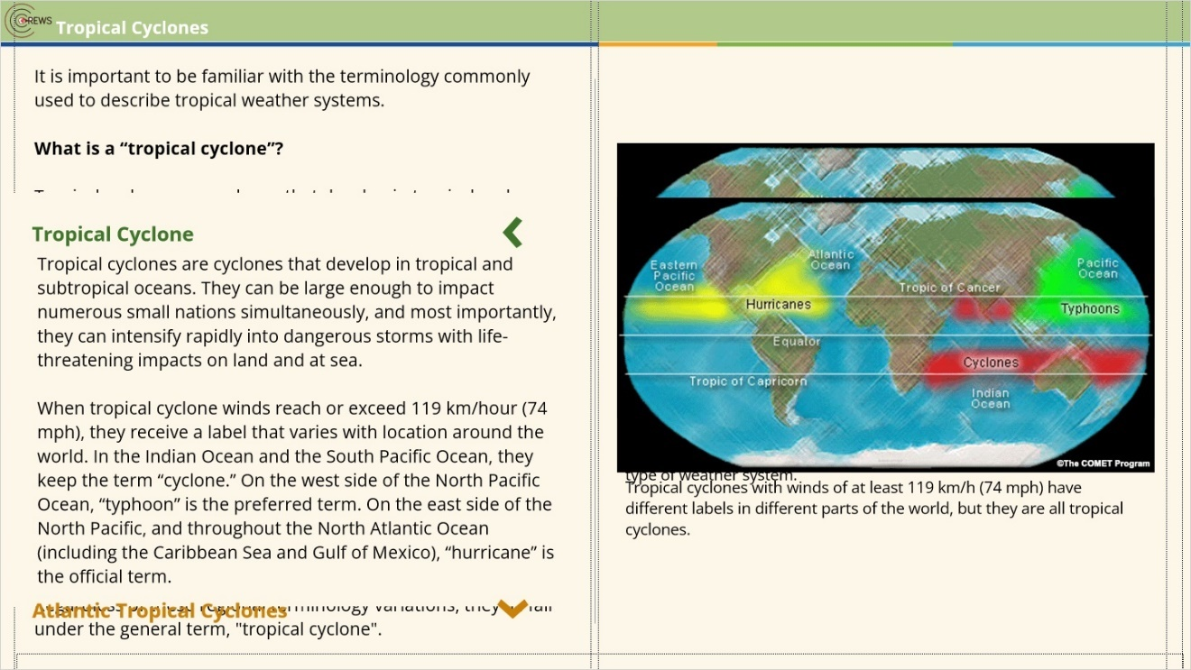

Item 03 (Slide Layer)
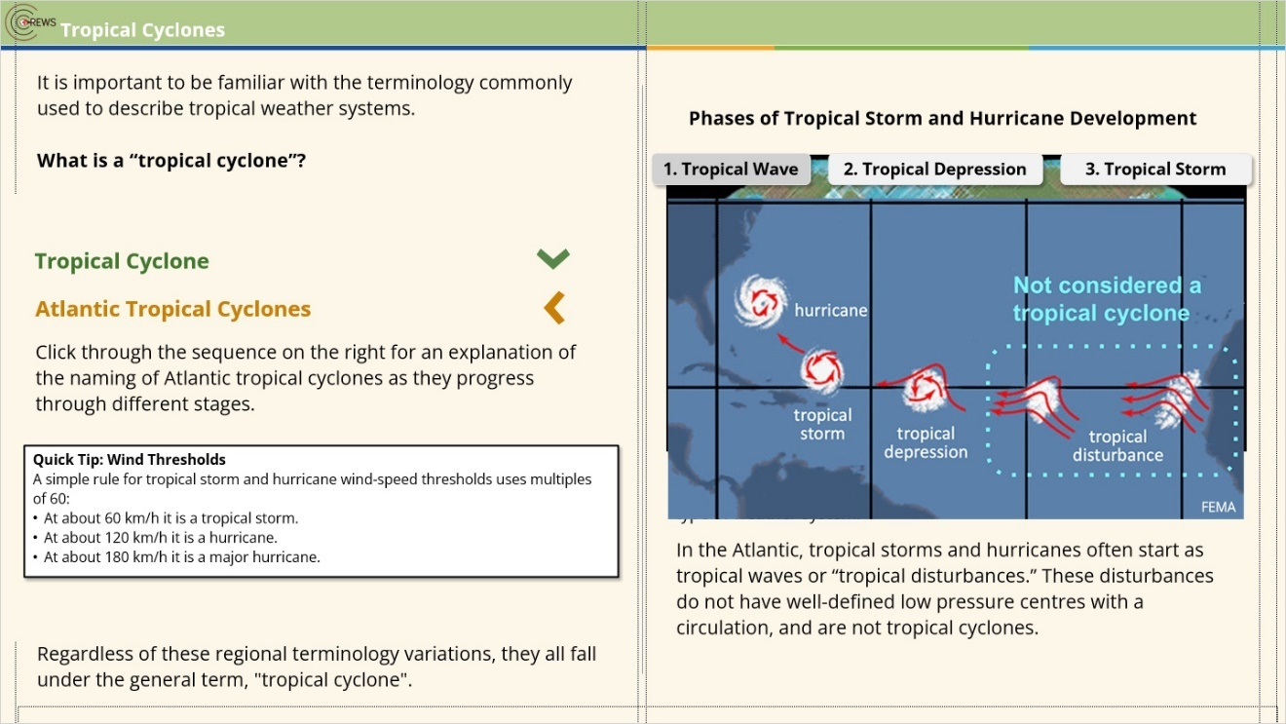

1.4 Atlantic Tropical Cyclones
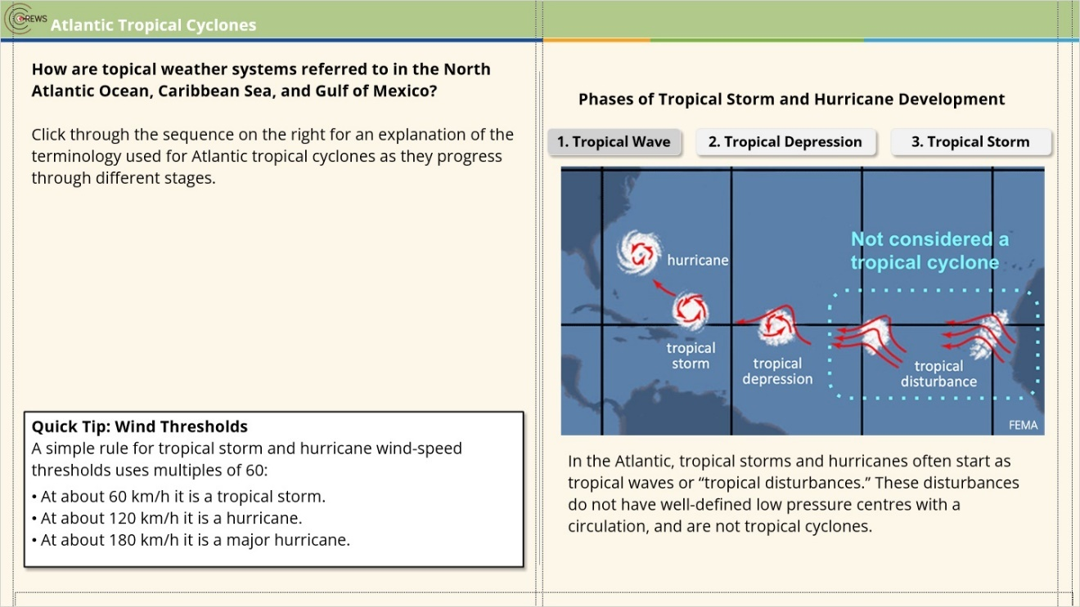
Notes:

1.5 TWO Compared with PTC
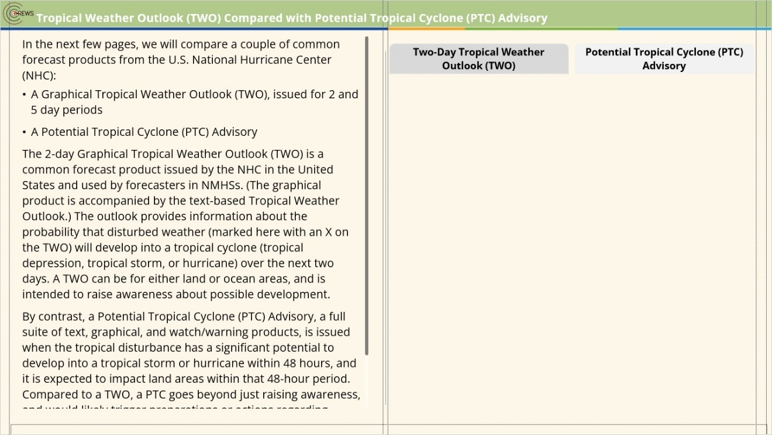
Notes:
In the next few pages, we will compare a couple of common forecast products from the U.S. National Hurricane Center (NHC):
A Graphical Tropical Weather Outlook (TWO), issued for 2 and 5 day periods
A Potential Tropical Cyclone (PTC) Advisory
The 2-day Graphical Tropical Weather Outlook (TWO) is a common forecast product issued by the NHC in the United States and used by forecasters in NMHSs. (The graphical product is accompanied by the text-based Tropical Weather Outlook.) The outlook provides information about the probability that disturbed weather (marked here with an X on the TWO) will develop into a tropical cyclone (tropical depression, tropical storm, or hurricane) over the next two days. A TWO can be for either land or ocean areas, and is intended to raise awareness about possible development.
By contrast, a Potential Tropical Cyclone (PTC) Advisory, a full suite of text, graphical, and watch/warning products, is issued when the tropical disturbance has a significant potential to develop into a tropical storm or hurricane within 48 hours, and it is expected to impact land areas within that 48-hour period. Compared to a TWO, a PTC goes beyond just raising awareness, and would likely trigger preparations or actions regarding tropical storm or hurricane impacts.
Compare these two products by clicking on the tabs to the right.

tab1 (Slide Layer)
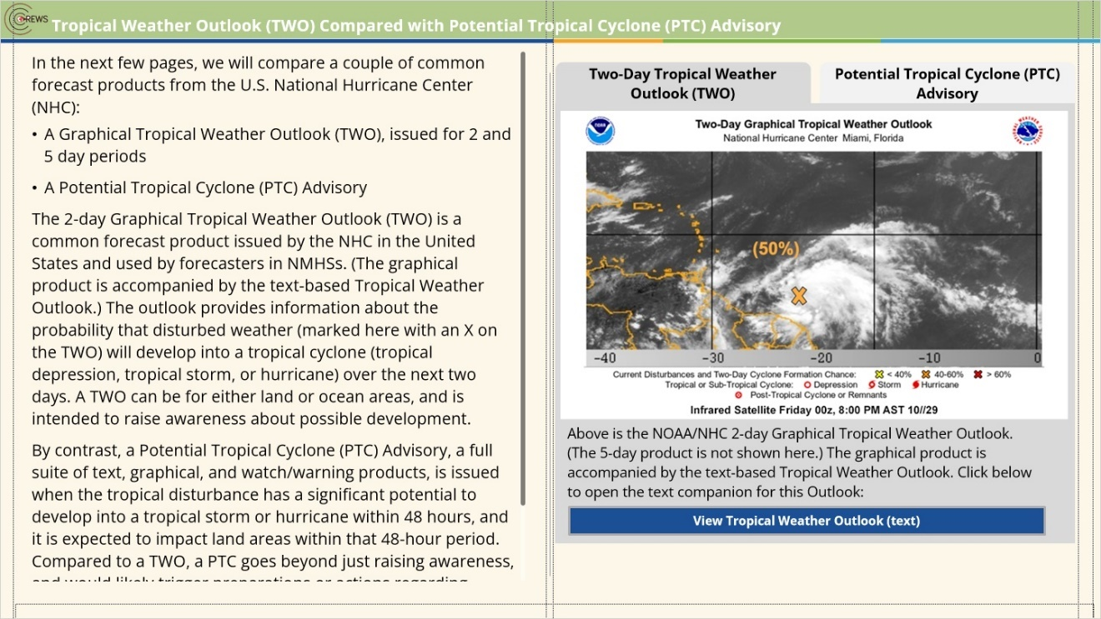

tab2 (Slide Layer)
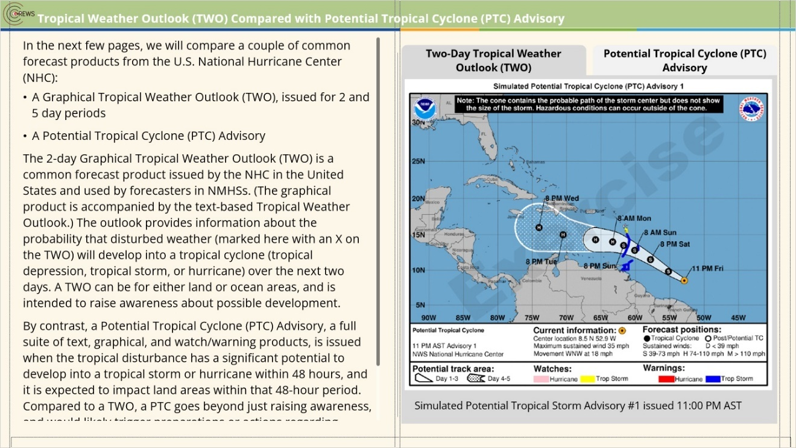

text TWO (Slide Layer)
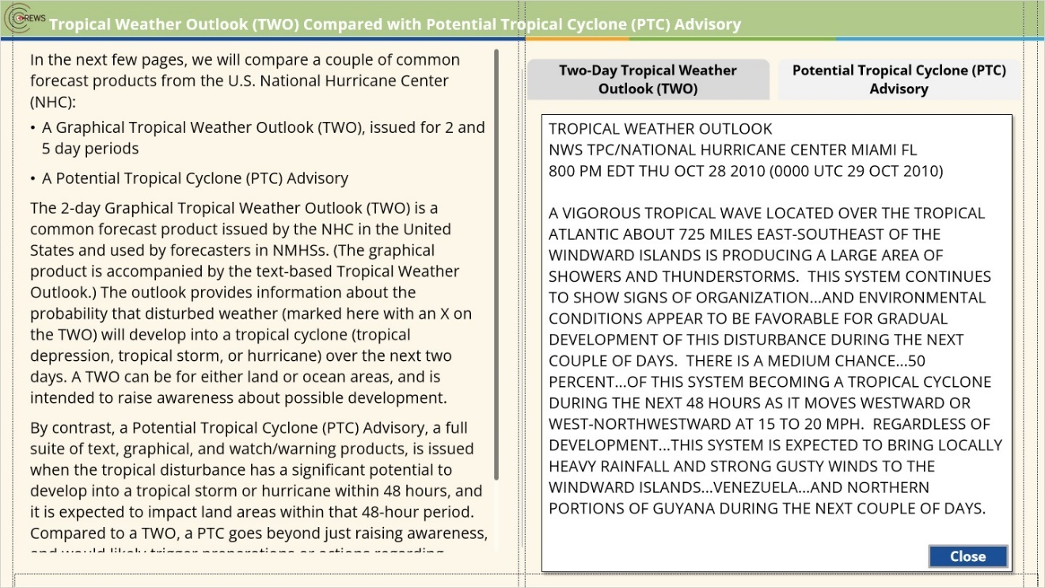

1.6 Case Activity: TWO versus PTC
(Pick Many, 10 points, 1 attempt permitted)
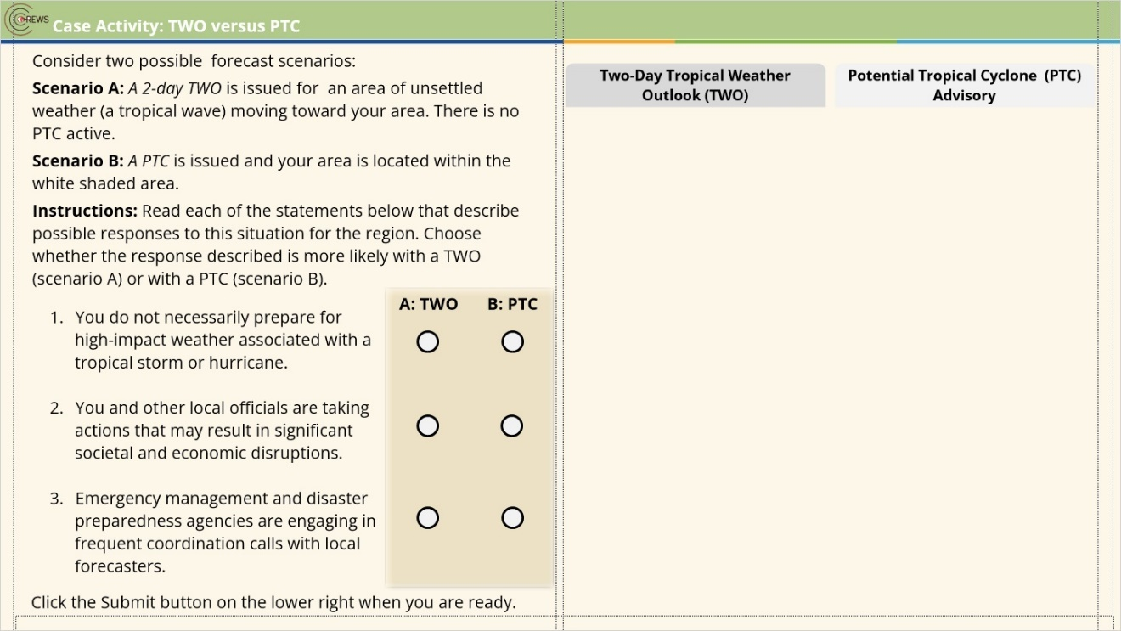
Correct | Choice
X | Q1a
 | Q1b
 | Q2a
X | Q2b
 | Q3a
X | Q3b

Notes:

text TWO (Slide Layer)
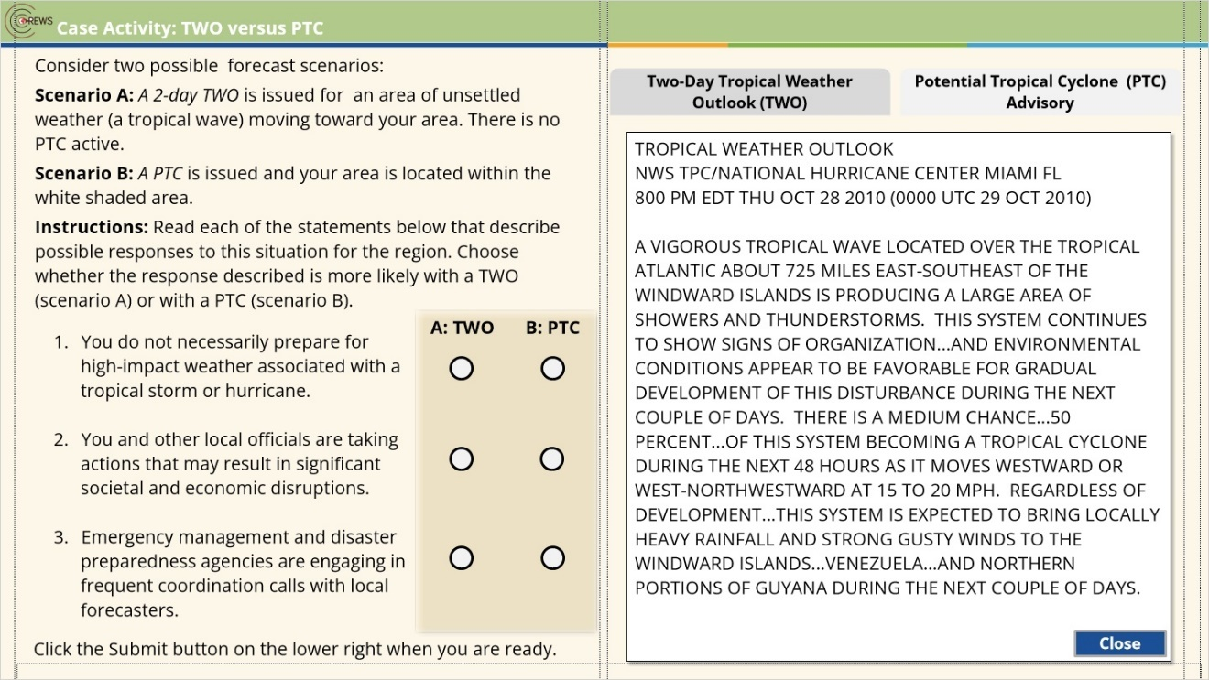

tab1 (Slide Layer)
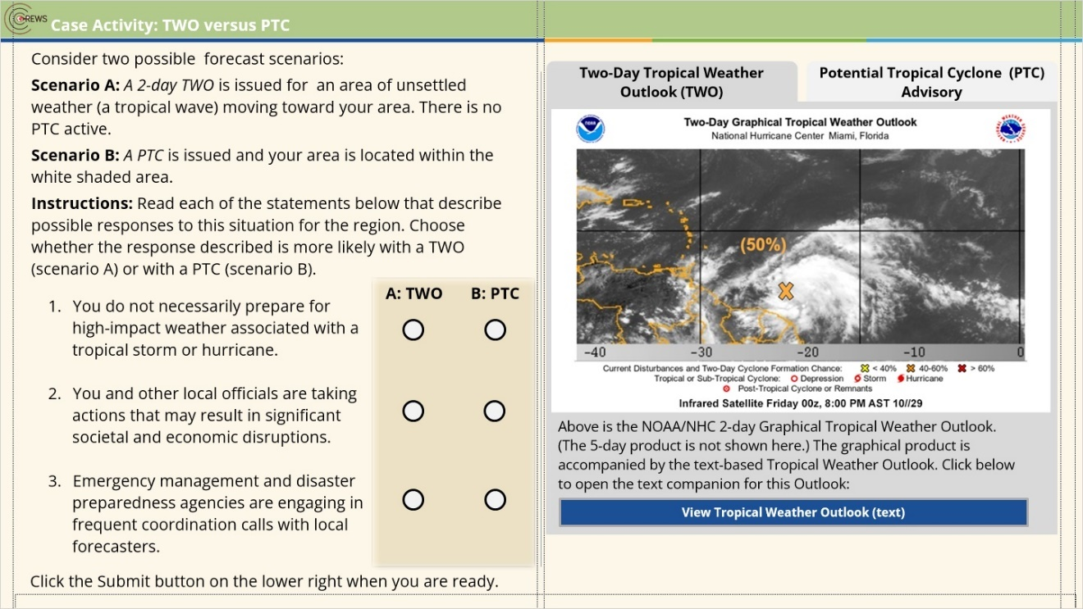

tab2 (Slide Layer)
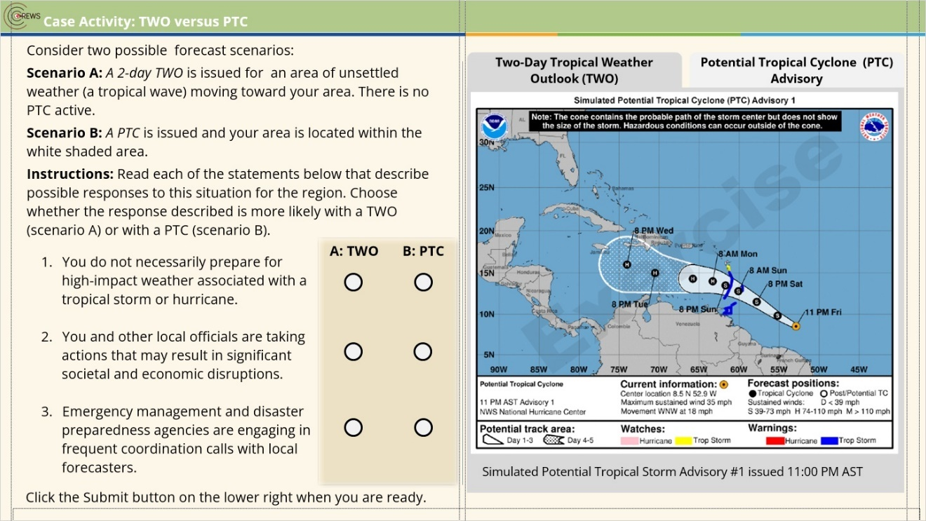

Incorrect (Slide Layer)
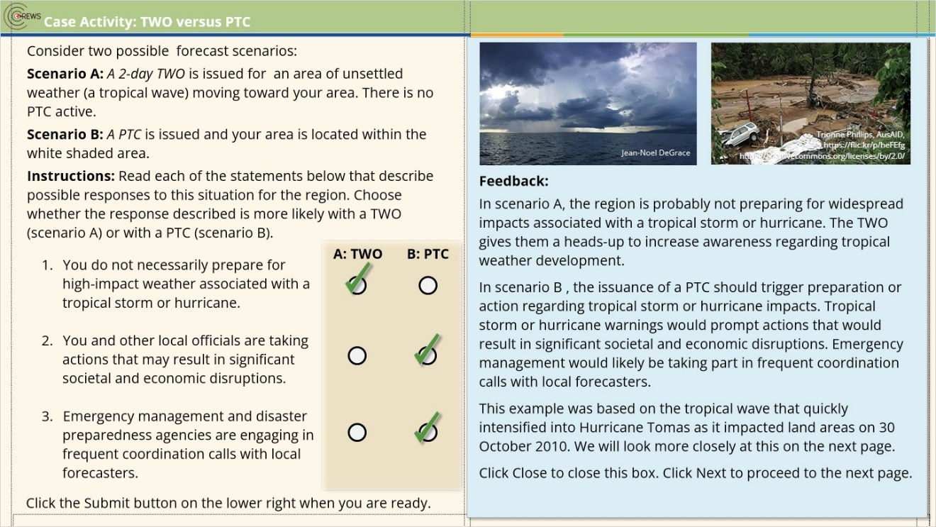

Correct (Slide Layer)

1.7 Example: Hurricane Tomas, October 2010
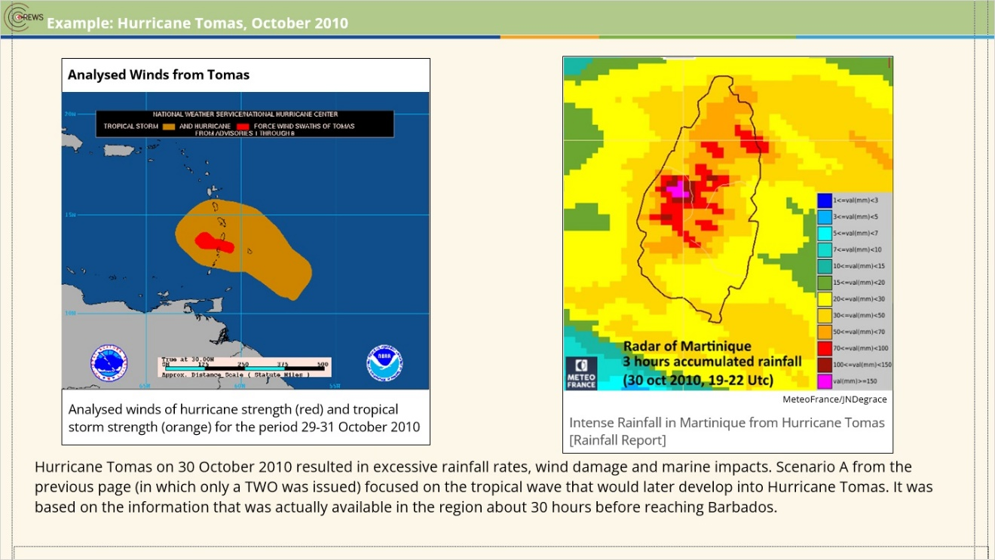
Notes:

1.8 Simulated PTC: Hurricane Tomas, October 2010
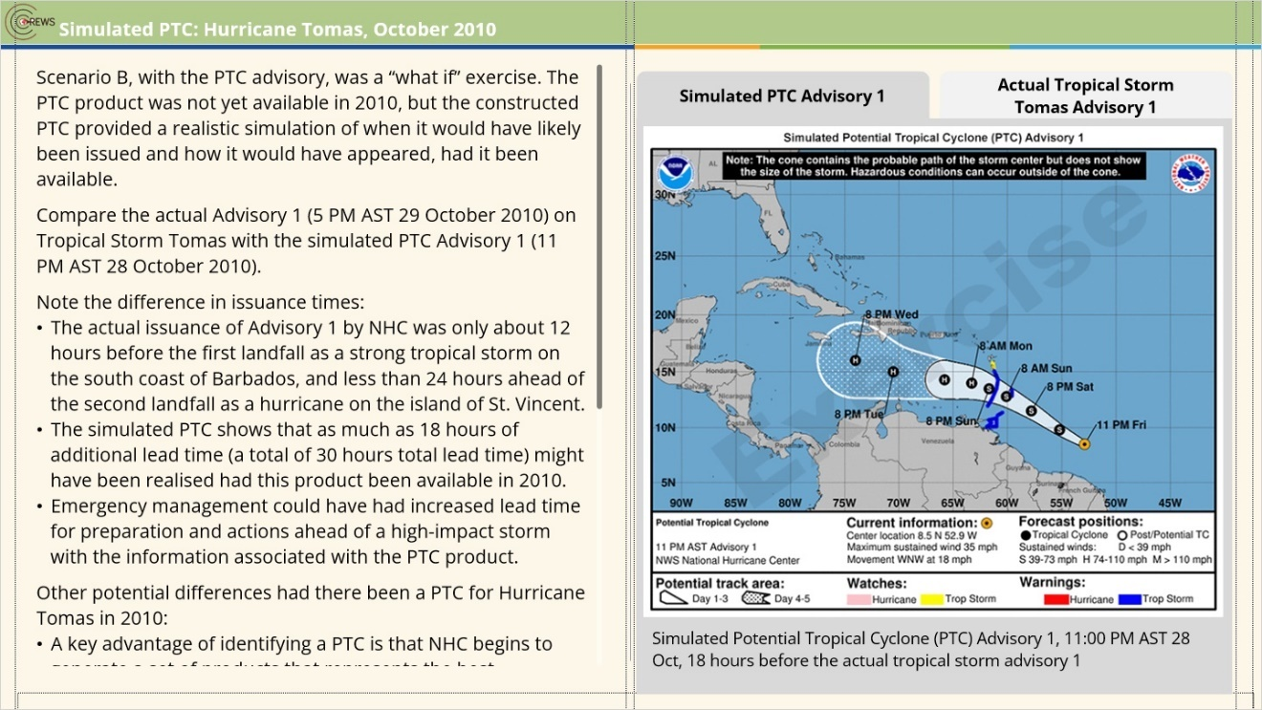
Notes:
Scenario B, with the PTC advisory, was a “what if” exercise. The PTC product was not yet available in 2010, but the constructed PTC provided a realistic simulation of when it would have likely been issued and how it would have appeared, had it been available.
Compare the actual Advisory 1 (5 PM AST 29 October 2010) on Tropical Storm Tomas with the simulated PTC Advisory 1 (11 PM AST 28 October 2010).
Note the difference in issuance times:
The actual issuance of Advisory 1 by NHC was only about 12 hours before the first landfall as a strong tropical storm on the south coast of Barbados, and less than 24 hours ahead of the second landfall as a hurricane on the island of St. Vincent.
The simulated PTC shows that as much as 18 hours of additional lead time (a total of 30 hours total lead time) might have been realised had this product been available in 2010.
Emergency management could have had increased lead time for preparation and actions ahead of a high-impact storm with the information associated with the PTC product.
Other potential differences had there been a PTC for Hurricane Tomas in 2010:
A key advantage of identifying a PTC is that NHC begins to generate a set of products that represents the best consensus of several models. This provides important decision-support guidance including storm track and uncertainties, wind probabilities, and timing.
The PTC may have been accompanied by warnings with much stronger wording about expected impacts on land and at sea, including warnings of tropical storm and hurricane impacts.
The issuance of a PTC advisory provides a basis upon which a NMHS may decide to issue a storm watch or warning for an event that is not yet a tropical storm.
Local officials may have felt greater justification and support for taking life-saving actions in preparation for tropical storm or hurricane impacts, even if they may have had significant societal and economic costs.
Coordination calls within the region may have started earlier and could have been more frequent.
Increased media attention about the expected impacts helps to build greater awareness among citizens.

zoom1 (Slide Layer)
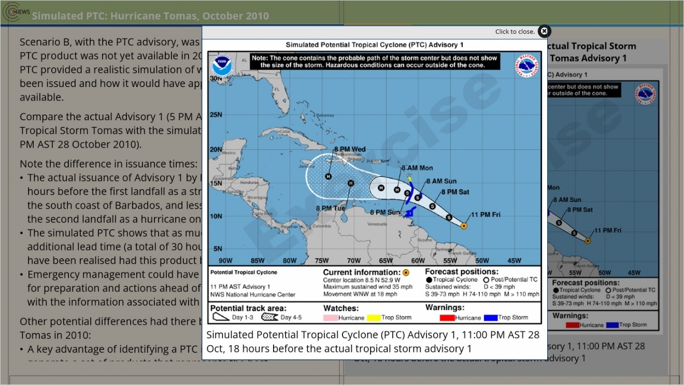

zoom2 (Slide Layer)
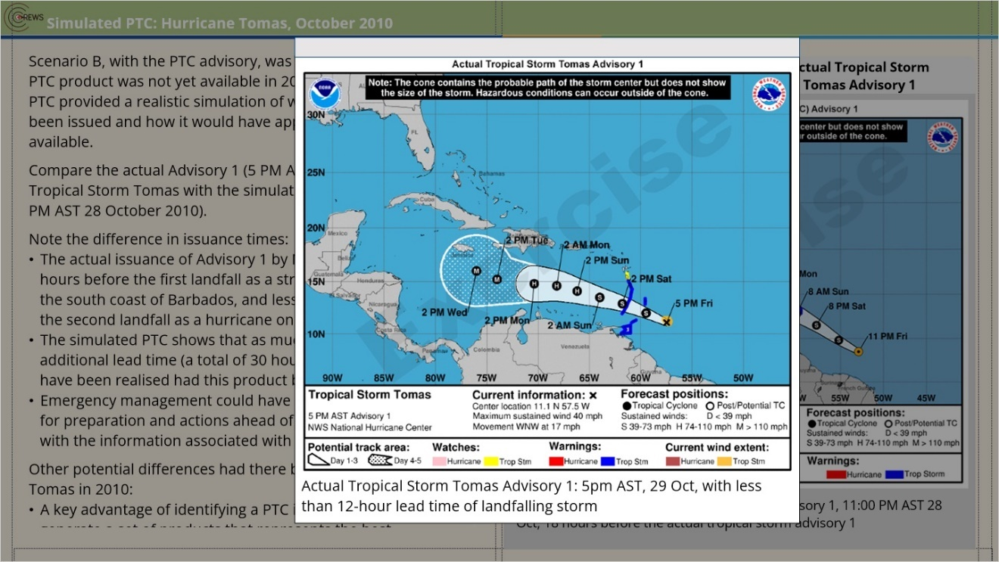

1.9 Tropical Cyclone Climatology
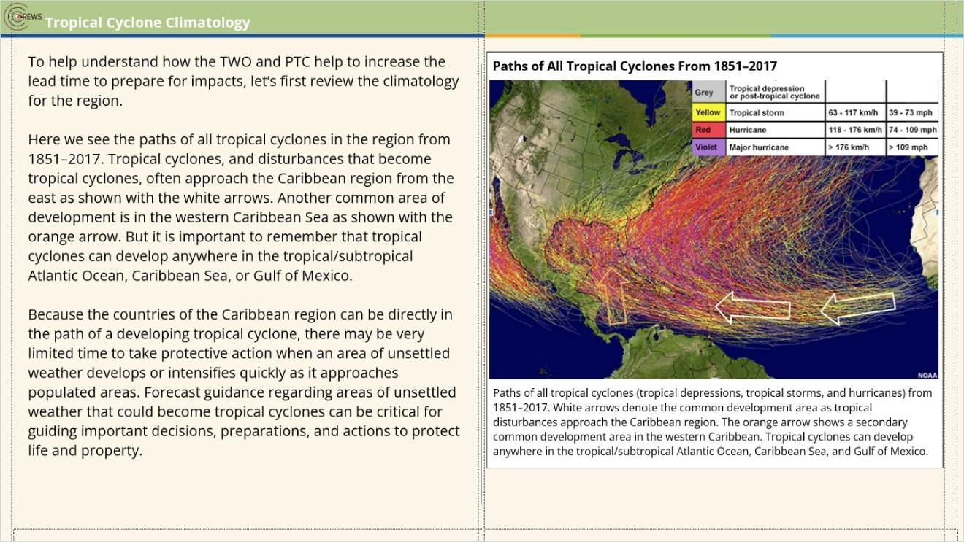
Notes:

zoom1 (Slide Layer)
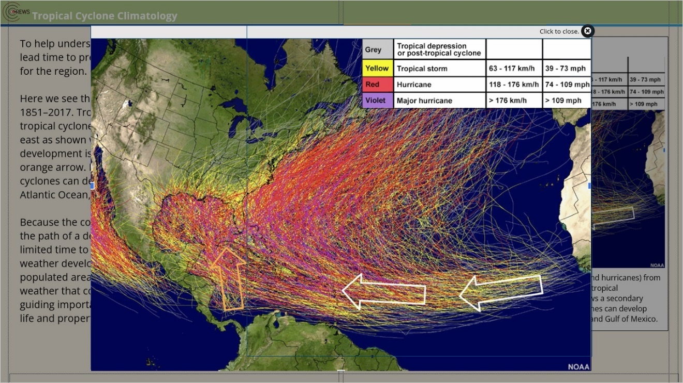

1.10 What Does the “Potential” in PTC Mean?
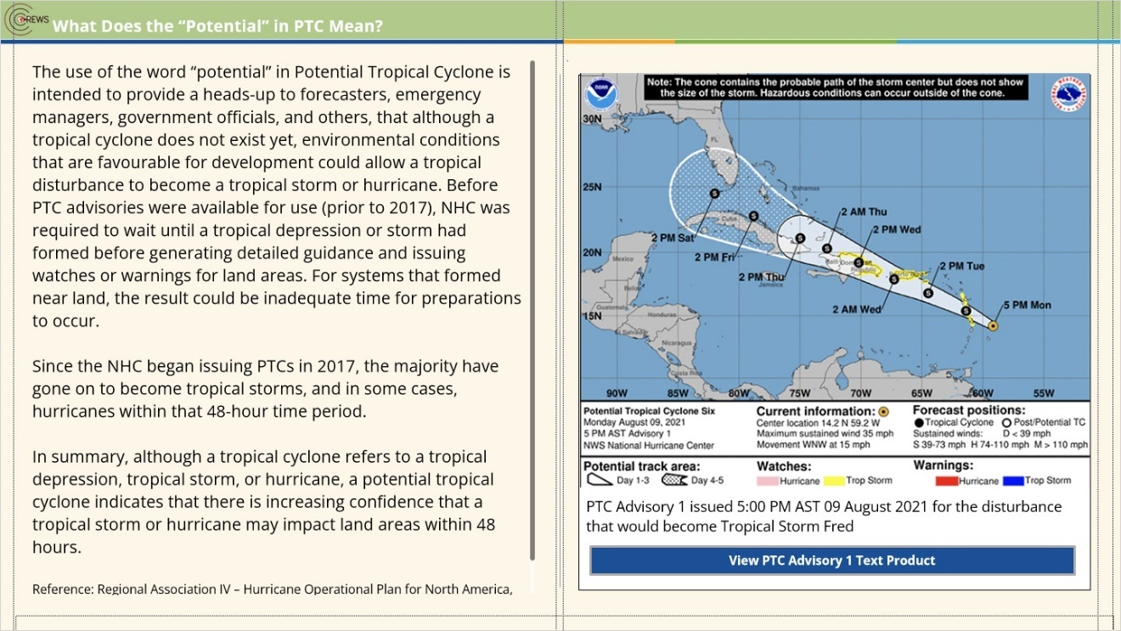
Notes:

Reference: Regional Association IV – Hurricane Operational Plan for North America, Central America and the Caribbean (WMO-No. 1163)
https://library.wmo.int/?lvl=notice_display&id=13696

text PTC (Slide Layer)
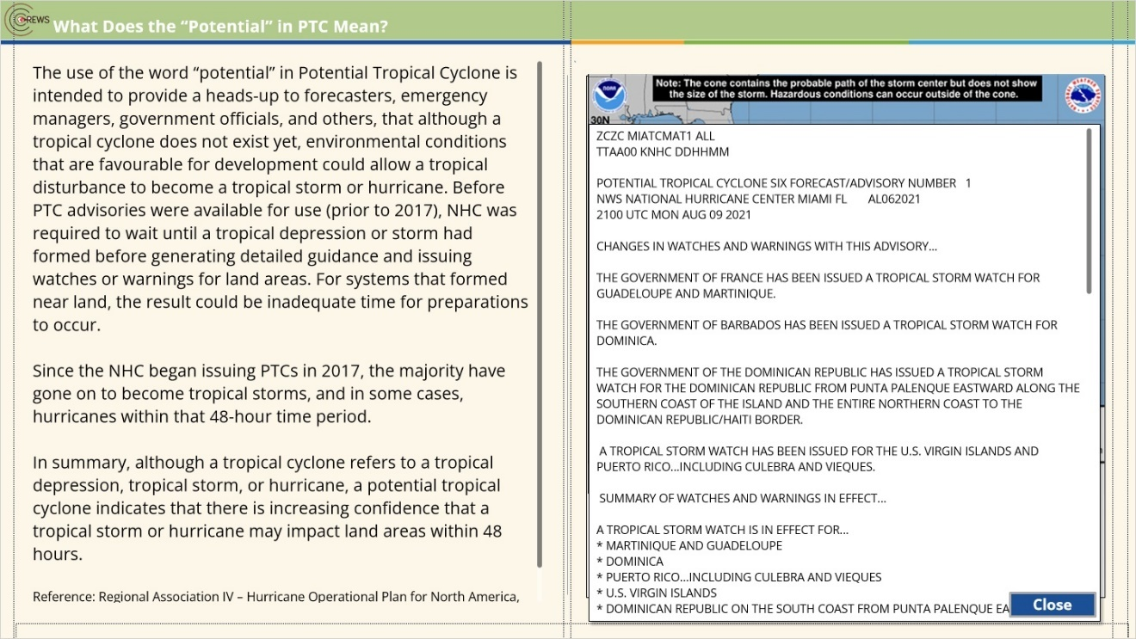

1.11 Knowledge Check
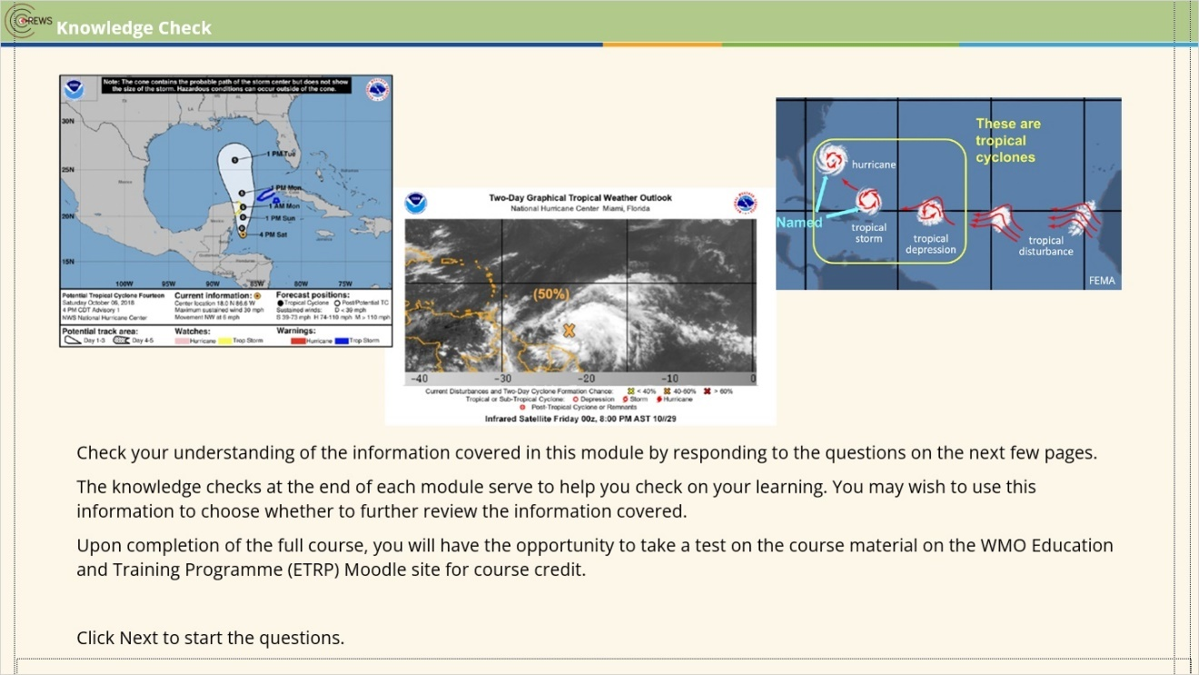
Notes:

1.12 Question 1
(Pick Many, 10 points, 1 attempt permitted)
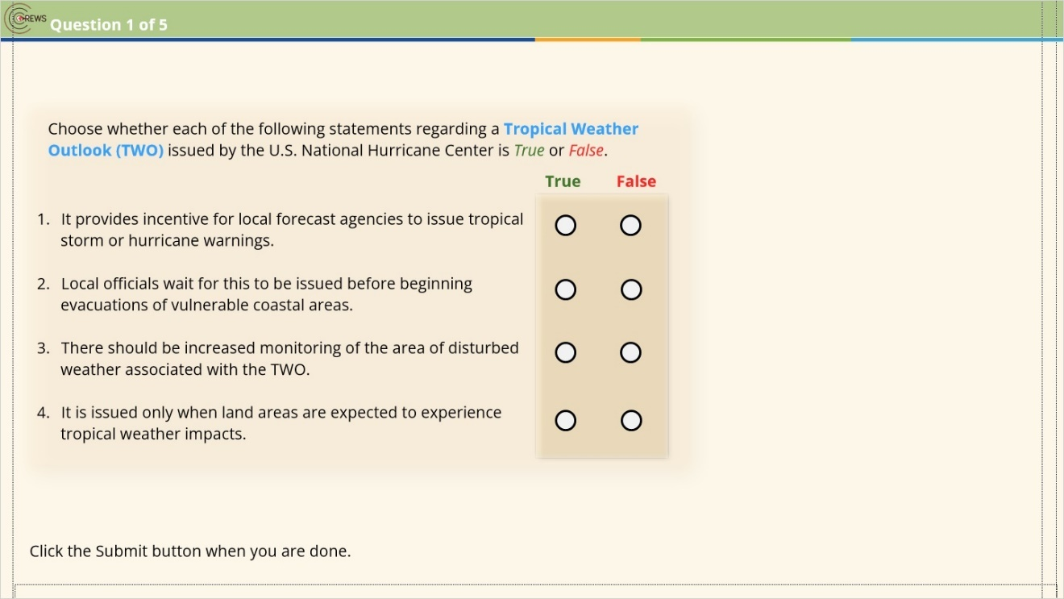
Correct | Choice
X | Q1-correct 1
 | Oval 1
X | Q2-correct 1
 | Oval 2
X | Q3-correct 1
 | Oval 3
X | Q4-Correct 1
 | Oval 4

Notes:

Correct (Slide Layer)
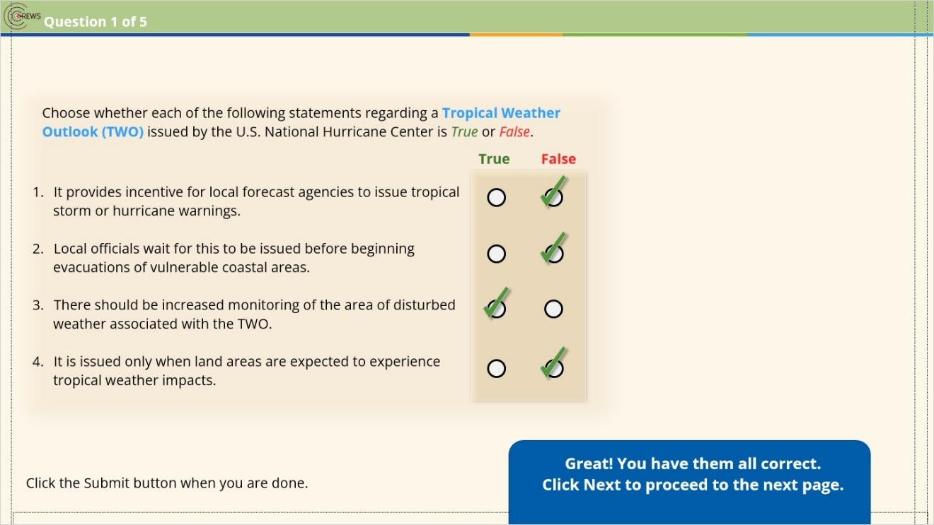

Incorrect (Slide Layer)
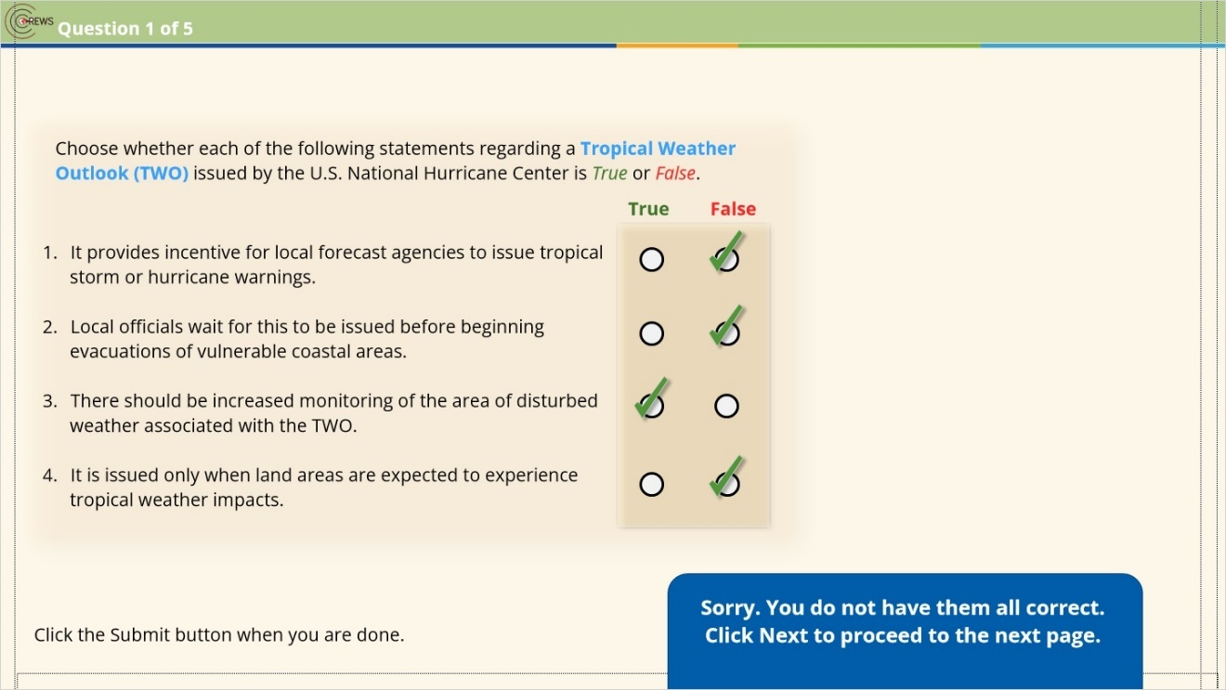

1.13 Question 2
(Pick Many, 10 points, 1 attempt permitted)
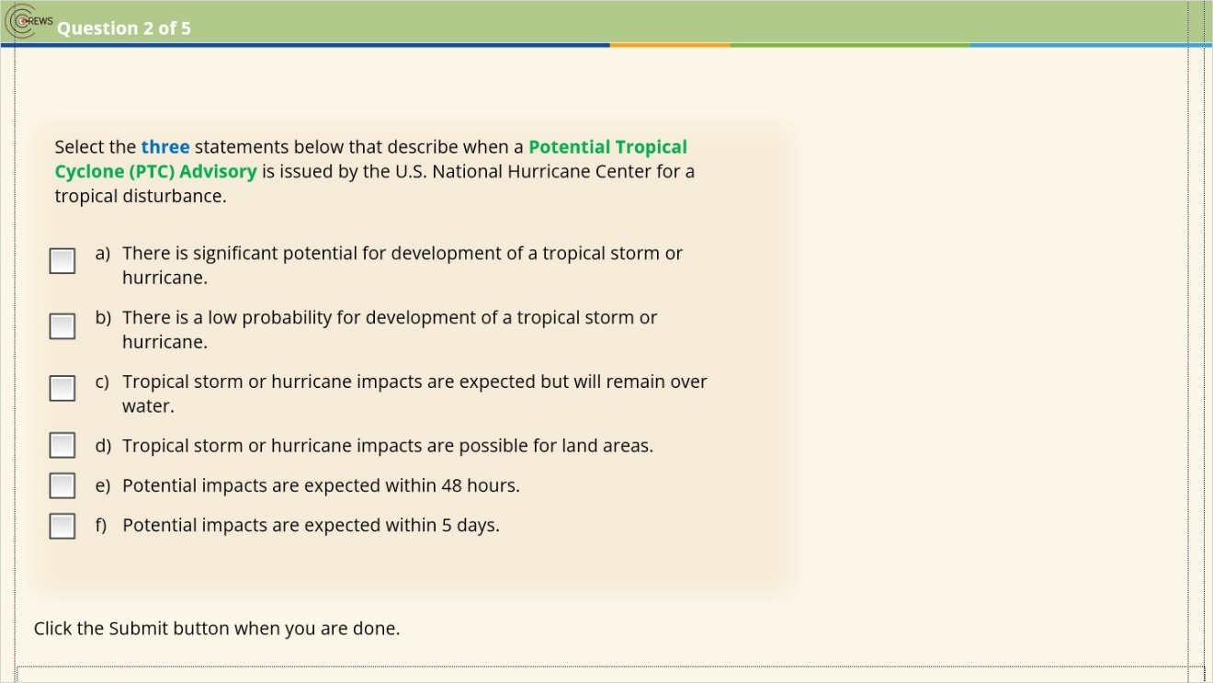
Correct | Choice
X | Check Box 4
 | Check Box 3
 | Check Box 2
X | Check Box 1
X | Check Box 5
 | Check Box 6

Incorrect (Slide Layer)
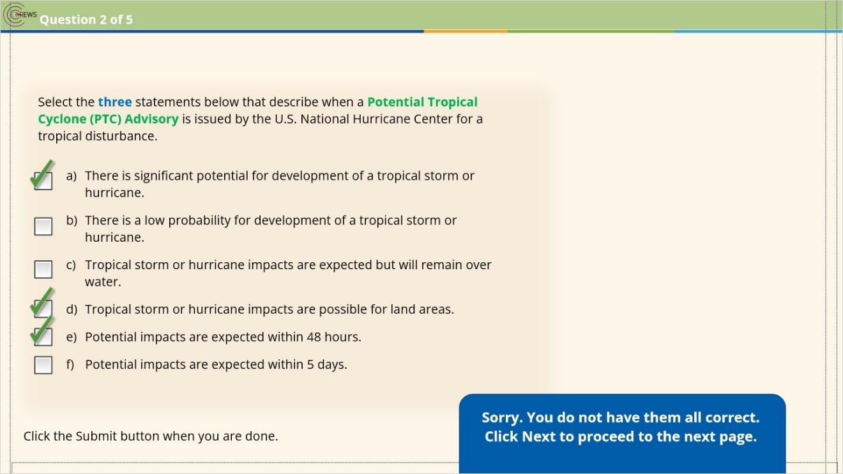

Correct (Slide Layer)
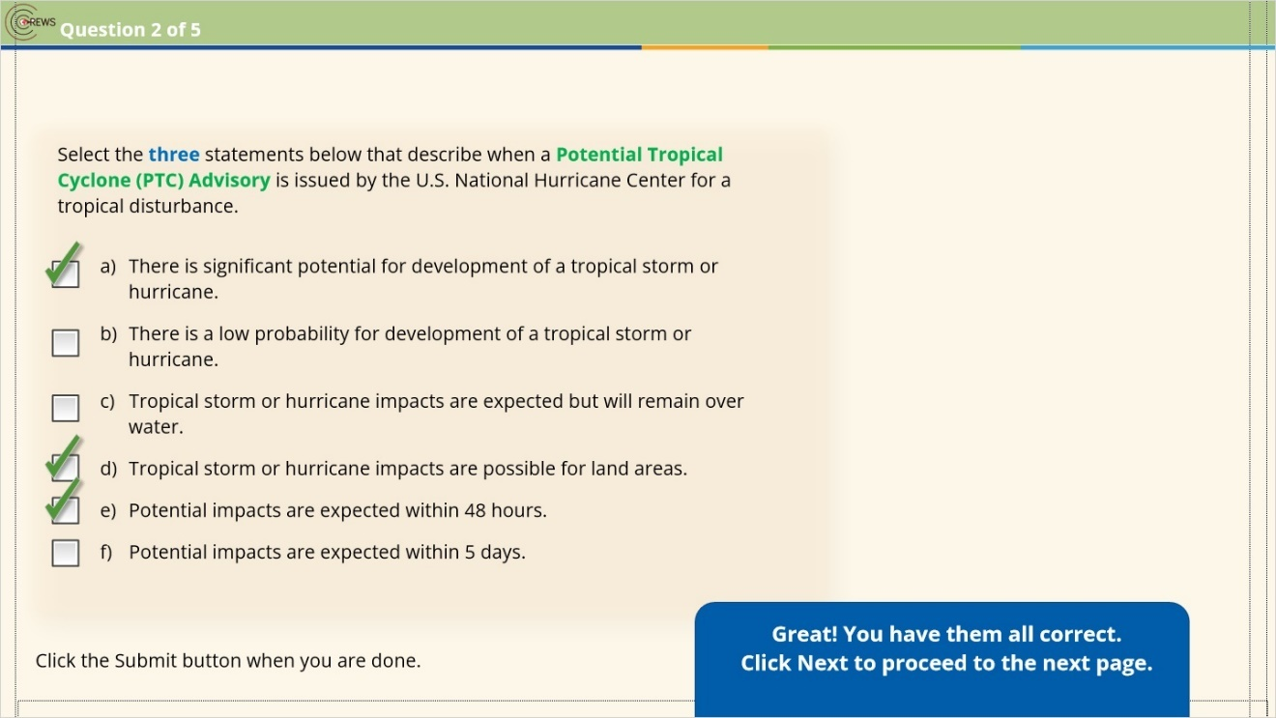

1.14 Question 3
(Pick Many, 10 points, 1 attempt permitted)
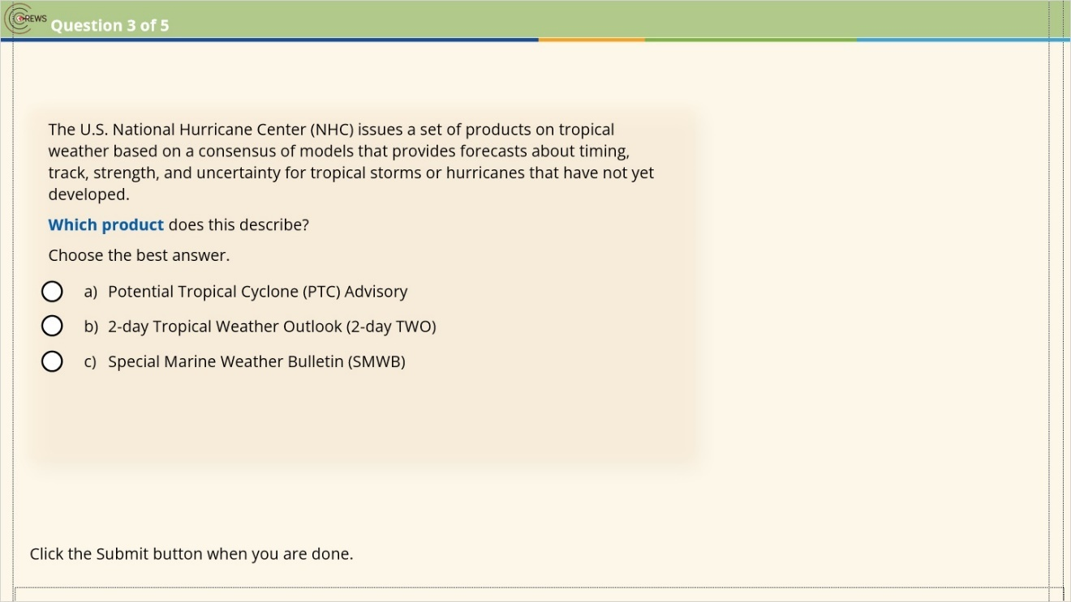
Correct | Choice
X | Radio Button 1
 | Radio Button 2
 | Radio Button 3

Correct (Slide Layer)
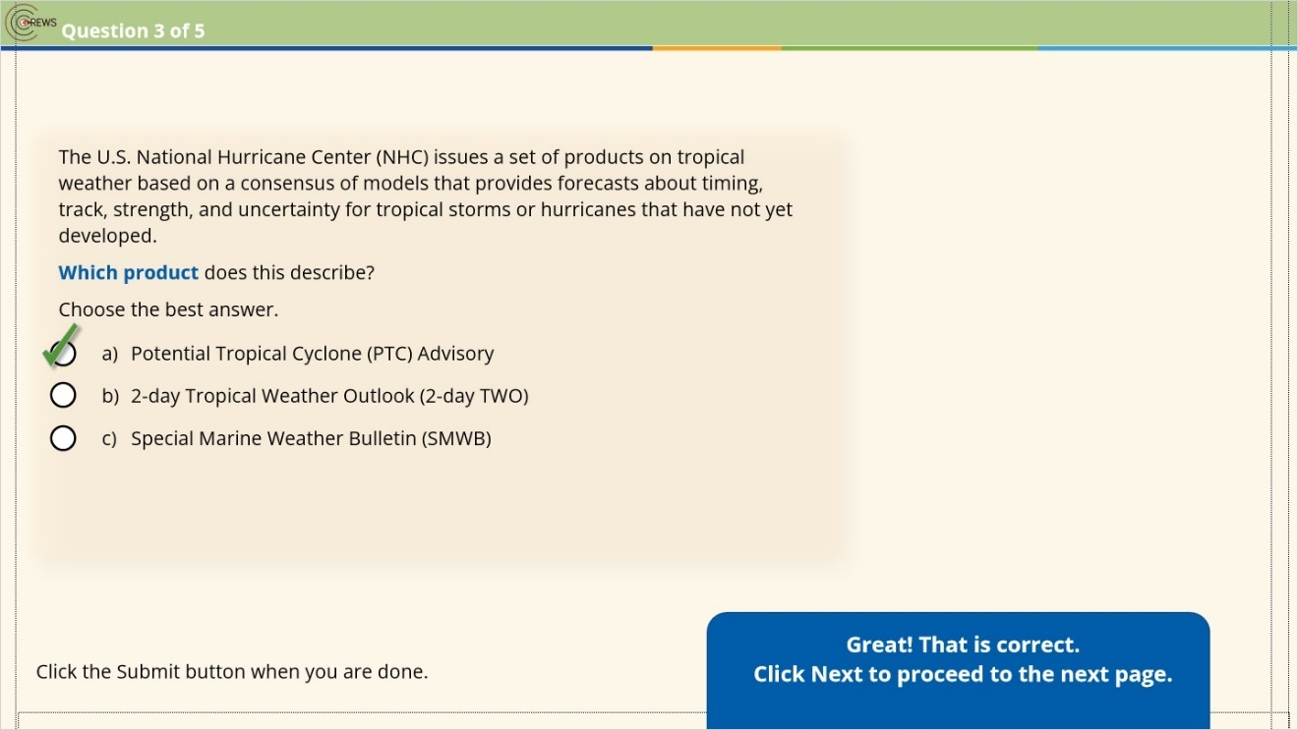

Incorrect (Slide Layer)
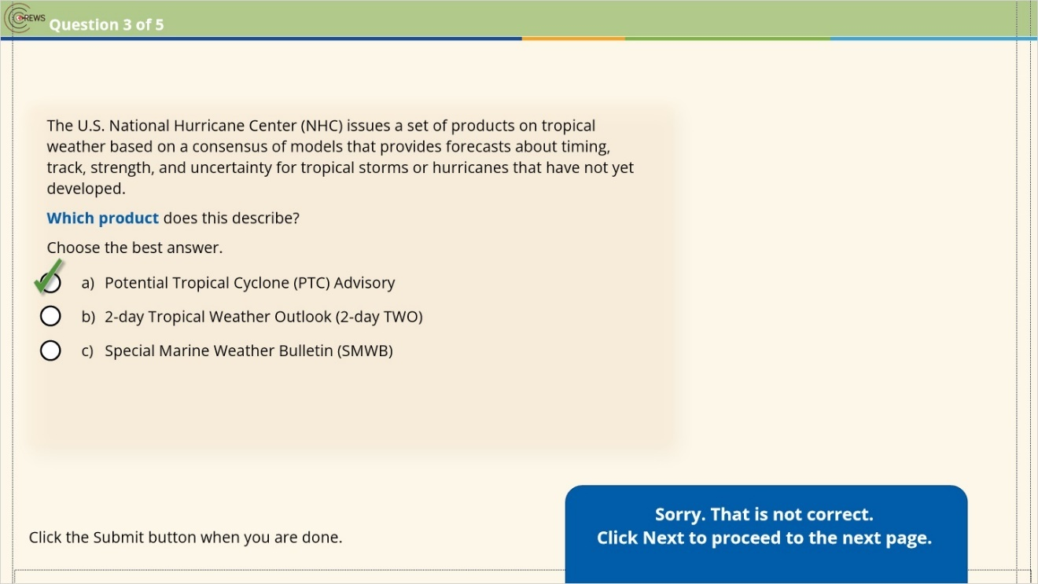

1.15 Question 4
(Pick Many, 10 points, 1 attempt permitted)
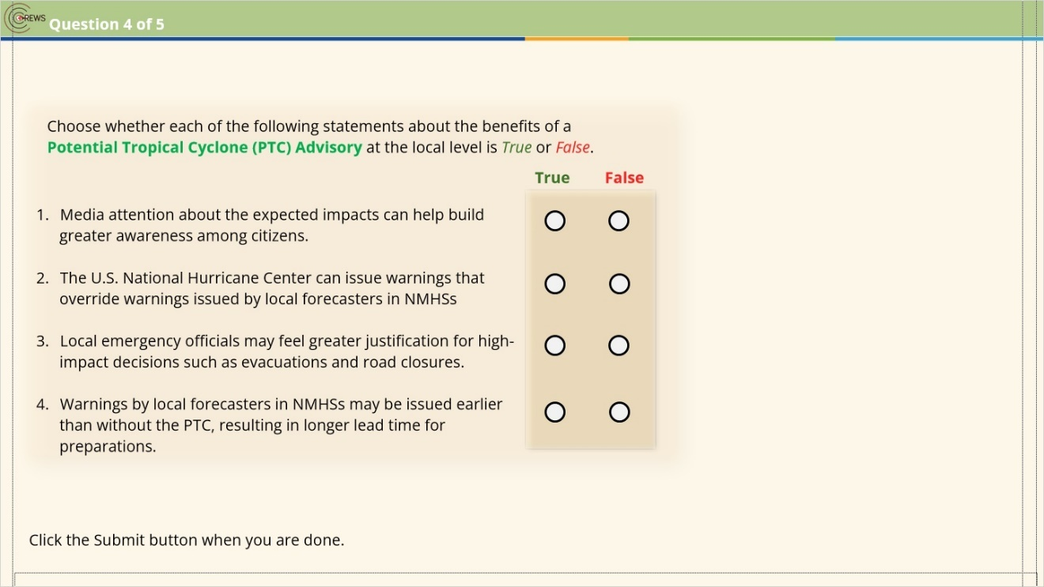
Correct | Choice
 | Q1F
X | Q1T
X | Q2F
 | Q2T
X | Q3T
 | Q3F
 | Q4F
X | Q4T

Correct (Slide Layer)
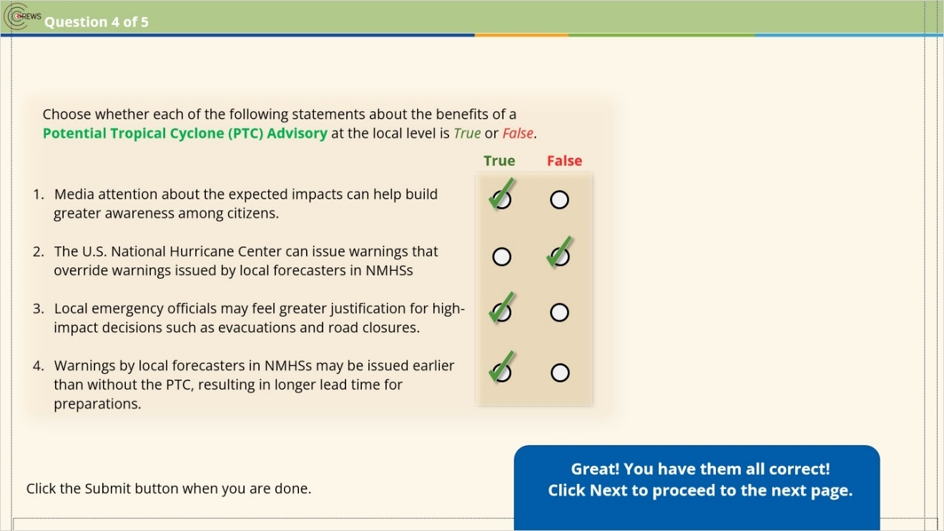

Incorrect (Slide Layer)
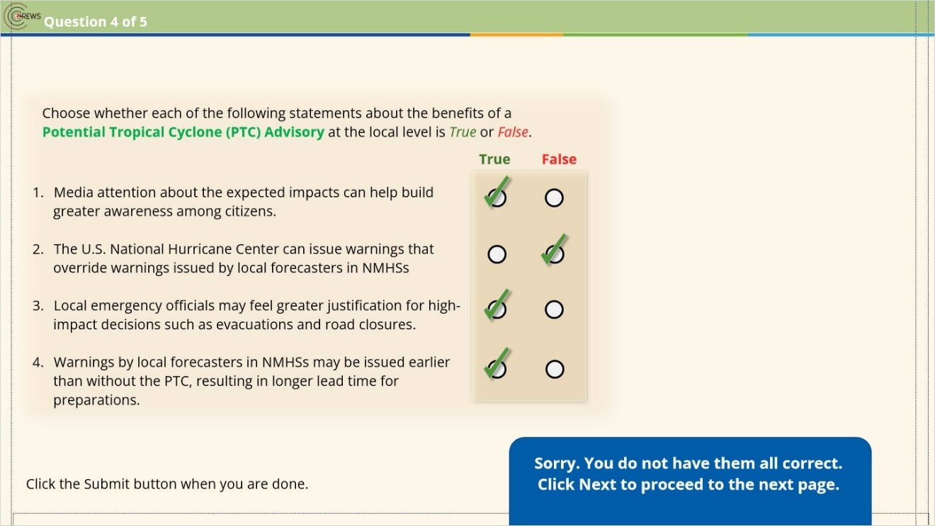

1.16 Question 5
(Pick Many, 10 points, 1 attempt permitted)
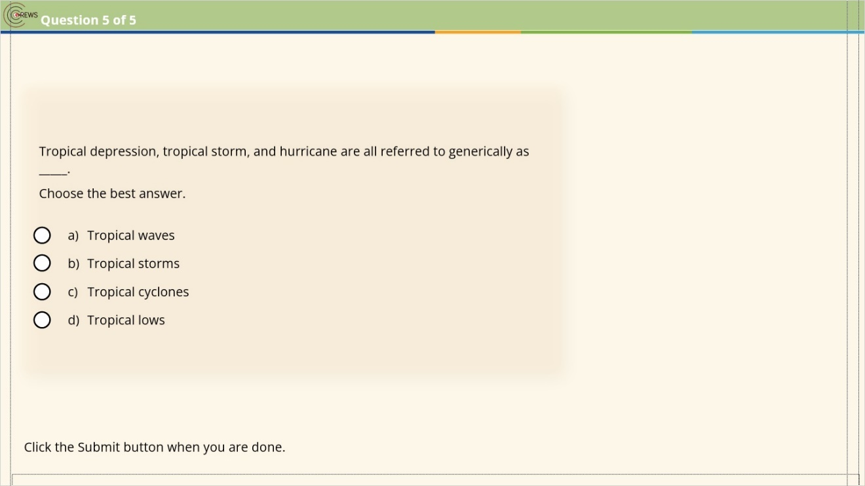
Correct | Choice
 | Radio Button 1
 | Radio Button 2
X | Radio Button 3
 | Radio Button 4

Notes:

Correct (Slide Layer)
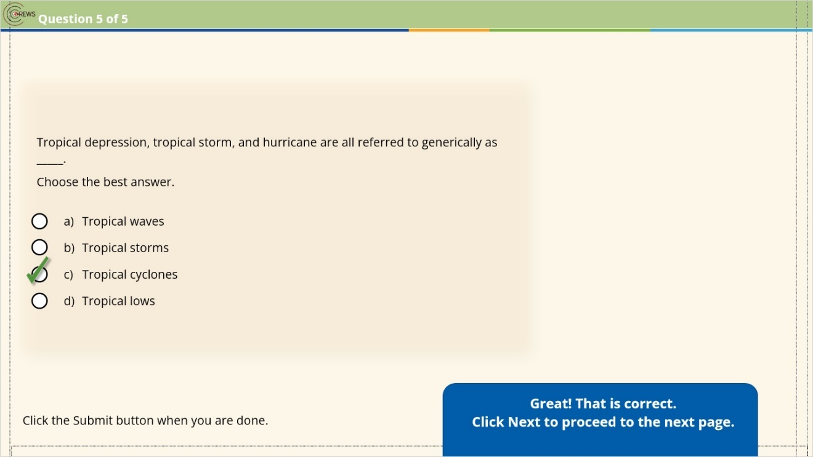

Incorrect (Slide Layer)
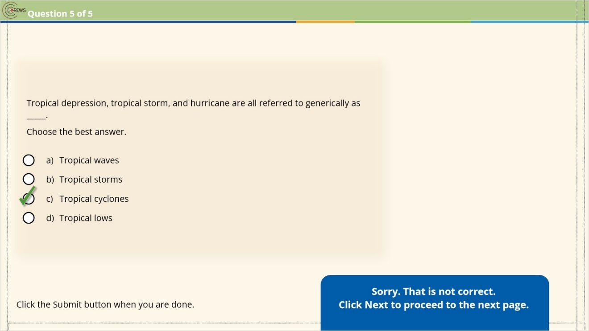

1.17 Results: Module 1 Knowledge Check
(Results Slide, 0 points, 1 attempt permitted)
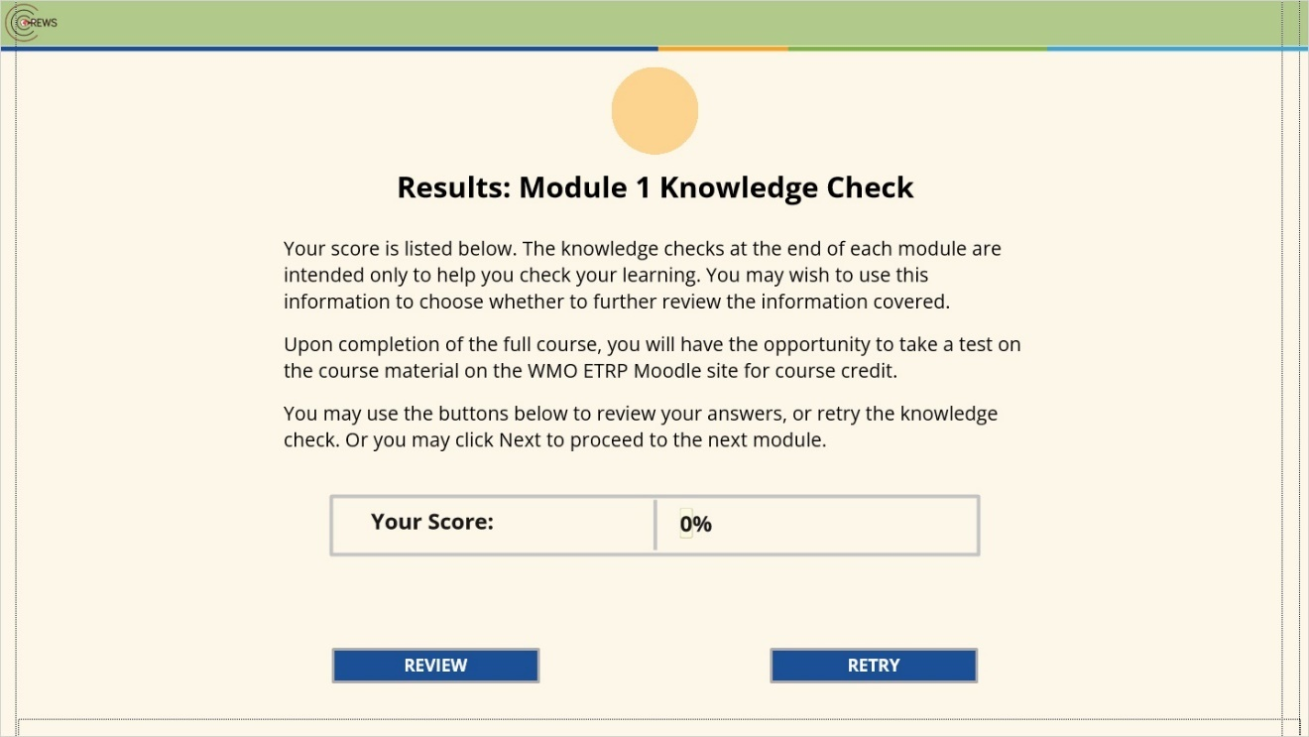

Results for
1.12 Question 1
1.13 Question 2
1.14 Question 3
1.15 Question 4
1.16 Question 5

Result slide properties
Passing  Score | 70%

Notes:

2. Module 2: Tools for Assessing Potential Impacts

2.1 Module Two Overview
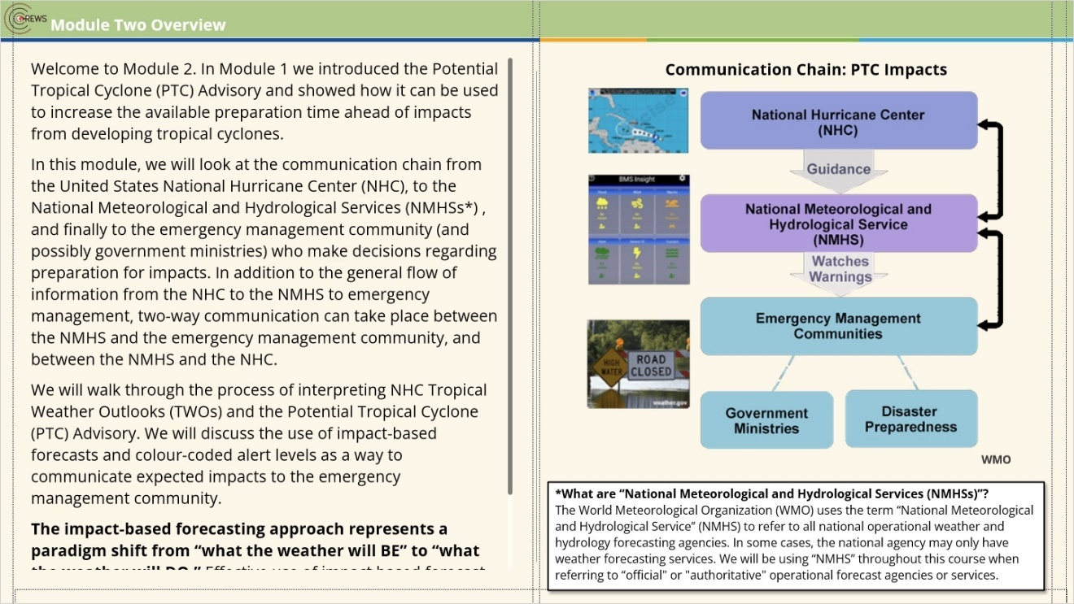
Notes:
Welcome to Module 2. In Module 1 we introduced the Potential Tropical Cyclone (PTC) Advisory and showed how it can be used to increase the available preparation time ahead of impacts from developing tropical cyclones.
In this module, we will look at the communication chain from the United States National Hurricane Center (NHC), to the National Meteorological and Hydrological Services (NMHSs*) , and finally to the emergency management community (and possibly government ministries) who make decisions regarding preparation for impacts. In addition to the general flow of information from the NHC to the NMHS to emergency management, two-way communication can take place between the NMHS and the emergency management community, and between the NMHS and the NHC.
We will walk through the process of interpreting NHC Tropical Weather Outlooks (TWOs) and the Potential Tropical Cyclone (PTC) Advisory. We will discuss the use of impact-based forecasts and colour-coded alert levels as a way to communicate expected impacts to the emergency management community.
The impact-based forecasting approach represents a paradigm shift from “what the weather will BE” to “what the weather will DO.” Effective use of impact based forecast and warning tools can ensure clear communication and meaningful assessment of potential impacts.
Click Next to continue.

zoom1 (Slide Layer)
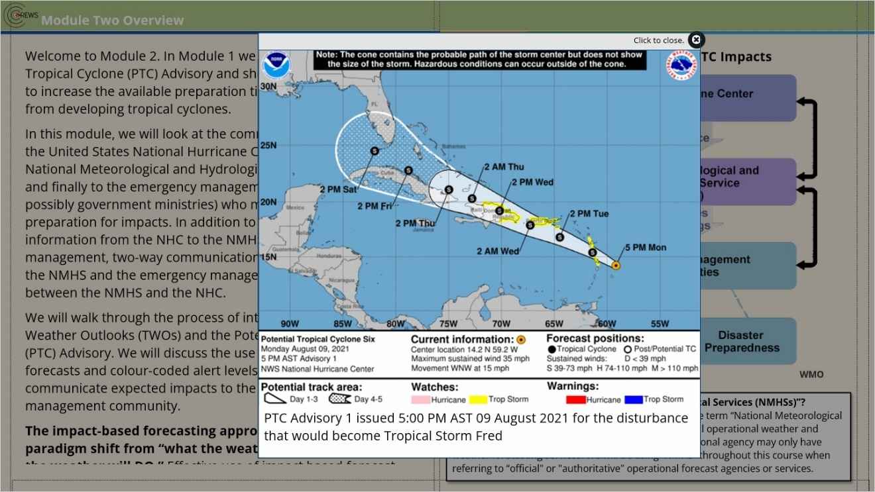

zoom2 (Slide Layer)
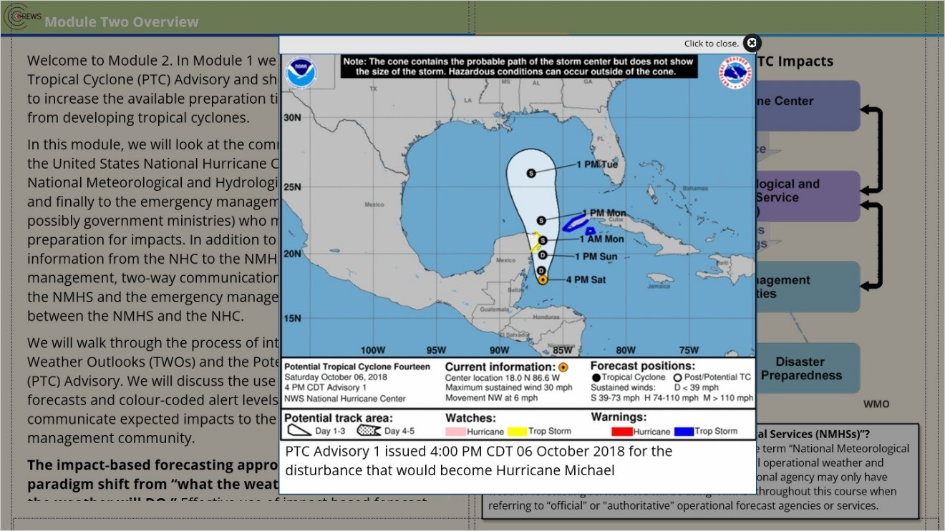

2.2 Impact-based Forecasts
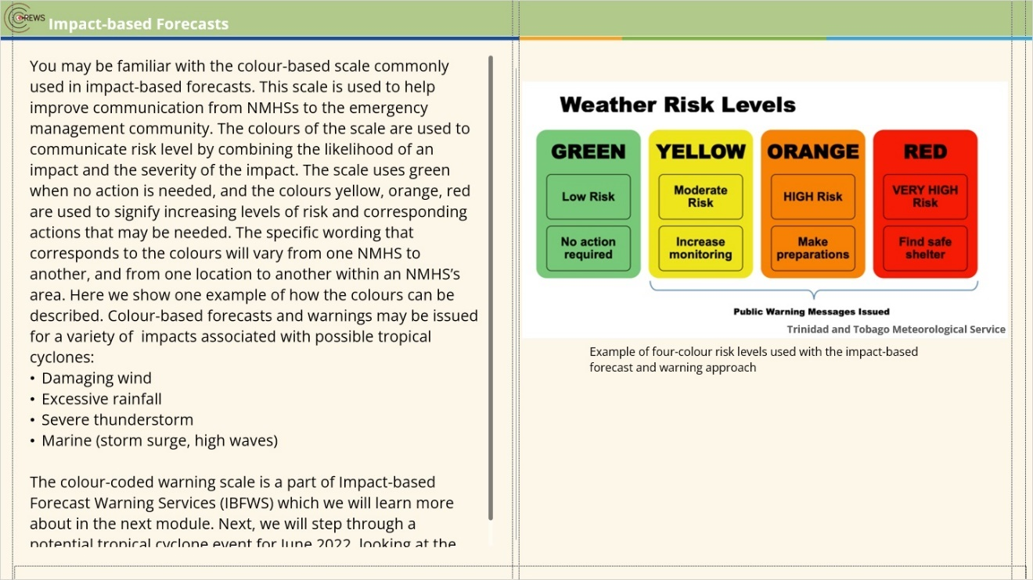
Notes:
You may be familiar with the colour-based scale commonly used in impact-based forecasts. This scale is used to help improve communication from NMHSs to the emergency management community. The colours of the scale are used to communicate risk level by combining the likelihood of an impact and the severity of the impact. The scale uses green when no action is needed, and the colours yellow, orange, red are used to signify increasing levels of risk and corresponding actions that may be needed. The specific wording that corresponds to the colours will vary from one NMHS to another, and from one location to another within an NMHS’s area. Here we show one example of how the colours can be described. Colour-based forecasts and warnings may be issued for a variety of impacts associated with possible tropical cyclones:
- Damaging wind
- Excessive rainfall
- Severe thunderstorm
- Marine (storm surge, high waves)

The colour-coded warning scale is a part of Impact-based Forecast Warning Services (IBFWS) which we will learn more about in the next module. Next, we will step through a potential tropical cyclone event for June 2022, looking at the role played by the PTC Advisory.

zoom1 (Slide Layer)
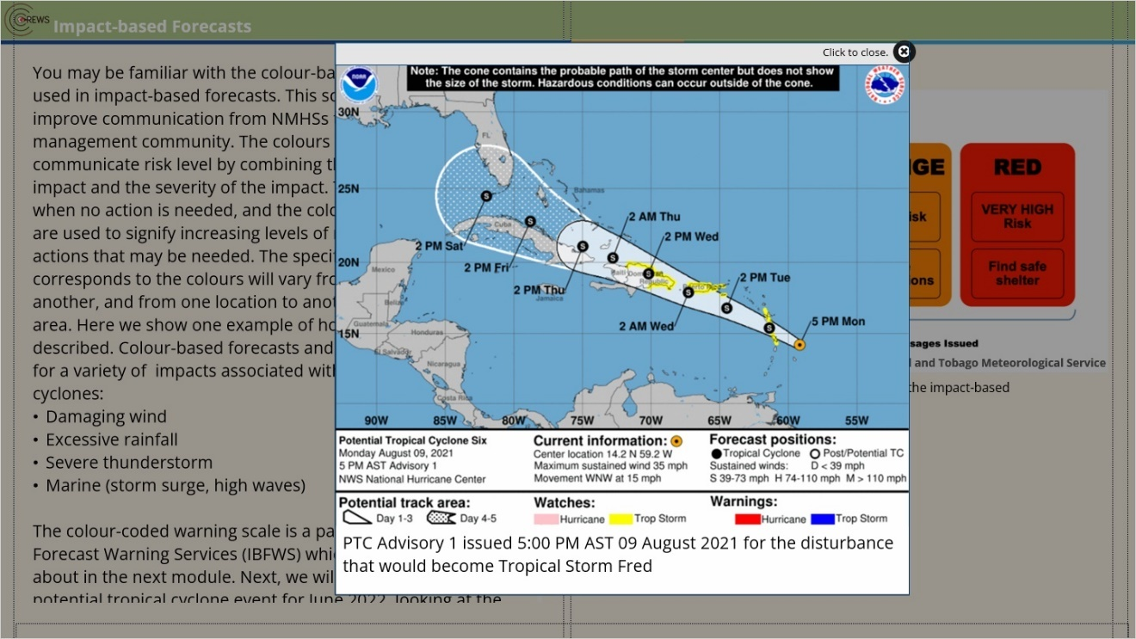

zoom2 (Slide Layer)
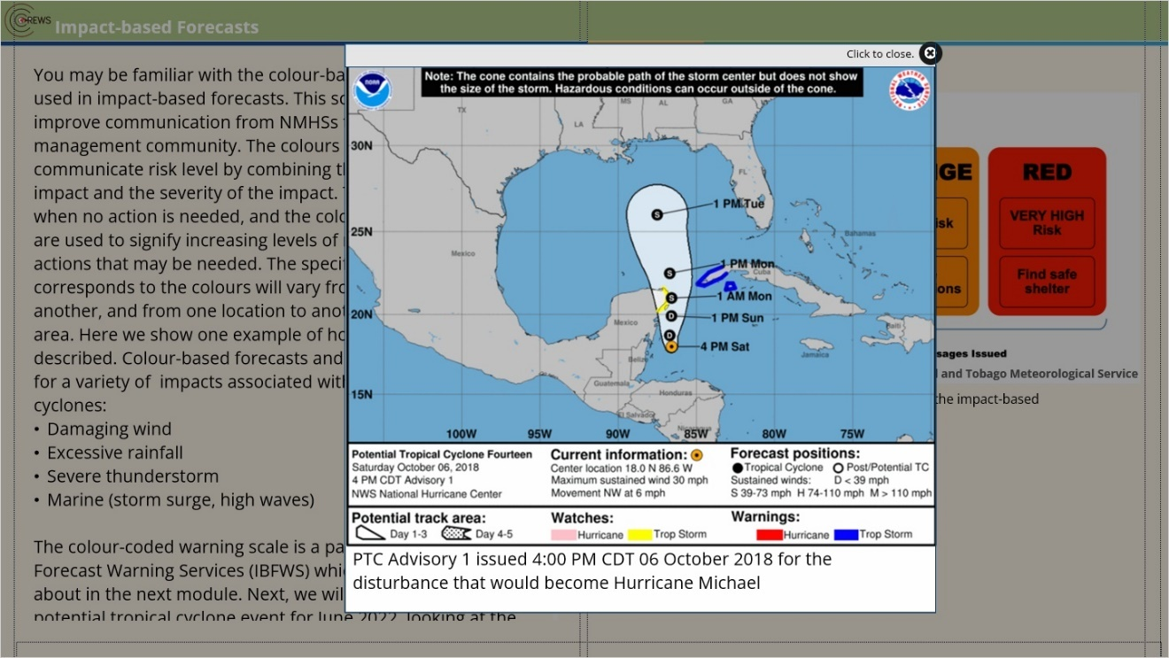

2.3 24–27 June 2022: Tropical Weather Outlooks (TWOs)
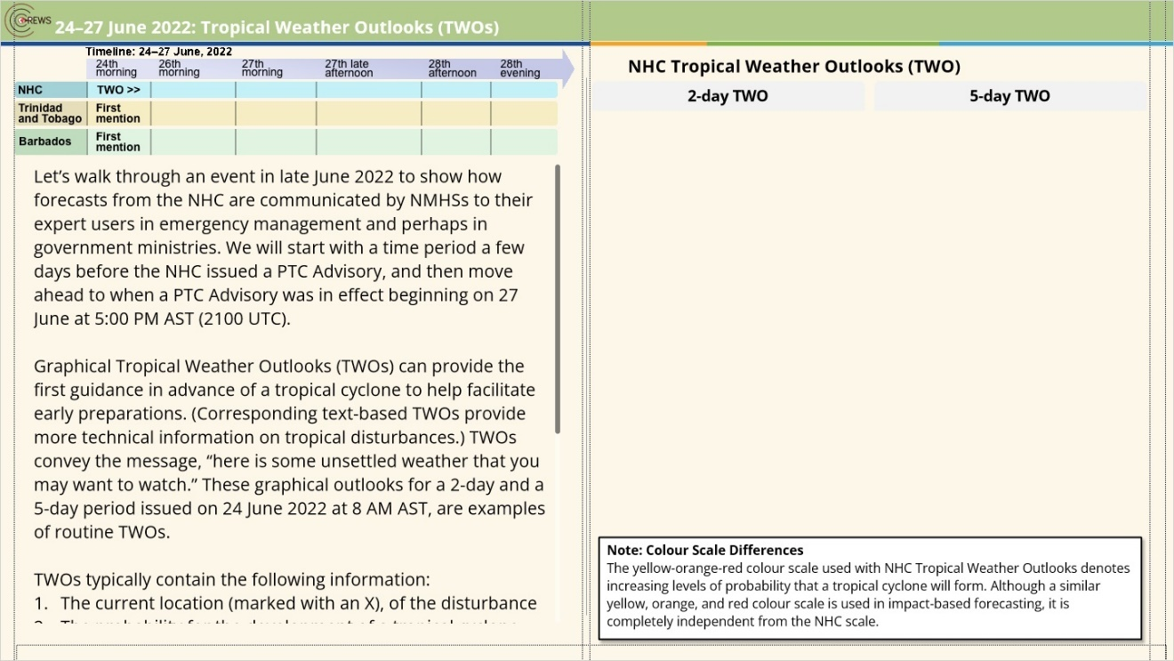
Notes:
Let’s walk through an event in late June 2022 to show how forecasts from the NHC are communicated by NMHSs to their expert users in emergency management and perhaps in government ministries. We will start with a time period a few days before the NHC issued a PTC Advisory, and then move ahead to when a PTC Advisory was in effect beginning on 27 June at 5:00 PM AST (2100 UTC).
Graphical Tropical Weather Outlooks (TWOs) can provide the first guidance in advance of a tropical cyclone to help facilitate early preparations. (Corresponding text-based TWOs provide more technical information on tropical disturbances.) TWOs convey the message, “here is some unsettled weather that you may want to watch.” These graphical outlooks for a 2-day and a 5-day period issued on 24 June 2022 at 8 AM AST, are examples of routine TWOs.
TWOs typically contain the following information:
The current location (marked with an X), of the disturbance
The probability for the development of a tropical cyclone
In the case of a 5-day outlook, the shading represents the potential formation area over the next 5 days. (Note: this is NOT a forecast track, as no tropical cyclone has developed yet.)
The probabilities are assigned by the NHC forecaster based on guidance from numerical weather prediction models, satellite observations, current conditions, and observed trends. The 2-day probability shows only a 20% (on average, 2 times out of 10) chance for development of a tropical cyclone. When we extend the forecast period to 5 days, there is a 40–60% probability for tropical cyclone development within the orange shaded area.

tab 1 (Slide Layer)
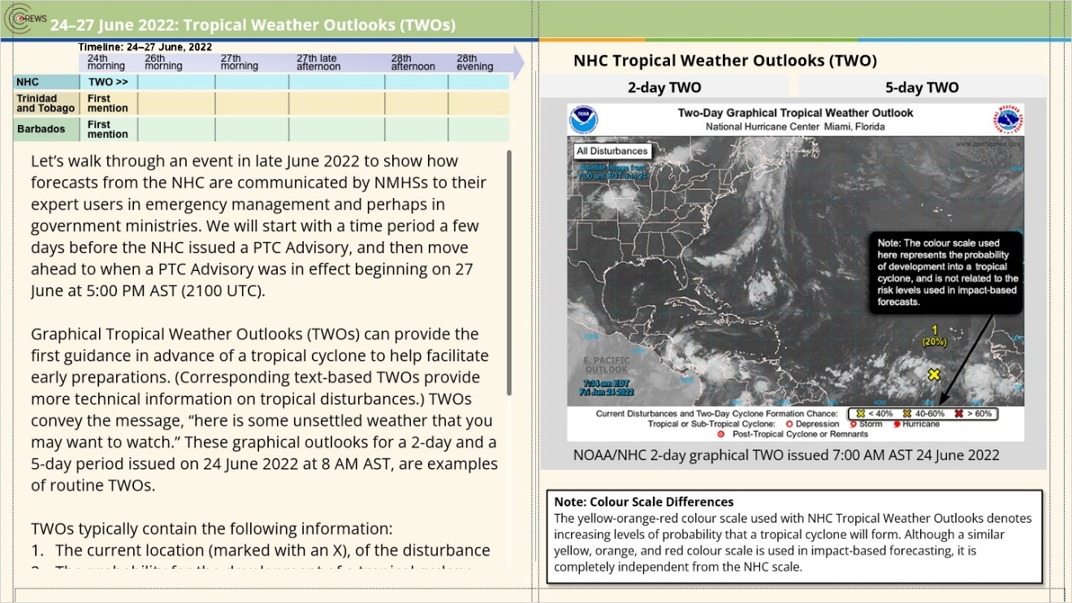

tab 2 (Slide Layer)
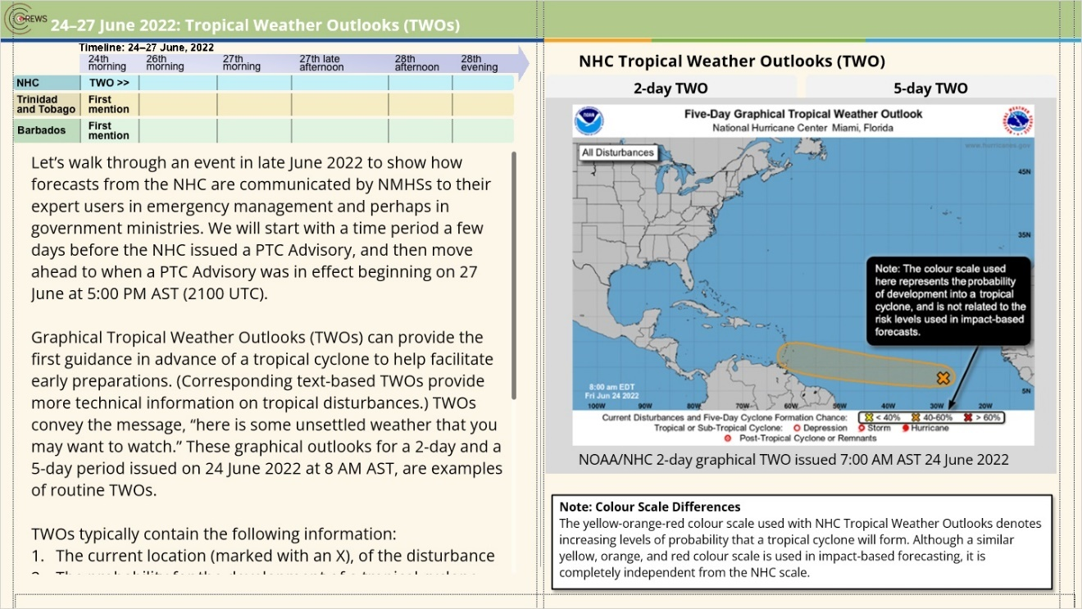

2.4 Activity: Interpreting a TWO
(Pick Many, 10 points, 2 attempts permitted)
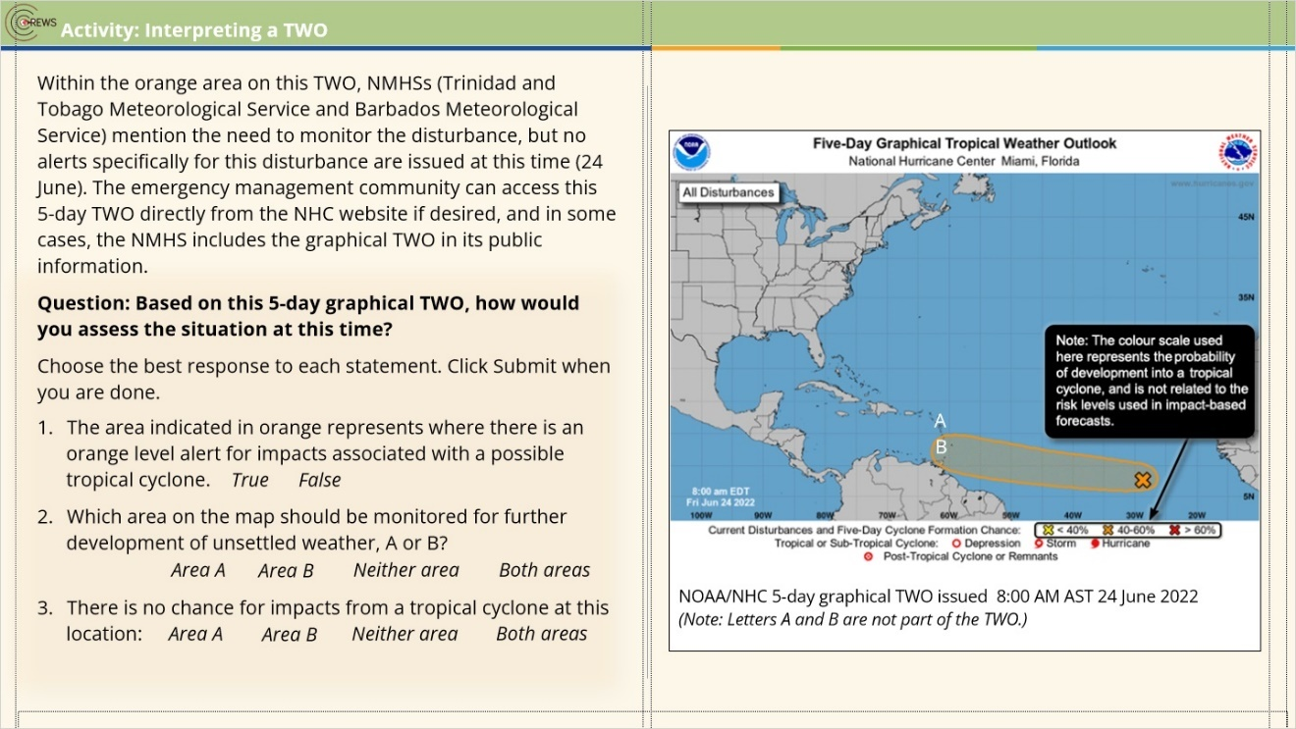
Correct | Choice
 | True
X | False
 | Area A
 | Area B
 | Neither area
X | Both areas
 | Area A
 | Area B
X | Neither area
 | Both areas

Notes:

Incorrect (Slide Layer)
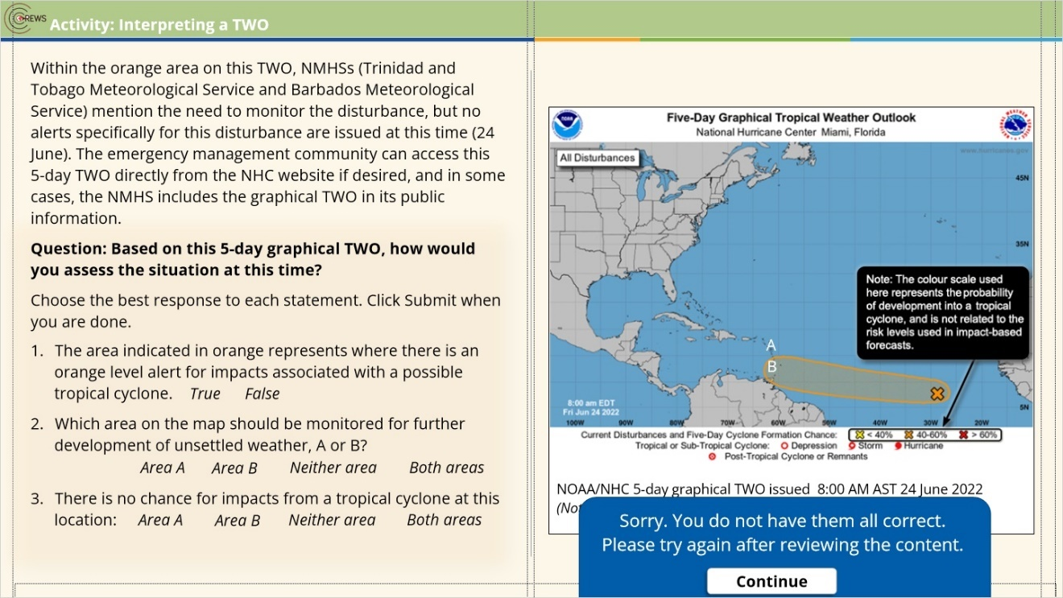

Final Right Answers (Slide Layer)
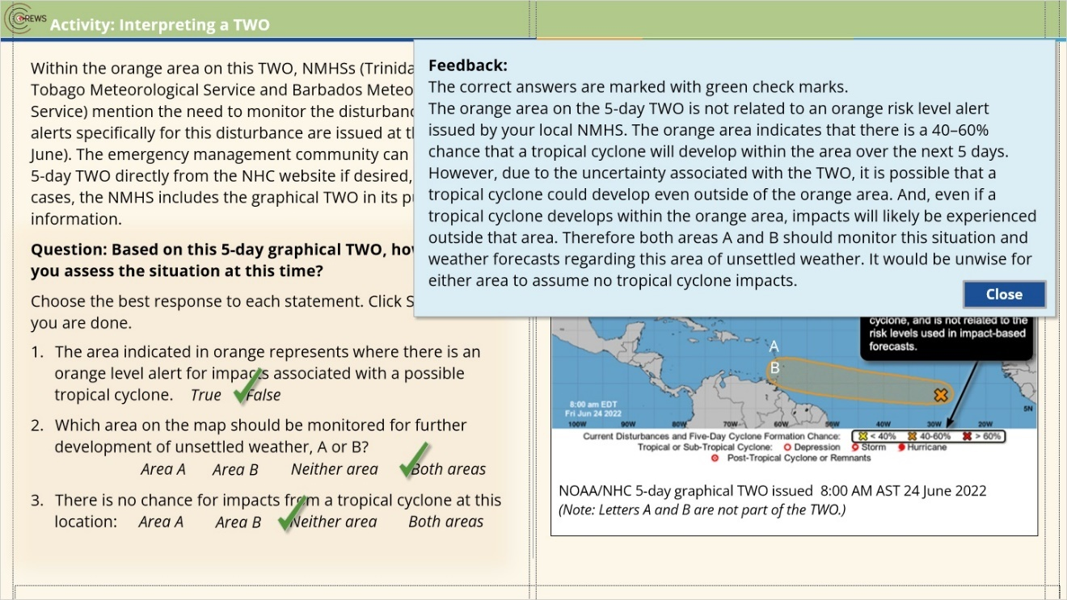

Try Again (Slide Layer)
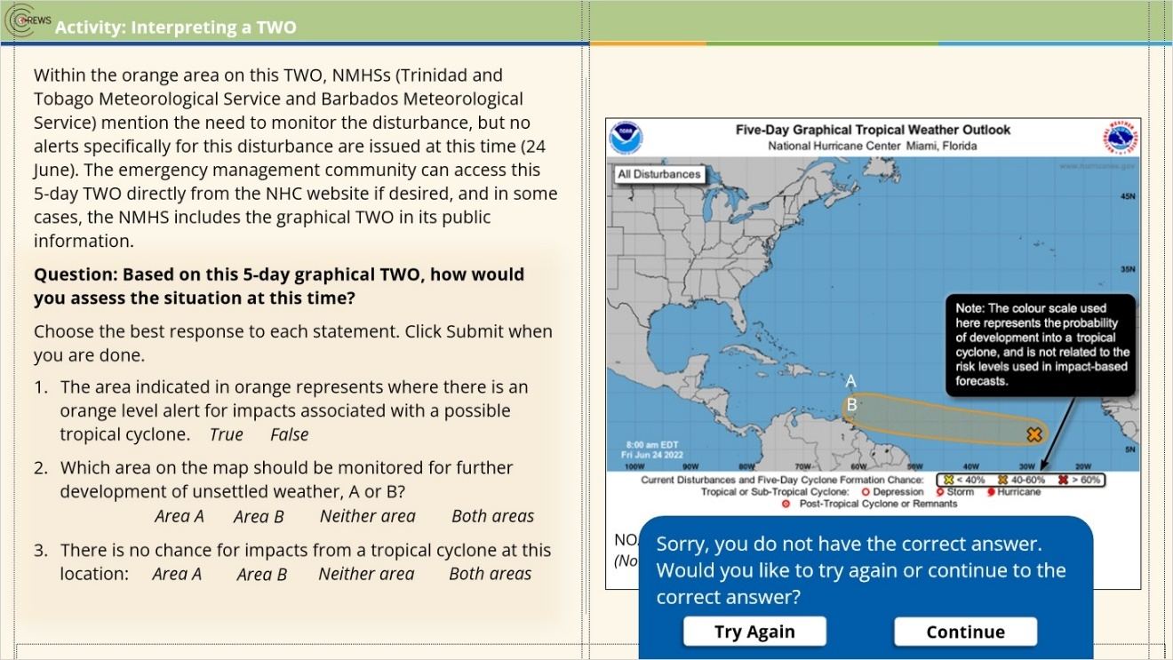

Correct (Slide Layer)
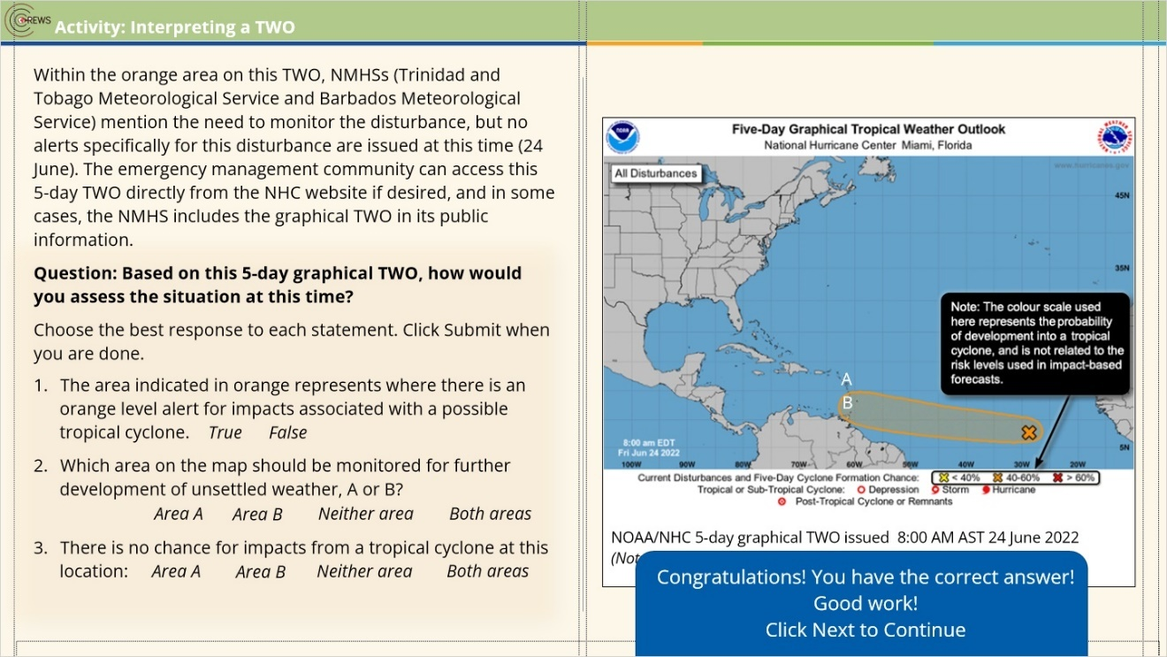

2.5 26 June: TWO and NMHS Guidance
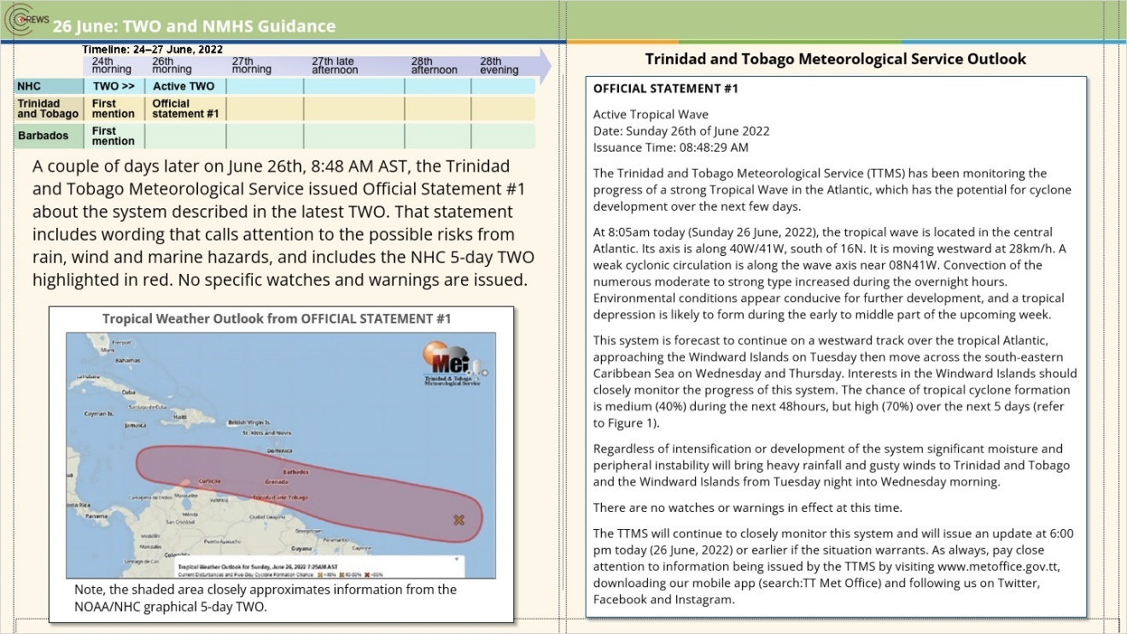
Notes:

zoom1 (Slide Layer)
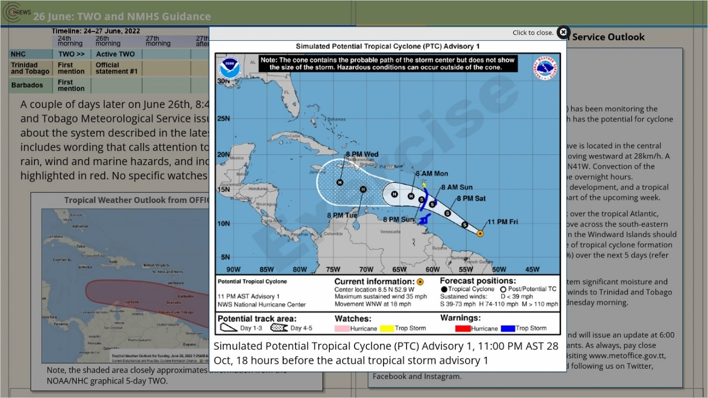

feedback (Slide Layer)
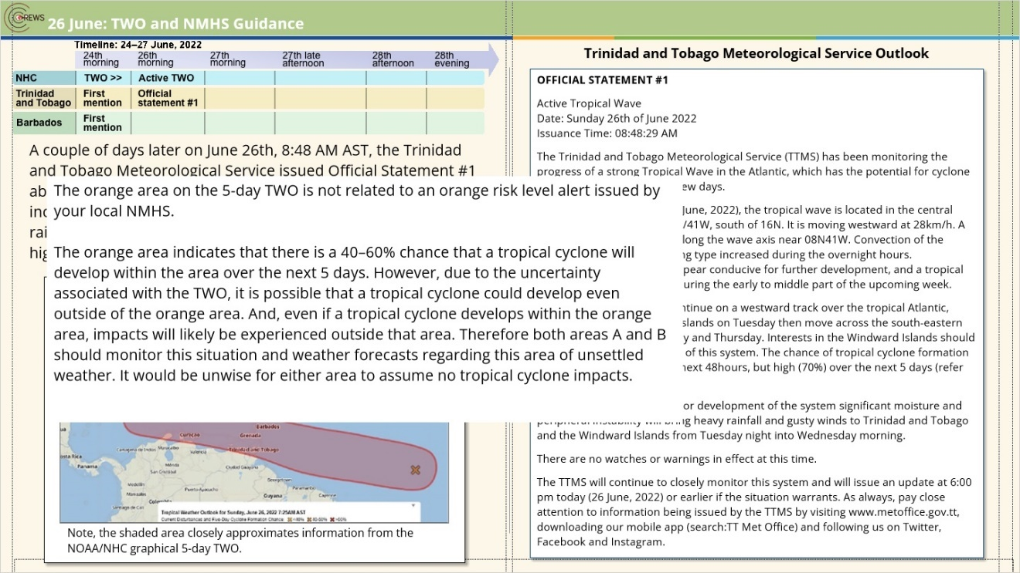

2.6 27 June, Early Morning: TWO & NMHS guidance
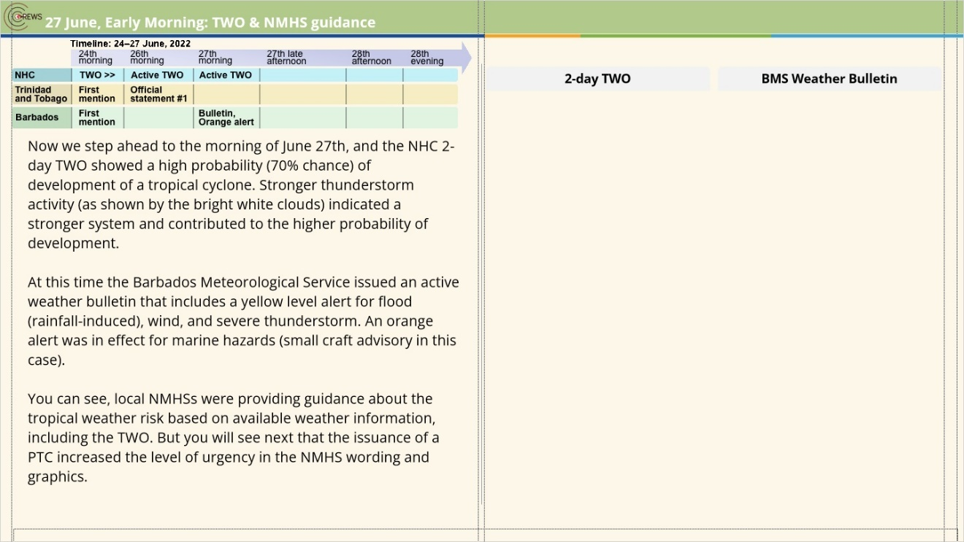
Notes:

tab 1 (Slide Layer)
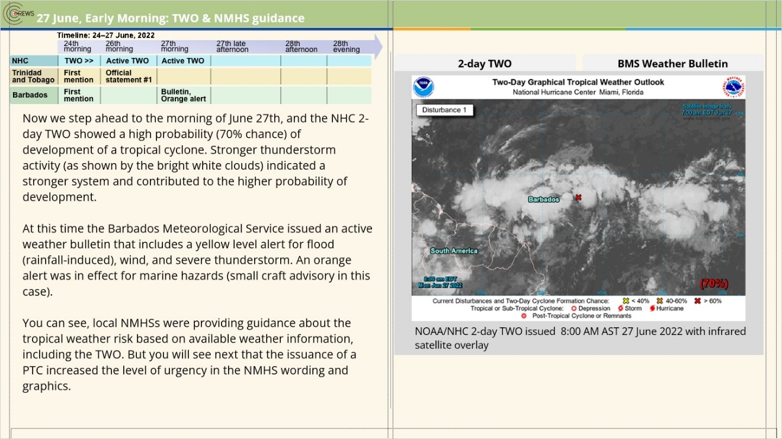

tab 2 (Slide Layer)
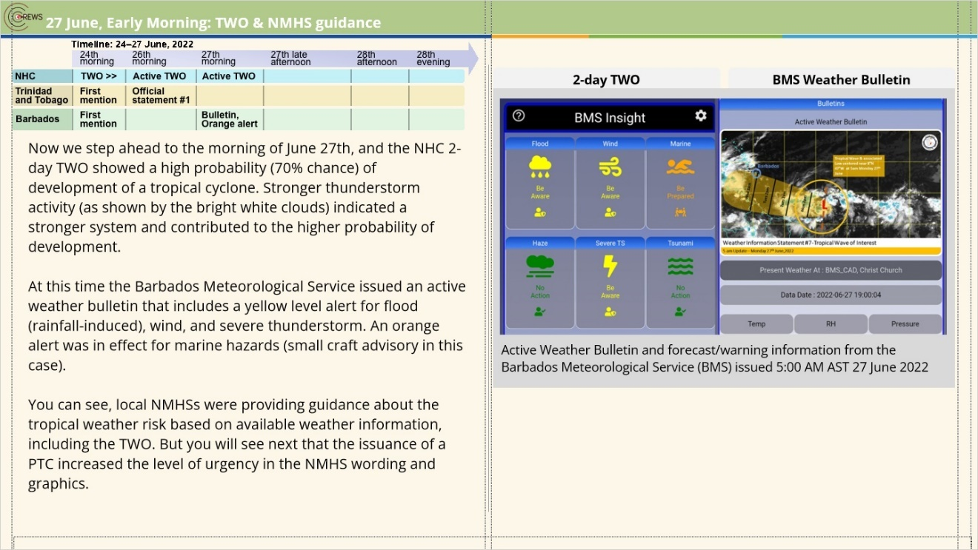

zoom1 (Slide Layer)
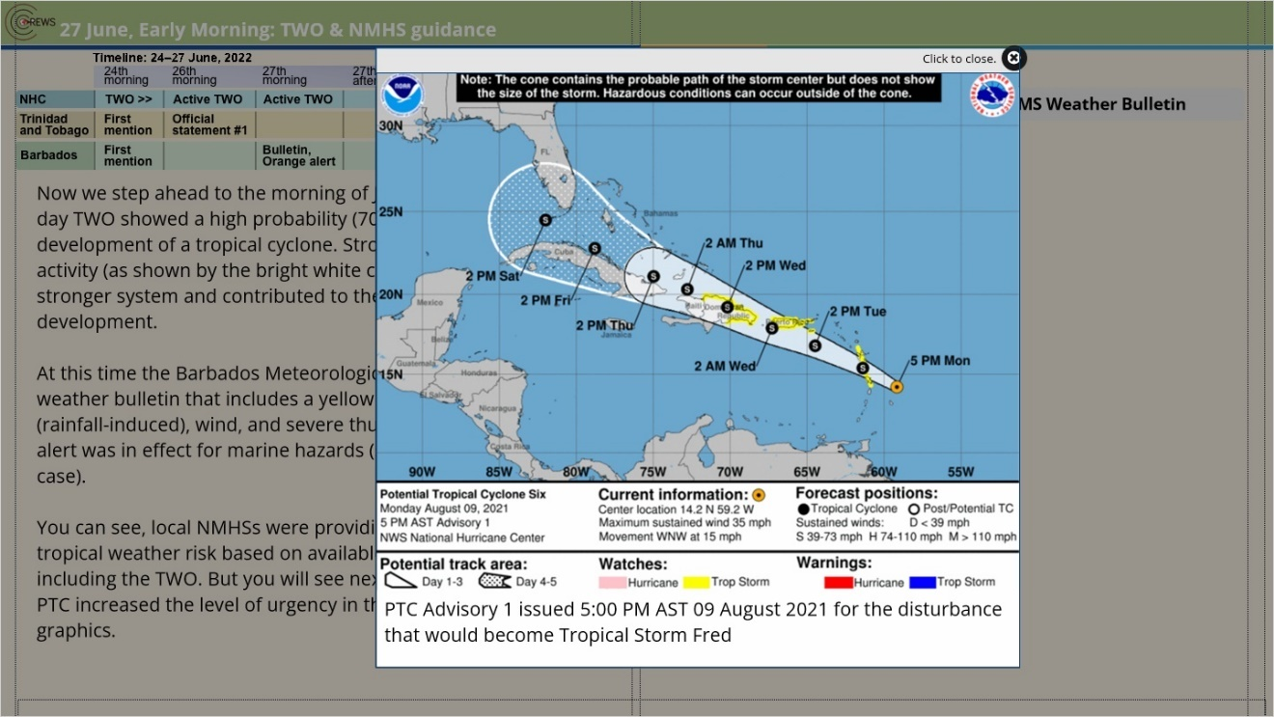

zoom2 (Slide Layer)
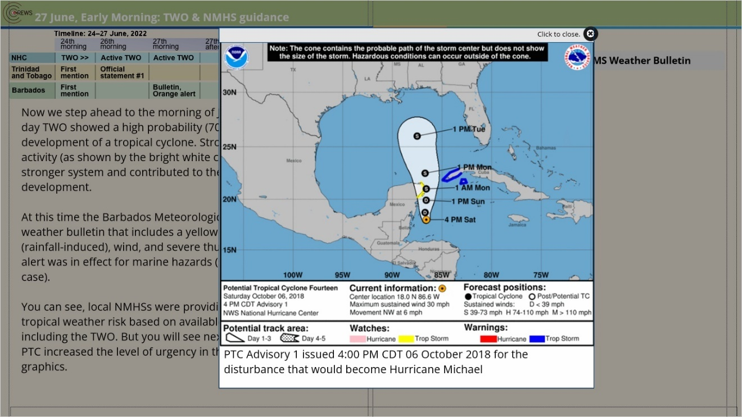

2.7 27 June 2022, Late Afternoon: PTC Advisory
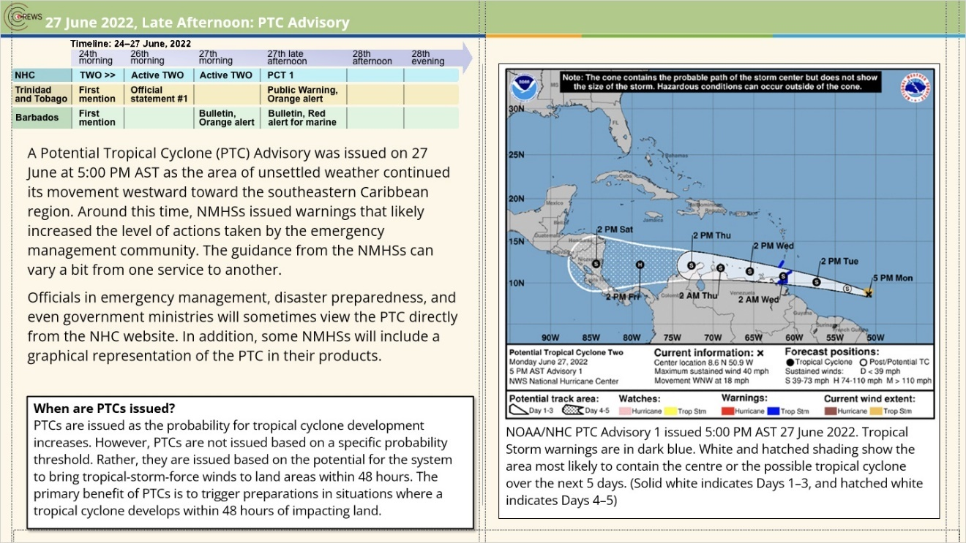
Notes:

zoom1 (Slide Layer)
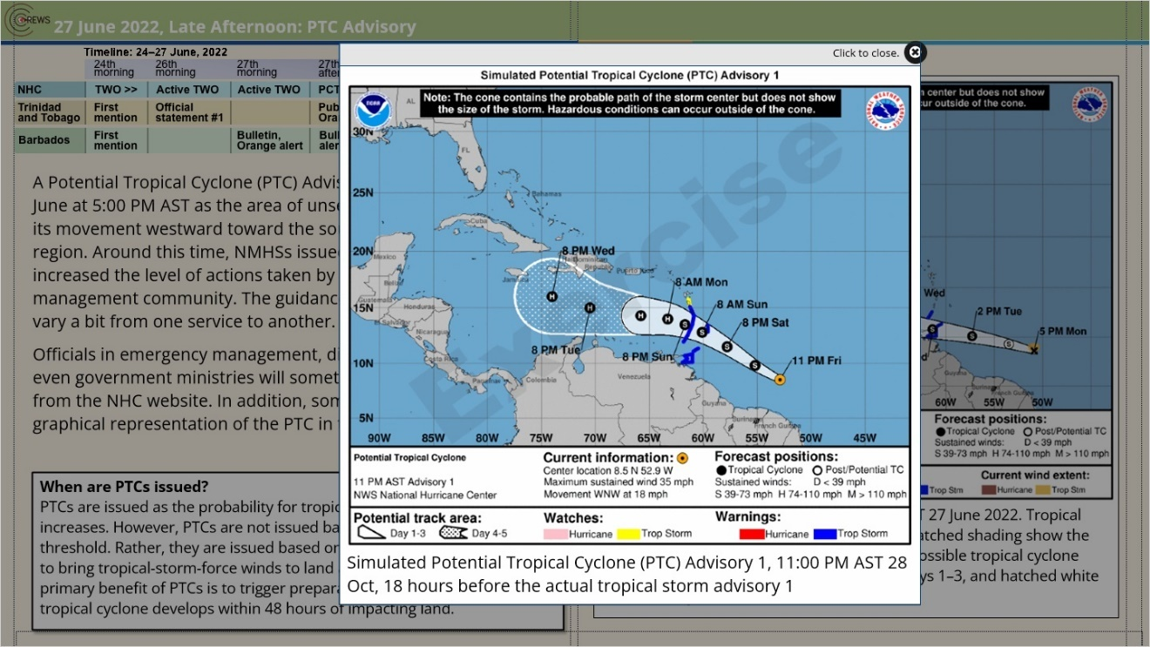

2.8 Activity: 27 June 2022 – Interpreting the PTC Advisory
(Pick Many, 10 points, 2 attempts permitted)
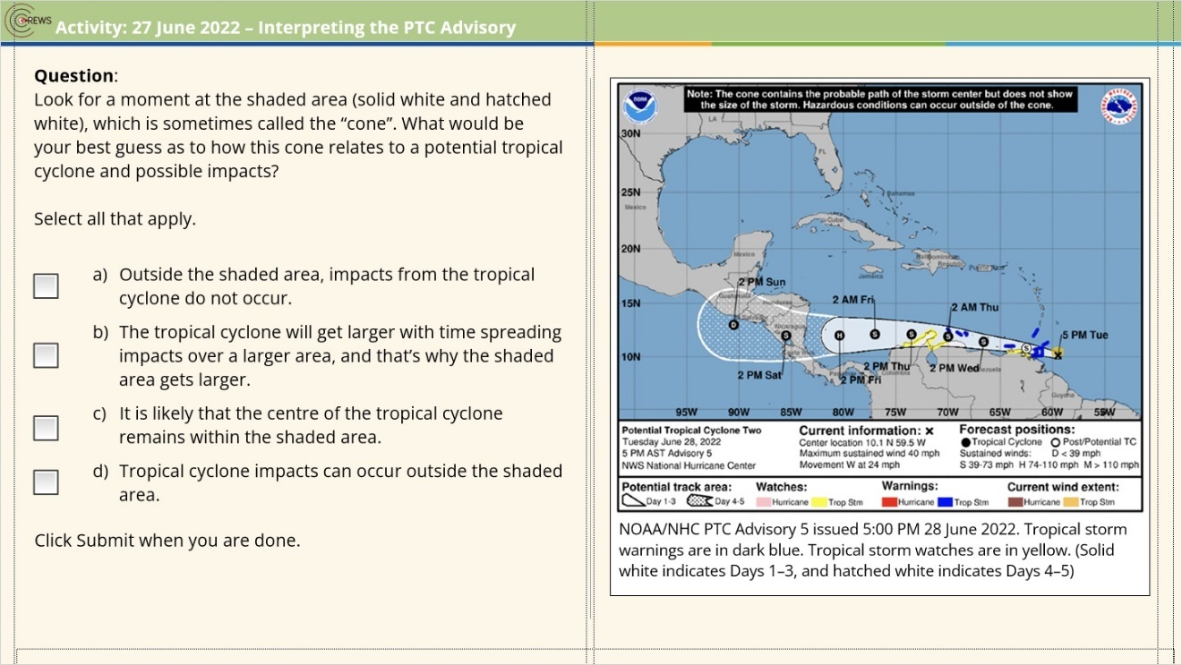
Correct | Choice
 | Check Box 3
 | Check Box 4
X | Check Box 5
X | Check Box 6

Notes:

Correct (Slide Layer)
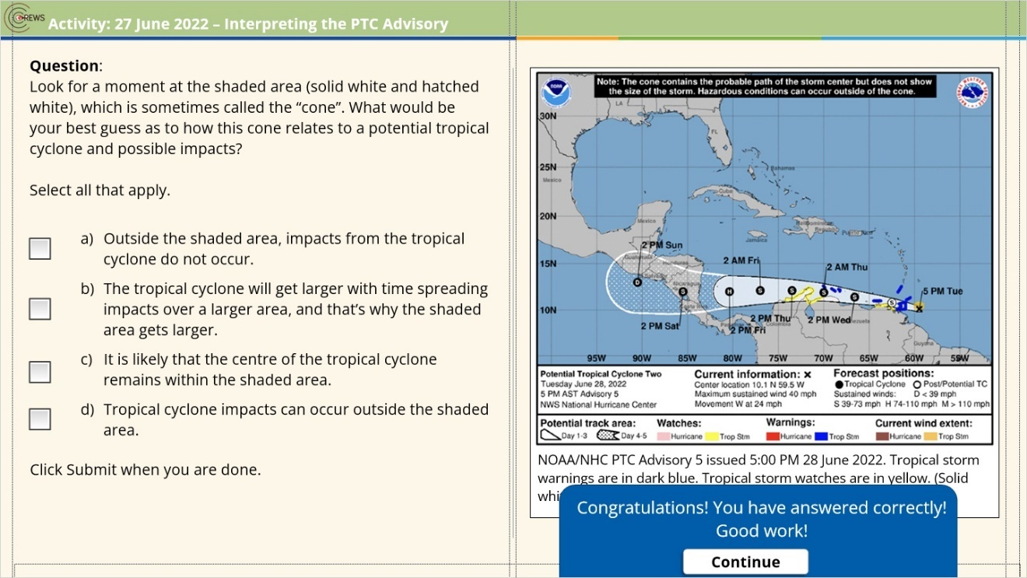

Incorrect (Slide Layer)
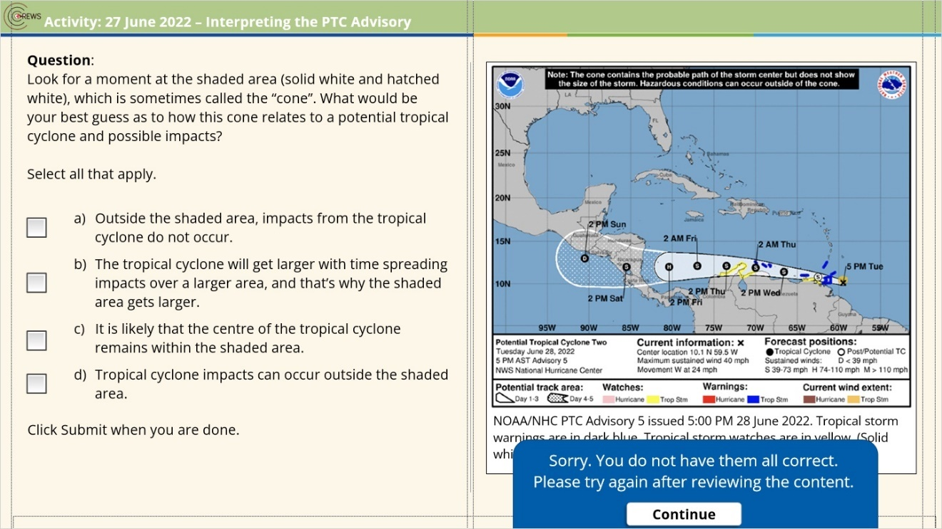

Try Again (Slide Layer)
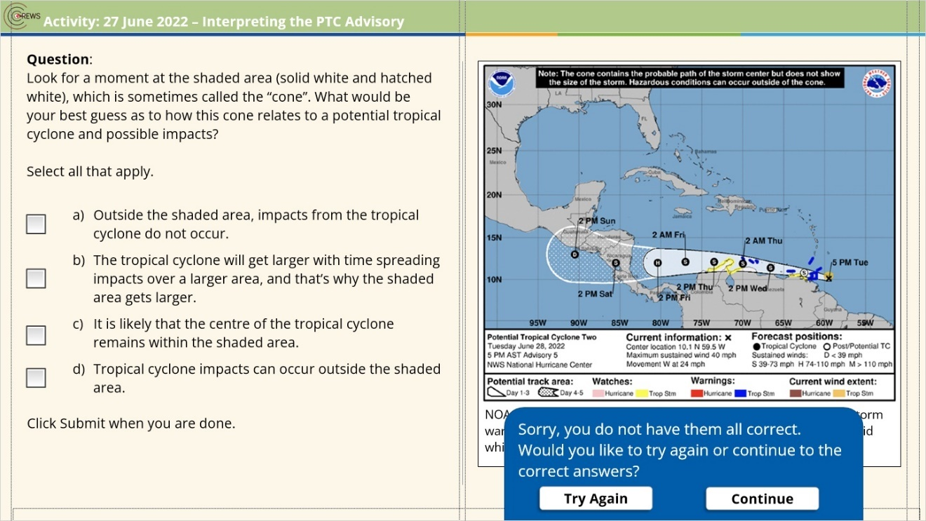

2.9 Activity Feedback: 27 June 2022 – Interpreting the PTC Advisory
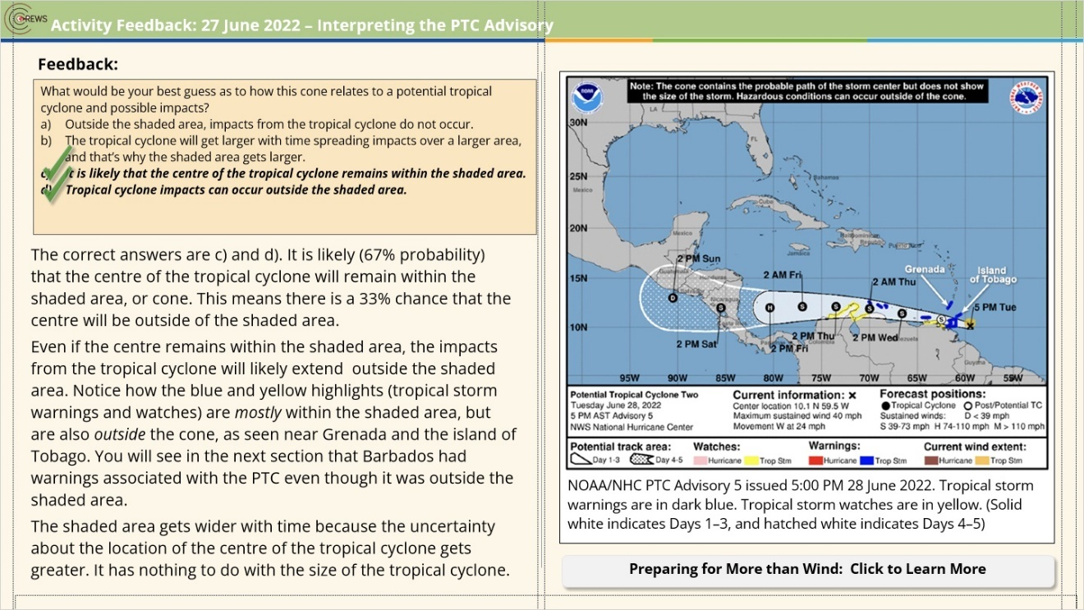
Notes:

zoom1 (Slide Layer)
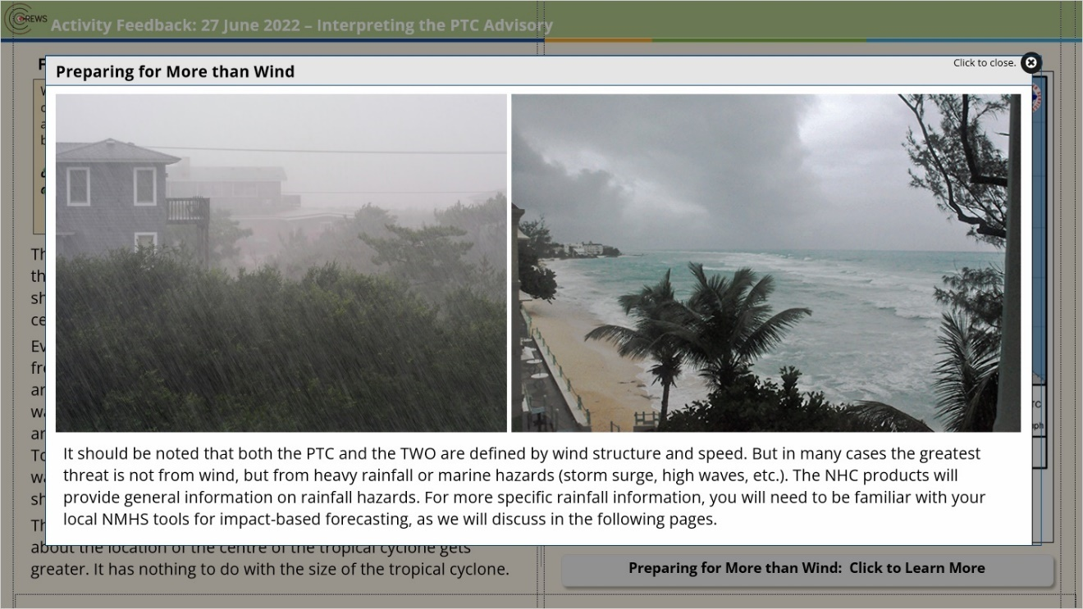

feedback (Slide Layer)
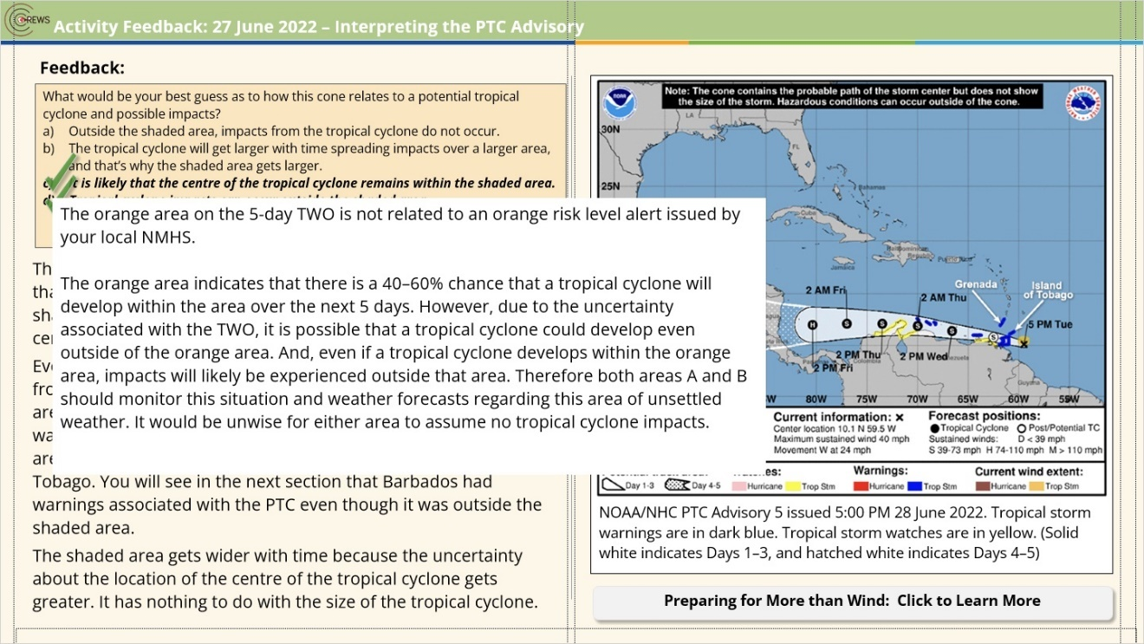

2.10 27 June 2022: NMHS Communication of PTC Impacts
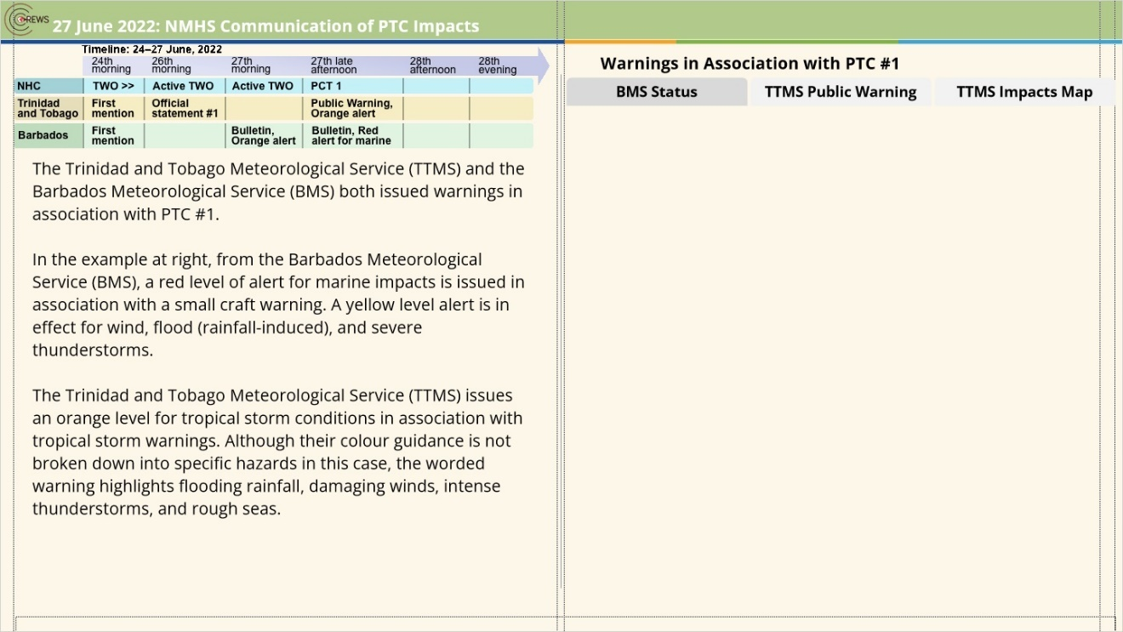
Notes:

tab 1 (Slide Layer)
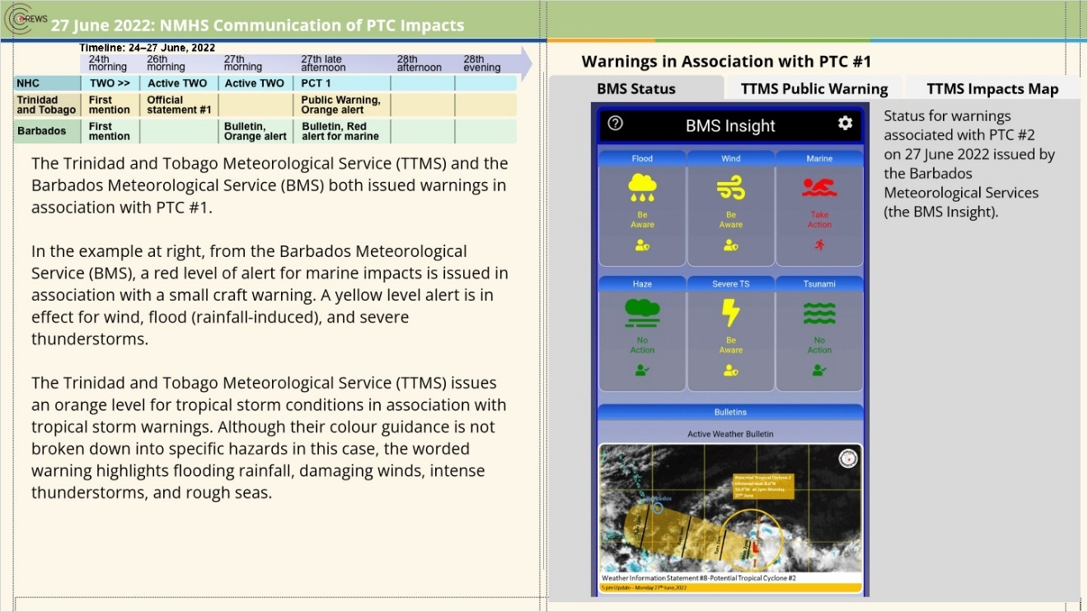

tab 2 (Slide Layer)
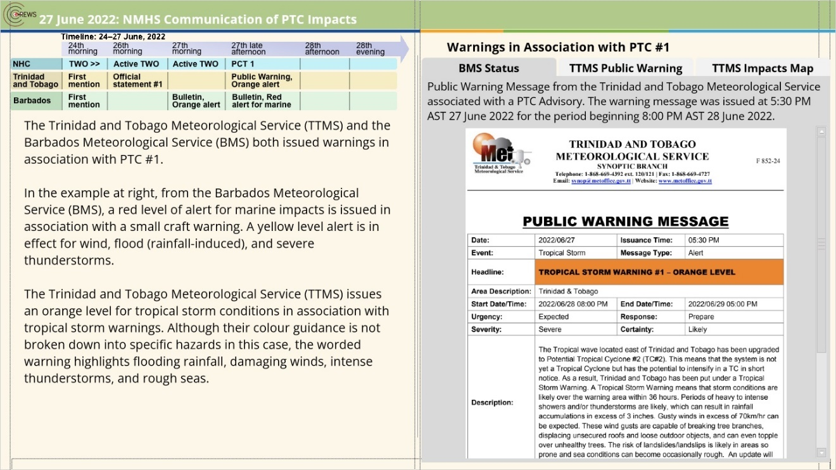

tab 3 (Slide Layer)
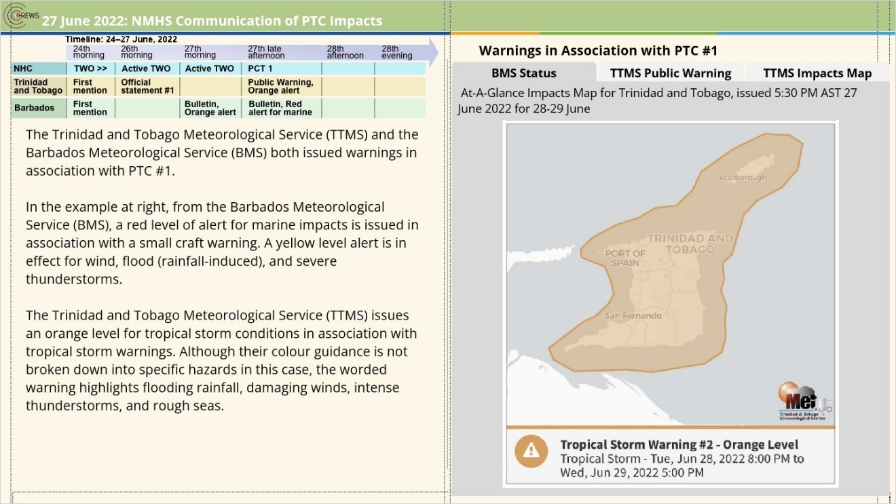

2.11 Case Summary
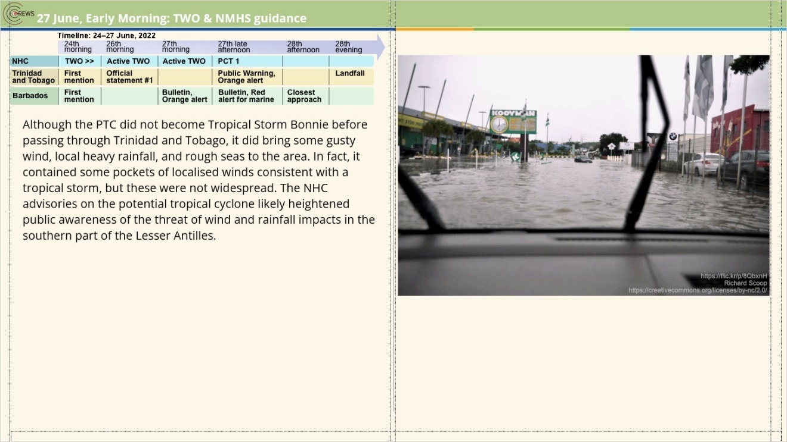
Notes:

2.12 Knowledge Check
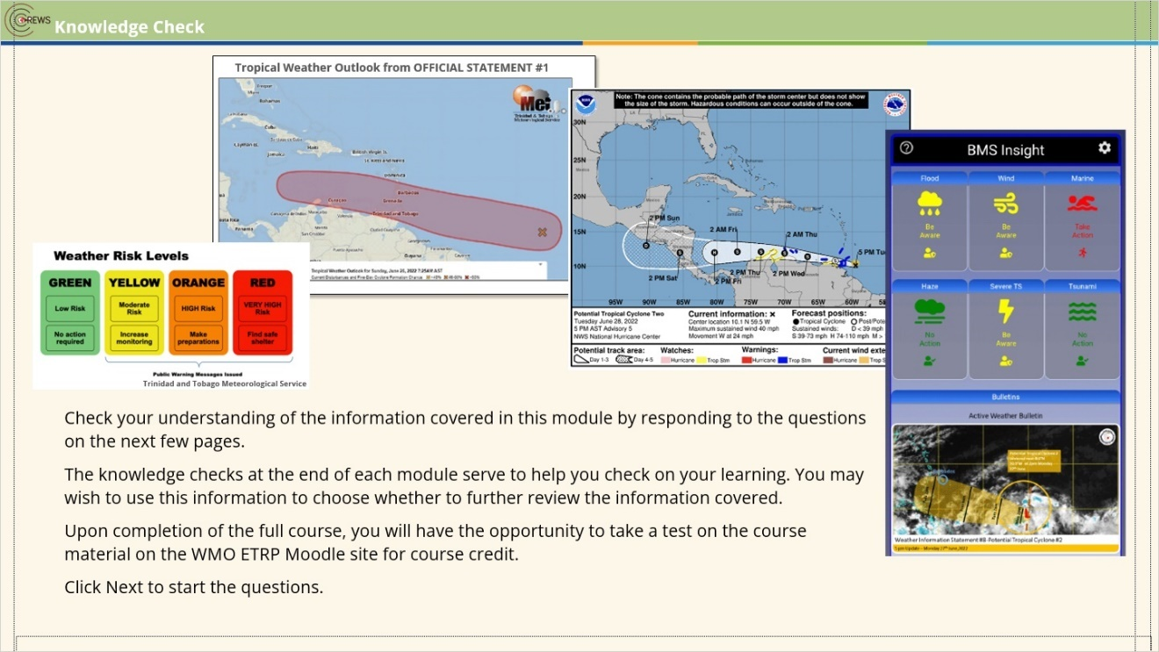
Notes:

2.13 Question 1
(Drag and Drop, 10 points, 1 attempt permitted)
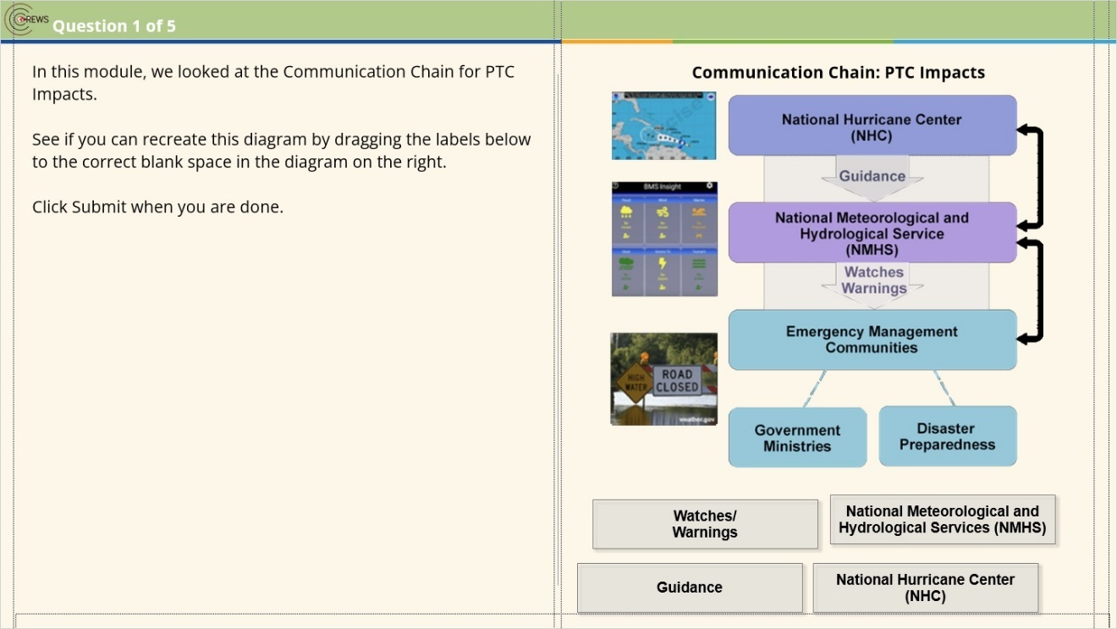
Drag Item | Drop Target
National Hurricane Center  (NHC) | dropzone1
Guidance | dropzone2
National Meteorological and Hydrological Services (NMHS) | dropzone3
Watches/  Warnings | dropzone4

Drag and drop properties
Return item to start point if dropped outside the correct drop target
Snap dropped items to drop target (Snap to center)
Allow only one item in each drop target
Delay item drop states until interaction is submitted

Notes:

Incorrect (Slide Layer)
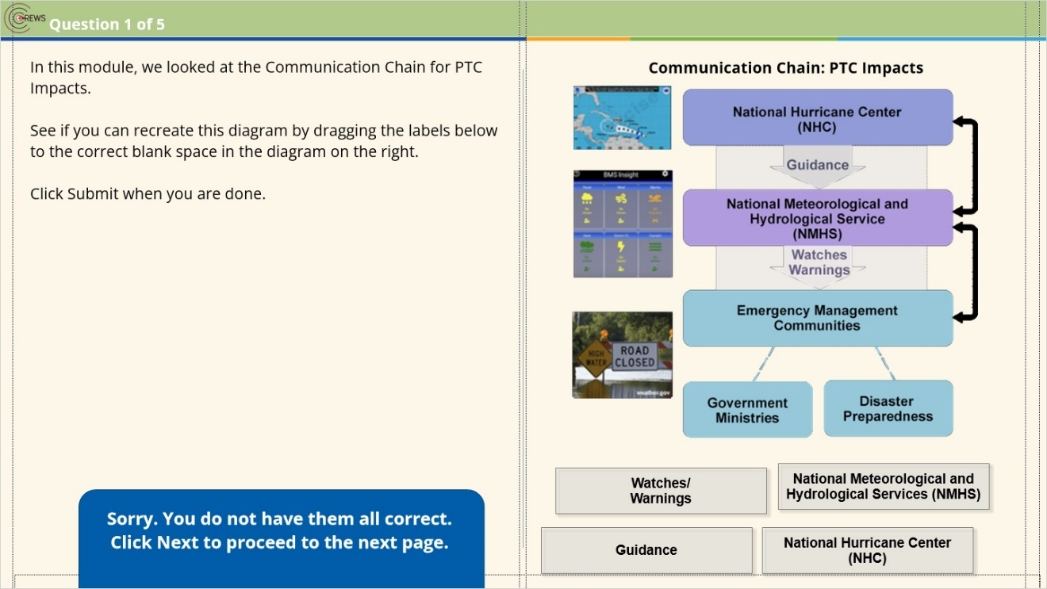

Correct (Slide Layer)
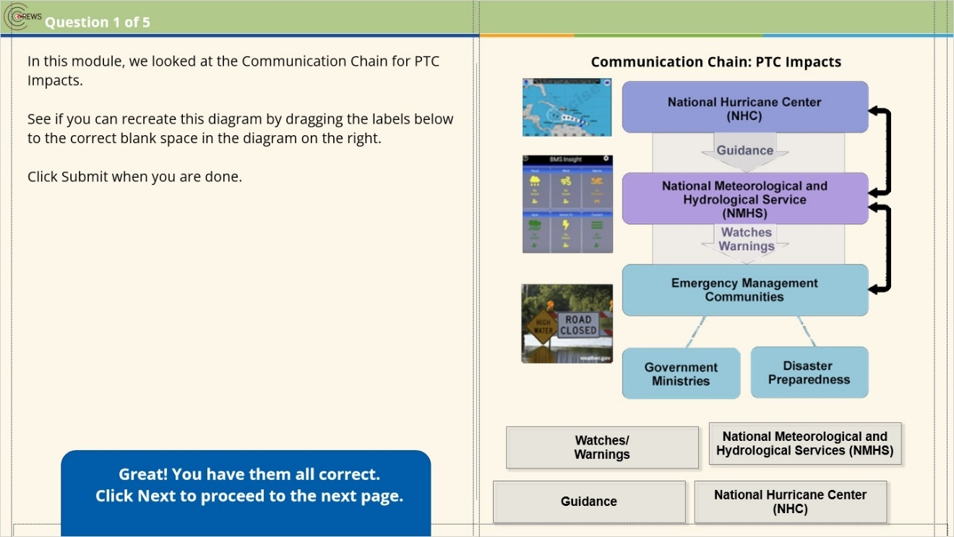

2.14 Question 2
(Pick Many, 10 points, 1 attempt permitted)
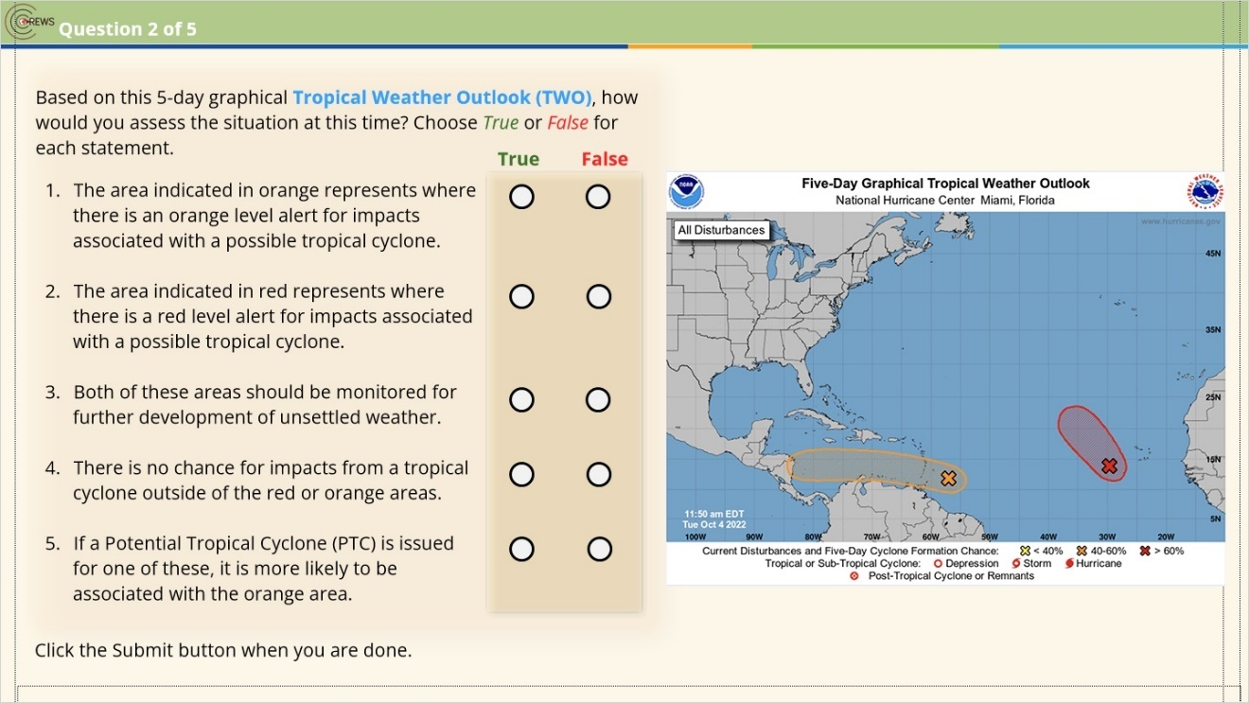
Correct | Choice
X | Q1F
 | Q1T
X | Q2F
 | Q2T
X | Q3T
 | Q3F
X | Q4F
 | Q4T
 | Q5F
X | Q5T

Notes:

Correct (Slide Layer)
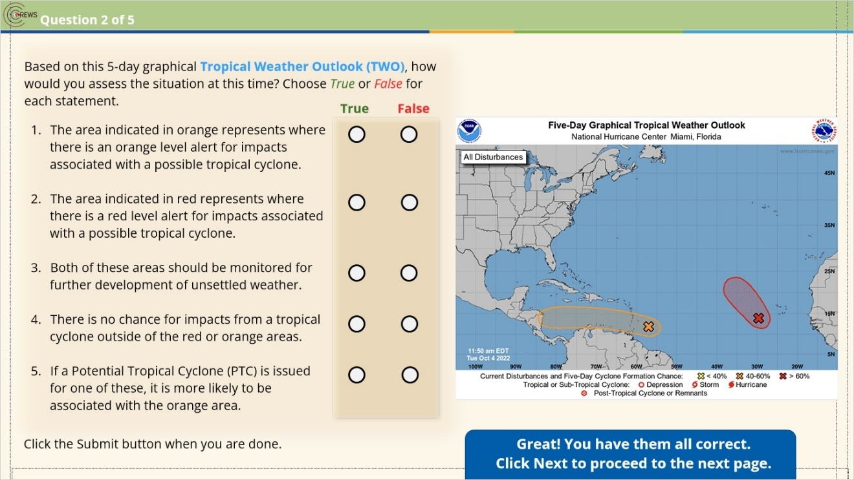

Incorrect (Slide Layer)
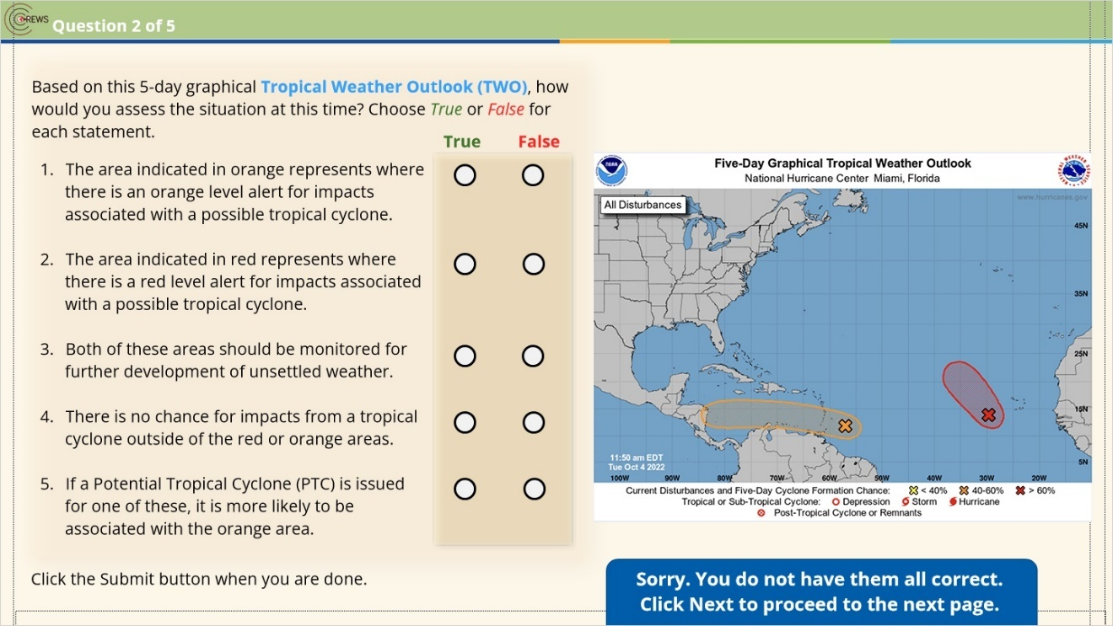

2.15 Question 3
(Pick Many, 10 points, 1 attempt permitted)
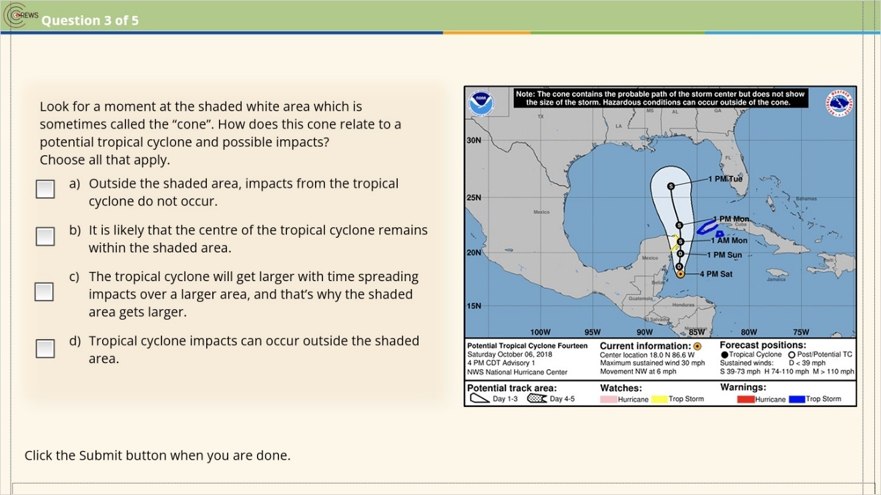
Correct | Choice
 | Check Box 1
X | Check Box 2
 | Check Box 3
X | Check Box 4

Incorrect (Slide Layer)
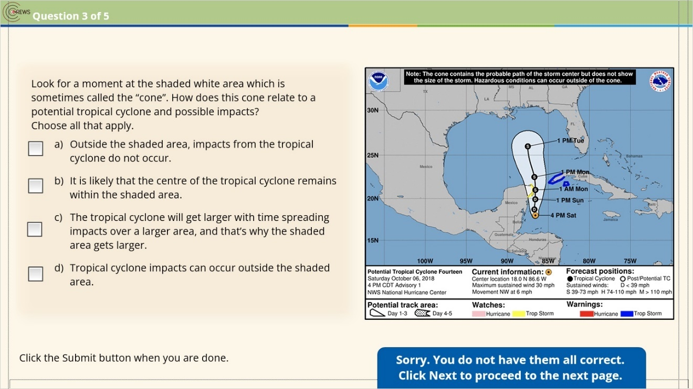

Correct (Slide Layer)
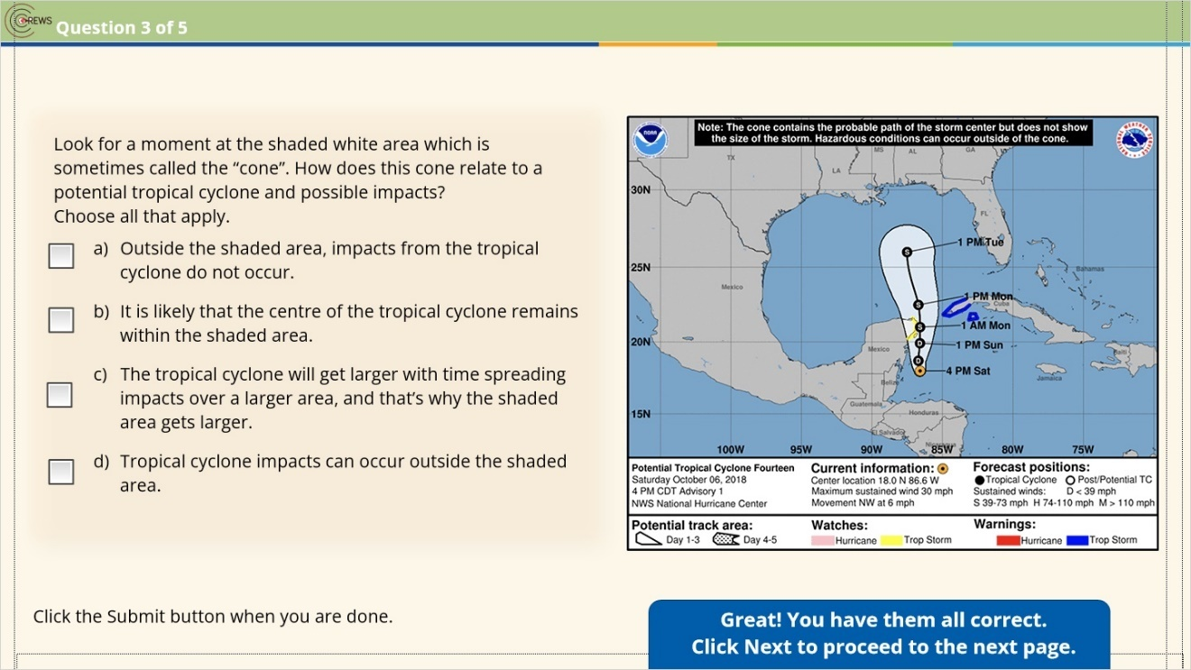

2.16 Question 4
(Pick Many, 10 points, 1 attempt permitted)
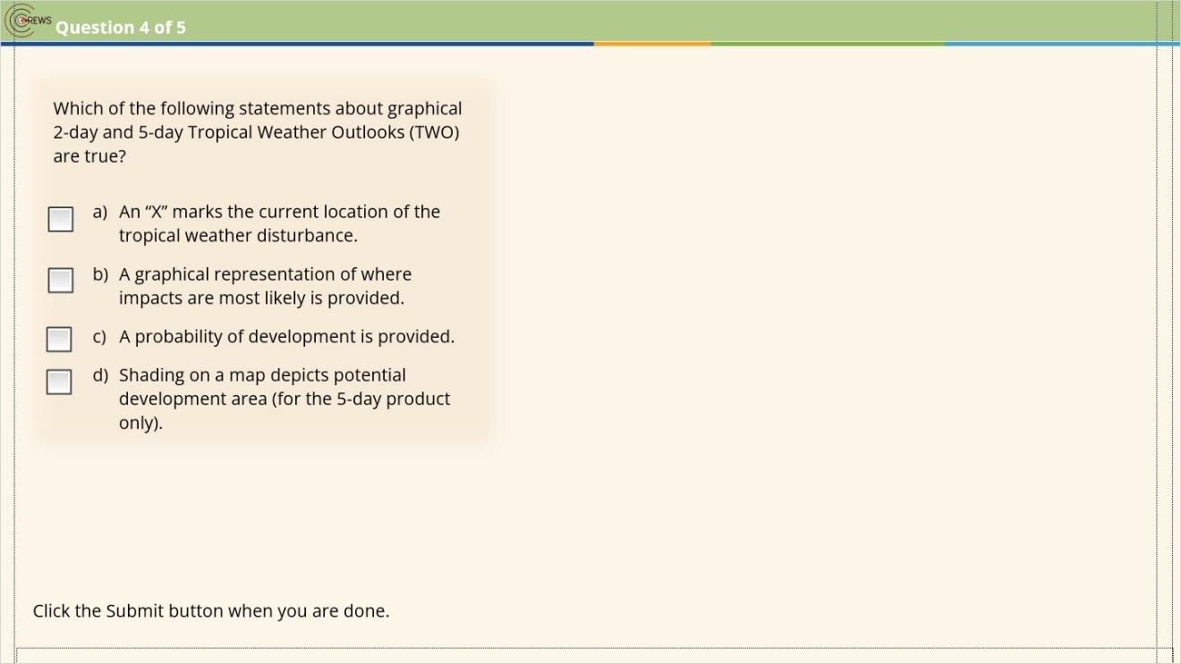
Correct | Choice
X | Check Box 1
 | Check Box 2
X | Check Box 3
X | Check Box 4

Notes:

Incorrect (Slide Layer)
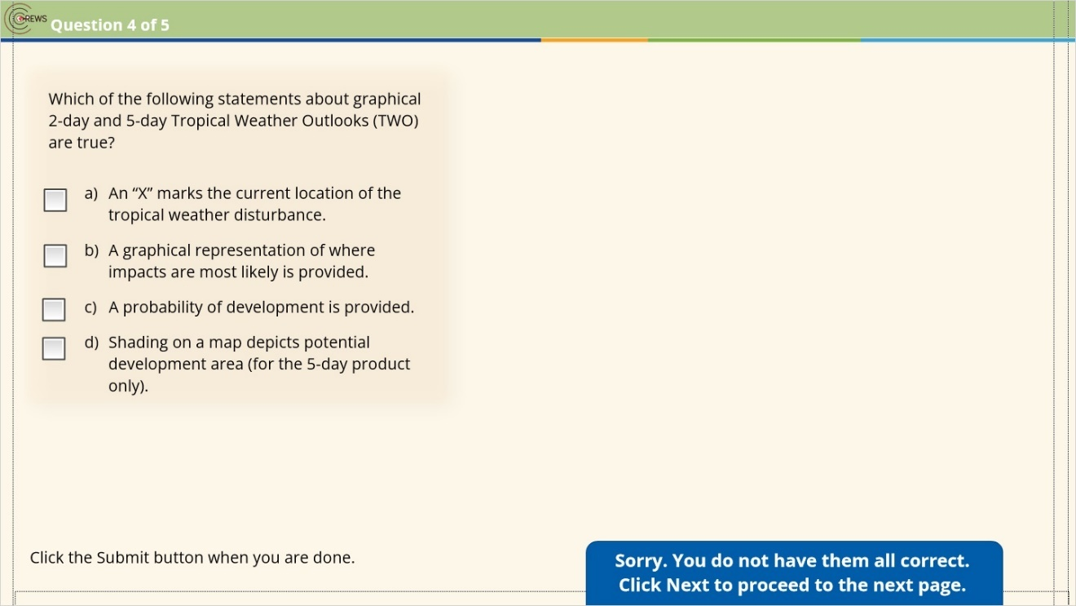

Correct (Slide Layer)
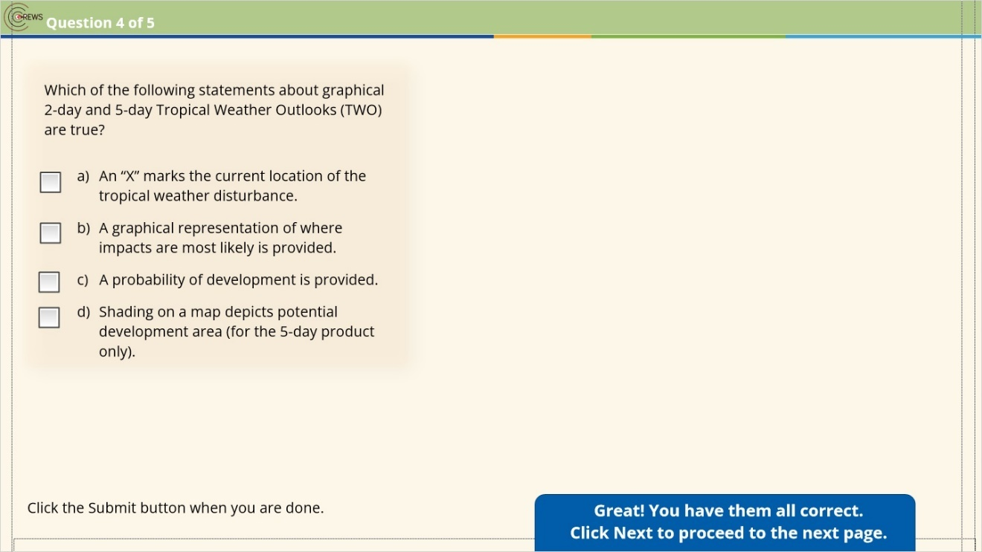

2.17 Question 5
(Pick Many, 10 points, 1 attempt permitted)
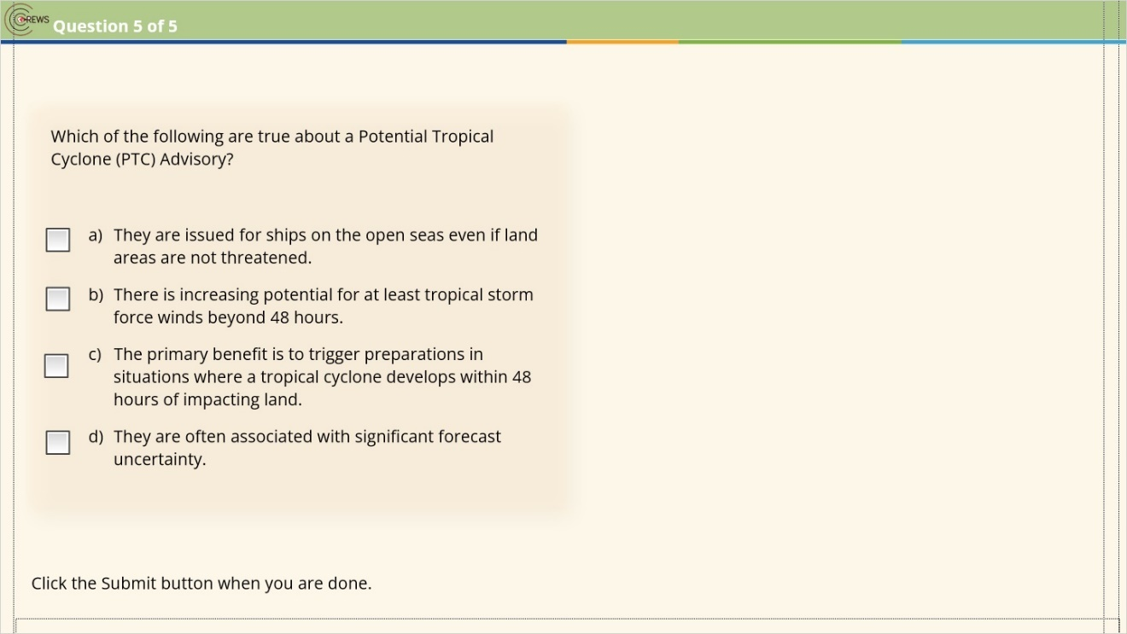
Correct | Choice
 | Check Box 1
 | Check Box 2
X | Check Box 3
X | Check Box 4

Notes:

Incorrect (Slide Layer)
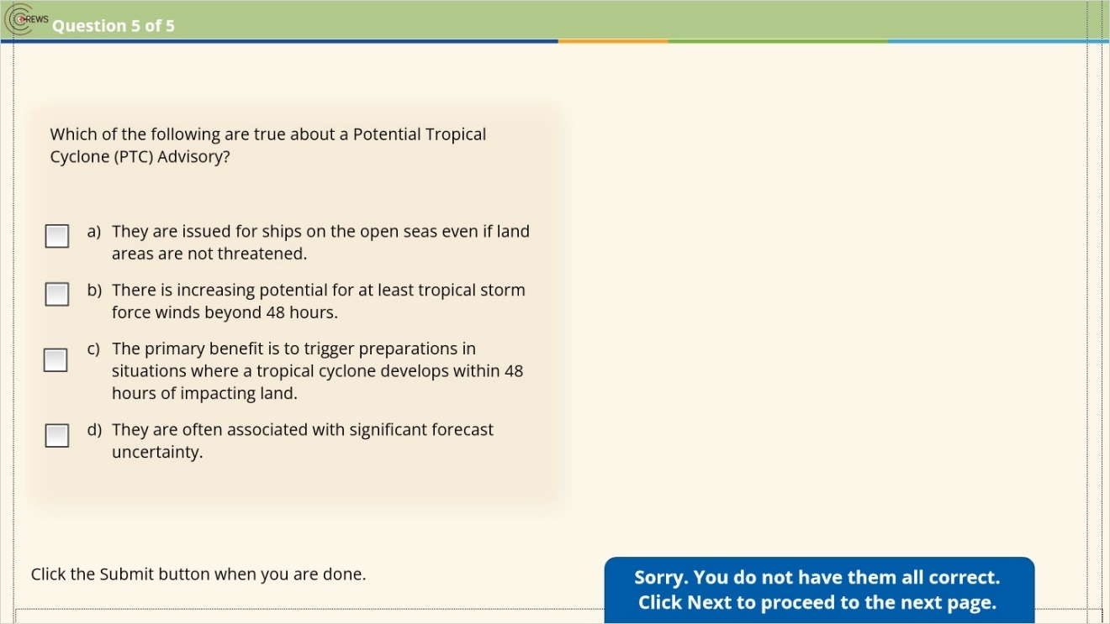

Correct (Slide Layer)
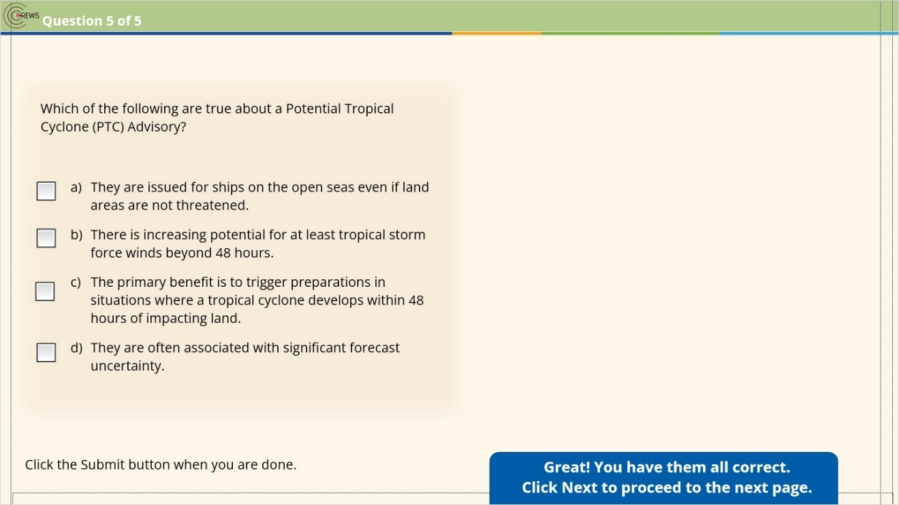

2.18 Results: Module 2 Knowledge Check
(Results Slide, 0 points, 1 attempt permitted)
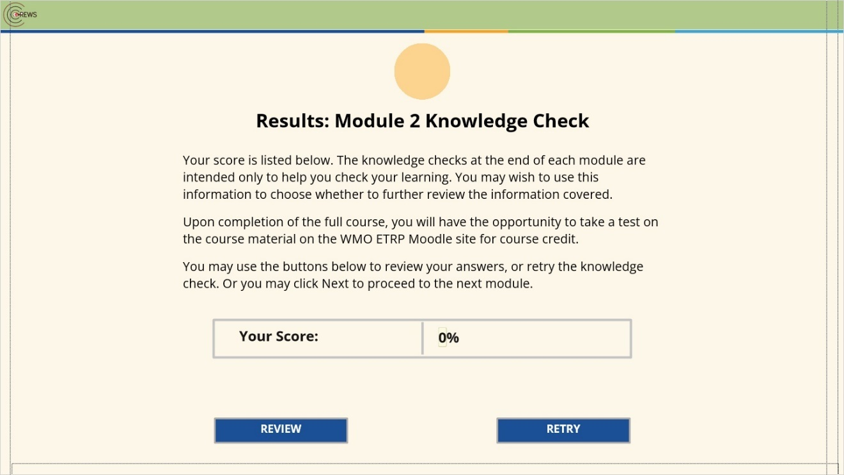

Results for
2.13 Question 1
2.14 Question 2
2.15 Question 3
2.16 Question 4
2.17 Question 5

Result slide properties
Passing  Score | 70%

Notes:

3. Module 3: Effectively Communicating Potential Impacts

3.1 Module Overview
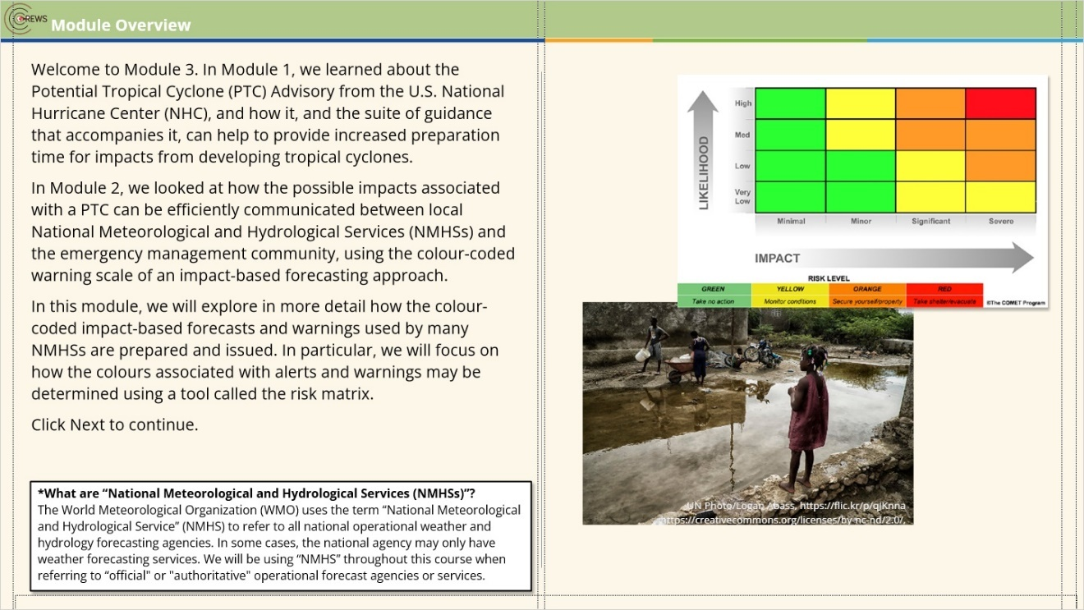
Notes:

3.2 IBFWS Considerations
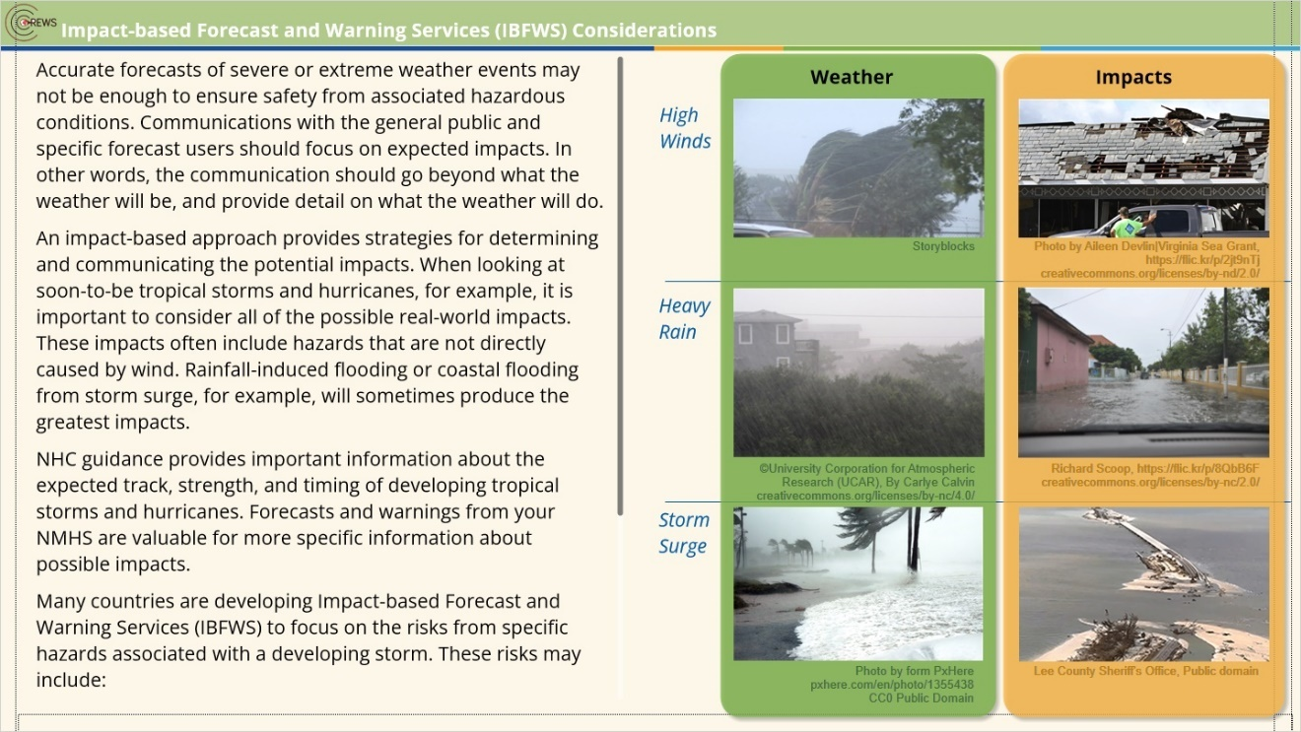
Notes:
Accurate forecasts of severe or extreme weather events may not be enough to ensure safety from associated hazardous conditions. Communications with the general public and specific forecast users should focus on expected impacts. In other words, the communication should go beyond what the weather will be, and provide detail on what the weather will do.
An impact-based approach provides strategies for determining and communicating the potential impacts. When looking at soon-to-be tropical storms and hurricanes, for example, it is important to consider all of the possible real-world impacts. These impacts often include hazards that are not directly caused by wind. Rainfall-induced flooding or coastal flooding from storm surge, for example, will sometimes produce the greatest impacts.
NHC guidance provides important information about the expected track, strength, and timing of developing tropical storms and hurricanes. Forecasts and warnings from your NMHS are valuable for more specific information about possible impacts.
Many countries are developing Impact-based Forecast and Warning Services (IBFWS) to focus on the risks from specific hazards associated with a developing storm. These risks may include:
- Wind damage
- Rainfall-induced floods and landslides
- Severe thunderstorm
- Marine hazards such as high waves and storm surge
References:
To learn more about Impact-Based Forecast Warning Services see the free WMO course:
Introduction to Impact-Based Forecast Warning Services (IBFWS)
https://etrp.wmo.int/course/view.php?id=253

3.3 Risk Matrix Walkthrough
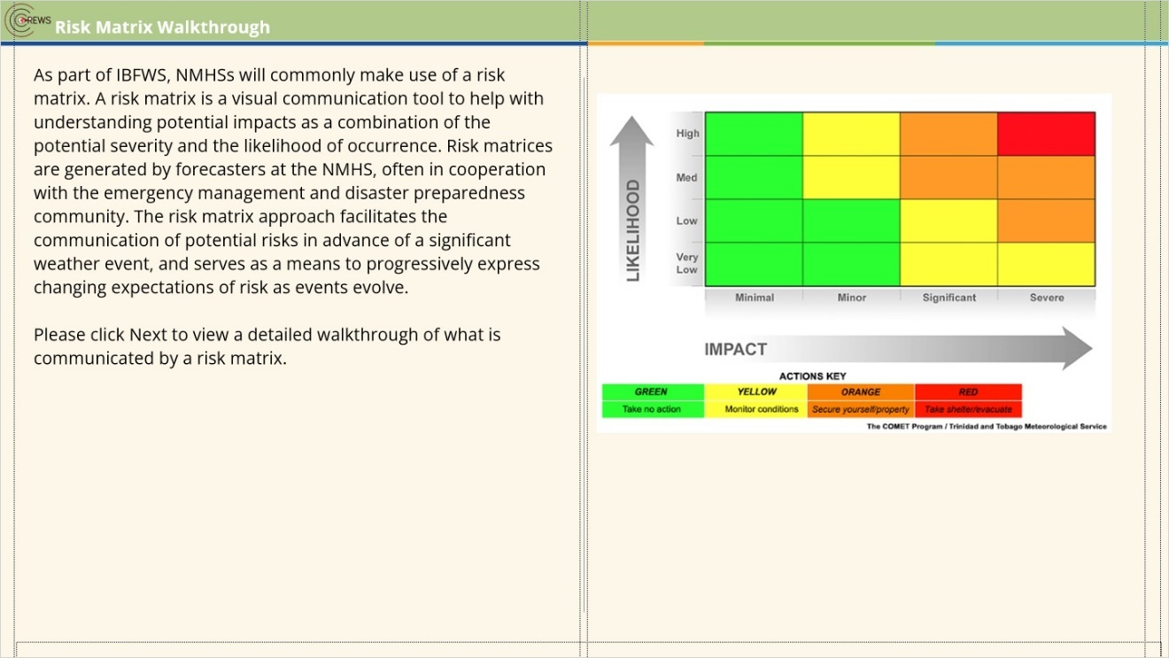
Notes:

3.4 Risk Matrix Walkthrough 1
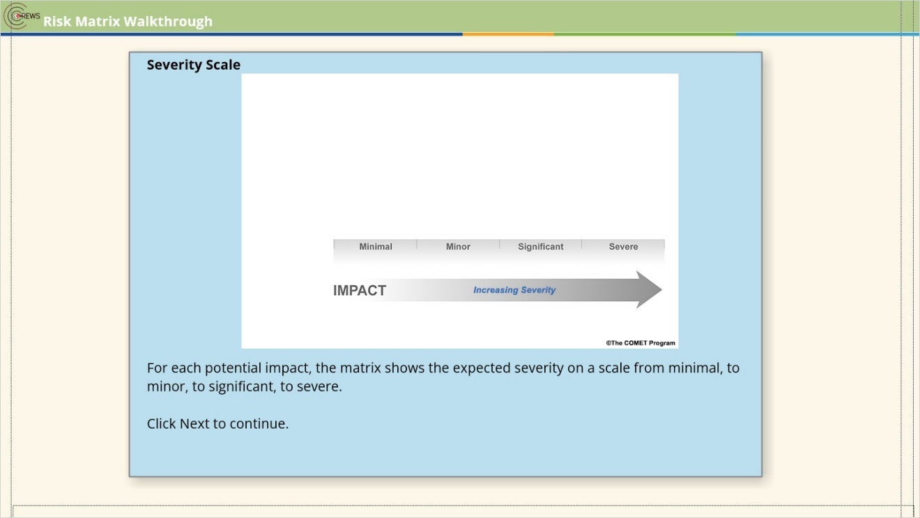

3.5 Risk Matrix Walkthrough 2
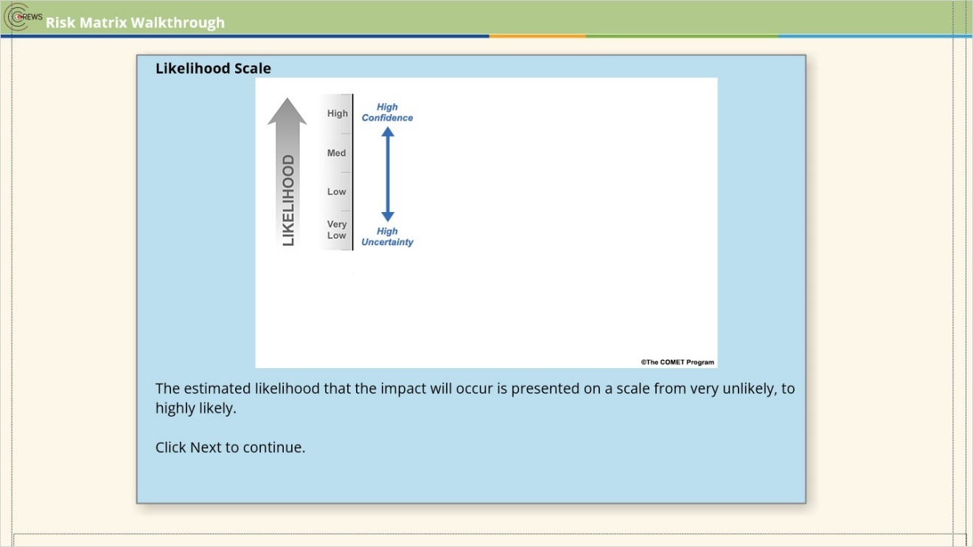

3.6 Risk Matrix Walkthrough 3
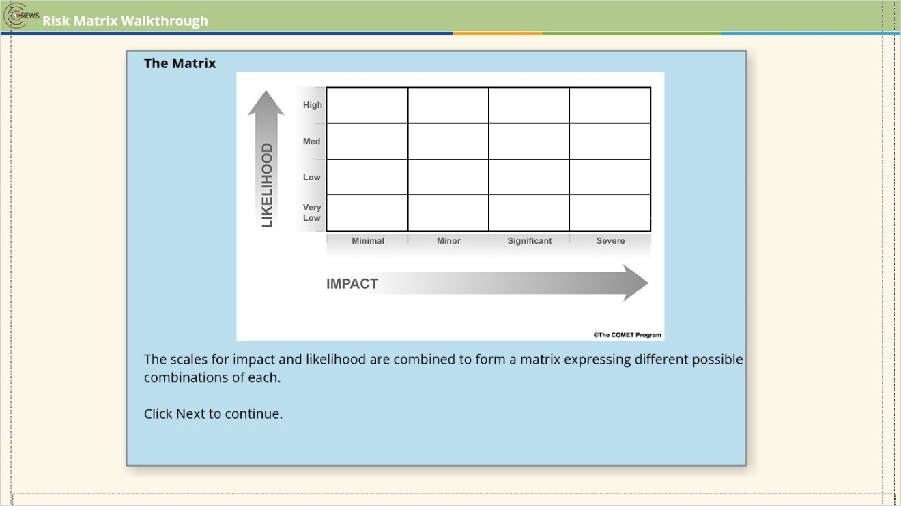

3.7 Risk Matrix Walkthrough 4
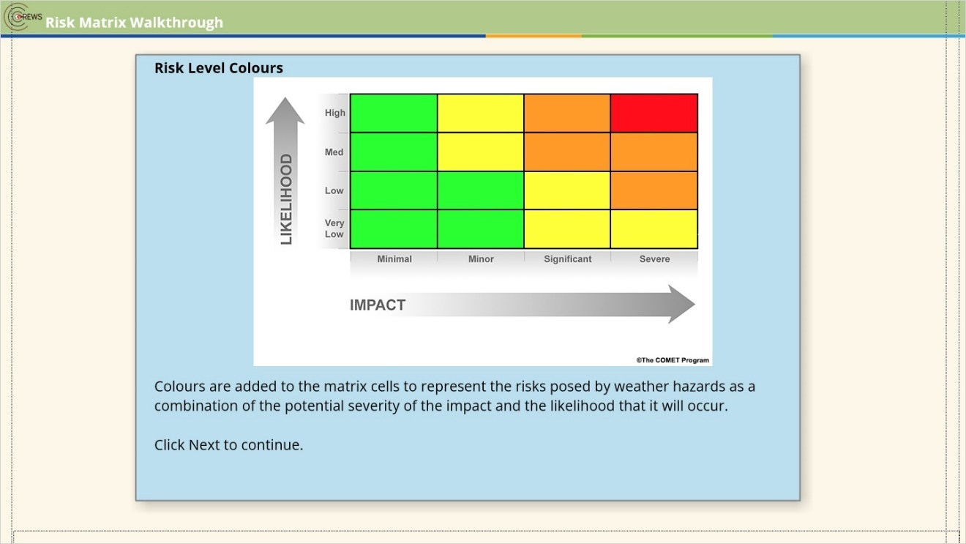

3.8 Risk Matrix Walkthrough 5
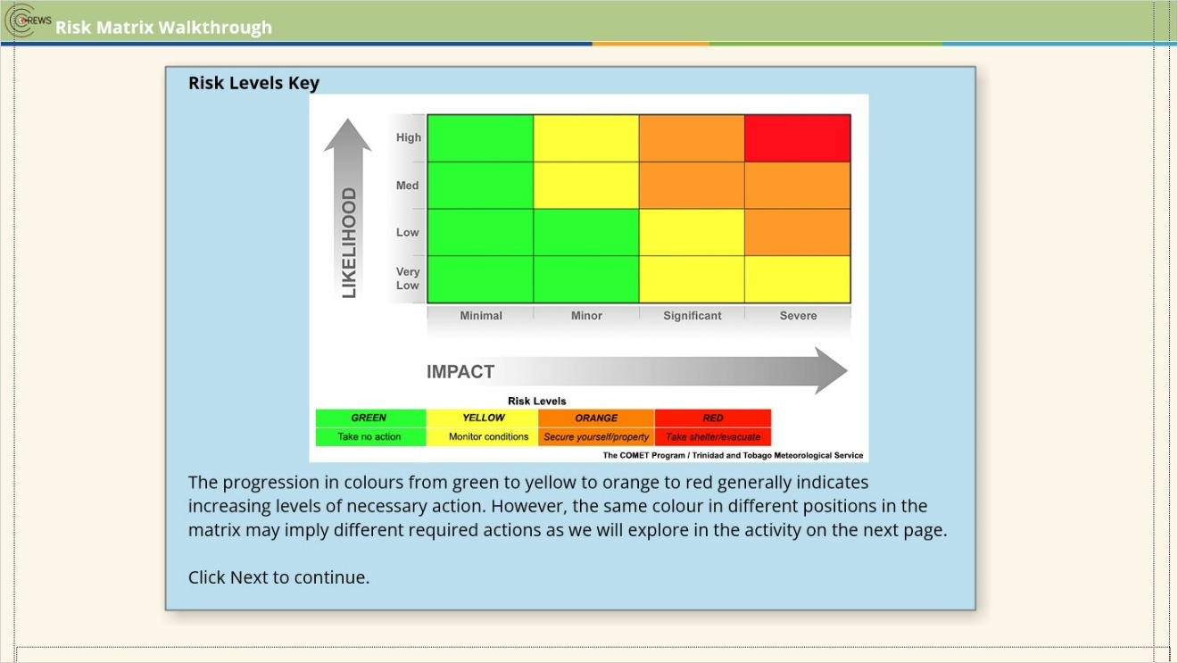

3.9 Risk Matrix Walkthrough 6
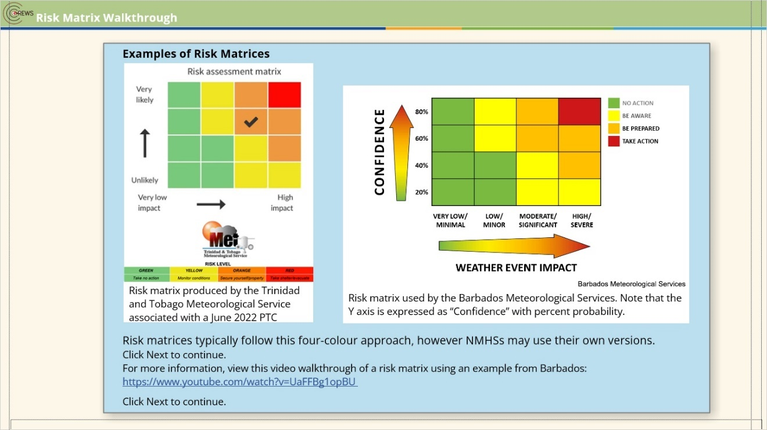

3.10 Activity: Interpreting Risk-Matrices
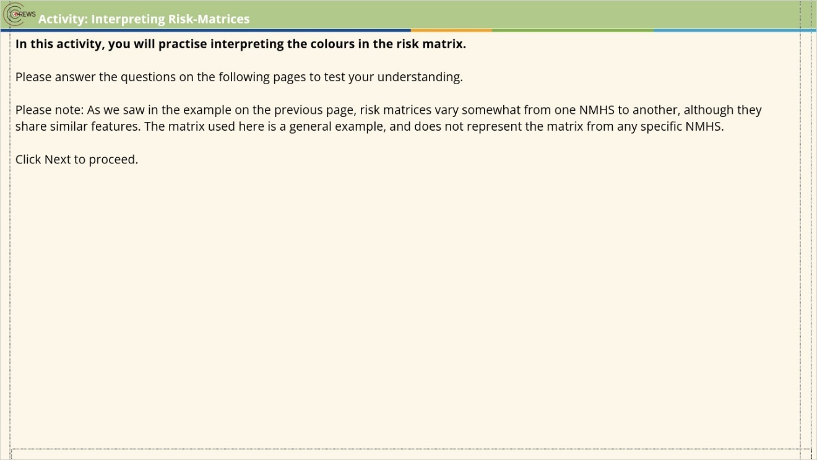

3.11 Activity: Interpreting Risk-Matrices 1
(Drag and Drop, 10 points, 2 attempts permitted)
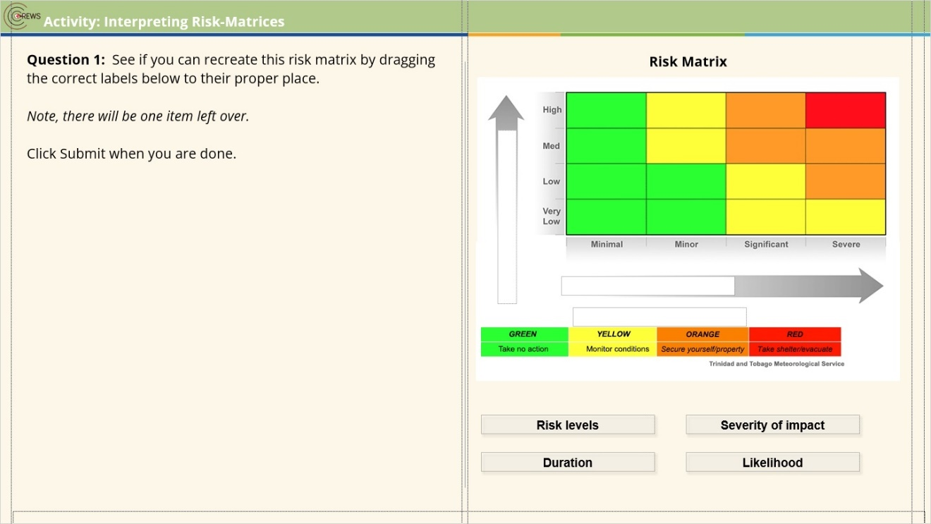
Drag Item | Drop Target
Risk levels | dropzone3 1
Likelihood | dropzone2 1
Severity of impact | dropzone1 1
Duration

Drag and drop properties
Return item to start point if dropped outside the correct drop target
Snap dropped items to drop target (Snap to center)
Allow only one item in each drop target
Delay item drop states until interaction is submitted

Try Again (Slide Layer)
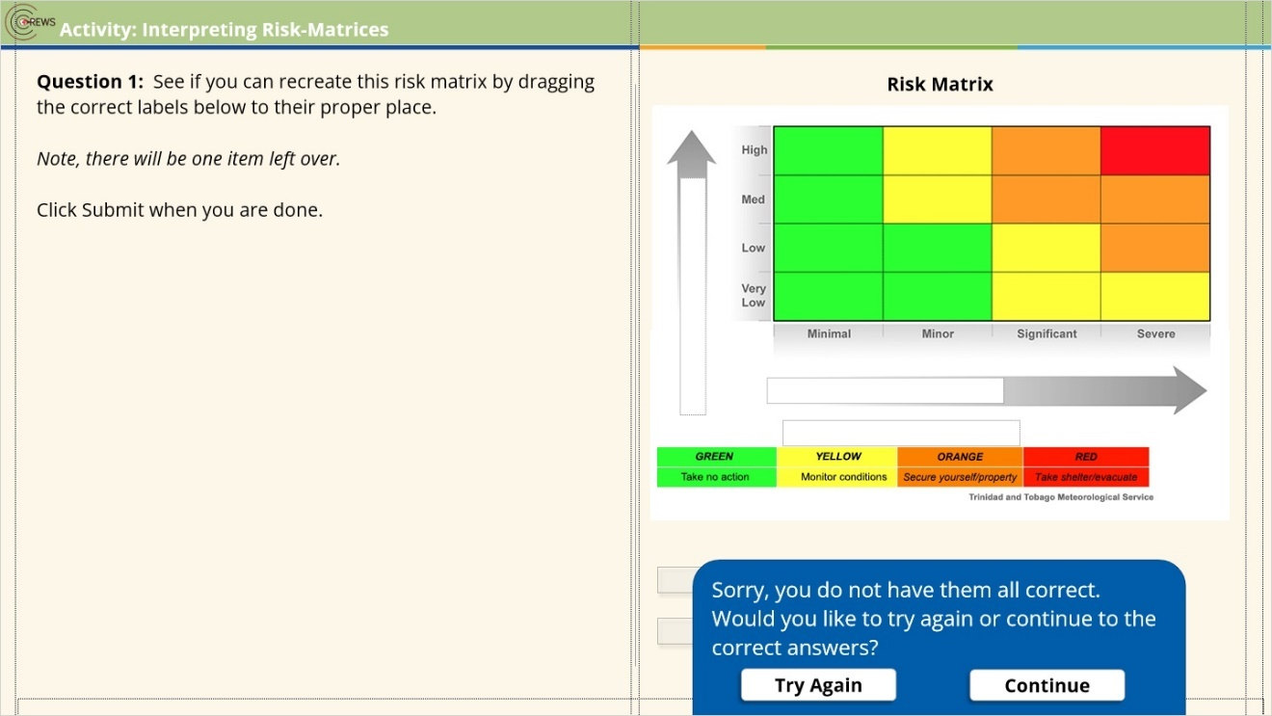

Correct (Slide Layer)
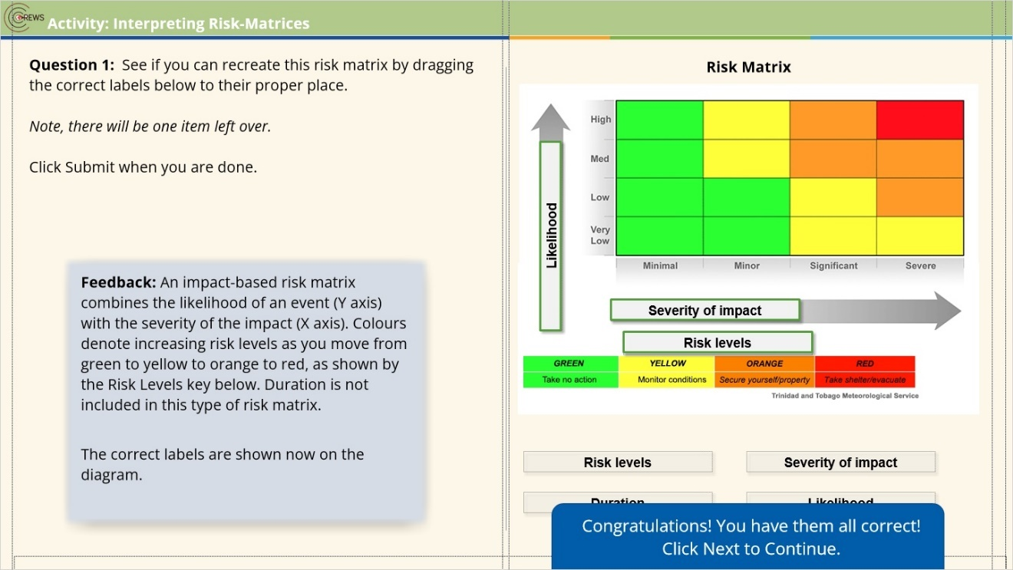

Incorrect (Slide Layer)
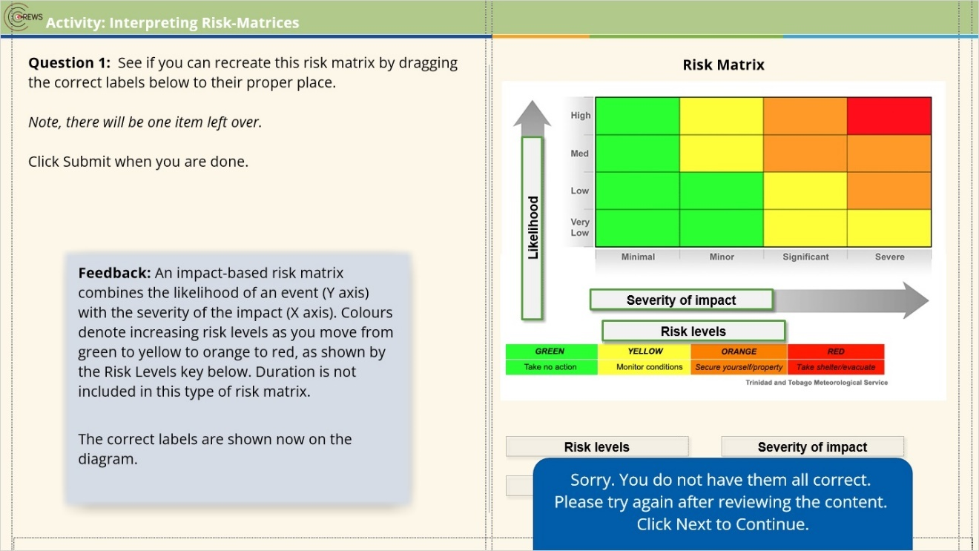

3.12 Activity: Interpreting Risk-Matrices 2
(Pick Many, 10 points, 2 attempts permitted)
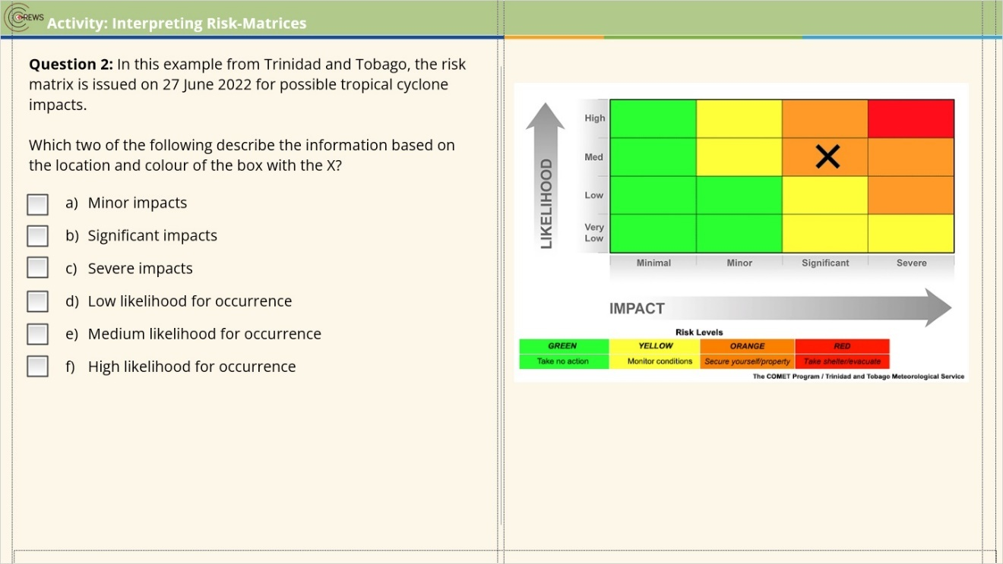
Correct | Choice
 | Check Box 1
X | Check Box 2
 | Check Box 3
 | Check Box 4
X | Check Box 5
 | Check Box 6

Try Again (Slide Layer)
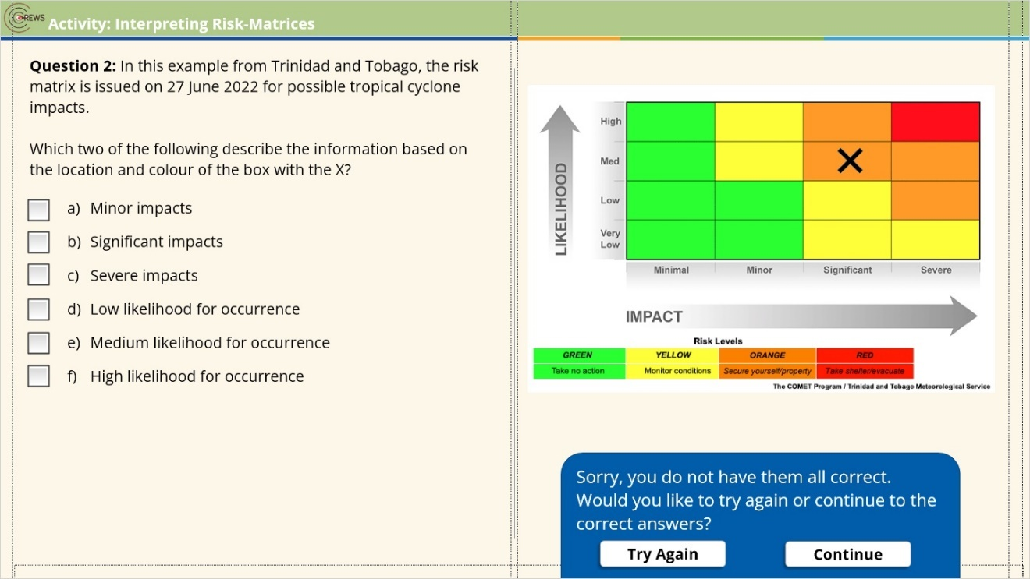

Correct (Slide Layer)
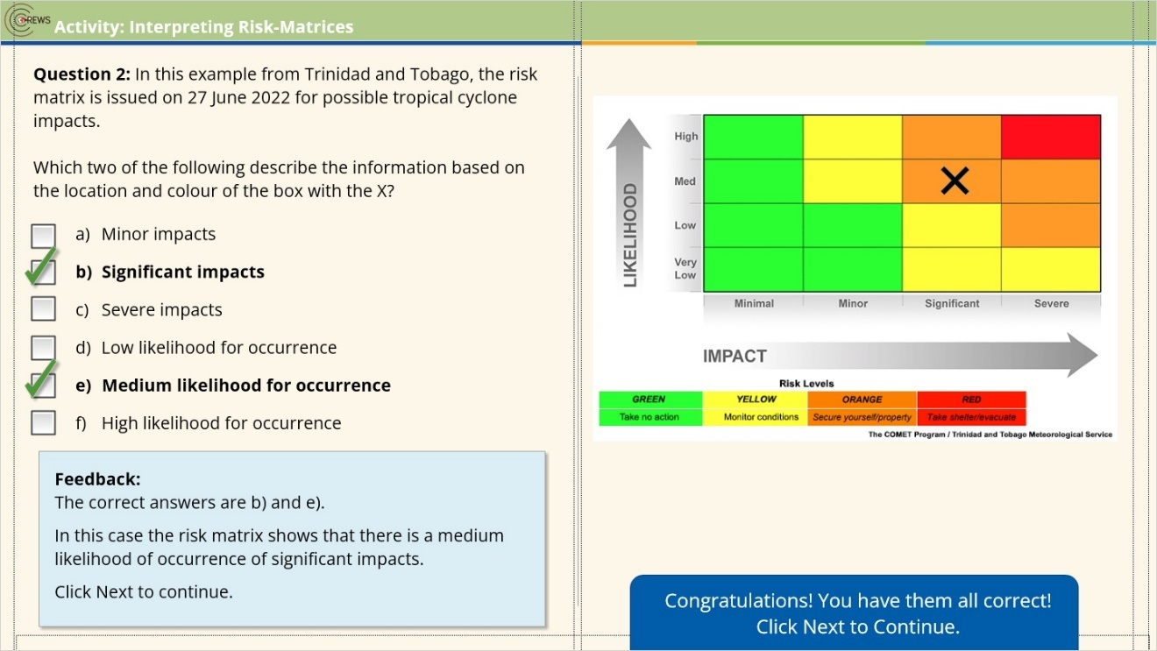

Incorrect (Slide Layer)
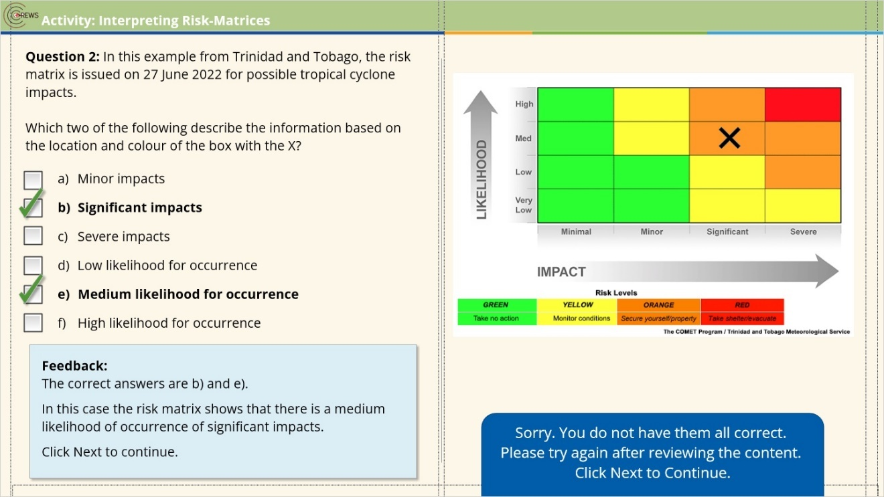

3.13 Activity: Interpreting Risk-Matrices 3
(Pick Many, 10 points, 2 attempts permitted)
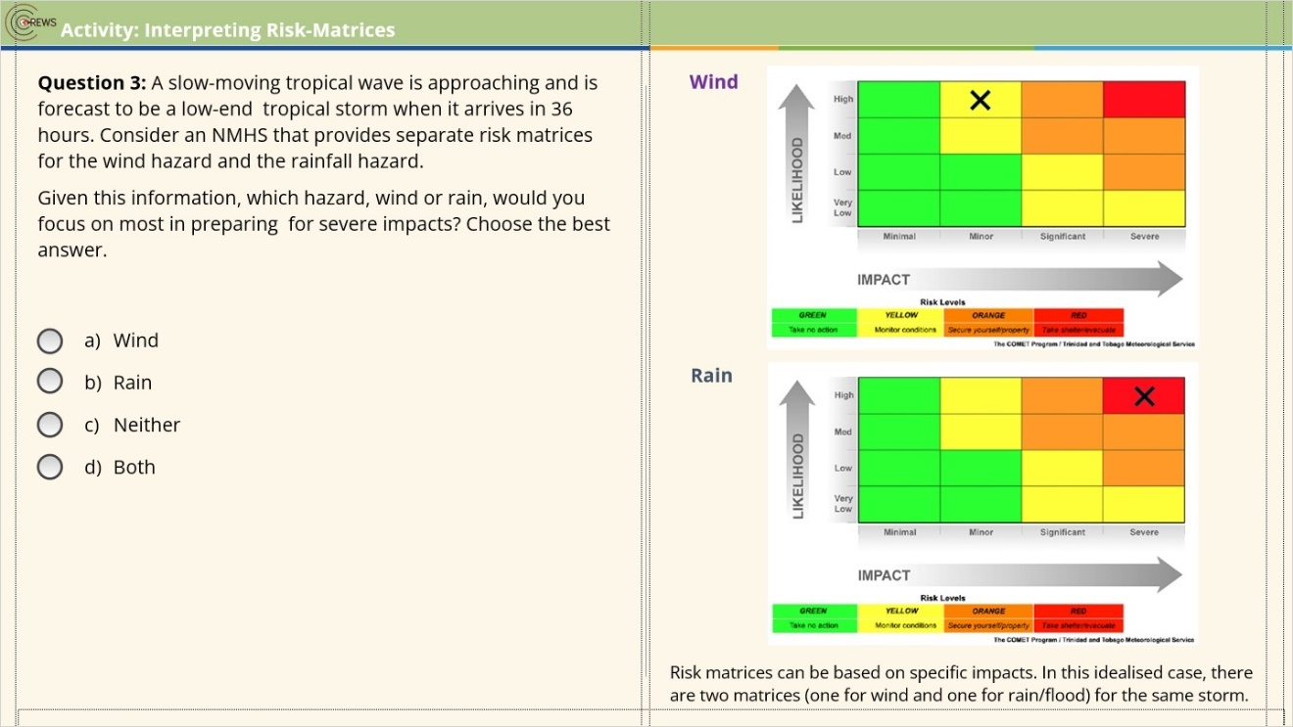
Correct | Choice
 | Radio Button 1
X | Radio Button 2
 | Radio Button 3
 | Radio Button 4

Correct (Slide Layer)
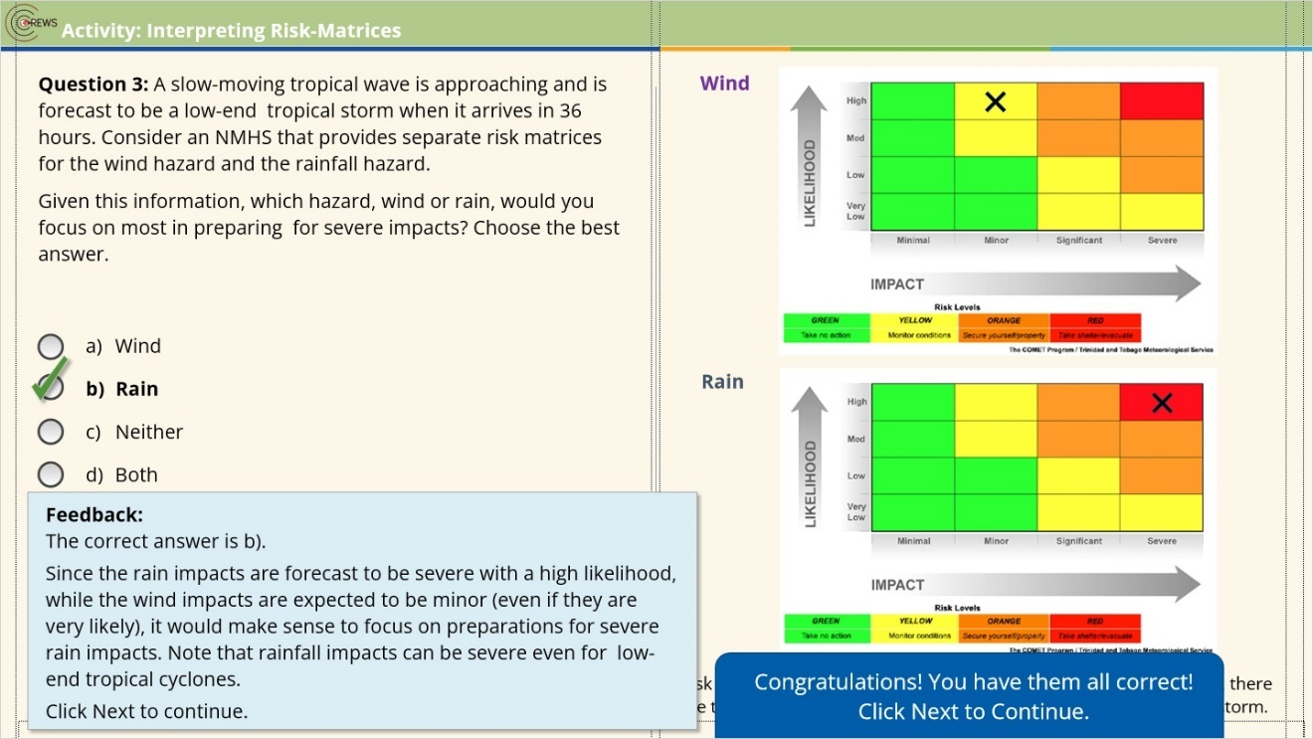

Incorrect (Slide Layer)
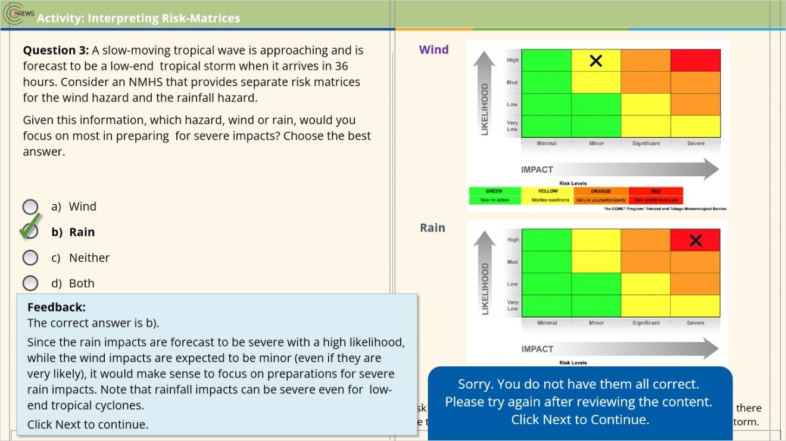

Try Again (Slide Layer)
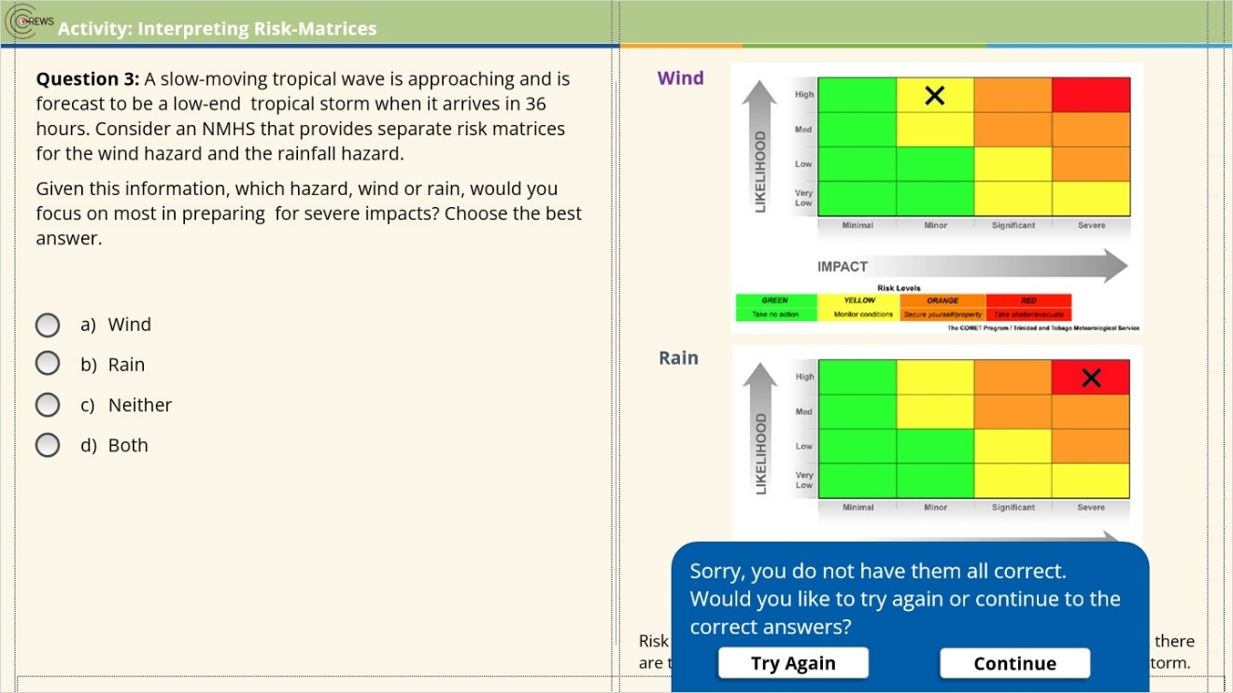

3.14 Activity: Interpreting Risk-Matrices 4
(Pick Many, 10 points, 2 attempts permitted)
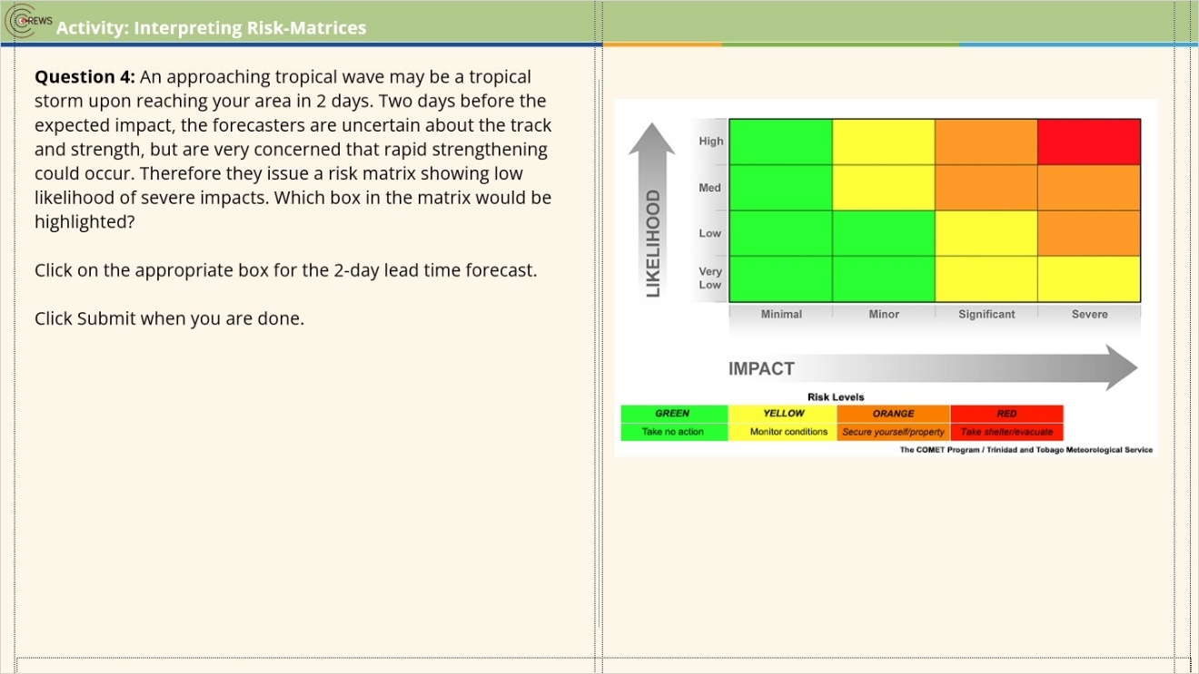
Correct | Choice
 | Rectangle 13
 | Rectangle 14
 | Rectangle 16
 | Rectangle 15
 | Rectangle 20
 | Rectangle 19
 | Rectangle 18
 | Rectangle 17
 | Rectangle 28
 | Rectangle 27
 | Rectangle 26
X | CORRECT-X
 | Rectangle 24
 | Rectangle 23
 | Rectangle 22
 | Rectangle 21

Correct (Slide Layer)
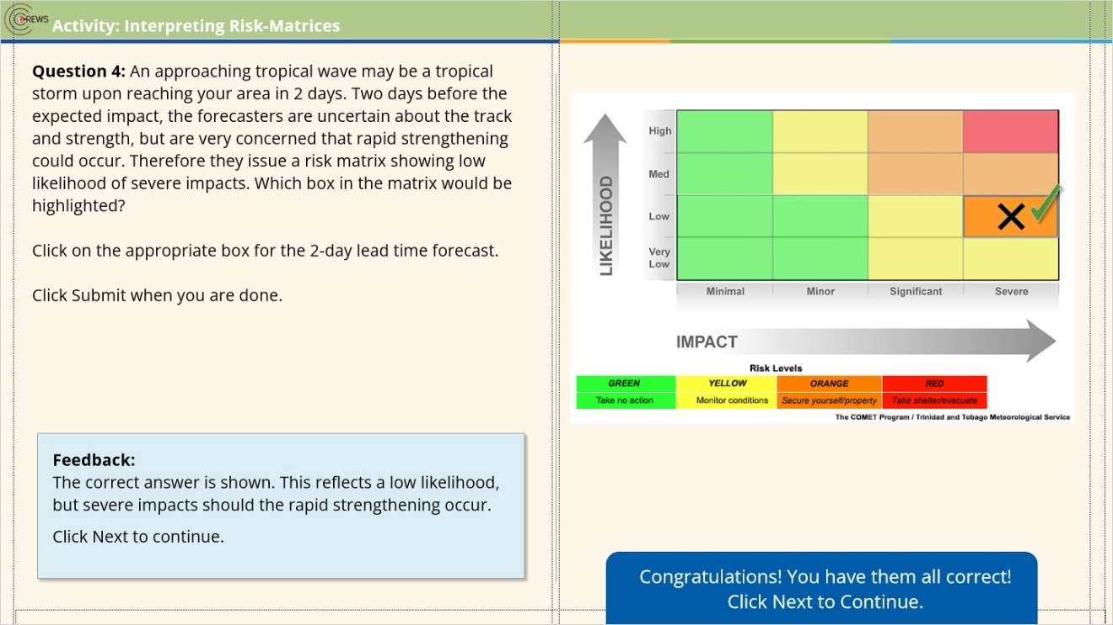

Incorrect (Slide Layer)
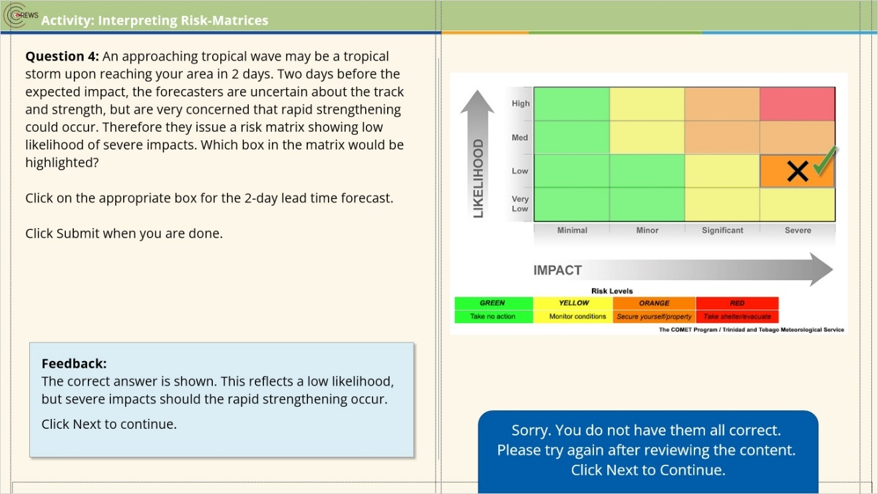

Try Again (Slide Layer)
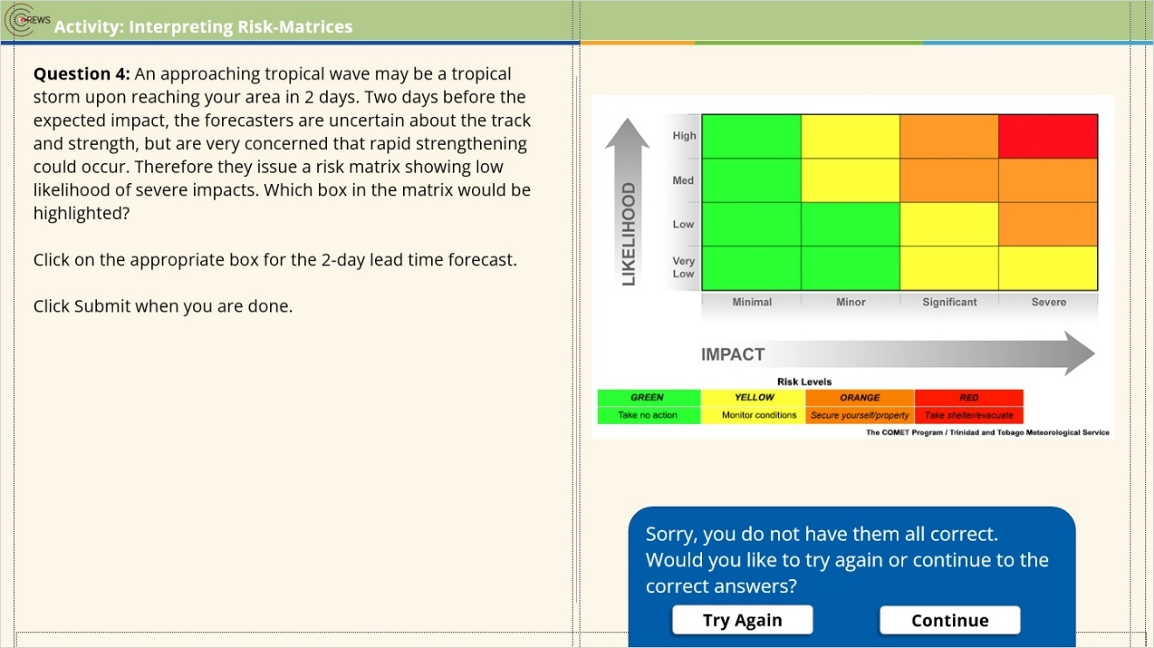

3.15 Activity: Interpreting Risk-Matrices 5
(Pick Many, 10 points, 2 attempts permitted)
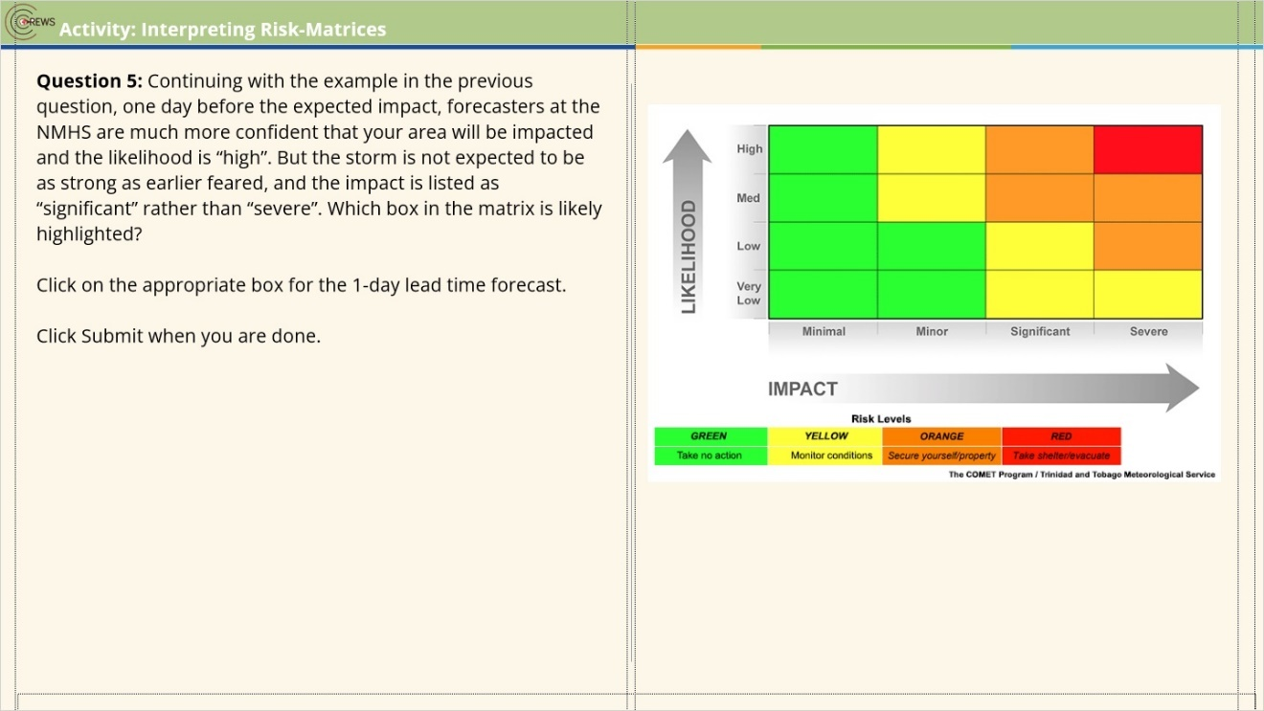
Correct | Choice
 | Rectangle 13
 | Rectangle 14
X | CORRECT-Rectangle 16
 | Rectangle 15
 | Rectangle 20
 | Rectangle 19
 | Rectangle 18
 | Rectangle 17
 | Rectangle 28
 | Rectangle 27
 | Rectangle 26
 | wrong
 | Rectangle 24
 | Rectangle 23
 | Rectangle 22
 | Rectangle 21

Final Right Answers (Slide Layer)
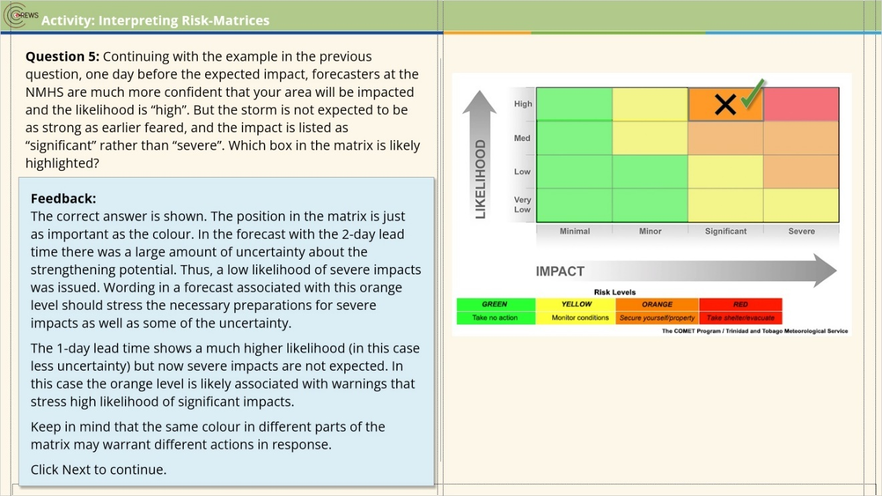

Correct (Slide Layer)
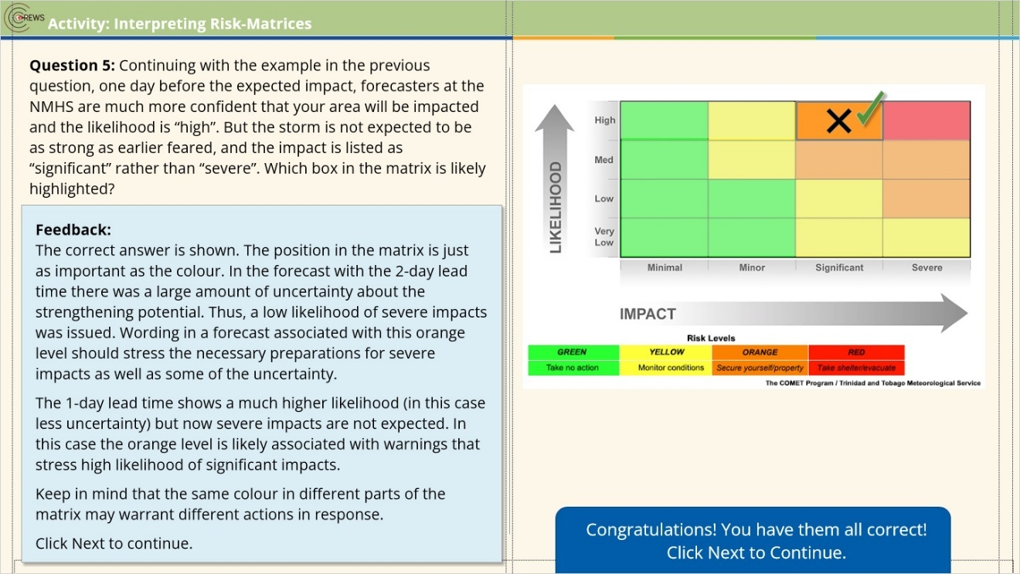

Incorrect (Slide Layer)
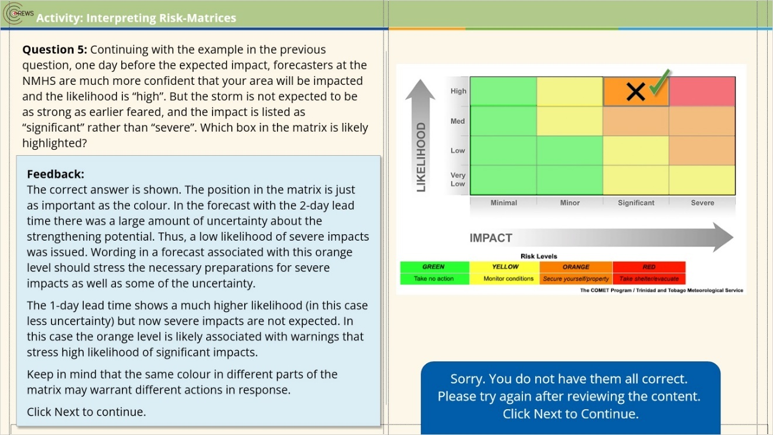

Try Again (Slide Layer)
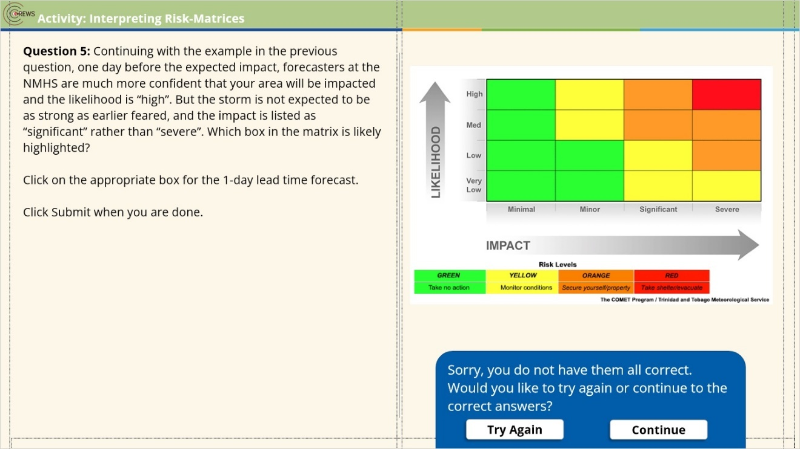

3.16 Activity: Colour-specific Messaging About Impacts
(Drag and Drop, 10 points, 2 attempts permitted)
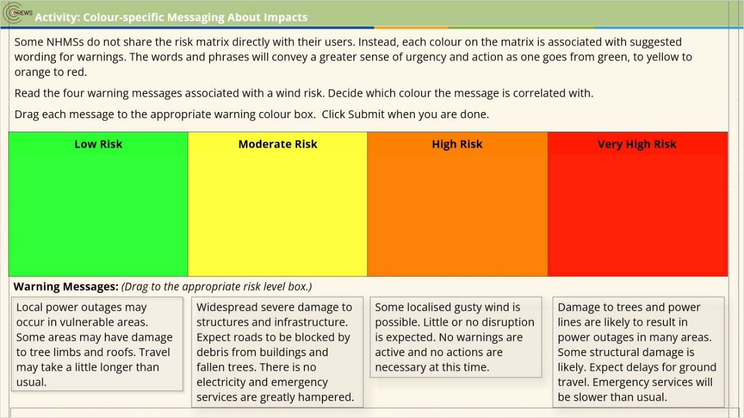
Drag Item | Drop Target
Widespread severe damage to structures and infrastructure. Expect roads to be blocked by debris from buildings and fallen trees. There is no electricity and emergency services are greatly hampered. | dropzone4
Local power outages may occur in vulnerable areas. Some areas may have damage to tree limbs and roofs. Travel may take a little longer than usual. | dropzone2
Some localised gusty wind is possible. Little or no disruption is expected. No warnings are active and no actions are necessary at this time. | dropzone1
Damage to trees and power lines are likely to result in power outages in many areas. Some structural damage is likely. Expect delays for ground travel. Emergency services will be slower than usual. | dropzone3

Drag and drop properties
Snap dropped items to drop target (Stack random)
Allow only one item in each drop target
Delay item drop states until interaction is submitted

Final Right Answers (Slide Layer)
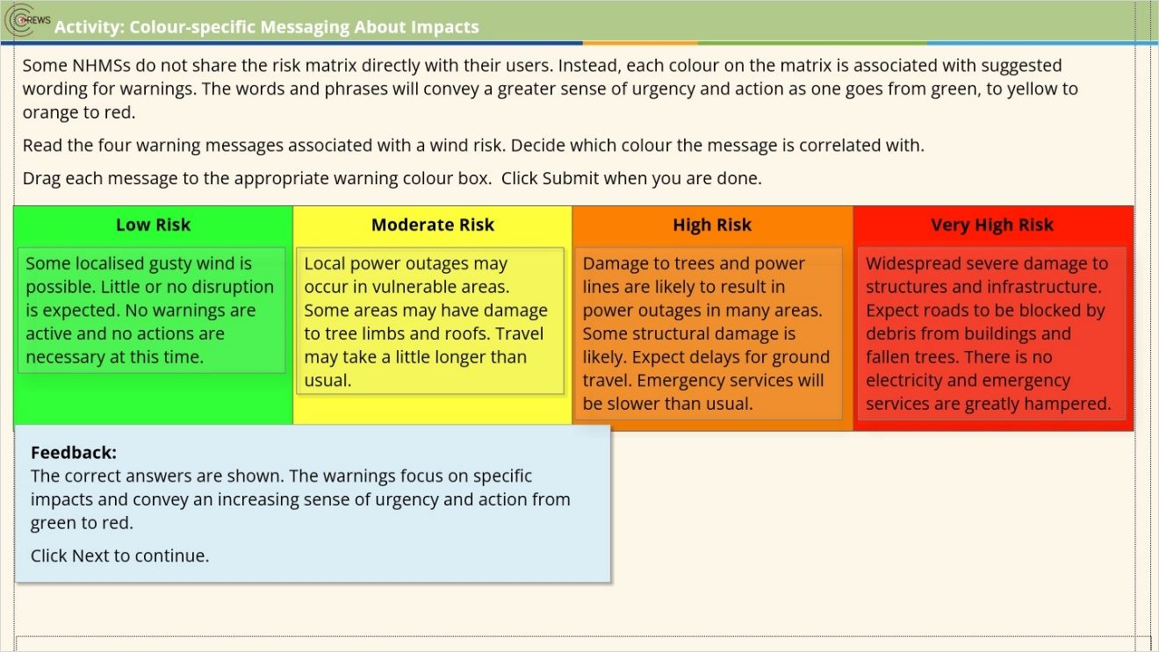

Correct (Slide Layer)
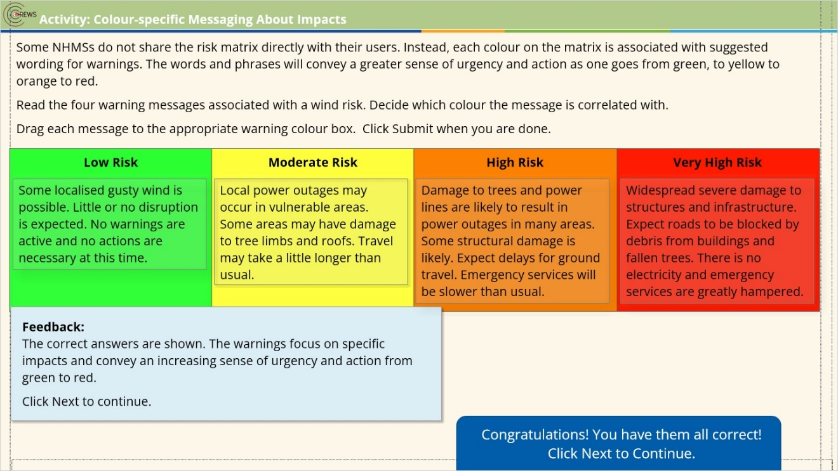

Incorrect (Slide Layer)
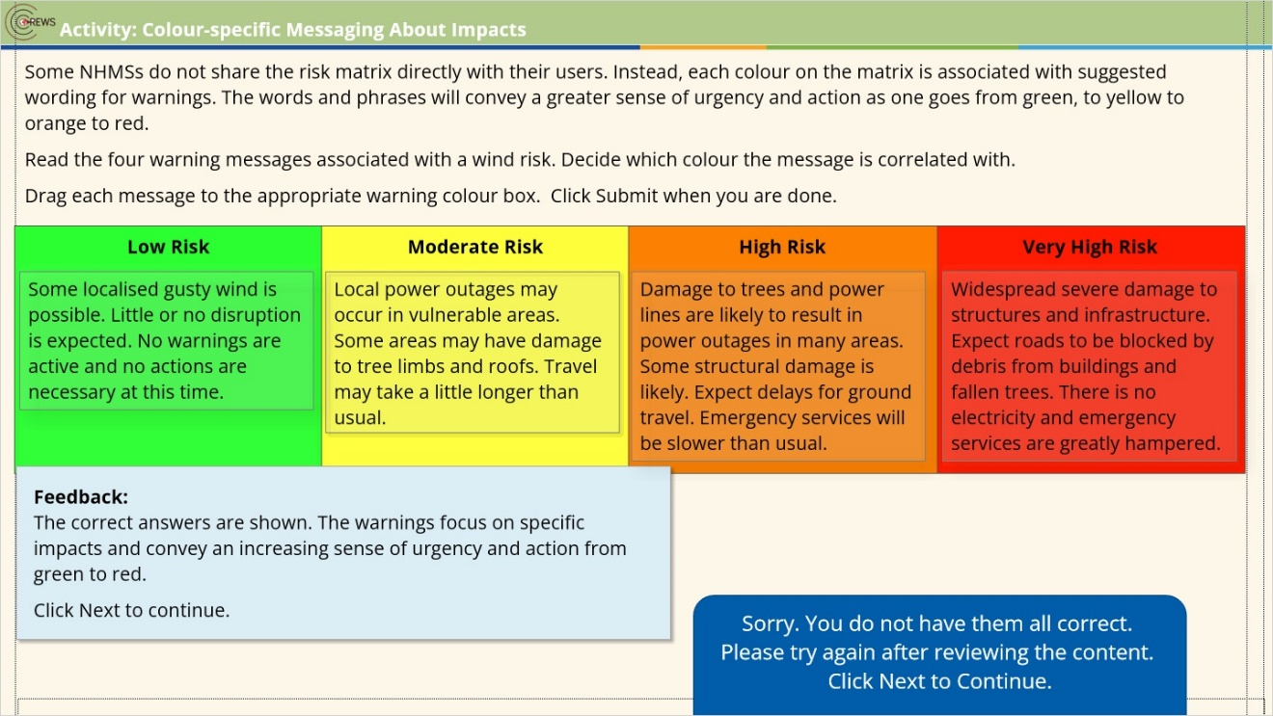

Try Again (Slide Layer)
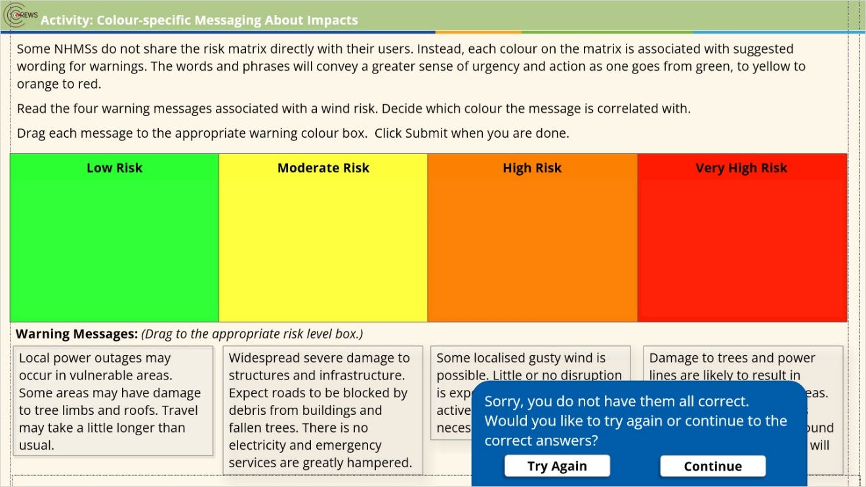

3.17 Communicating Localised Impacts
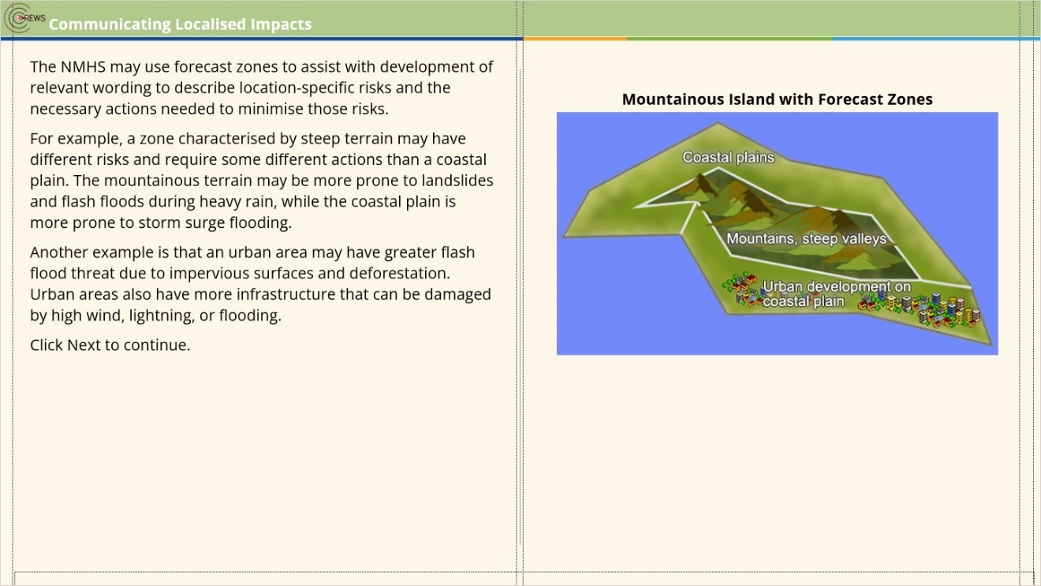

3.18 Activity: Location-specific Messaging about Impacts
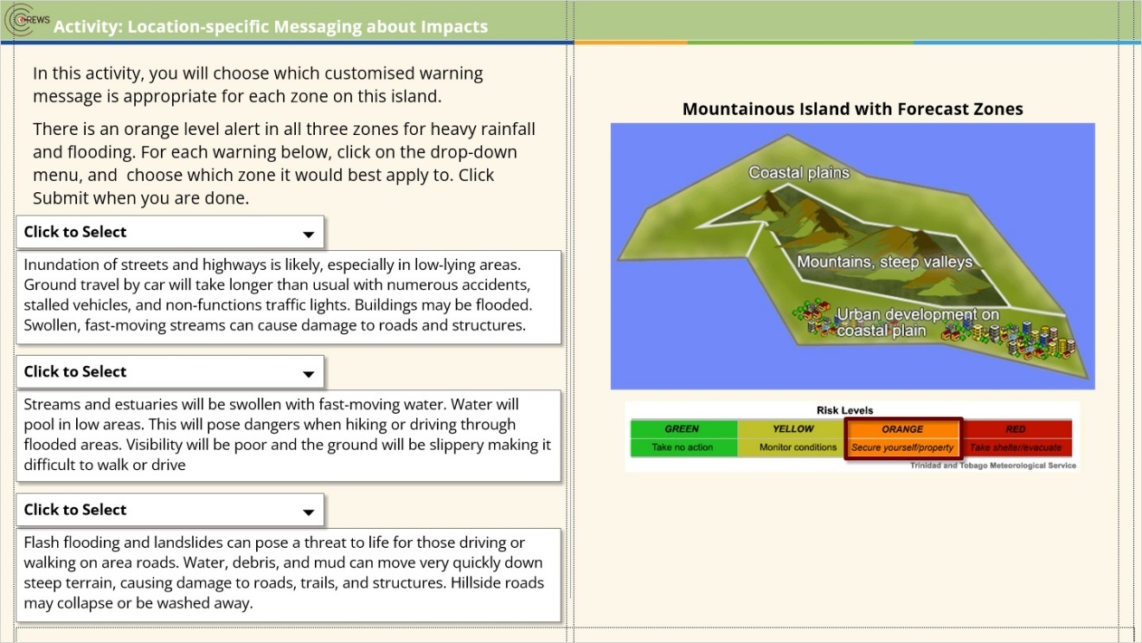
Notes:

dropdown list1 (Slide Layer)
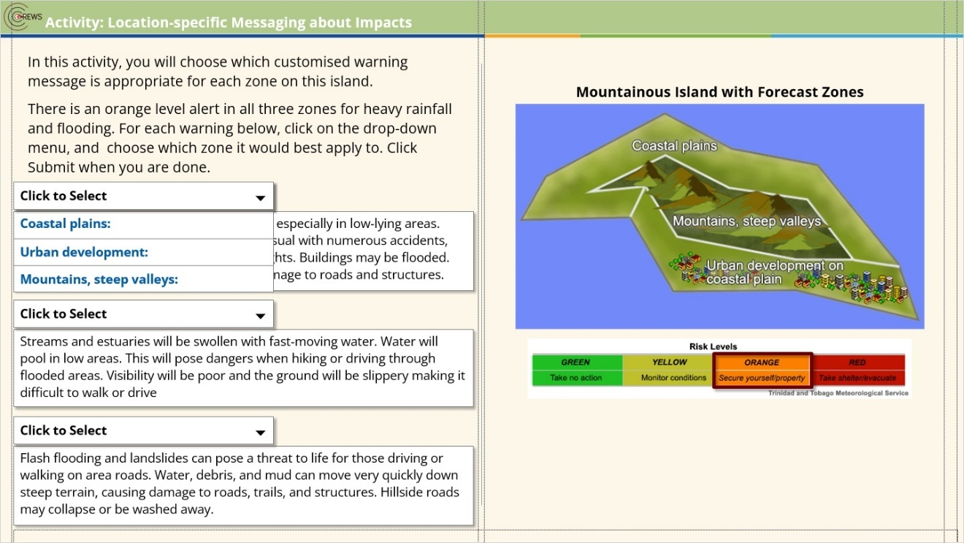

dropdown list2 (Slide Layer)
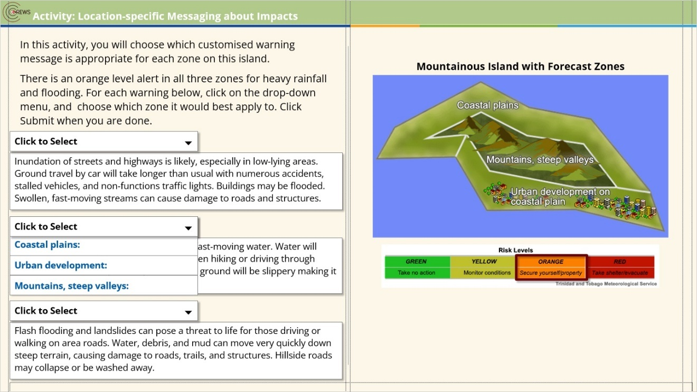

dropdown list3 (Slide Layer)
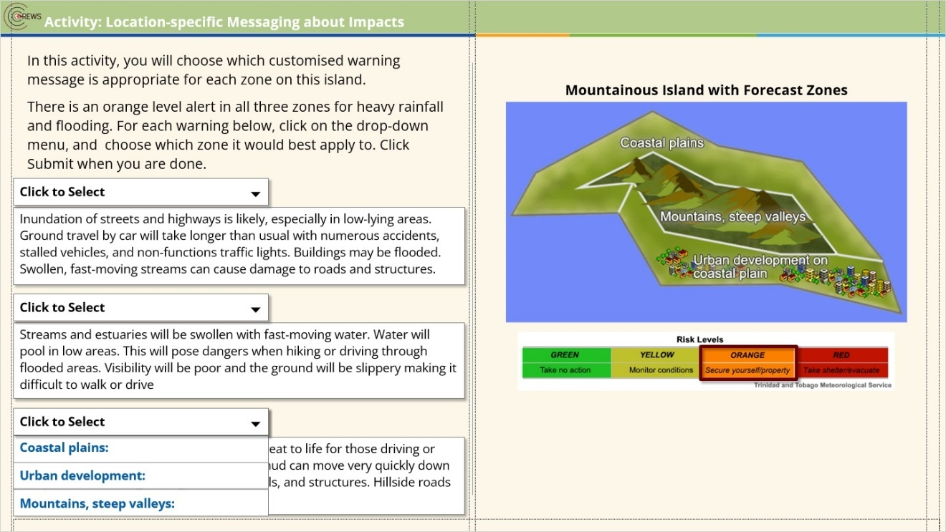

Try Again (Slide Layer)
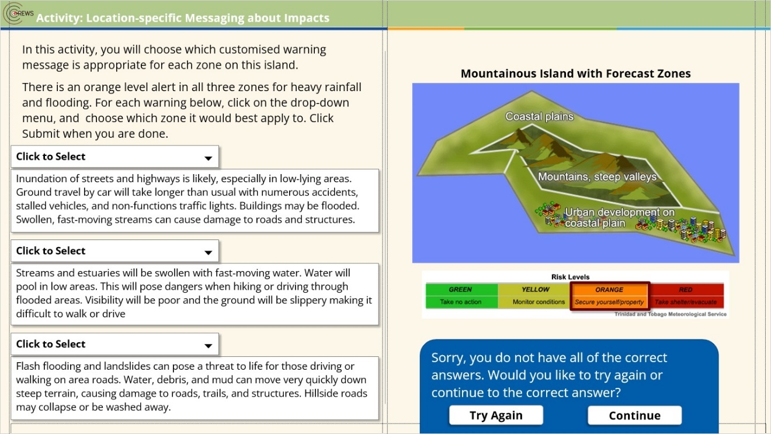

Incorrect (Slide Layer)
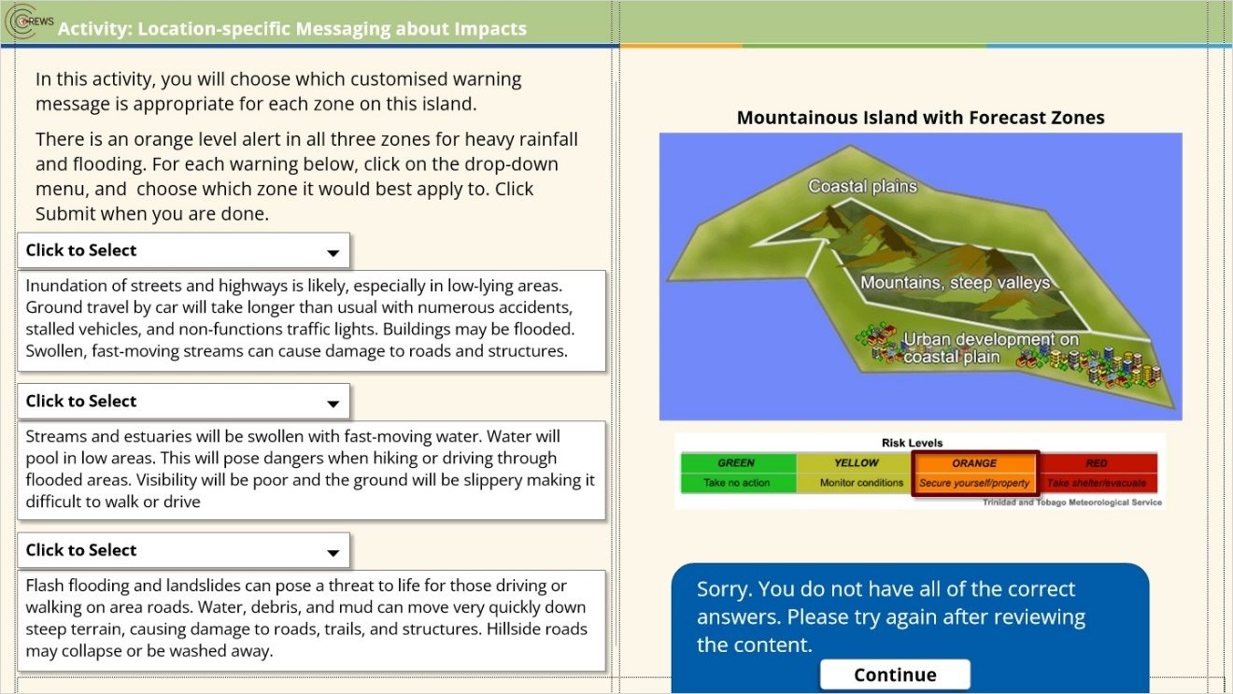

Correct (Slide Layer)
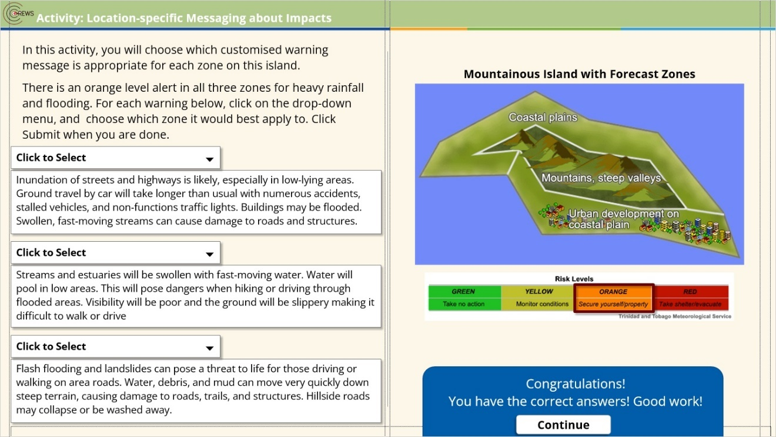

Final Right Answers (Slide Layer)
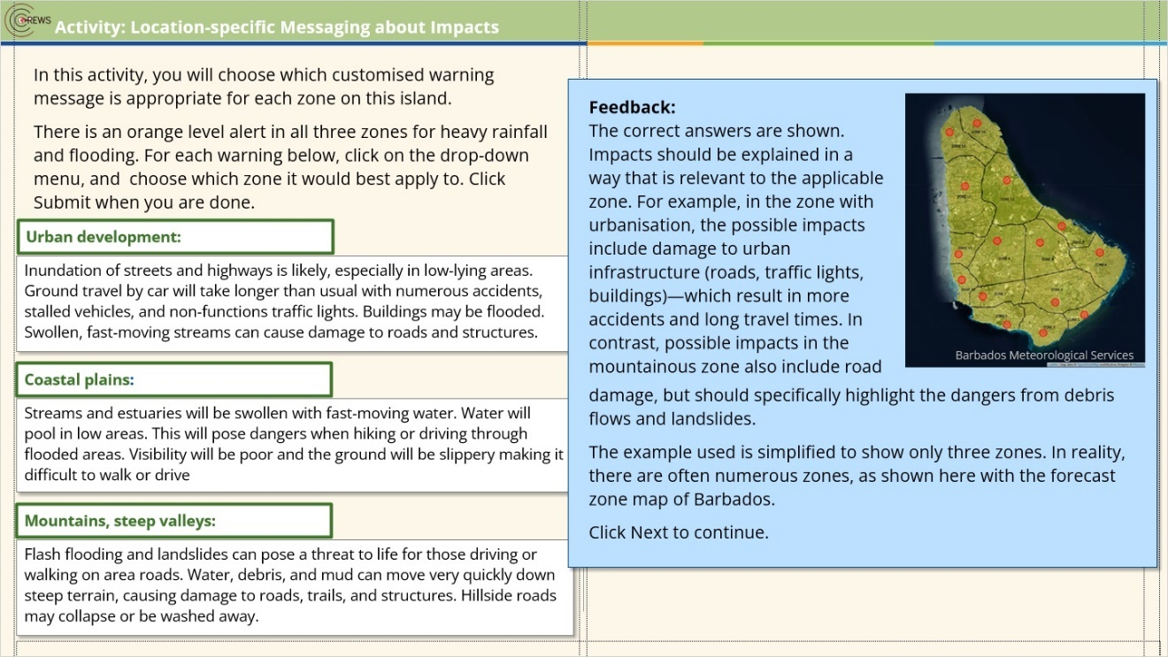

3.19 Knowledge Check
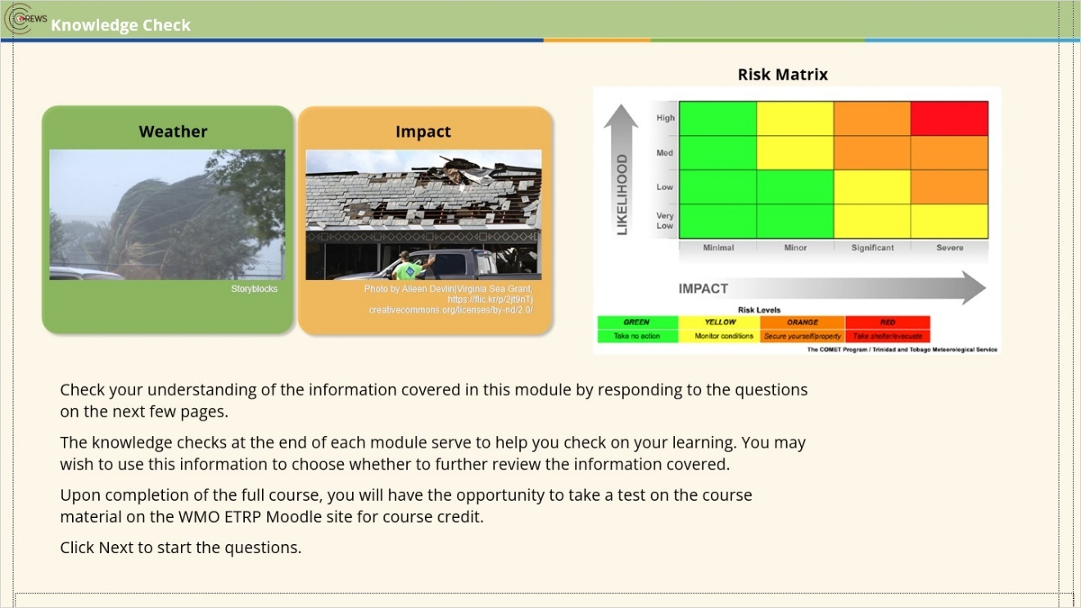
Notes:

3.20 Question 1
(Drag and Drop, 10 points, 1 attempt permitted)
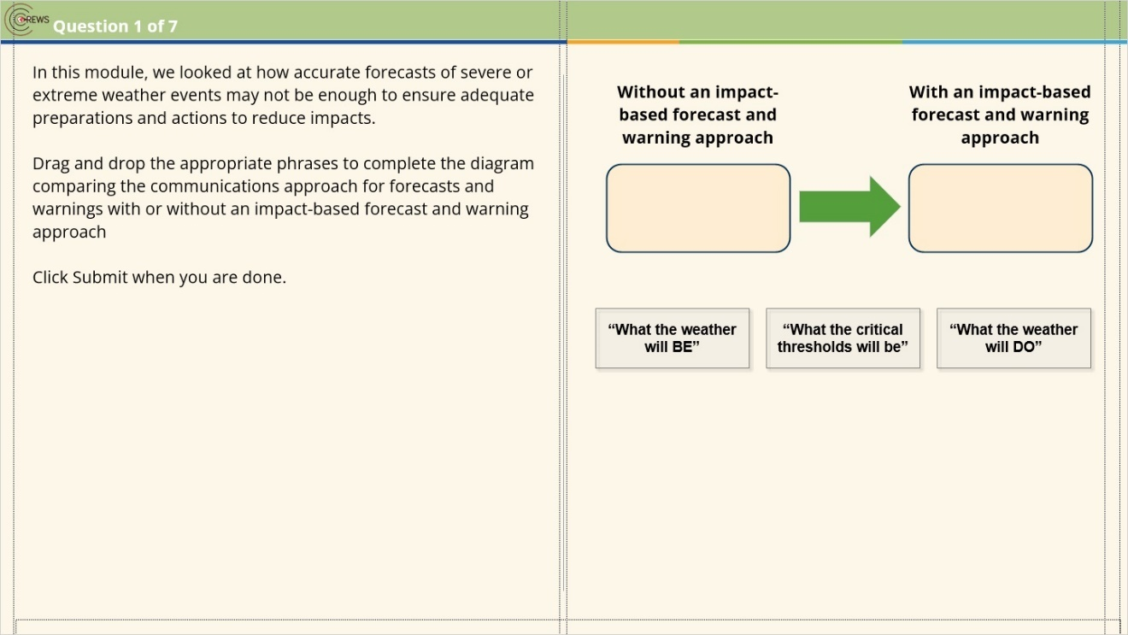
Drag Item | Drop Target
“What the weather will BE” | left drop
“What the weather will DO” | right drop
“What the critical thresholds will be”

Drag and drop properties
Return item to start point if dropped outside the correct drop target
Snap dropped items to drop target (Snap to center)
Allow only one item in each drop target
Delay item drop states until interaction is submitted

Incorrect (Slide Layer)
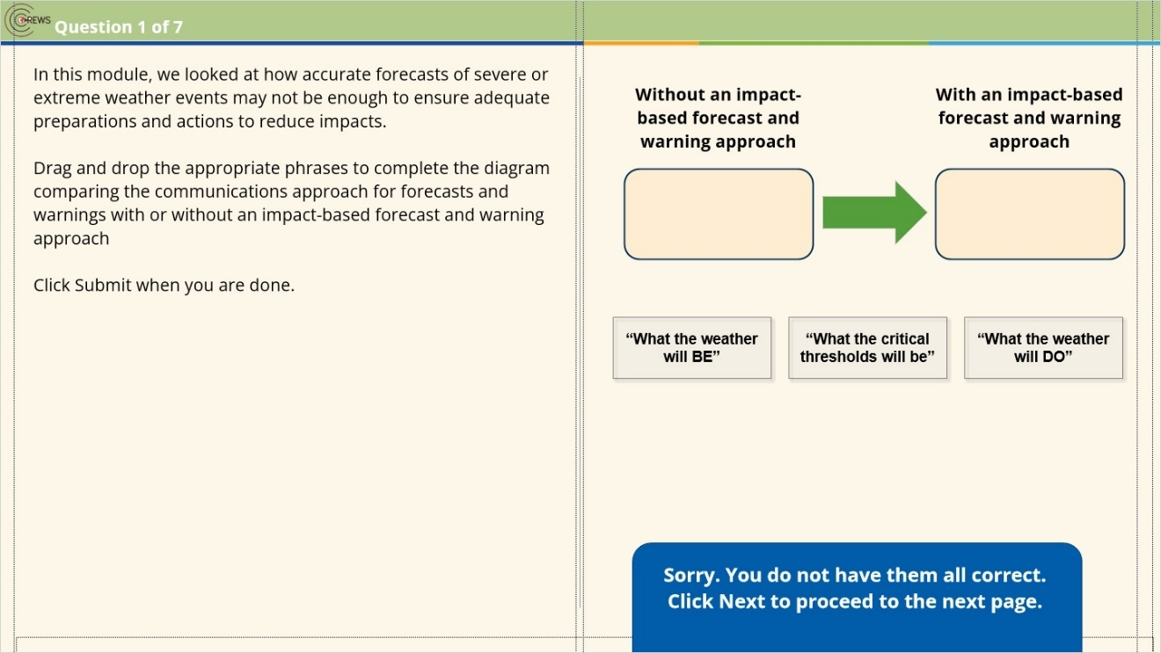

Correct (Slide Layer)
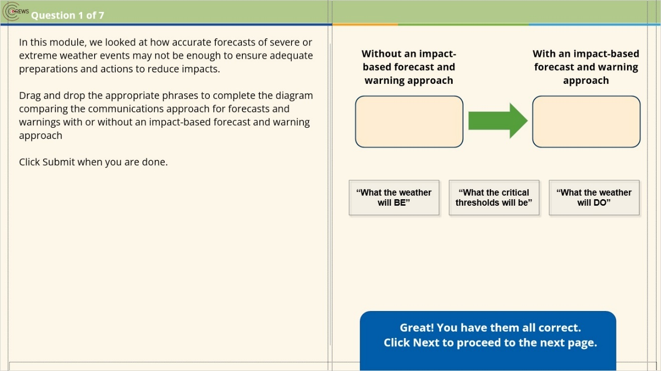

3.21 Question 2
(Pick Many, 10 points, 1 attempt permitted)
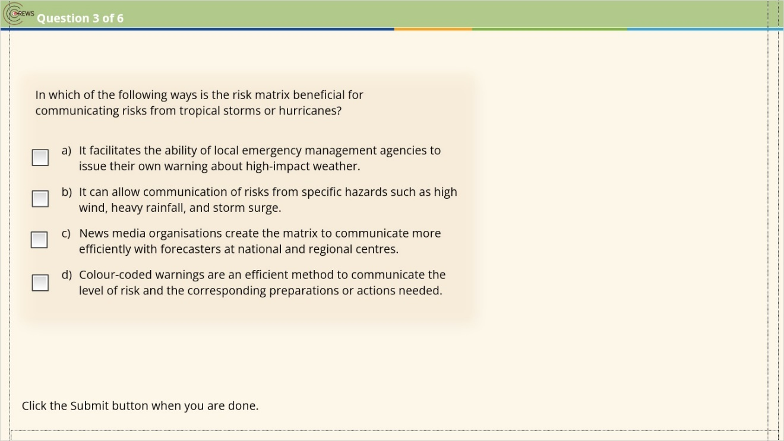
Correct | Choice
 | Check Box 1
X | Check Box 2
 | Check Box 3
X | Check Box 4

Incorrect (Slide Layer)
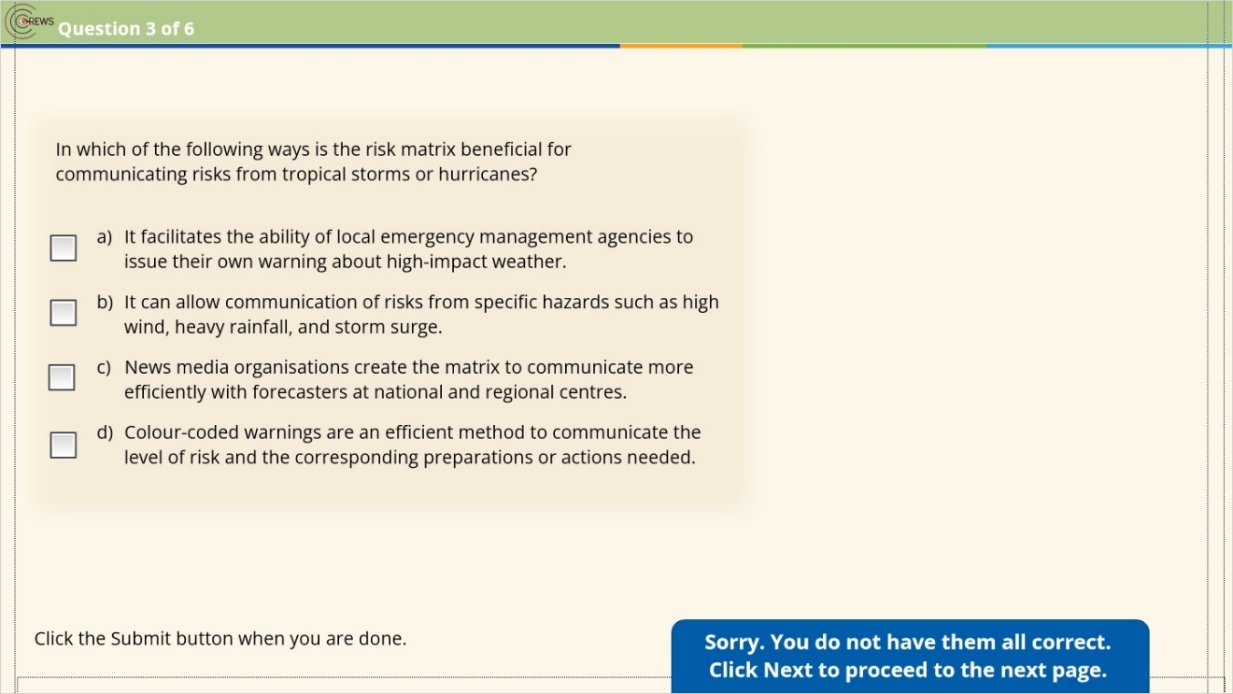

Correct (Slide Layer)
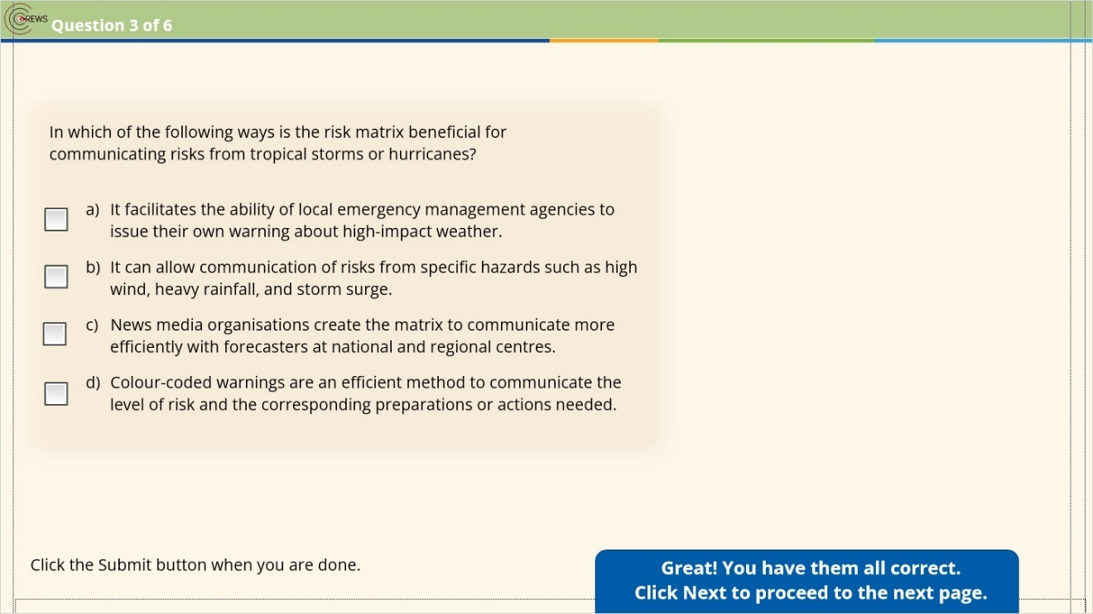

3.22 Question 3
(Pick Many, 10 points, 1 attempt permitted)
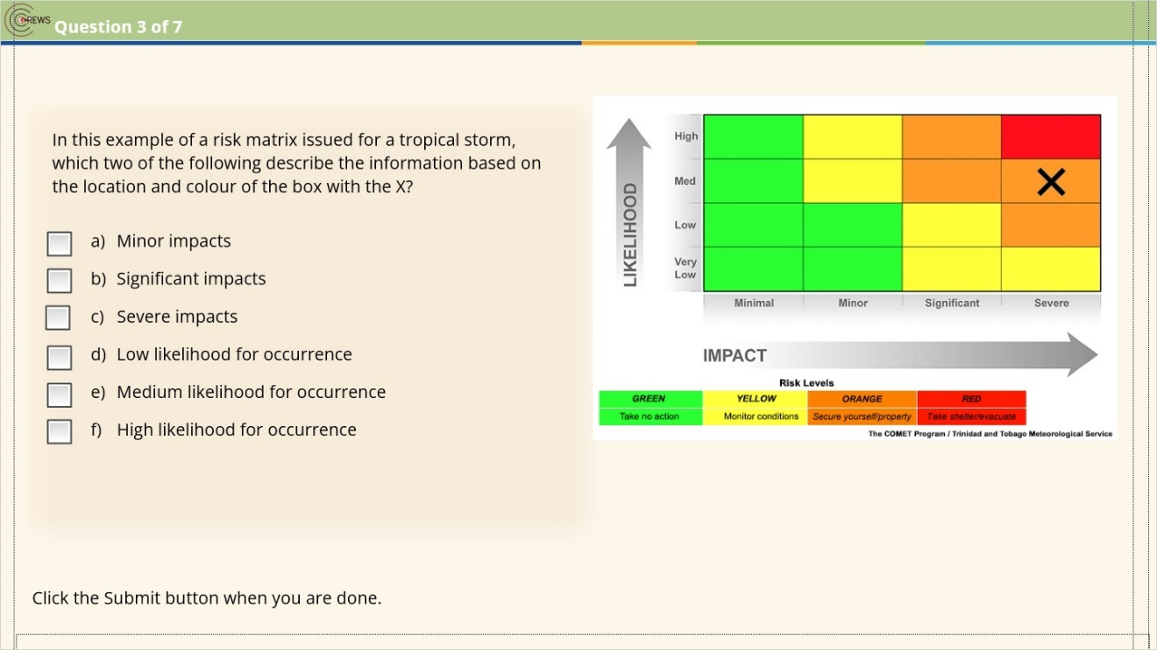
Correct | Choice
 | Check Box 1
 | Check Box 2
X | Check Box 3
 | Check Box 4
X | Check Box 5
 | Check Box 6

Incorrect (Slide Layer)
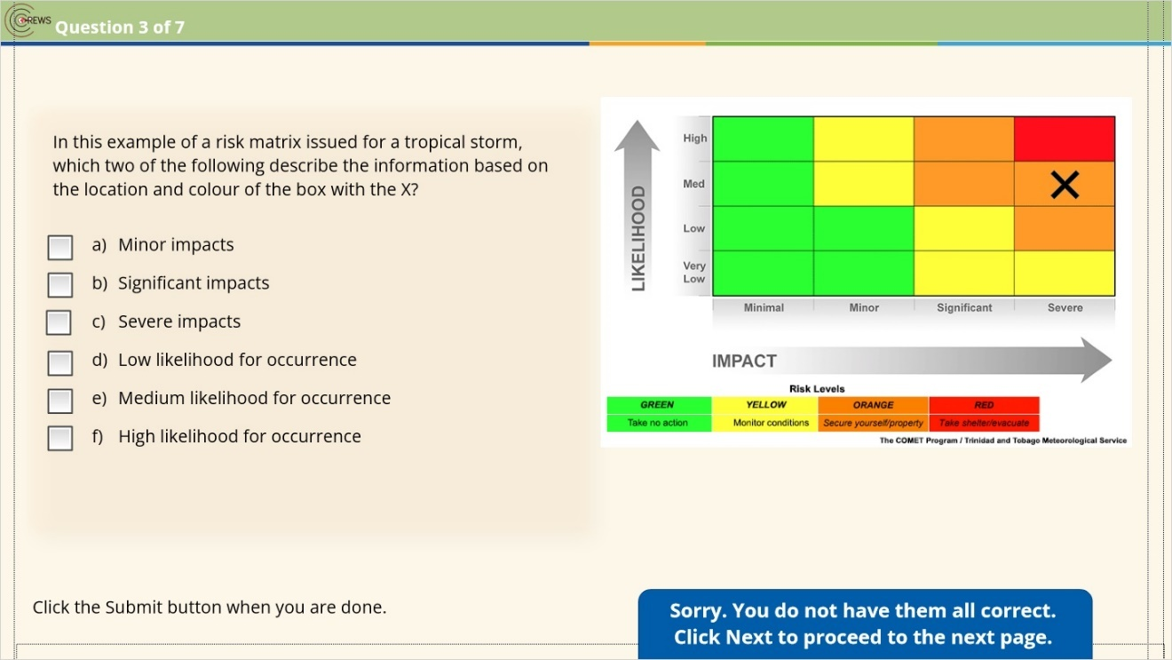

Correct (Slide Layer)
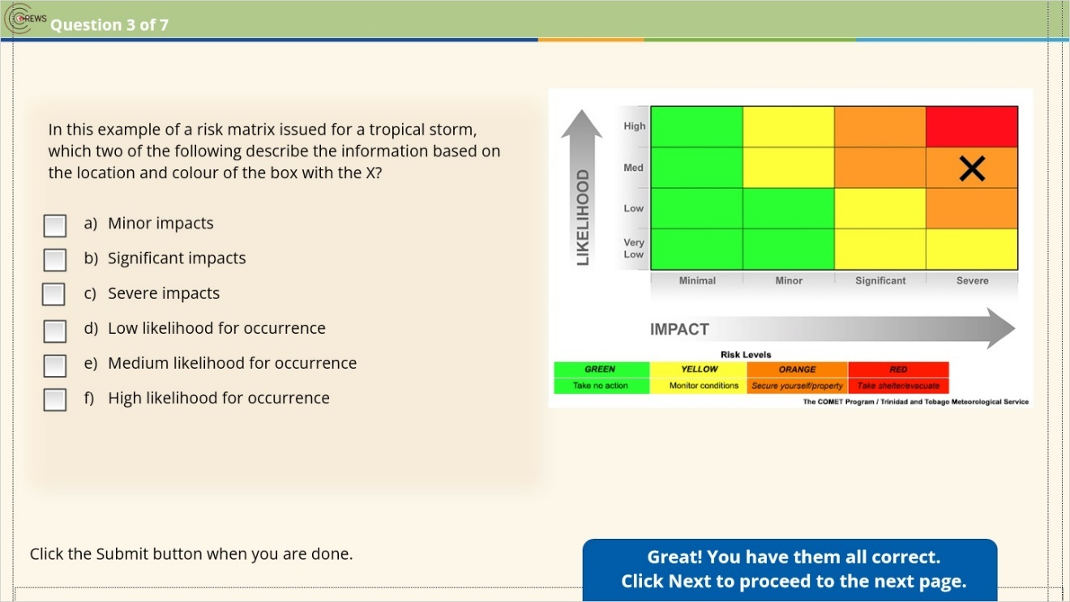

3.23 Question 4
(Pick Many, 10 points, 1 attempt permitted)
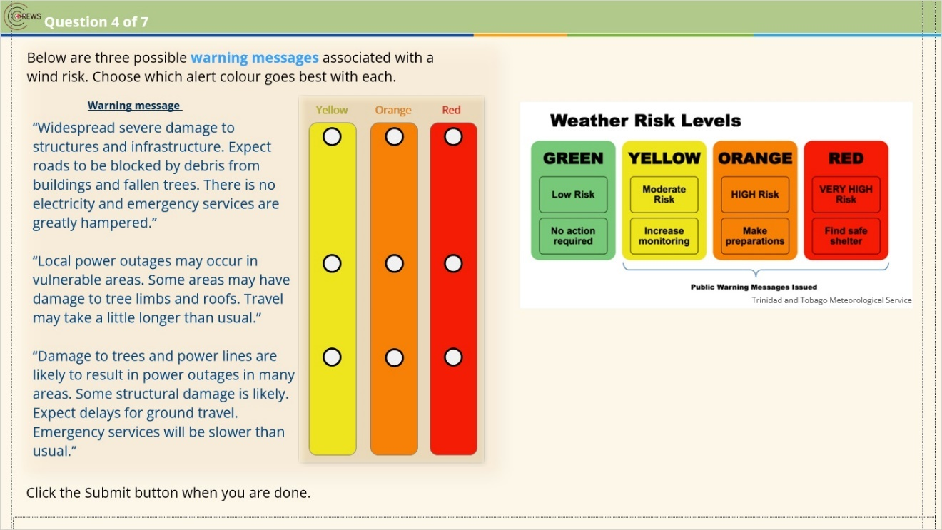
Correct | Choice
 | Q1-1
 | Q1-2
X | Q1-3
X | Q2-1
 | Q2-2
 | Q2-3
 | Q3-1
X | Q3-2
 | Q3-3

Incorrect (Slide Layer)
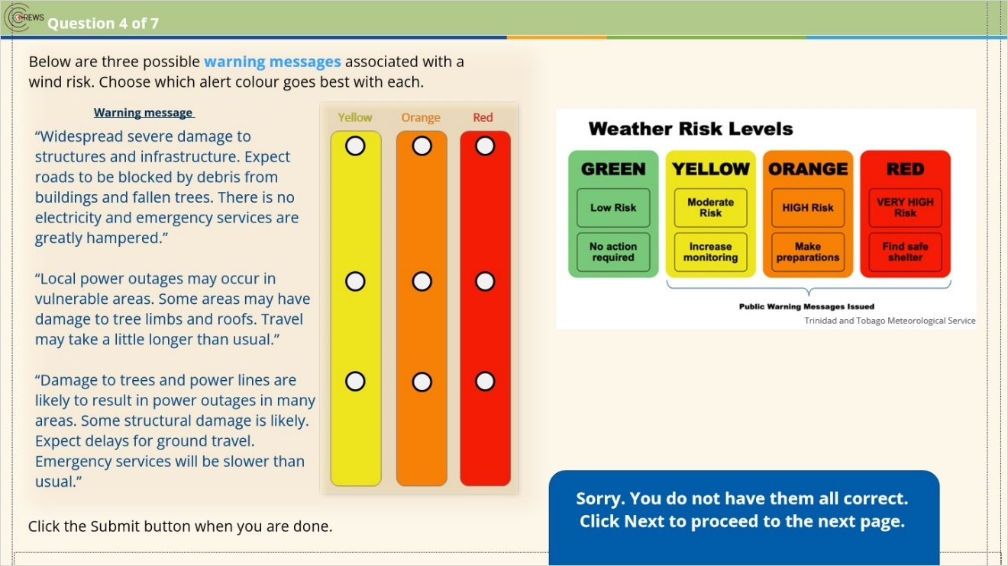

Correct (Slide Layer)
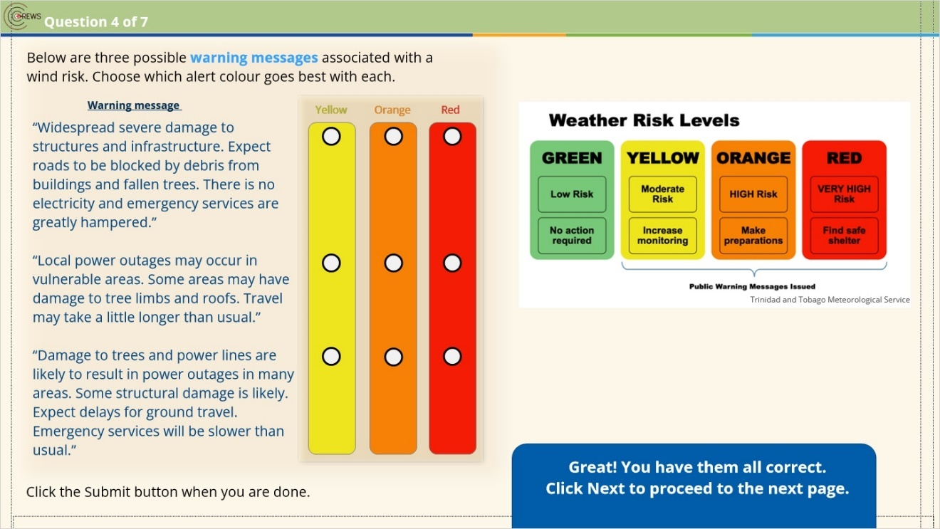

3.24 Question 5
(Pick Many, 10 points, 1 attempt permitted)
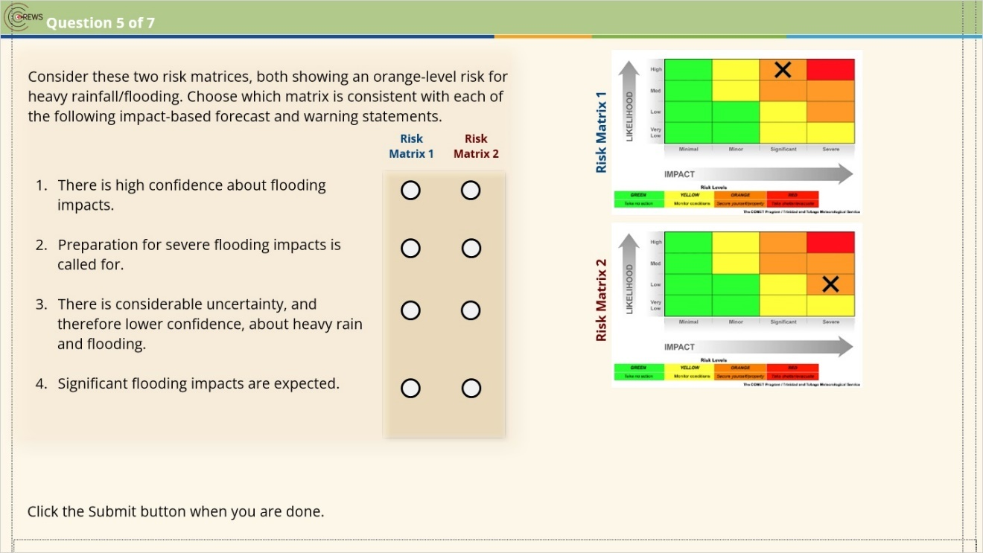
Correct | Choice
X | Q1T
 | Q1F
 | Q2T
X | Q2F
 | Q3T
X | Q3F
X | Q4T
 | Q4F

Notes:

Incorrect (Slide Layer)
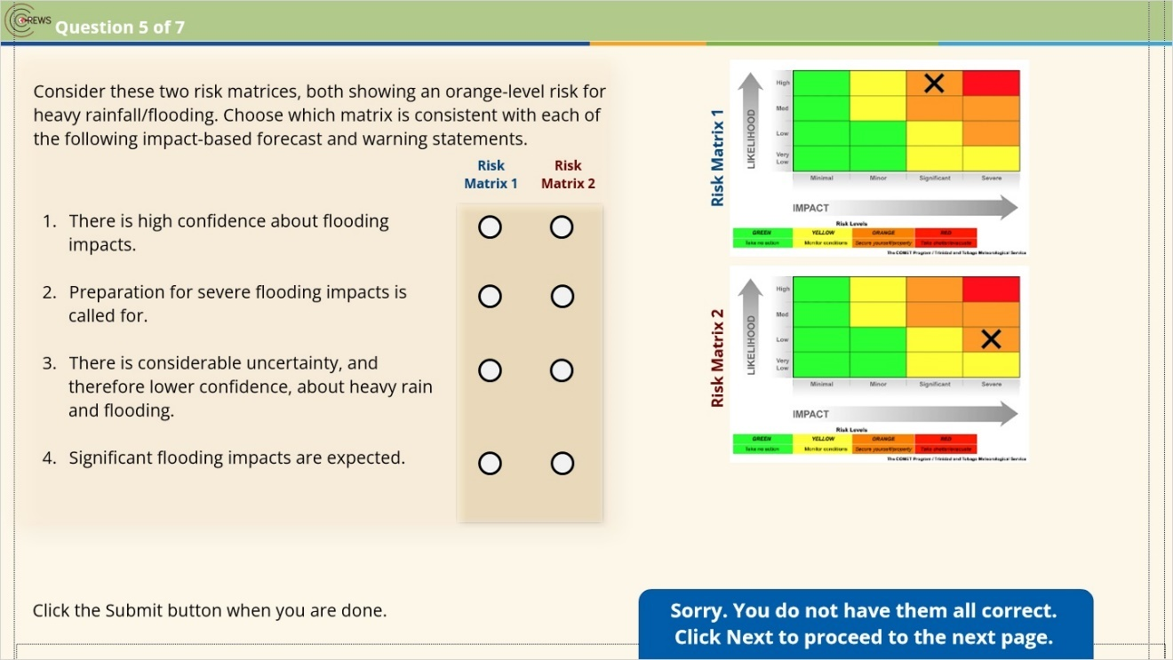

Correct (Slide Layer)
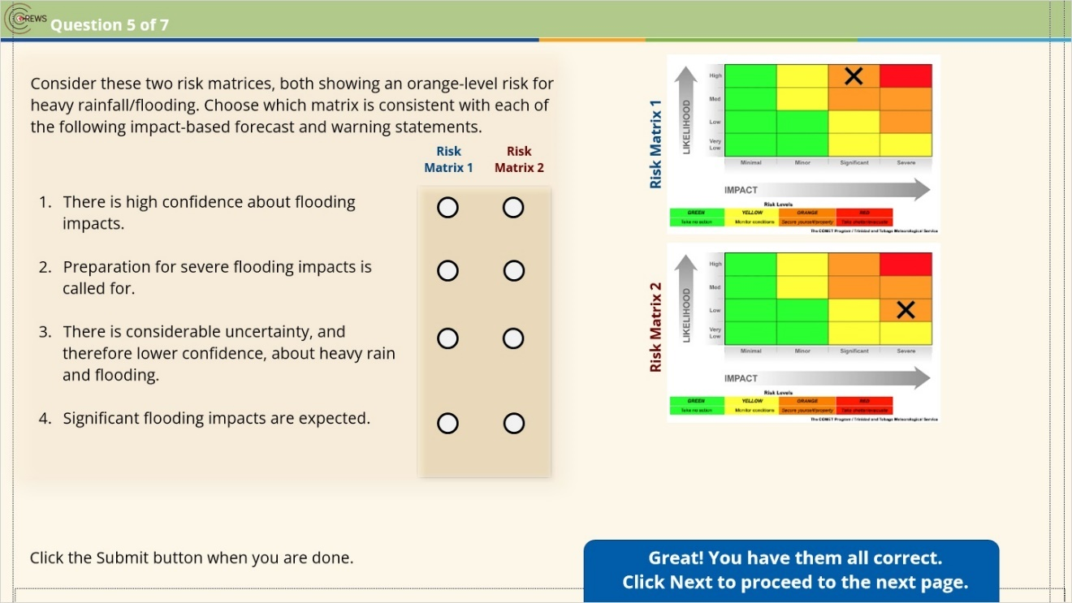

3.25 Question 6
(Matching Drop-down, 10 points, 1 attempt permitted)
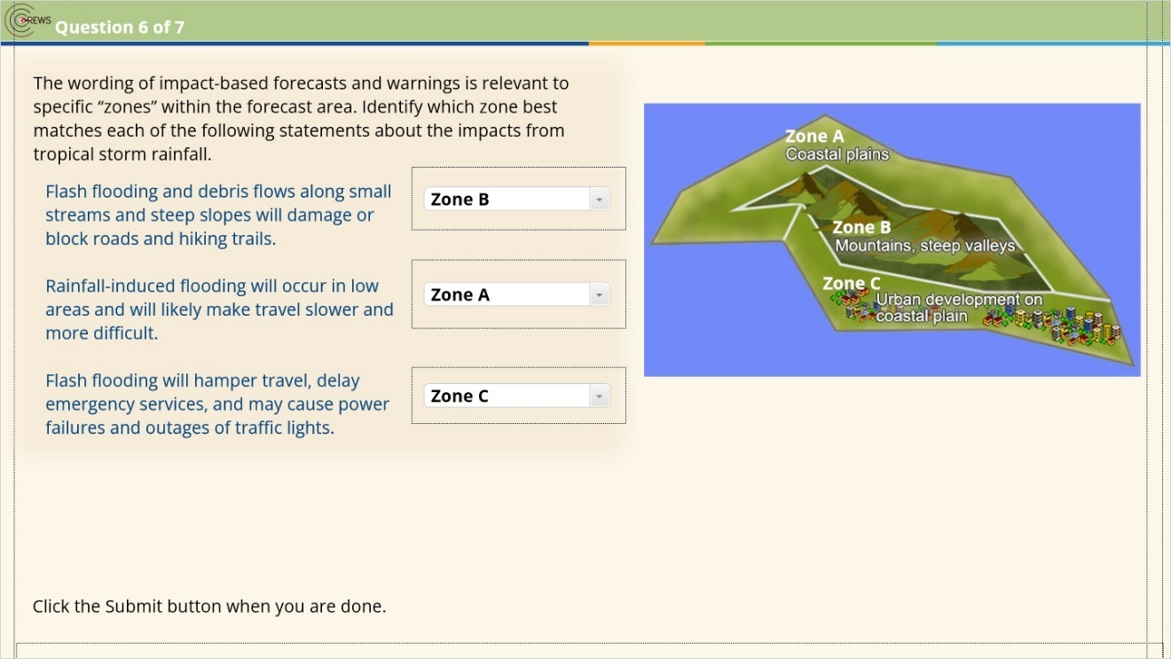
Correct | Choice
 | Zone B
 | Zone A
 | Zone C

Incorrect (Slide Layer)
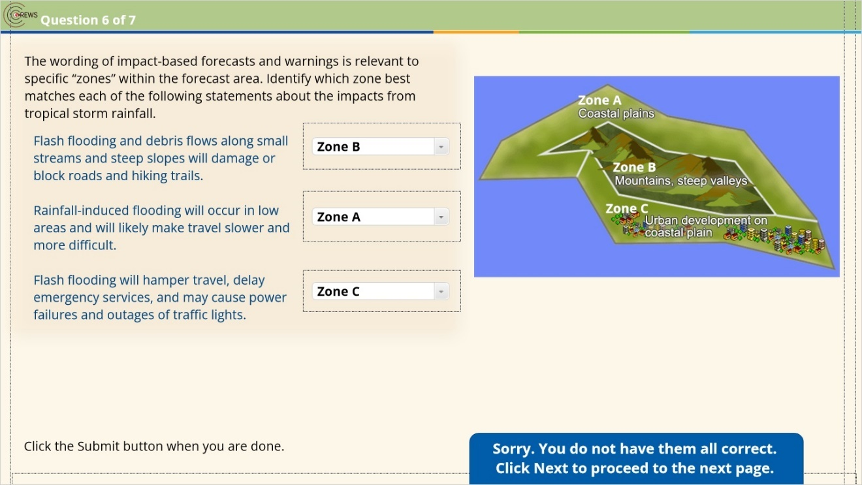

Correct (Slide Layer)
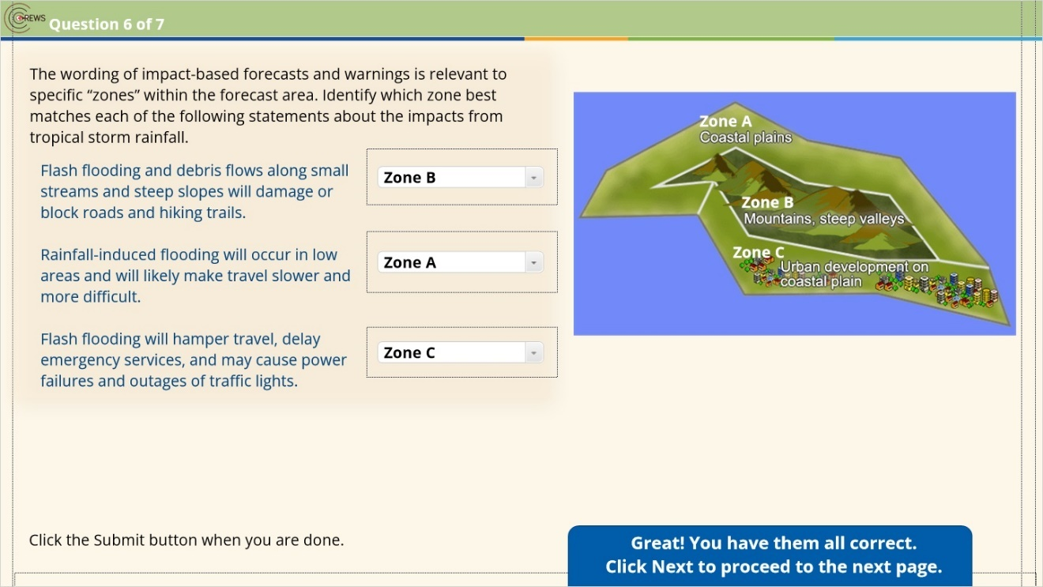

3.26 Question 7
(Pick Many, 10 points, 1 attempt permitted)
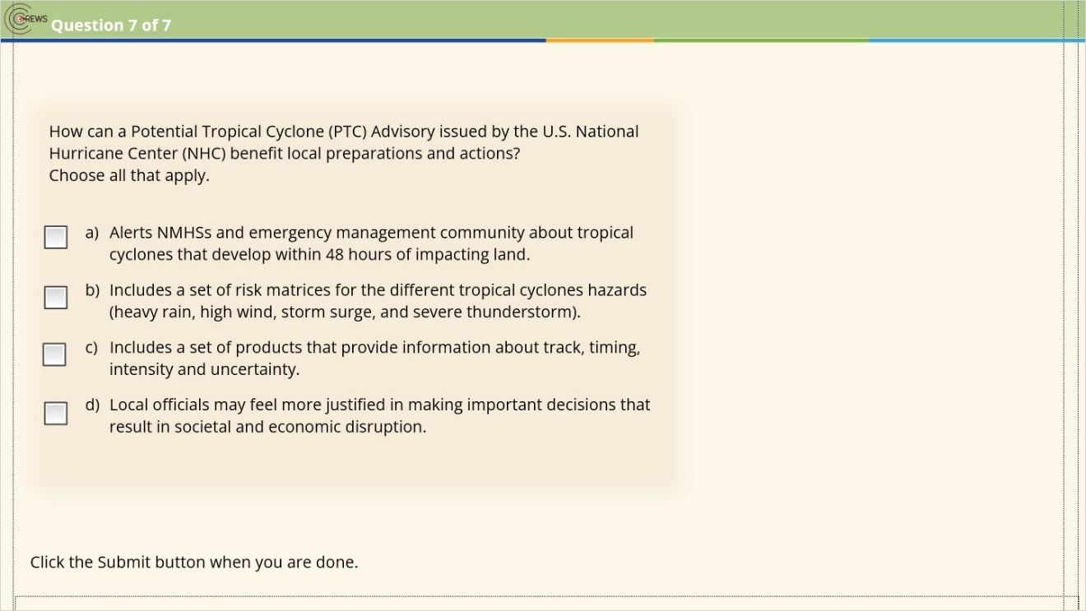
Correct | Choice
X | Check Box 1
 | Check Box 2
X | Check Box 3
X | Check Box 4

Incorrect (Slide Layer)
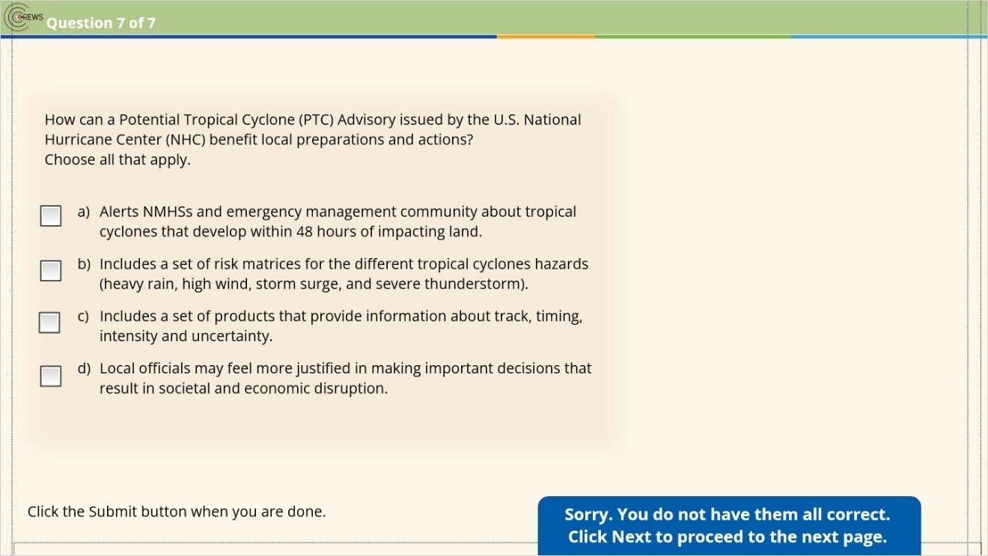

Correct (Slide Layer)
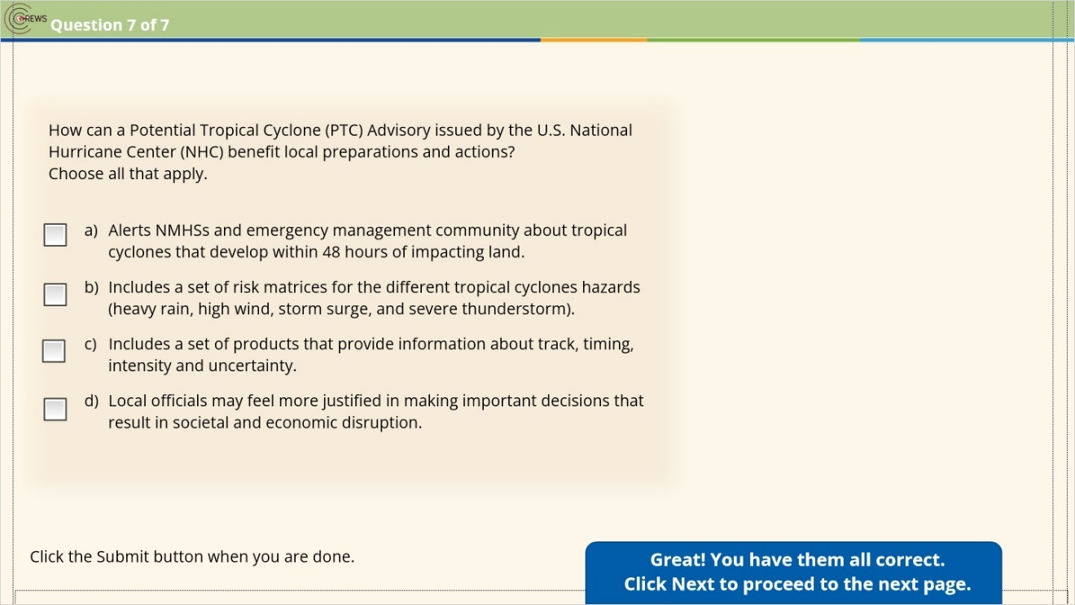

3.27 Results: Module 3 Knowledge Check
(Results Slide, 0 points, 1 attempt permitted)
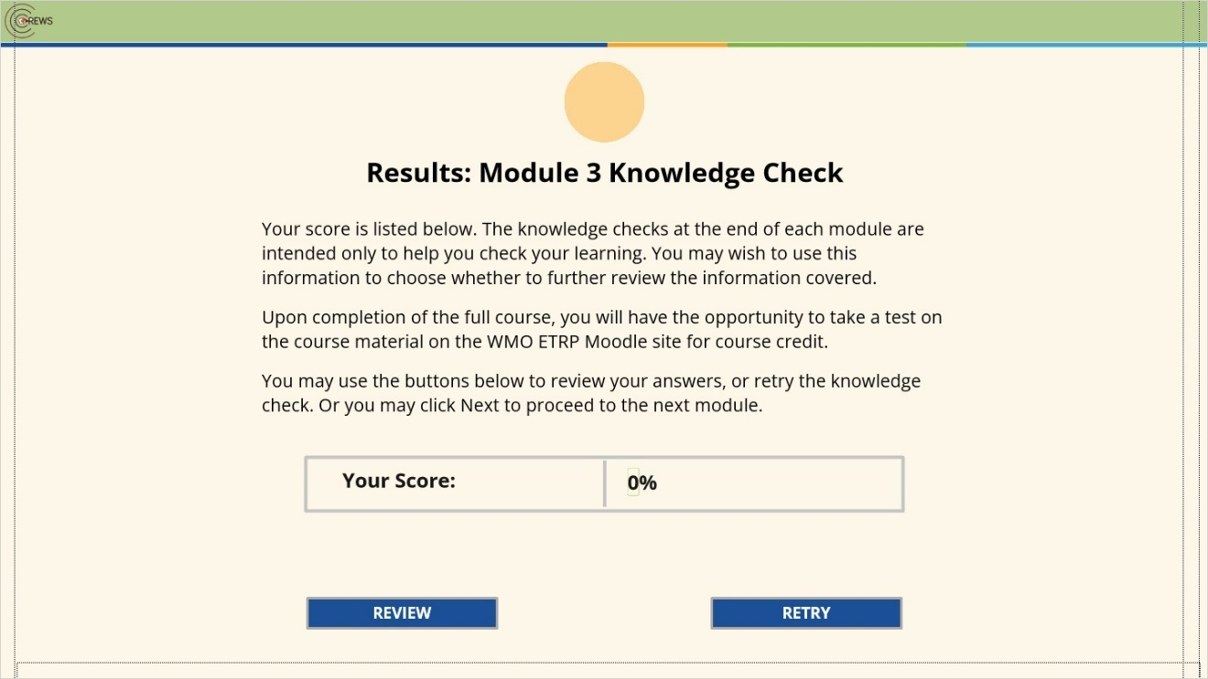

Results for
3.20 Question 1
3.21 Question 2
3.22 Question 3
3.23 Question 4
3.24 Question 5
3.25 Question 6
3.26 Question 7

Result slide properties
Passing  Score | 70%

Notes:

3.28 Key Takeaways: Using a PTC Advisory
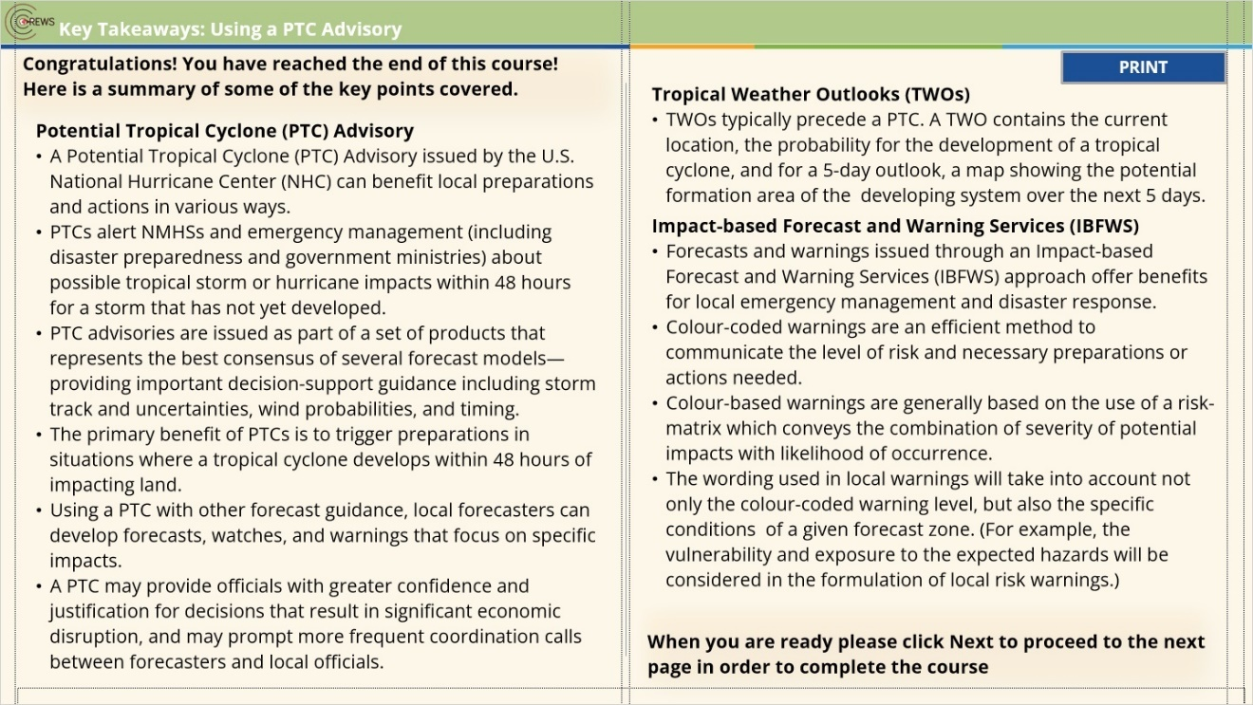

3.29 Course Completion
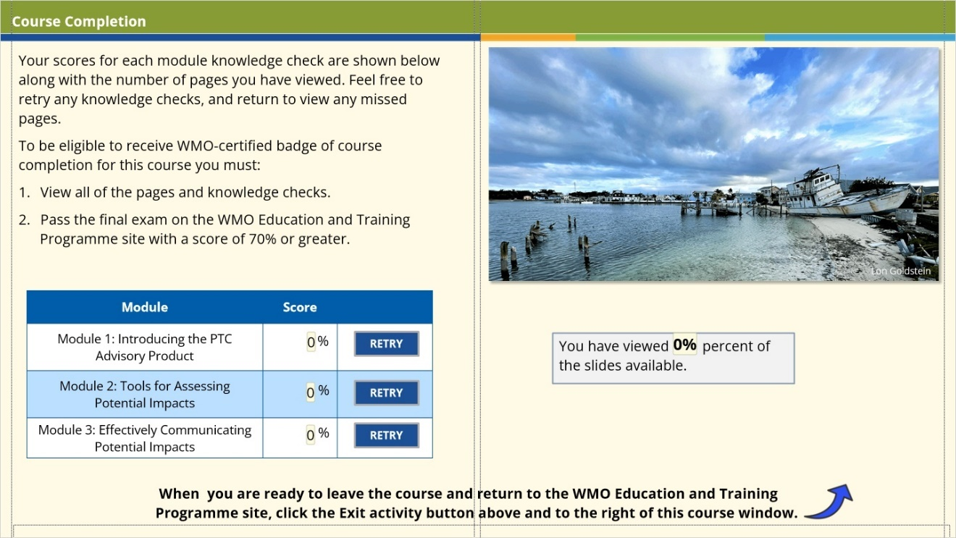
Notes:

