Neon Network

Overview
The central component in the Neon system is the "Neon Network". The Neon Network defines the organizational and physical hierarchy of data loggers and measured data.

One thing to clarify is that “nodes” in Neon do not necessarily refer to a single NRT. Neon nodes are only logical entities which are used to define the hierarchical logger network within Neon. They may represent actual physical NRTs, sites, regional areas, or be purely organisational entities.

Nodes may contain no NRTs or they may contain many NRTs.

User access to nodes is controlled by the defined hierarchy. For example, a user that has access to a particular node will automatically have access to all sub-nodes within that node.

The functions that a user is able to perform once they have access to a node are also defined by the user's security privileges. For example, a user may have the privilege to access the data measurements assigned to a node but not the privilege to configure the loggers assigned to that node. Also, a user may be assigned different privileges for different nodes.

For information on adding users, please go to System Administration > User List. (NOTE: You will only be able to add users if you have the appropriate security privileges.)

Node Tree
The node tree is a graphical representation of the Node Network and illustrates the hierarchy of the nodes in the network. Only the nodes that a user is privileged to access will be visible in the Node Tree.

The Node Tree is always visible in the left hand menu when a user is navigating between nodes in the network. The Node Tree will collapse and be hidden when the user selects away from the Neon Network to a different area of the Neon System, such as the System Administration area. The Node Tree will re-appear when the Node Network area is reselected.

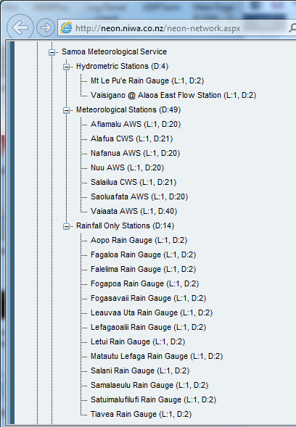

Expanding and Collapsing Nodes
When a node has sub nodes within it, it is possible to expand and collapse that node to show or hide its sub-nodes. This may be useful if the node tree has grown to a large size and it may be easier to view the full list of nodes if some of them are collapsed. To expand or collapse a node, you need to click on the plus or minus buttons respectively.

Node Details
The Node Details screen shows the basic information for a node. Across the top of the screen is a row of tabs that are used to select the different functions that relate to a node. The tabs that appear will be dependent on the security privileges for a user.

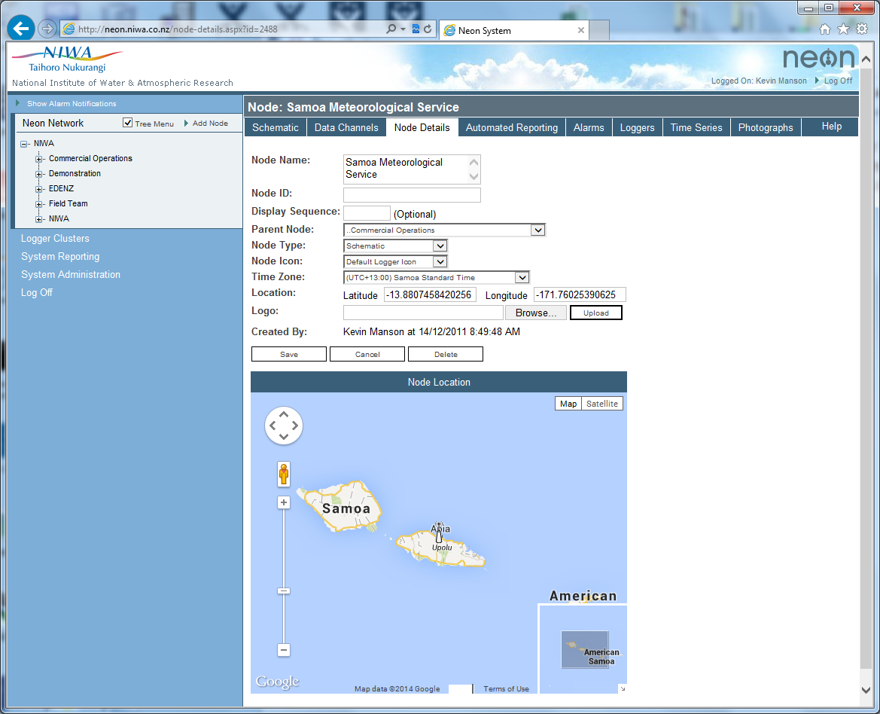

Adding a Node
Nodes are added using the Add Node link at the top right of the Neon Network panel at left of screen.

When adding a node, this Node Details screen is the only tab that will appear and must be completed before the node can be created. Once created, the remaining tabs for this node will be available for selection.

Deleting a Node
Note that when a node is deleted, any loggers on that node will be promoted to the deleted node’s parent node. i.e. the loggers are not deleted along with the node.

Mark for Deletion
This checkbox flags a node for deletion and is a warning to the user.

The node will be coloured red in the Neon Network tree. Each parent node higher up the tree will be coloured orange.

These colour highlights warn the user that the node is planned for deletion, and that they should contact the System Administrator before it is deleted if he would prefer the node not be deleted.

The time when the node is deleted is at the discretion of the system administrator.

Data Fields
The table below describes what each of the data fields mean in this screen.

Field | Description | Compulsory
Name | A name for the node. It can be any alphanumeric value. | Yes
Node ID | A user-based code for the node. It can be any alphanumeric value. | No
Display Sequence | Determines this node’s position in the node tree. Unnumbered nodes will appear first, followed by nodes in their assigned order. Unnumbered nodes are sorted alphabetically in the tree. | No
Parent Node | The node that this node resides under. If a node belongs to another, parent node, then users who can access the parent node will also be able to access this node. | Yes
Node Type | Indicates the type of node you have.  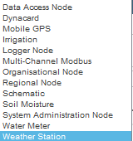  Additional tabs may become available depending upon the chosen node type. See further below. | Yes
Node Icon | Selects the size of the icon on the Node Location map below these configuration parameters.  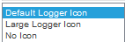
Time Zone | The time zone you would like your node to be reference by. All loggers below this node will have their data times affected by this setting. | Yes
Location | Physical location of the node, if applicable. The location is expressed in decimal format latitude and Longitude. | No
Logo | Attach an image to the right of your node details. | No

Node Location Map
The node icon is used to locate the node on the location map.

The default zoom level of the map and its type {Map, Satellite or Terrain} is configured under System Parameters in the System Administration section of Neon. These parameters are normally only configurable by an administrator.

Node Types:
For more information on additional data channel fields added for each Node Type see the Help screen for the Data Channels tab.

Data Access
Data Access nodes are the basic node type used to contain loggers. Data Channels are listed in tabular form using a standard set of fields.

Dynacard
Dynacard nodes are used by the Oil & Gas Industry to diagnose and monitor well pump performance. A special Dynacards tab charts load versus beam position.

Mobile GPS
Mobile GPS nodes update the logger icon position on Google Maps according to the logger’s latest GPS position. Mobile GPS nodes must use a GPS-enabled logger in association with a scheme that logs LATITUDE and LONGITUDE data channels that Neon can get its position data from. A track of the logger’s position over time is created on Google Maps as the logger moves.

Irrigation
Irrigation nodes add an Irrigation Map tab to the node that enables placement of live data channel icons onto a background image. The data channel icons will update their values automatically at the Map Refresh Interval.

Logger

Organisational

Region
These node types are pseudonyms for Data Access nodes but do not add any fields to the data channel. Their names better reflect the node’s intended use.

Water Meter
Water Meter nodes add a Multichart tab to the node as well as the following fields to each data channel.

Weather Station
Weather Station nodes add a Weather Station tab that contains special weather-related instrument panels for Wind Speed, Temperature and Humidity, Rainfall, Barometric Pressure, Solar Radiation and Soil Moisture.

Loggers (NRT’s)
Loggers are the physical devices in the field that measure and collect data, then send this data back to the Neon system. This screen is used to add and configure the loggers.

A node that has a logger associated with it is, by its nature, a node that represents a physical location. The only users that can add and change the configuration of loggers in a node are users that have the appropriate privileges for that node.

NOTE: An important concept in Neon is that of the time series database. This database holds all of the data that is generated by loggers in the field over time. It may also hold derived data that is calculated from the raw logger data. When viewing data, a user is not accessing the logger directly, rather they are accessing a time series that holds data from a logger. In most cases, there will a time series associated with each logger, but this is not necessarily the case and a time series may be created to hold derived types of data.

This screen lists the loggers currently associated with a node. To view the details for logger, click on the logger Name. If only one logger is present, that logger’s details page will be displayed directly rather than the list of loggers on that node.

