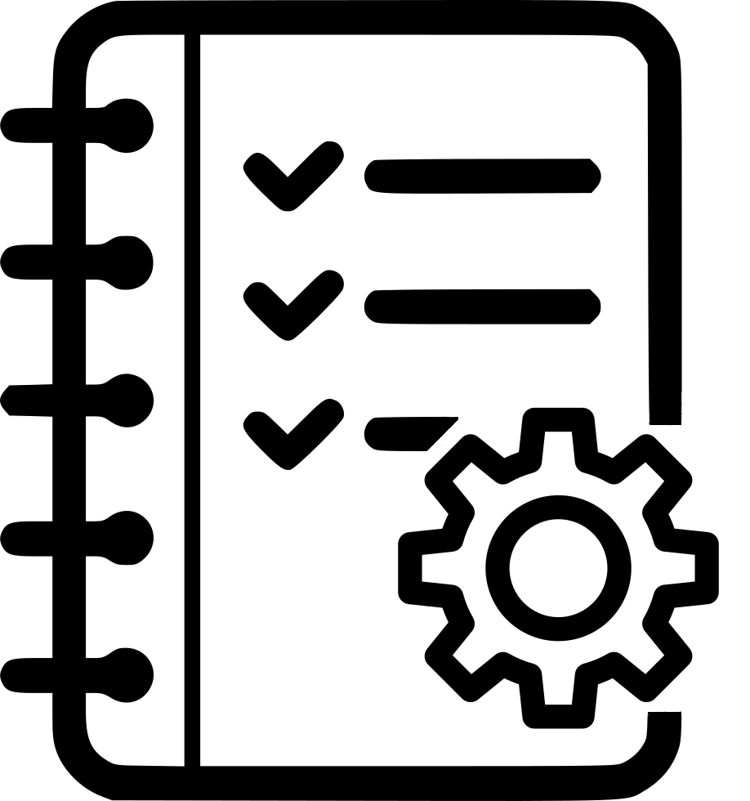 | Marine Service Delivery  Context Analysis

Submitter(s) Name(s)
Organization
Date

Service Area of Interest |  | List the service area (i.e., Services for the High Seas, Services for Coastal, Offshore, and Local Areas, Part IIb - Residential areas):
Include a short description of this service area as offered by your organization:

Primary Customers |  |  | Needs and Requirements
List all primary customers for this specific marine service: |  |  | List customer needs and requirements, including products, issuing times, dissemination/communication tools; indicate whether these have been verified through customer interaction or survey, or revealed by incidents:

Current Forecast Products and Services
Product/service |  |  | Description
List of products/services: |  |  | Description of current status of this forecast product, including issuing times, dissemination/communication tools, and verification processes:

Staffing and Roles
Staff |  |  | Role and Responsibilities
List of responsible staff for delivery of these products/services: |  |  | Description of current role and responsibilities:

METAREA Coordination
Describe the current level of coordination with your METAREA coordinator:

MHEWS
Comment on how your organization currently implements or plans to implement multi-hazard, impact-based forecasting for this service area:

CAP
Comment on how your organization currently implements or plans to implement CAP for this service area:

Discrepancies
Identify any discrepancies in current service offerings to those required by customers and as described in WMO-No. 471 and 558. Include incident descriptions that highlight the discrepancies, if known:

Suggested Upgrades and Improvements
Identify potential upgrades to tools, products, processes, and training:

Comment on how your services are, or can become, more customer-oriented. Indicate whether more customer surveys need to be conducted:

Review the Assessment of Service Delivery Progress Model (SDPM) conducted in Lesson 1. Will addressing the suggested upgrades and improvements assist your organization’s progress in implementing the strategies of the SDPM?

