Why is it important to share content?

The first and most fundamental question anyone arguing for sharing of free and open educational resources has to answer is: Why should anyone give away anything for free?
From an individual standpoint, educators most commonly mention (OECD, 2007) the pleasure of sharing with peers, the personal non-monetary gain such as publicity and reputation within the open community, and the altruistic motivation of sharing, which is supported by traditional academic values.
Educational institutions and other organisations also start from the point of view of altruistic motivation of sharing, but add that it is good for the institution’s public relations to showcase their work. They also point out that open sharing can speed up the development of new learning resources, stimulate internal improvement, innovation and reuse and help the institution to keep good records of materials and their internal and external uses.
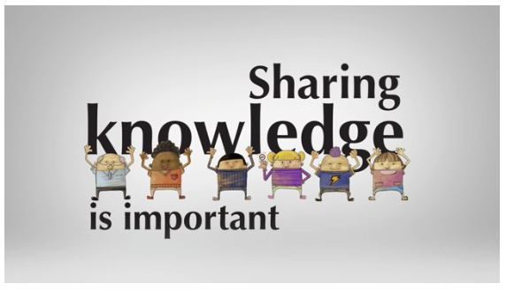
The short video clip below provides an inspirational representation of the points made above, showing how sharing and reusing Open Educational Resources (OER) can support better education and training opportunities by creating community-improved content.
WATCH NOW

http://www.youtube.com/embed/dTNnxPcY49Q

If you are not familiar with the concept of Open Educational Resources or just OER as it is most commonly referred to, it means “free and openly licensed educational materials that can be used for teaching, learning, research, and other purposes”. You can read more about OER and examples of great projects and organisations adopting the idea of Open Education at the Creative Commons website. The following link will direct you to a useful page https://wiki.creativecommons.org/wiki/What_is_OER%3F

How is sharing happening in our community?
Sharing of training resources or at least parts of content has always taken place in our community. Perhaps this may not have been as visible and active as we would like, or even not as easy to organise, but we do have good examples.
The WMO Course for Trainers is a good example to start with. The training resources used in the course were always produced with the intention to be shared and adapted. This intention has been recently made clearer by the inclusion of the Creative Commons license in the footer of the training resources (as seen in the footer of this document). One adaptation that has been done a few times in the training resources for the course is the translation. This meant the content was reused to offer training for trainers in English, Spanish, French and Russian. As part of the efforts to widen the use of these resources, they are now available to all in the Trainer Resources Portal at http://etrp.wmo.int/moodle/course/view.php?id=30
Another example regards to training resources produced by The COMET Program. Most resources on their website are freely available for reuse for non-commercial, educational use. The “Legal Notices and Reuse of MetEd Material”, that is communicated besides every training resource, includes a link to the Legal Notices page, where you can find information about credits and/or copyrights to be acknowledged when reusing their material. Easy access to clear information on copyrights is very important and can be a decisive factor on the decision of reusing an existing training resource.
In addition to the examples above, many others could be mentioned here. For the moment, a good place to check what repositories of training resources are available to consult, and maybe reuse, is the listing available at https://public.wmo.int/en/resources/training/wmolearn#

How can we encourage sharing and reusing?
Two of the main barriers for sharing and reusing training resources in our community seem to be the difficulty to know what OERs are available in meteorology, hydrology and related subjects, and the lack of information regarding the copyrights of some existing resources.
While good efforts to facilitate the discovery of existing training resources are being done by various WMO Regional Training Centres and other WMO-designated Centres engaged in training (e.g. example of listing available in the WMOLearn website cited above), there is still plenty of room to improve. Encouraging our organisations to engage with the ideas of Open Education, by discussing the advantages of sharing content, can make a great difference to the joint effort of increasing the availability of shareable training resources.
Another important step that we could all take is to make sure the copyrights of the resources we create are well understood and clearly identified. For example, do you know what are the copyrights of training resources you create as part of your job?

OECD (2007), Giving Knowledge for Free: The Emergence of Open Educational Resources. Available at http://www.oecd.org/edu/ceri/givingknowledgeforfreetheemergenceofopeneducationalresources.htm

