What do competency frameworks mean
for training providers?

This resource explains why WMO technical commissions have been developing competency frameworks for many of the service areas of an NMHS, and what they mean to the delivery of training services. For a more complete Guide to Competency, see WMO-No. 1205.
Why Competencies?
Competency frameworks are being developed in many professions and industries, including those related to meteorology, hydrology and climatology. Several benefits can come about from their introduction into training practices in national and international contexts. These benefits are why WMO Congress-16 recommended that all technical commissions make definition of competency standards in their areas of service a high priority.

Global standards: When competencies are adopted as standard practices, they can promote consistency of service across organizations. One of WMO’s missions is to introduce standards of service, and competency frameworks are a key way to do this. They enhance trust and stimulate collaboration. Globalization means that personnel should be expected to perform at similar levels and have similar skills no matter their country of service. In fact, each NMHS serves a global market, not just a national one. Global standards allow for training to be obtained from a variety of institutions, as long as those providers design courses that are driven by the competency standards.

Guidance for resource allocation: Competencies help organizations identify the most critical learning needs, but since competencies describe service responsibilities, they also may help to identify technical infrastructure needs. If projects and training events are clearly tied to competency frameworks, they will be more highly regarded.

Clarifying training needs: Finally, by using a competency framework to drive choices, training events will more likely address true job needs. If competencies have been used to help define the curriculum and learning outcomes, and to help determine the learning activities to achieve the outcomes, the training will be addressing true job needs, and not merely potential needs or nice-to-know information.

Training opportunities are precious. Considering the high cost of travel and facilities for face-to-face events, and the high cost of preparation and delivery of distance learning events, as well as the cost of lost opportunity to work when personnel attend training, the return on investment should also be high. Competency frameworks help to ensure this.

Types of Competency
Fulfill any job responsibility depends upon a range of skills and knowledge, as well as personal attributes or behaviors, often called attitudes.

At the base are the many Core Competencies, including fundamental skills like communication, team work, creativity, and leadership, as well as behaviors (attitudes) such as accountability, ethical treatment of others, and commitment to quality.

Above those are many Transferable Skills, which may be technical in nature, but are still applicable to many jobs. Computer skills, writing, research, and management skills are examples.

Finally, the most job-specific competencies are the Technical Competencies. These include the specific tasks that must be done to fulfill a job responsibility, as well as the background knowledge and skills required for the task. WMO is developing only technical competency frameworks currently.

Terminology
The terms used for competencies may vary between organizations. Some terms have very generic meanings, as well as the more specific meanings intended. For the sake of our discussion, let us assume the following definitions.

What are the alternatives to competencies?
If competency frameworks do not exist, we are left with several alternatives for deciding what training should occur. All the alternatives are either difficult or frequently flawed.

Needs assessment: If we want to be sure we are training people to address critical learning needs, we can perform a rigorous needs assessment that surveys representative workers, supervisors and managers, and experts. While this is always possible, the process is very time consuming. Having a competency framework means that half the work is done. A needs assessment is still required prioritize training, but that is easier than starting from scratch.

Persistence: Teaching what we taught previously is good ONLY if planning was well done, and only if the needs have not changed. Unfortunately, persistence is frequently chosen for expediency, to avoid taking time for a deeper analysis of needs.

Trainers decide: Trainers can be solely responsible for deciding what to teach, and they often make great choices because they are in touch with learners and understand their needs, and because they are often experts in the topics they teach. But they also can have incorrect assumptions, and may focus more on the content than on what learners need to learn most. They can also be biased by their own interests, and by their own strongest skill and knowledge areas.

Experts decide: For all their strengths, experts can have biases as well, and they may be more out of touch with learners since they may teach only part-time, if at all. Some may know too little about operational jobs, and can also lack knowledge of what novices are ready to learn, since it has been a long time since they were novices themselves.

Principles of competencies
Competencies have several characteristics. These can help us know when we are defining proper competencies that will stand the tests of time and, when defining them for international contexts, variations across organizations and regions.

- Because they describe job tasks and responsibilities, there are no basic and no advanced competencies, only those appropriate for different job functions. People can be novice or expert and possess the same competencies. They just apply them with varying degrees of skill. Competencies define what must be done, not the level of skill expected.
- Having a qualification, such as a university degree or certification, prepares a person to enter a profession, but it doesn’t mean that person is competent to perform the job assigned.
- Within different organizations, competencies may be carried out using different processes and procedures appropriate to the organization.
- Because they are written a high level and are fundamental to meeting job responsibilities, competencies should not require significant changes over time. The introduction of new tools or data does not change the responsibility or need to perform the tasks, even if they will be accomplished in a different way.

Anatomy of a competency framework
WMO seeks to standardize the format of its competency frameworks, but since the format has evolved over time, not all WMO competency frameworks will look exactly alike. The following boxes contain excerpts of a recent and relatively standard competency framework, written for the jobs of Public Weather Forecasters.

1. Fundamental WMO Competency Requirements For A PWS
Forecaster
The competency requirements . . . are divided into five top level competencies.

Taking into consideration the following:
(a) The nationally-defined PWS areas of responsibility;
(b) Meteorological and hydrological impacts on society;
(c) Meteorological and hydrological user requirements, local procedures and priorities.

A PWS Forecaster should have successfully completed the BIP-M (as defined in the revised WMO-No. 49, Volume I) and, in taking into account conditions a to c, should be able to perform the work indicated in the five top level competencies below:

1. Analyse and monitor continually the evolving meteorological and/or hydrological situation;
2. Forecast meteorological and hydrological phenomena and parameters;
3. Warn of hazardous phenomena;
4. Ensure the quality of meteorological and hydrological information and services; and
5. Communicate meteorological and hydrological information to internal and external users.

Each framework begins with a preface that has been written to achieve two things.

- Taking into consideration… It describes conditions that may cause the competencies to be varied in different contexts. If a weather service does not provide certain products or services, or does not experience certain weather phenomena, it may not need personnel to perform all the tasks or have all the skills and background knowledge described in the framework.
- Should have successfully completed… It also describes the qualifications that are expected to provide essential background knowledge.

The high-level competencies that follow the preface look more like a job description than a syllabus for training. They describe high-level responsibilities, which must be broken down further into tasks to reveal the complexity of the decisions and actions that need to be taken.

The high-level competencies are succinct, and they contain few indicators of the expected quality of performance. The tell WHAT to do, and not HOW to do it.
1. Analyse and monitor continually the evolving meteorological and/or hydrological situation

Competency Description: Observations and forecasts of weather parameters and significant weather phenomena are continuously monitored to determine the need for issuance, cancellation or amendment/update of forecasts and warnings according to documented thresholds and regulations.

Performance Criteria (or Components):
(a) Analyse and interpret data to identify weather features pertinent to the area of forecast responsibility;
(b) Monitor weather parameters and evolving significant weather
phenomena and validate current forecasts and warnings . . .
(c) Evaluate the need for amendments . . .

1.1 Background knowledge and skills
(a) Awareness of the importance of meteorological and hydrological services, and an understanding of the effects of forecasts and warnings on users and decision makers, in particular for public safety;
(b) An understanding of the key elements of synoptic, dynamical, and physical meteorology and core analytical/diagnostic skills at least to the level of a BIP-M;
(c) Application of the theory, methods and practices of meteorological and/or hydrological analysis and diagnosis;
(d) An ability to visualize/conceptualize meteorological and/or hydrological information in multiple dimensions (spatial, temporal);
(e) An appreciation of the influence of topography, land cover, and
(if relevant) bodies of water and/or snow fields on local meteorology;
(f) Interpretation of in-situ and remote-sensed observations and data;
(g) Understanding of the characteristics of meteorological and/or hydrological sensors and instruments;.
After the preface and introduction to the competencies, each of the high-level competencies is given a more complete description, including qualitative information. In addition, Performance Criteria or Performance Components are included, which break the high-level responsibility into smaller tasks, which may further differentiate responsibilities.

Finally, the Background knowledge and skills provide a detailed depiction of general skills and knowledge required to carry out the job tasks. These might have been learned during studies for a university degree or initial forecaster course.

The complete second-level competency information, including the Performance Criteria and Background knowledge and skills provides much more insight into the typical roles and responsibilities of personnel. WMO Members are expected to adapt the second level competency information to meet their specific national circumstances, taking into account institutional structures and responsibilities, technologies used, staffing, the service levels expected by customers, and the weather, water and climate phenomena that impact the country.

The role of competencies in the organization

Training evaluation flow | Organizational Goals | Training requirements flow
 | Organizational Resources
 | Job Competencies
 | Training Needs
 | Training Delivery

Well-defined competencies are central to meeting organizational goals. They provide a pivot point between the goals of the organization and the training that helps personnel to achieve the goals.

The relationships between these elements of a training system is important for determining training processes. Training needs and delivery decisions (what must be trained and how) are determined by the organizational goals, the resources acquired, and competencies needed to achieve them. Similarly, the quality of training delivery can be evaluated by how it impacts the development of the competence of personnel and, ultimately, how it helps the organization achieve its goals.

Who creates competency frameworks?
Within WMO, it is the Technical Commissions, which provide standards and guidance to the various service delivery areas of NMHSs, that are responsible for developing the competency frameworks. This is similar to how competencies are set in any organization. Training providers do not set them, even if training departments are expected to guide the competency definition process.

See also WMO-No. 1205.

Enabling skills, transferrable skills, and core competencies
While the WMO competency frameworks go a long way in describing the competence required of personnel in NMHS services, it is also important to describe forecaster skills in the use of some complex data and products in more detail. These “enabling skills,” in areas such as satellite and radar imagery interpretation, as well as the use of NWP products, are now in various stages of development. They will likely be referenced in the Background knowledge and skills sections of existing frameworks, although they will be described in their own frameworks as well.

Implementing competency frameworks
The development of competency frameworks is just a first step in the ongoing process of their implementation. After the establishment of a competency framework, three implementation steps should occur:

- competency-based training processes should be used,
- competency assessment of personnel should be conducted, and
- competency documentation, including competency development through training, should be one form of quality information included within a quality management system (QMS), or other human resources or talent management systems.

Competency-based training
So, how does the introduction of competency frameworks impact training processes? In fact, it impacts each step of the training cycle. It also is embedded in each of the competencies within the WMO Competency Requirements for Training Providers.

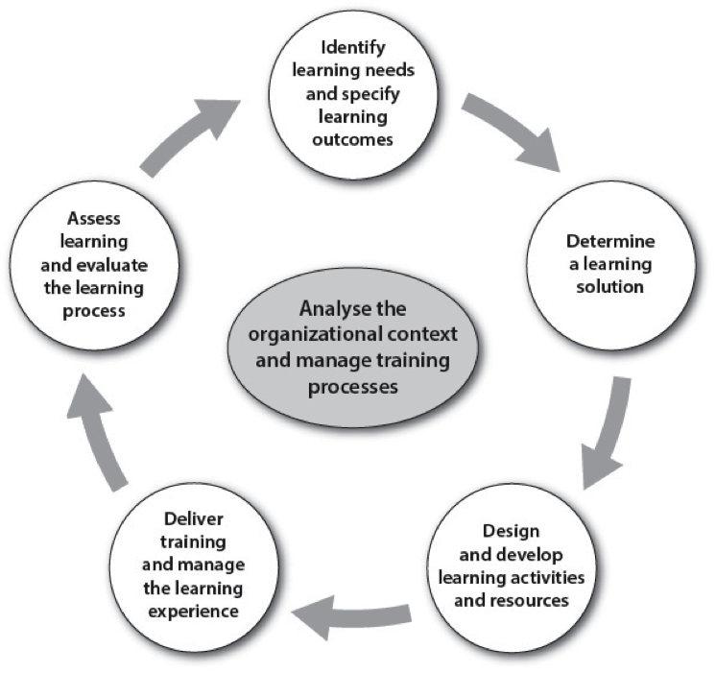

- Organizational context: Competency frameworks are a significant component of the organizational context, and will help to prioritize which training should be offered.
- Learning needs and outcomes: Defined competencies should guide the identification of learning needs, determining which competencies must be developed after a competency assessment of existing personnel, or showing which skills are most important to develop for new personnel. The performance criteria of a competency framework, those second level details of competency frameworks, should also drive the specification of learning outcomes.
- Learning solutions: To some degree, competencies will drive the learning solution, because the need to practice certain skills may determine which delivery format will be best. However, most learning solutions can contribute to any competency development, and informal, on-the-job solutions will complete everyone’s development of competence.
- Learning activities: The learning activities used during training should be driven by an analysis of the kinds of practice needed to develop competence. Training activities should resemble the job.
- Training delivery: Training delivery for competency-based training should include many opportunities for feedback and coaching to help develop improved performance. We learn by doing, but only if we also receive feedback about how well we are doing.
- Assessment and evaluation: What is assessed during training should be based on the intended learning outcomes, driven by the performance criteria of the relevant competency framework (see 2 above). Records of training should indicate how competency gains were assessed during training, which will lend validity to the training. Evaluation of the effectiveness of training should also be based on the competencies gained, not just on reactions to the training.

Competency assessment
Competency assessment, the assessment that is conducted to determine if someone can be entrusted to perform a job, is the second critical element in implementing competency frameworks. Competency-based training will help develop competence, but competency is ultimately demonstrated on the job. Therefore competency assessment data should ideally be gathered in the work environment. In the case of skills that are only infrequently applied, such performance during rare and extreme events, simulations can play a critical role in competency assessment. Many forms of competency assessment exist, such as observations, interviews, portfolios, testing, simulation, and third-party reports, such as feedback from customers, managers, and peers.

Competency documentation and management
Finally, competency frameworks make tracking the development of training and assessment outcomes essential. Quite often, a system of badges, competency transcripts, and assessment results need to become part of the ongoing and permanent records of personnel development, from entry into the organization to transitions of staffing in the workforce. In some organizations this is called talent management.

