The Training Cycle

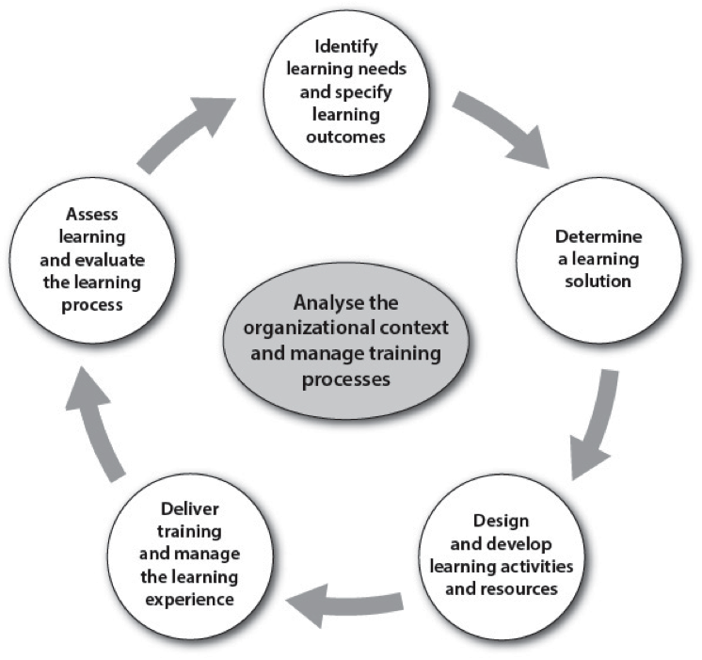

The training process is often depicted as a cycle. This depiction suggests a process of continuous improvement, both in terms of training processes and in terms of the professional development of learners.
- Being competent is a process of continual change—job requirements change with time and with technologies and organizational needs.
- Every organizational process offers room for continuous improvement based on customer demands and to meet changing service expectations.
- No professional ever stops growing in expertise—there is always something new to learn and ways to improve.
- No training organization is static either—opportunities for improvement always exist based on what is learned from past training and the evolving profession.
The training cycle reflects how this continuous improvement occurs.

This cycle is composed of interrelated components that are the steps of a systematic process, usually starting with identifying learning needs and ending with assessing learning and training evaluation. But the cycle can be started at other points, depending on what has previously occurred.

Each component also impacts the others through ongoing “formative” evaluation and reassessment of decisions and outcomes along the way, so the path is never completely linear—it is iterative and often adjusted along the way. In other words, training is also an interdependent system—it is systemic, and not just systematic. For example, learning needs determine what must be learned and how it should be taught, and assessments of learning that occur during or after a course might show that teaching methods should be changed. Lines could be drawn from each component to all the others to reflect this, rather than just to the “next” component.

Going through the steps in the training cycle when designing training provides opportunities to reflect on each aspect of the training, helping to make well informed decisions at each stage of the training design process. Keeping a record of all the decisions taken during this process by writing a Training Development Plan (TDP), like the one used in the WMO Course for Trainers, is a useful practice.

Appropriately, the steps in the training cycle depicted above define each of the competencies in the WMO Competency Framework for Training Providers. This competency framework drives the structure and activities that make up the WMO Course for Trainers. Each of the steps is further described below according to how they should be carried out according to the WMO competency framework.

Identify learning needs and specify learning outcomes

An analytical approach is used to identify organizational and individual learning needs, which are then specified in terms of a set of learning outcomes that describe what learners should be able to do after training. The learning needs can be based on job competencies already specified, but they are also guided by deeper analysis of the needs of a specific set of learners or the organization, as indicated by current levels of performance. Learning outcomes should be specified in collaboration with stakeholders so that, if the outcomes are achieved, learners will be able to perform the job at the expected level.

Determine a learning solution

The learning solution, or modality for training (e.g., formal versus informal, classroom versus online or on-the-job training), is determined based on pertinent criteria, and a plan is prepared for implementing the chosen solution. Some of these criteria include costs, organizational and audience characteristics, resource implications, and the extent to which they can satisfy the required learning outcomes. Solutions can be a mixture of formal, semi-formal and informal learning methods. Plans for implementing the chosen solution, including timeframe, costs, location, technologies, personnel, targeted learners and evaluation criteria, follow the choice of learning solution.

Design and develop learning activities and resources

The design of learning activities and resources are justified based on the intended learning outcomes and established learning theory. The choice of learning activities drives the learning experience, which should include practice in authentic tasks that represent what must be done on the job. They should build upon prior knowledge but challenge learners to grow further. Once designs are in place, development may include preparing presentations, resources to read or view, and resources to support activities. Trainers should test and revise the activities and resources during their development.

Deliver training and manage learning experience

Classroom and/or distance-learning courses are delivered in an environment that fosters lasting learning, including sufficient guidance and support. Informative, active and engaging learning activities are conducted with many opportunities for practice and feedback. Technologies are used to facilitate learning, and disruptions to learning are minimized.

Assess learning and evaluate the learning process

Learners are assessed against the intended learning outcomes, using both formative assessment during training, which gives learners and teachers time to adjust, and summative assessment at its completion, to certify that learning occurred and to provide recommendations for future improvements. Feedback and data are collected from learners and others involved in the training and used to improve the ongoing and future training.

Analyze the organizational context and manage the training processes

This component is an ongoing process conducted to ensure that training services meet the needs of stakeholders and that training is conducted according to established processes. The organizational context, including both internal and external factors, is analysed, and training plans, policies and processes are developed and monitored for effectiveness. Managing the process includes human resources management, such as hiring, developing, and providing feedback on performance. Keeping a written record of the analysis is valuable for continuous improvement. The Organizational Context Analysis template available on the WMO Resources for Trainers Portal provides a good basis for developing a written record.

