Levels of Training Evaluation

Just as it is important to assess learners, it is important to evaluate the training itself. In our diagram of the training cycle, evaluation of training is the step that leads to continuous improvement in the development and delivery of training. It is shown, along with assessing learning, as the 6th competency and final step in the process, because most training evaluation takes place at the end of training. But training evaluation is not isolated to surveys you submit to students at the end of training, and can occur during and long after training is complete as well.
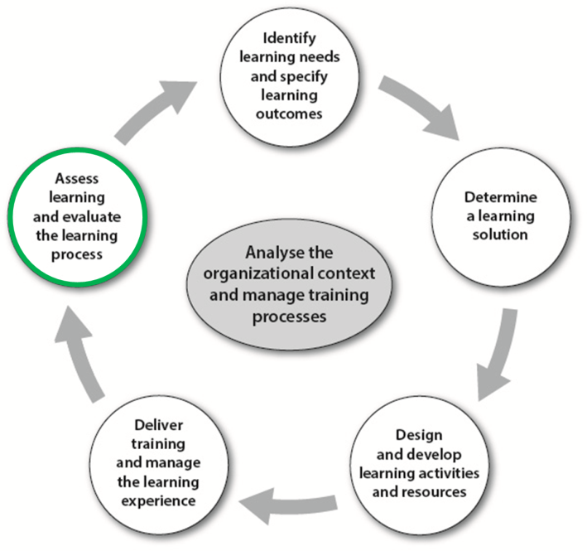
Who and what is evaluated in Training Evaluation?
It might seem obvious that trainers, along with the resources and activities they create, are evaluated. But from a learning systems viewpoint, there is actually much more to evaluate in order to get a complete picture. The table below lists who can be evaluated and what might be be evaluated about them.

Who is being evaluated | What is being evaluated
Learners (in this case, learners are evaluated as an indicator of training effectiveness, not as individuals) | Readiness for training, learning achievement, ability to apply learning, attitude toward the training
The training team (teachers, trainers, instructional designers, training support staff, administration) | Training content, training delivery, learning resources, learning activities, training logistics, and planning
The training department or academic department (including the managers) | Decisions on training needs and priorities, curriculum design, facilities and tools, and choice of learning solutions,
The organization or institution (those that set the curriculum or request training, and the managers who influence training decisions) | Decisions on training needs and priorities, personnel decisions, planning processes, support for and management of the training team
Learners’ organizations (those who assign training to learners) | Support for training application and performance improvement, support for organizational quality improvement

Levels of evaluation
Training evaluation can be seen as existing in at least four levels, defined in terms of purpose, who is evaluated, and scope. The four levels described here were made famous by Donald Kirkpatrick. For additional details beyond this short summary, try the following websites:
- http://www.kirkpatrickpartners.com/OurPhilosophy/TheKirkpatrickModel/tabid/302/Default.aspx
- http://www.businessballs.com/kirkpatricklearningevaluationmodel.htm

Level 1: Reaction
Participants’ thoughts and feelings about the learning experience are evaluated, including
- Whether they think it was effective
- Whether it was a positive experience
- Whether it was relevant and valuable
Who is evaluated? Directly, the training team is evaluated. Indirectly evaluated:
- the learners (Were they prepared and motivated to learn?)
- the training department (Was the training team well supported? Were conditions conducive to learning?)

Level 2: Learning
Increase in participants’ knowledge, skills, and improved performance are assessed.
Who is evaluated? Directly, the learners are evaluated. Indirectly evaluated:
- the training team (Did they design effective training?)
- the training department (Were good training development processes in place?)

Level 3: Behavior (or Application of learning)
Whether learners can apply, or choose to apply, learning to their jobs is evaluated.
Who is evaluated? Directly, the learners are evaluated. Indirectly evaluated:
- the training team and training department (Did training address critical skills and provide application practice?)
- the organization or institution (Is application-oriented training supported?)
- the learners’ organizations (Are supports and motivation in place to apply learning?).

Level 4: Results
The impact of the targeted learning outcomes are evaluated. Does the training, assuming it has been successful in achieving learning (Level 2) and has been applied (Level 3), have an impact on organizational performance?
Who is evaluated? Directly, the organizations in which learners work are evaluated. Indirectly evaluated:
- All components of the training system are being evaluated. (Did the training address priority needs? Is application of learning (transfer to the job) supported by the organization? Were assessments of learning valid? Was the practice conducted during training valid for application on the job? Were learners motivated to change and improve performance?

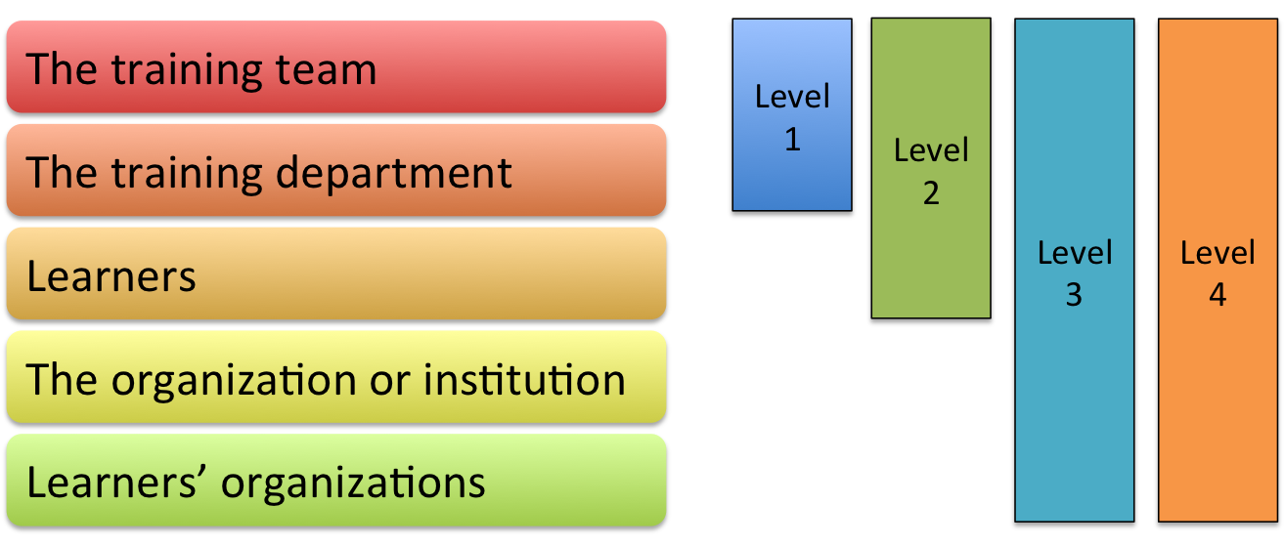
Who is evaluated at the four evaluation levels?
Examine the diagram above. Explain why the group of stakeholders being evaluated broadens as the level of evaluation rises. Do you disagree with any of the statements regarding who is evaluated at the different levels? What other components of the training system are being evaluated that are not mentioned?

