Interaction Modes
Education and training is all about interaction.¹ Without interaction with other people, a domain of knowledge, the tools of a profession, or the world in general, no learning can occur. Learning can be defined as a change in knowledge, skill or behavior in response to external influence, aided by internal reflection and practice. Interaction modes are the forms in which this external influence and internal response can take place. The brief analysis of interaction modes below is just representative, not exhaustive.

Scope of Interaction

The most fundamental variable regarding interaction mode is the scope of the groups of people involved. Because learning is also always a social activity, this can be also be the most crucial variable. Offering a variety of scopes of interaction within a learning experience can multiply the impacts of learning.

- Full group: When a learning event is created, it is most often, for logistical reasons, carried by bringing a number of students together at a single time to work with one or more teachers. In additional to logistical reasons, there is a value in allowing students to interact with one another. Many feel the optimal full group is no more than 20-30 students. One disadvantage of full group learning is that even at this modest size, not all students have opportunities to contribute.
- Very large group: A variation on the full group mode is the very large group mode, such as is found in large university lecture halls of 100, 200, or even more students. Interaction becomes very difficult, and often only a few students respond on behalf of the entire class. However, the introduction of technologies such as “clickers,” with which students can respond electronically to questions to help the lecturer gauge understanding, has led to more interactive very-large-group teaching. At the extreme end, Massive Open Online Courses, or MOOCs, may have 1000’s of participants. Interaction is still possible due to a variety of online media, such as discussion forums and social media. Both full group and very large group interaction modes can be accompanied by the use of meetings with teaching assistants or facilitators who interact with the students more directly in smaller venues.

- Small group: Breaking a class into small groups of 3-6 students is a very popular mode because it encourages more students to contribute. In small groups, students can be highly interactive with one another, and the teacher can move between groups to offer facilitation. Small group is a flexible mode, and many criteria can be used to form groups—mixed or homogeneous groups, hybrid groups that rotate to broaden interaction, groups in which students serve different roles, etc. (see Discussion strategies in the resource, “Learning Strategies.” ) Small groups might work together only briefly, or over extended periods under collaborative learning models.
- Peer-to-peer (pairs): Breaking the class into pairs offers an opportunity for intensive interaction. It can be benefit comprehension to discuss a topic from the perspective of one novice to another. However, smaller groups can also require more facilitation by teachers. Project work is often more effective in pairs or groups of three.

- Individualized learning: The ultimate small group is one person learning at his or her own pace, guided periodically by a teacher (unless luxury offers fully private tutoring). This mode is useful when students are highly heterogeneous, or when a few students are much more advanced or behind the group average. Individualized education plans are a compromise, providing time for individual coaching, but also full group work. Individualized learning is the goal of much computer-based instruction.
- Individualized small-group learning: A variation of individualized learning occurs when one or more instructors work with small groups for intensive training, such as on-site training at the place of work. The benefit is that the learners can learn in their everyday work environment, helping trainers to make the training as relevant and transferrable as possible.

- Self-directed learning: Finally, the self-directed mode is being used when a learner takes steps to learn without a teacher at all (informally), using readings and online research, and individual practice to deepen understanding or develop skills. More of our learning is self-directed than we probably realize. Some formal learning programs are self-directed in that while materials and a learning path is provided, the learner is completely independent in following this path.

Types of Interaction

Michael Graham Moore , followed by the Canadian scholar Terry Anderson, generated the idea of Types of Interaction , particularly focused on distance education, but applicable to any form of learning. This discussion expands upon Anderson’s work published in 2003, which covers the first six types described here. The Venn diagram below captures the sense of the range of interactions in a complex learning environment, viewed from the perspective of a learner.
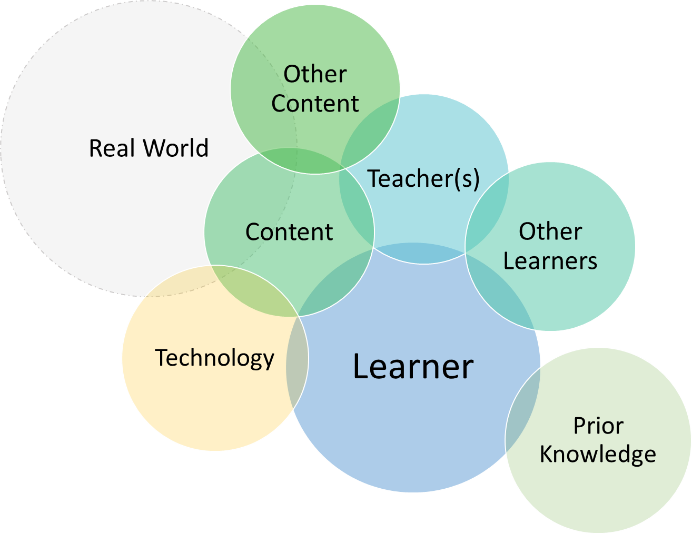
- Learner-Teacher: This most traditional interaction type includes the teacher lecturing or leading exercises and providing feedback to students. The teacher can take on many different roles, from deliverer of information, facilitator, and coach. In this relationship, there is always a question of who is in control during interaction, and how receptive or attentive the learner is during the interaction. Teachers might be more or less nurturing or challenging in their interactions.
- Learner-Content: The second-most traditional interaction is when the learner is reading, listening, making notes, taking tests, answering questions, and writing about the content. Note that none of these need to be characterized only by passive acquisition, but can also include active engagement such as reflection, questioning, and articulating content in new ways.
- Learner-Learner: This type of interaction can sometimes be de-emphasized in lieu of the learner-teacher type, but learners discussing and collaborating with other learners at their same level can be a critical part of learning. It can also help to build a helpful learning community that extends beyond the life of a single learning event. Other learners can bring complementary skills and knowledge, divergent opinions, and moral support for the challenges of learning.
- Teacher-Content: The teacher often has a special relation to the content due to their familiarity and participation as experts in the domain, and can be more or less protective of their authority, and more or less encouraging in the growth of new and equal experts. The teacher interacts with content in its selection, but also in assignments, explanations to students, the questions and exercises they ask students to respond to, and in the assessments they design.
- Teacher-Teacher : Teachers are never isolated experts, but part of a community within their domain of expertise. Sometimes they even co-teach to balance workload or, more importantly, complement skills and expertise for the benefit of students. During a course, a teacher might dialogue with other teachers, reference other experts, and cite the diverging or converging opinions of others in their profession.
- Content-Content: Learning content is not scripture (unless of course you study religion). It is chosen by a teacher to be representative of a discipline, a distillation at the level required by learners. Content usually includes references to other content , whether directly or implicitly. Content often borrows and adapts other content. At times, students themselves bring related content to a learning experience based on their own interests and discoveries.
- Learner-Self: A fundamental requirement of learning is self-reflection that checks whether one is understanding and learning. The learner always interacts with his or her growing self to observe and monitor the quality and value of that growth. Reflection might also identify emotions that help or hinder learning, such as fears about failure that must be managed, as well as the rewards gathered from the experience.
- Learner-Technology: Learners learn skills to manipulate tools that will help them practice within a discipline. These tools might be physical and tangible technologies used to manipulate data and materials. They might also be communication tools for producing and accessing information. The can also be conceptual tools for helping to analyze and synthesize new ideas and information.
- Learner-Prior Knowledge: Every learner comes to a learning opportunity flush with knowledge gained from prior experience. Some theorists suggest we that we never really learn new things in themselves, but merely connect them to our existing knowledge through a process of “accretion”, the way a crystal expands by growing new layers. In this way, learning is a process of considering how new knowledge fits with prior knowledge, through analogy or direct connection. New knowledge might also expand the applications of prior knowledge.
- Content-Real World: The content we learn can take various levels of authenticity in its relation to the real world. A teacher helps to make these connections through cases, stories, and example applications, but also through making a choice of content relevant to the work responsibilities a learner may be asked to master.
- Technology-Real World: The technologies that students use to learn with and through also have a variety of interaction levels with the real world. Simulation can be highly authentic, representing with precision the work environment, or, alternatively, simplifications that opt to suggest only key aspects of the work environment in order to reduce complexity. The tools students use to work with learning content might be derived from the real world, invented to approximate it, or meant to abstract it in order to reveal new perspectives not easily evident in the complexities of a real world situation.

Quality or Level of Interaction

Finally, a teacher needs to realize that the quality of the interaction plays a big factor in the learning that takes place. Not all interaction is equal. A button click to move to the next screen is not the same as responding to a simulation request to make a decision. The nodding head of a student in agreement is not the same as being questioned or challenged by a student about some aspect of the content. Quality or level of interaction might also be an indicator of the level of engagement, or the sustained curiosity of a learner that creates the conditions to learn more.

Below is a rough outline of levels of interaction, based on the quality of engagement.

- Avoidance: Characterized by non-participation or simple dismissal of new ideas without challenging them.
- Acquisition: Remembering what is being taught by accepting what it has to offer. Connecting new learning to prior knowledge.
- Participation: Willingly collaborating in learning activities, such as discussions. Dissent also counts as a form of participation, as long as it is supported by arguments.
- Contribution: A bit more than just participation, contribution means to actively share experiences that might benefit others and to help in generating new ideas, reacting and being open-minded to the ideas of others, and seeking balance in a project or discussion.
- Leadership/Coaching: Leadership can take many forms, such as formally or informally coaching peers who require help, or helping to move discussions forward by summarizing or weaving what has been offered by the group, or helping the teacher by offering an explanation in new words.

- Disruption: Interaction is not always positive. It can be disruptive to group learning by generating unnecessary distraction, often for the sake of self-interest or self-defensiveness when over-challenged. At times, there can be a fine line between dissention, which is challenging ideas through debate, and disruption, which is merely distracting from the subject at hand. Disruption might also be confused with leadership through dissent if minds are not open to new and validly argued ideas. The worst kind of disruption is exemplified by malignant trolling in social media, which purposely tries to generate argument without purpose other than to disrupt productive conversation.

--------------------------------
1. “Interaction (or its derivative term interactivity) serves a variety of functions in the educational transaction. Sims (1999) has listed these functions as allowing for learner control, facilitating program adaptation based on learner input, allowing various forms of participation and communication, and as aiding the development of meaningful learning. In addition, interactivity is fundamental to creation of the learning communities espoused by Lipman (1991), Wenger (2001), and other educational theorists who focus on the critical role of community in learning. Finally, the value of another person’s perspective, usually gained through interaction, is a key learning component in constructivist learning theories (Jonassen, 1991), and in inducing mindfulness in learners (Langer, 1989).

Interaction has always been valued in education. As long ago as 1916, John Dewey referred to a form of internal interaction as the defining component of the educational process that occurs when the student transforms the inert information passed to them from another, and constructs it into knowledge with personal application and value (Dewey, 1916). Later, from a distance education perspective, Holmberg (1989) argued for the superiority of individualized interaction between student and tutor when supported by written postal correspondence or via real time telephone tutoring. Holmberg also introduced us to the idea of simulated interaction that defines the writing style appropriate for independent study models of distance education programming, which he referred to as “guided didactic interaction.” Garrison and Shale (1990) defined all forms of education (including that delivered at a distance) as essentially interactions between content, students, and teachers. Laurillard (1997) constructed an ideal conversational model of learning applicable to all forms of education in which interaction between students and teachers plays the critical role. Finally, Bates (1990) argued that interactivity should be the primary criteria for selecting media for educational delivery. Thus, there is a long history of study and recognition of the critical role of interaction in supporting and even defining education.” ( from Anderson, T., 2003. Retrieved 30 March 2019 from http://www.irrodl.org/index.php/irrodl/article/view/149/230, Getting the Mix Right Again: An Updated and Theoretical Rationale for Interaction. International review of research in online and distance education, 4(2). https://doi.org/10.19173/irrodl.v4i2.149)

