Er Gaurav R. Choudhari (Junior Engineer)
working status:- Hydrology and planning circle, Nashik, Maharashtra(IND)
(Data collection) Hydrology Project Division Amravati, Subdivision Dhule, Nandurbar section.
Greetings Sir,
I used to collect data of rainfall and river discharge in my section and report to the subdivision office. In subdivision office data is filled in SWEDES software and is primarily valued. Then the primarily valued data is send to the Division office, there the data is secondarily valued in the HYMOS software. The data is stored in data collection center Nashik(MH)
About Tapi Basin
The basin extends over states of Madhya Pradesh, Maharashtra and Gujarat having an area of 65,145 Sq.km with a maximum length and width of 534 & 196 km. It lies between 72°33’ to 78°17’ east longitudes and 20°9’ to 21°50’ north latitudes. Situated in the Deccan plateau, the basin is bounded by the Satpura range on the north, by the Mahadev hills on the east, by the Ajanta Range and the Satmala hills on the south and by the Arabian Sea on the west. The hilly region of the basin is well forested while the plains are broad and fertile areas suitable for cultivation. The Tapi is the second largest westward draining river of the Peninsula. It originates near Multai reserve forest in Betul district of Madhya Pradesh at an elevation of 752 m. The total length of the river from origin to outfall into the Arabian Sea is 724 km and its important tributaries are the Suki, the Gomai, the Arunavati and the Aner which joins it from right, and those joining from left are the Vaghur, the Amravati, the Buray, the Panjhra, the Bori, the Girna, the Purna, the Mona and the Sipna. The major part of basin is covered with agriculture accounting to 66.19% of the total area. 2.99% of the basin is covered by water bodies. The basin spreads over 18 parliamentary constituencies (2009) comprising 12 of Maharashtra, 3 of Gujarat and 3 of Madhya Pradesh.

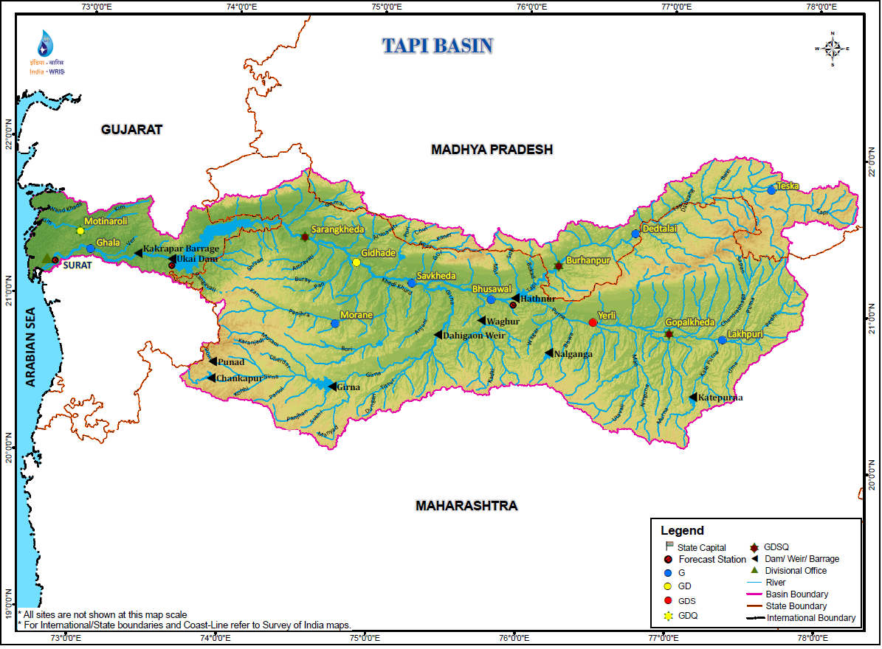

Climatic Conditions of Tapi basin
The climate of the Tapi Basin is characterized by a hot summer and general dryness throughout the year except during the south-west monsoon season in the upper and middle part of basin but the lower part of the Tapi River Basin shows variation in temperature, rainfall, humidity and other climatic parameters. The year may be divided into four periods. The winter from December to February, the summer from March to May, the south-west monsoon season from June to September and the post-monsoon period from the October to November.

Temperature
Temperature of Tapi basin is like any other part of central India, the temperature is maximum in the month of May and minimum in the month of December to January. In general, upper and middle part of Tapi basin record lower temperature as compared to the lower Tapi basin where the influence of the sea is prominent, and temperature fluctuation is lower than the upper and middle basin.

Rainfall
The south west monsoon sets in the Tapi basin in the middle of June and withdraws by mid October. About 90 percent of total rainfall is received during the monsoon months, of which 50% is received during July and August. The Tapi River basin shows different climatic characteristics due to the variation of topography from upper to lower part of basin. The average rainfall in the Tapi basin is 888.0 mm.

Wind
Wind speed profile of the basin, based on data collected, is given in table-7. The average monthly wind speed in the Tapi basin varies between about 15 km/h and 1.2 km/h. In the pre and post monsoon period, the wind speed is generally higher. The predominant wind direction is NW followed by SW and W.

Humidity
The morning relative humidity in the basin varies between 92.4 % to 34.6 % and the evening relative humidity is between 85.8 % to 25.4 % depending upon the season. Humidity is maximum during the monsoon months and is around 80% to 90%. In winter months of December and January, relative humidity comes down to around 30%. Variation in relative humidity between upper, middle and lower section of basin is not very pronounced except in the vicinity of coastal areas.
The last major flood in tapi river was in 2005. it brakes wire rope of winch and cradle at sarangkheda. The series of bandharas is constructed. sulwade, sarangkheda and lat barrage is prakasha barrage then the river enters in Gujrat state.

Thanking you..

