Plan for an EUMETNET Education and training (E&T) Programme.
Date: 01-09-2017

IT SHOULD BE VERY CLEAR THAT THIS IS A DRAFT PLAN AND NO DECISION HAS BEEN MADE YET. IT IS UP TO THE EUMETNET ASSEMBLY TO DECIDE UPON THE WAY FORWARD.

EUMETNET Working Group On Education and Training (WGET)
Heleen ter Pelkwijk (KNMI, Chair)
Didier Reboux (Meteo France)
Wilfried Jacobs (DWD)
Andrew Henretty (UK Met Office)
Sally Wolkowski (UK Met Office)
Kai Rosin (ESTEA)
Izabela Zablocka (IMGW)
Paulina Hellgren (SMHI)
Miguel Ángel Pelacho (AEMET)
Alessandro Chiariello (Eumetcal PM)
Anna Ghelli (ECMWF)
Mark Higgins (EUMETSAT)
Patrick Parrish (WMO)
Dick Blaauboer (EUMETNET)

Background
In Autumn 2016 during the STAC 13 and EUMETNET Assembly 16 the WGET Proposal for the EUMETNET strategy for Education & Training (E&T) was discussed and was adapted as uncontroversial. Since then WGET has worked on a plan for a future EUMETNET E&T programme, captured requirements and placed this work in the context of the global Education and Training Community. In Spring 2017 WGET already gave her view on a future marketplace for education and training. This document presents the full plan for a future EUMETNET E&T Programme.

The WGET Plan for a EUMETNET E&T Programme

WGET suggests that the EUMETNET E&T strategy plan can be pulled apart into three components, as illustrated in the sketch below:
- A marketplace functionality
- A training consultancy
- A joint E&T infrastructure with accompanied support

The outlined plan is designed to support the education and training needs of the full EUMETNET Community and will only be successful if it is well framed and clear. There are many different models of training provision within the EUMETNET community. Training design or supply is not expected to be provided for free and opportunities for paid work will be openly competed. This must be managed openly and without bias. The involved roles, requirements and the context with WMO Global Campus will be described in the next chapters.

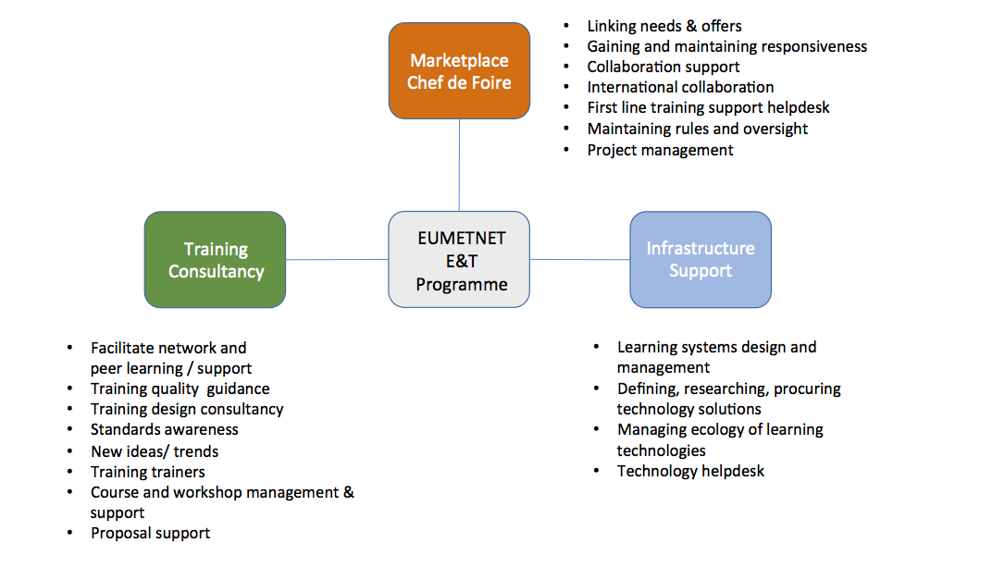

The benefits of this approach will be elements of cost efficiency through the provision of training resources which fulfil the needs of multiple stakeholders, the facilitation of coordination in work taking place in other international organisations and EUMETNET members’ training bodies or activities, (unexpected) collaboration between members, innovation of the training process and through more efficient procurement processes. It should be recognised that the following sections provide more detail about what is included in the marketplace, training consultancy and infrastructure support elements. Discussions about the resource required to support each of the elements are included in the options analysis in section 5.

The Marketplace functionality

The Marketplace is a metaphor for a place to ask questions, to be informed, to find solutions, to create and to maintain links between institutions. It is proposed to be a combination of an organising entity to moderate this marketplace supported by online functionalities. For this functionality, the capabilities being developed by the WMO Global Campus Project will be used as much as possible. Indeed, it is likely to further contribute to this project as the concept is developed further. The marketplace is not a place where institutions try to optimize their own activities or interest, but work together to resolve European wide training requirements. This implies commitment between all participating entities, to establish a real partnership between them, understanding and integrating the commercial objectives of the bodies, but agreeing that commercial aspects do not have to overcome general interest. The marketplace will provide mechanism for the development of the community, dialogue, commitment to share and help each other. Other words for a marketplace are Foire (Fr), Börse (De), Mercato (It), Turg (Et), Targ (Pl), Kauppatori (Fi), Market (En).

On this marketplace you will find:
- Offers: Providers of training can present their offers (capabilities, courses, resources and trainers) to the community through a European portal to the WMO Global Campus catalogue and calendar which pre-filters by our European location. Users will be able to see what is offered that suits their need within Europe and will be able to evaluate the potential return on investment. Work has been done through the Global Campus Working Group to ensure consistency in the presentation of offers so comparisons can be easily made and as the EUMETNET market place will be making use of capability provided by the Global Campus project, this capability will also be accessible to EUMETNET members.
- Demands: Through an online forum, users can inform the providers community and other potential questioners about their training needs. Users and providers can articulate their wishes and training providers hear perceived needs for the future and use this marketplace to start the negotiations needed to be able to implement training. It provides evidence that supports the legitimacy and mandate for a course.
- Interoperability: This represents how we will work together within our community in the most cost effective way. For this to be possible, there is a need for standards, protocols and procedures in infrastructure, design, presentation and competencies used. This will increase the quality of the material and the possibility to reuse the material. Again, this will draw on and at times lead work which is being developed within and for WMO Global Campus.
- Exchange/Nurture: within the future EUMETNET education and training community there should be mechanisms for the development of the community, dialogue, commitment to share and help each other.

These elements will lead to efficiency by reducing duplication and creating easier connections between the European E&T providers and users. Users will become aware of training offers they did not know about and thus avoid making investments in developing something that already exists. Leverage will be gained through the ability to gather together others with similar needs which makes it sometimes more worthwhile to organise a training activity. The marketplace integrates information and therefore allows training providers to generate intelligence from it for themselves. All organisations involved will be able to access competencies that they don’t have as an organisation, through a diversity of providers. These providers can be public, private, universities and NMHSs. This marketplace should make the capacity development activities easier.

The Marketplace functionality should
- provide a broker, with a helpdesk function where it is possible to make enquiries
- include animation, moderation and enabling constraints, rules and procedures to support efficient functioning
- include legal guidance on the reuse of materials, information or any other content available with the E&T Programme
- act as a neutral mediator to enable the solving of problems, to get projects started through seed funding or collaborations or capability, regulations and materials changed
- manage the tensions between the different agendas, sizes aspirations and mandates of participants.
All together the Marketplace should be a central place to go for all Meteorological related training that is easy to access and use. The marketplace should be integrated with WMO Global Campus and the detailed implementation plans of these activities should take account of the timeline for development of work within this WMO project.

To keep the Marketplace functioning well, WGET advises that the resource is required to moderate this marketplace with the following roles:
- Animator: For gaining and keeping responsiveness
- “Chef de Foire”: To maintain rules and oversight
- Broker: linking needs & offer, to second line support
- Helpdesk: For 1st line support
- Technical support and maintenance

The European E&T Marketplace primary role is to help address the education and training issues within the EUMETNET community AND to facilitate collaboration and coordination between the different training bodies at both a strategic and operational level. The connection between this marketplace and WMO Global Campus will aim to be seamless for the EUMETNET members who need capability beyond that offered within the EUMETNET community.

It should be noted that full training needs analyses will be required to support the detailed design of any training, particularly where courses will be developed to meet the needs of a number of stakeholders so that expectations can be managed. This capability has yet to be developed on either a European or Global scale and is not taken into the marketplace functionality.

Training Consultancy

Based on experience there is a large need for a centralised trainer support function to strengthen the quality of training through developing the community of practice and support on instructional design. This Training Consultancy will also aim to facilitate innovation in the training community. The use of innovative training approaches will be the only way to address the competing education and training needs of EUMETNET members - big and small. To do this, the Training Consultancy will:
- support training managers to make sure that they know what is available for new trainers and how the meteorological education system works
- develop and run community wide needs assessments, coordinating with WMO needs assessment gathering where possible
- support members to improve their capability in instructional design
- facilitate a network for friendly support from peers
- introduce new training practices/ trends from in and outside our community through, for example, the organising of conferences and workshops for trainers and supporting EMO-/ETR Office to run the RA-VI training of trainers training
- share success stories about training activities
- improve the use of resources
- encourage the community to talk about quality and help to set and/or to reach quality standards in in training (this includes the competency standards)

Depending on utilisation, the resource associated with the Training Consultancy could provide additional support with the management, design and implementation of courses on a cost recovery basis.

This is a really useful option if the development and innovation of the EUMETNET education and training community is desired.

A joint EUMETNET E&T Infrastructure with accompanied support

The scope of a joint EUMETNET E&T infrastructure support is to provide a base infrastructure of learning technologies to support training activities and collaboration as well as to facilitate sharing of technologies to bring efficiency across the network. WGET considers that a state-of-the-art infrastructure is one of the main and most needed features of the EUMETNET Education and Training Collaboration. Without this infrastructure, training development and delivery would get very challenging for small countries without their own training facilities. Also, it might enable countries with more advanced training facilities to access technologies they would not have.

The entity who manages the joint EUMETNET E&T Infrastructure should:
- manage the shared (state of the art) infrastructure(s) including the current technical suite:
- a Learning Management System (Moodle)
- a video-conferencing system tailored for online training activities
- a document collaboration environment
- a calendar of events (through Global Campus) which is currently managed by EUMETSAT
- manage ecology of learning technologies, be aware of what is needed and what is the best solution for the problem at hand
- research finding technical solutions (learning technologies and collaboration tools)
- capture the user needs definition and write the needed documents
- manage the contract placement & procurement, and maintain the communication once in place
- keep up a list of free and open source software (FOSS) tools that the E&T community may find useful to training development and collaboration
- provide support and training on how to use the shared tools and infrastructure
- enable the sharing of others’ infrastructure within Europe (examples: the simulator building tool from UK Met Office and the option to get help to build a MOOCs from EUMETSAT)
- support the network of technical support officers across EUMETNET members

Tools like a video-conferencing system and a document collaboration environment are possibly also needed in other EUMETNET projects and could be shared. In that case the EUMETNET E&T project would manage the interfaces to these tools.

Depending on utilisation, the resource associated with the EUMETNET E&T Infrastructure could provide additional support with the use of the shared infrastructure on a cost recovery basis.

WGET thinks that this is a mandatory option to be able to run a EUMETNET E&T programme.

Does this future EUMETNET E&T plan duplicate WMO Global Campus?

The WMO Global Campus is planned to enhance the collaborative network of WMO Member institutions and National Meteorological Hydrological Services involved in the development and delivery of education and training. Its goal is to better address the evolving global priorities for learning. It is the fruit of the synergies, sharing and cooperation within this community of institutions. At this moment a feasibility study on the WMO Global Campus concept is being conducted. A decision on endorsement of WMO Global Campus will be made at the 18th World Meteorological Congress in May 2019. The Global Campus Feasibility study is targeting two WMO priority areas, the RTCs and developing countries. The primary WMO Global Campus coordination and communication mechanism can be found at: https://public.wmo.int/en/resources/training/wmolearn

Seen from an international perspective, most but not all of the RA-VI countries represented by the NMHS, ECMWF and EUMETSAT are within the EUMETNET structure. The work within the proposed EUMETNET E&T structure will form a contribution to RA-VI Global Campus work, alongside other individual NHMS Global Campus contributions. This is in keeping with the WMO regional structure of six regions, each with presidents, vice-presidents, and management groups, as well as WMO Regional Training Centers. Additionally, through engagement and strong links with WMO, the work that will be done in Europe by EUMETNET will draw upon the experiences, resources and infrastructure generated in other WMO Regions in support of Global Campus.

Within Europe we will specifically benefit from the centrally facilitated WMO Global Campus activities like
- a course calendar / database tool (database[s] / API[s] / web GUI). The training institutions can easily implement their own GUI, to customize the training calendar interface in their sites
- a learning resource database or catalogue (currently intended to be based on Open Educational Resource Commons technologies),
- WMO ETR Training of Trainers

It is proposed that access to the Global Campus calendar and catalogue will be through a Europe / RA-VI dedicated front-end portal with an easy option to view the global portal as well. The purpose of our work is to support Europe, and this is a defining the condition of our work. The focus is the user in the EUMETNET community and the provider may be from within or outside of the EUMETNET community. It should also be noted that updates which are made to the calendar or course catalogue within the European portal will directly update the Global Campus calendar and catalogue.

As Eumetcal Community, we highly appreciate the great work done within the European E&T network during the past 15 years. We didn’t realise the power and value of this network until it was less proactive for a short period. As community, we just don’t want to give up things we have accomplished in this collaboration. It is great to see that the desire for a wider collaboration in education and training clearly has grown at European level in the recent years.

Given,
- the EUMETNET strategy which shows human resource challenges (capacity and capability) of the EUMETNET Services for the future
- the current Eumetcal programme doesn’t have the capacity to fully support the member states activities and help to make them more efficient or even possible
- there are training capabilities and capacities available across the member states
it is clear that there is a requirement for a revised Education and Training programme within Europe. The programme which has been proposed by the WGET aims to utilise the capability provided by WMO Global Campus but tailor it to our European stakeholders needs.

WGET suggests that this Future EUMETNET E&T Programme will contribute to the European related Global Campus work that really needs to be done. The main strength of this EUMETNET E&T Programme is the facilitation, the presence of someone behind these dedicated environments to support members in their work. A European state of the art E&T network in its turn can help the WMO Global Campus project to make steps forward by leverage the knowledge and resources developed in Europe, ensuring Europe remains present on the global stage.

Roles involved in this future EUMETNET E&T Programme

To frame this EUMETNET E&T Programme in a clear way the WGET has described roles and skills needed for the three components of the future EUMETNET E&T Programme, the Programme Management, the Governance and Participants in the Programme.

The WGET advises STAC to consider the following principles for a future EUMETNET E&T Programme, inherited from the WMO Global Campus.
Institutions
- are encouraged to contribute
- should bring value to collaborations and agree on equity in the collaboration
- agree to share information about their offerings (note this could be commercial and non-commercial)
- agree to treat each other fairly and with mutual respect
- ensure any collaborative platform has community ownership and coordination
- respect and abide by the copyright and intellectual property of others
- can seek advice from the Chef de Foire in case of any barriers arising
- agree to meeting minimum WMO ETR / EUMETNET standards and practices for offerings

To work for this future EUMETNET Education and Training Programme the people need
- to have understanding of the meteorological operational service delivery context
- to be diplomatic, show no bias and have a good communication skills, working well across European cultures, openness, willingness to communicate and travel

Marketplace
Support needed around the Marketplace:
- Animator: For gaining and keeping responsiveness
- “Chef de Foire”: To maintain rules and oversight
- Broker: linking needs & offer, to second line support
- Helpdesk: For 1st line support
- Technical support and maintenance

Participants in the Marketplace need to commit to
- participate following the principles of the Marketplace as they develop
- respect each other, be open, be realistic about what can and cannot be done ...
- act in solidarity

Training Consultancy
Support needed to be able to work on strengthening the quality of training (Training Consultancy):
- Facilitate network and peer learning / support
- Training management skills as applied to training institutions
- Instructional design consultancy - across instructional design areas, standards in our community, new ideas/ trends from in and outside our community, train trainers in training, get people talking about quality
- Communication skills
- Course and workshop management skills
- Ability to support/assist a member when drafting proposals
- Technical support and maintenance skills

Joint EUMETNET E&T Infrastructure
Support needed around a joint EUMETNET Infrastructure:
- Very good learning systems design and management skills. The needed skills can be taken from the Guidelines for CMALT candidates and assessors:
https://www.alt.ac.uk/sites/alt.ac.uk/files/assets_editor_uploads/CMALT%20Guidelines%202014.pdf
- User needs definition capture / writing
- Researching finding technical solutions (learning technologies and collaboration tools)
- Management of contract placement & procurement, and corresponding communication once in place
- Management of ecology of learning technologies, be aware of what is needed and what is the best solution for the problem at hand.
- First line training and Helpdesk: provide 1st line support
- Support the Technical Support Officers’ network
- Basic knowledge in CSS/HTML5/Javascript, social media

The governance
WGET suggests that the future E&T programme requires appropriate governance to be able to be flexible and adaptive when needed however keeping the changes within the frame and scope of the programme. In this regard the following roles should be kept:
- Ability to provide useful oversight to the programme
- Ability to monitor implementation of the program
- Ability to manage changes needed during program implementation

WGET is prepared to take this role and advise STAC accordingly.

The different EUMETNET E&T Programme Options

The following section presents a number of options so that STAC and the EUMETNET Assembly can make clear choices which ensure there is enough resources to deliver against the expectations of members and to prevent misconceptions of what the programme can deliver. It is recommended to STAC and EUMETNET Assembly that the structure and resourcing of this new EUMETNET E&T programme is reviewed in 2 years to establish fit against changes in the external environment and that a time bound programme of deliverables is put in place.

Option 1

Eumetcal as it is today: continue with Eumetcal as it is (consisting of components of the in chapter 4 suggested Infrastructure and Training Consultancy and only available for EUMETNET Forecasting Programme) with 1.25FTE plus 68 KEUR for implementing the actual project activities (e.g. organization of Eumetcal workshops, maintenance of training infrastructure, coordination and support of expert teams, support of NMHSs’ staff to participate in E&T activities, travels of project management team).
In the following an estimate of the 1,25 FTE work distribution in the various project activities:

1. 0.2 FTE Support to member events (advertising, teaching, organising, participant finance)
2. 0.1 FTE Facilitation/coordination of themed expert teams
3. 0.2 FTE Collaboration with other projects / institutions / networks
4. 0.35 FTE Support to and maintenance of technical infrastructure (training portal, videoconferencing system, online learning environment)
5. 0.1 FTE Planning and organizing Eumetcal workshops
6. 0.1 FTE Communications with project stakeholders, members and users - newsletter etc.
7. 0.2 FTE Project management - monitoring, reporting, planning

The option 1 strengths:
- Facilitate and promote collaboration on E&T matters among members and international organizations
- Financial support for NMHS staff (meteorologists or trainers) to attend training courses and events
- Coordination of Expert teams for development of learning opportunities e.g. EPS modules; Marine course (supporting EUMeTrain activity); Radar course; HIW team
- Planning and organizing Eumetcal workshops, to strengthen the network of trainers, introduce new ideas, trends and practises in training,
- Focused on meteorological operational forecasting,
- Current Eumetcal management team has the core competencies to facilitate the network and have the respect and attention of the people they work with.
- Eumetcal today has some international collaborations which are leveraged to support and contribute to the development of learning opportunities in Europe (e.g. COMET; MSC to support the EPS lessons)
The option 1 weaknesses:

- Only focusing on meteorological operational forecasting. The other EUMETNET initiatives may want and need support in the E&T environment.
- Eumetcal does not provide a unique way to access international learning resources: NMHS training managers and trainees have to look for resources on Eumetcal, EUMETSAT, EUMeTrain, COMET, systems. It is extremely challenging for training development that the useful learning resources are spread over so many portals.
- Eumetcal has the capabilities to support and assist the development of learning opportunities that reaches a few hundred people. Actually we have about 4000 forecasters in our part of Europe.
- The project does not have the capabilities and tools to facilitate partnership and provide support at the level needed in the community. The Marketplace functionality would be a good additional capability.
- The project performs national service training needs assessment through different channels, e.g. from the heads of forecasting meeting, workshops and sporadic member states visit. However there is need for a more thorough and comprehensive needs assessment that training organisations can respond to.
- The project does not address the communication on available courses standards, needs, and tools at least at European level.
- The FTE level requires split attention (inside Eumetcal and split with other activities in the implementing partner) and so inefficient.
- Training quality is a free for all, there is not peer review, stimulus to find areas of low quality and improve. The project does not have capabilities to provide a widespread and systematic support for improving training quality, e.g. promoting course information sheet, training development plan, etc.
- The project success depends very much on the skills of people the coordinating member assigns to implement the project (RISK).

The current EUMETCAL project is not functioning to benefit all members so there is a requirement to refresh the aims of the project as agreed at STAC. Therefore this option is not recommended.

Option 2

Functions: Infrastructure/Training Consultancy plus a modest implementing budget comparable with the current Eumetcal Budget and 2 FTE. The programme management like monitoring, reporting and planning is included in these 2 FTE

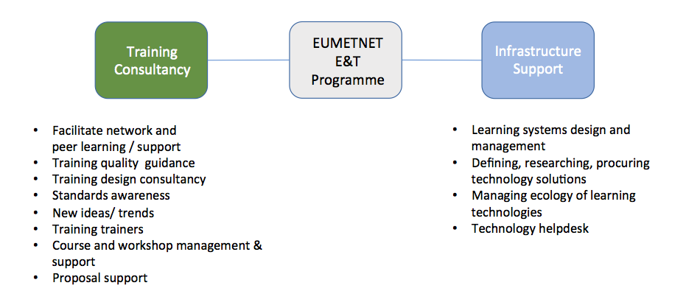

The option 2 strengths:
- Smaller training functions have the support they need to deliver the internal training their services need.
- Everyone has access to the shared infrastructure
- We get the wider and more strategic collaboration that we need
- The needs assessment is available and used to drive the training that is implemented.
- Development of the training network and peer learning is happening.
- Cost saving on Infrastructure
The option 2 weaknesses:
- Without the Marketplace we cannot extend to other areas such as climate, hydrology, observations - the training function is much less responsive to the operational needs than is required by the services to develop.
- Many countries are inventing the same wheel because of lack of coordination.
- Without the Marketplace it is more difficult to link needs and offers. We may know the needs but have no coordination to meet the needs from within the community.
- No enhanced communication and coordination possibilities - no facilitation of coordinated actions / cooperation (we get quite far today but know there is much more needed).

After the strategic discussion WGET found that this would be Eumetcal as WGET wishes it to be. In this “Eumetcal 2.0” intended for the full EUMETNET programme you will find a training consultancy and infrastructure to standards, but no Marketplace and therefore not the most desired solution.

4.3 Option 3

Functions: Marketplace / Infrastructure plus a modest implementing budget comparable with the current Eumetcal Budget and 2 FTE. The programme management like monitoring, reporting and planning is included in these 2 FTE

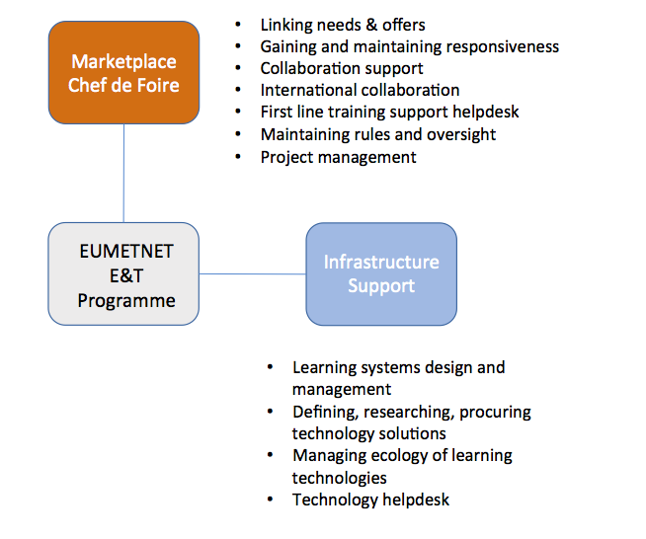

The option 3 strengths:
- Wider than forecasting - all operational areas of Eumetnet members.
- Allows coordination and fluid communication between organization
- Allow larger collaboration opportunities & more people being trained
- The system is flexible and adaptive: it can flex to the needs, community resource are deployed to the priorities and how they evolve, it allows for different ways to achieve a goal people work together or bring money together for a single procurement or ...
- The facilitation of matching between the operational challenges and the training is provided.
- Collaboration at strategic and operational level, for example: aeronautic qualification - we have a large & shared problem (strategic) or climate service training support (again strategic) or operational such as a nowcasting course, implementing a climate course (this uses the expert teams).
- The Marketplace will intensify the international collaborations (e.g. COMET; the rest of the WMO Global Campus). People will be continuously informed about training offers and could plan accordingly well in advance
- Relies on national training quality approaches
- Cost saving on infrastructure
- Could generate revenue for the stronger training providers by providing an expanded market.
The option 3 weaknesses:
- People may expect Eumetcal type courses (if this a training consultancy role rather than marketplace role - the marketplace may mitigate some of this loss.)
- No Eumetcal workshops, no developing of the community of trainers
- Budget emphasis on marketplace - no financial support of people to courses
- No support for countries without national training quality systems that work for the meteorological training institution.
- Getting new ideas and expertise in relation to training has to be done on an individual institution basis
- Needs assessment would be missing (or has to be done as part of marketplace)
- No training design consultancy - institutions that are not able to have this skill available will be left without guidance and advice. This is not feasible option for those institutions, it may suit countries with larger training institutions but removes a/the key benefit for the smaller institutions.
- Risk: we have not yet implemented a marketplace so we don’t know what will and will not work. Require an adaptive project management/implementation approach.
- Risk our old thinking keeps us working in old patterns ... the “Eumetcal course” is depreciated

In this option intended for the full EUMETNET programme there is nothing on training consultancy. As the WGET really believes in the need for training consultancy within EUMETNET this is not a feasible option. It may suite the countries with larger training institutions but will leave the smaller institutions that are not able to have this skill available without guidance or advice.

Option 4
All Functions: Marketplace / Infrastructure Support/ Training Consultancy plus a modest implementing budget comparable with the current Eumetcal Budget and 3 FTE. The programme management like monitoring, reporting and planning is included in these 3FTE

The option 4 strengths:
- All E&T within Europe (Eumetcal, EUMeTrain, EUMETSAT, WMO Global Campus) is fully integrated and presented through one window and you have one point of contact for all E&T related contacts.
- It has the very needed European wide coordination, facilitate partnership, advice within the European E&T world
- Having solidarity and help to solve your own E&T problems.
- Saving time and money for each country in this buffet.
- Wider audience for your courses. (Save money)
- Wider than forecasting - all operational areas of EUMETNET members.
- Efficient utilisation of resources will be paramount

The option 4 weaknesses:
- Members may not support this level of increase in resource

This option intended for the full EUMETNET programme includes all that is written in the, by STAC and Assembly, adopted proposal for the EUMETNET strategy discussion in the area on Education and Training (E&T), see chapter 7.1, and is therefore the most desired option for WGET.

Option 5
All Functions, slightly reduced capability across all three: Marketplace / Infrastructure Support/ Training Consultancy plus a modest implementing budget comparable with the current Eumetcal Budget and 2 FTE. The programme management like monitoring, reporting and planning is included in these 2FTE

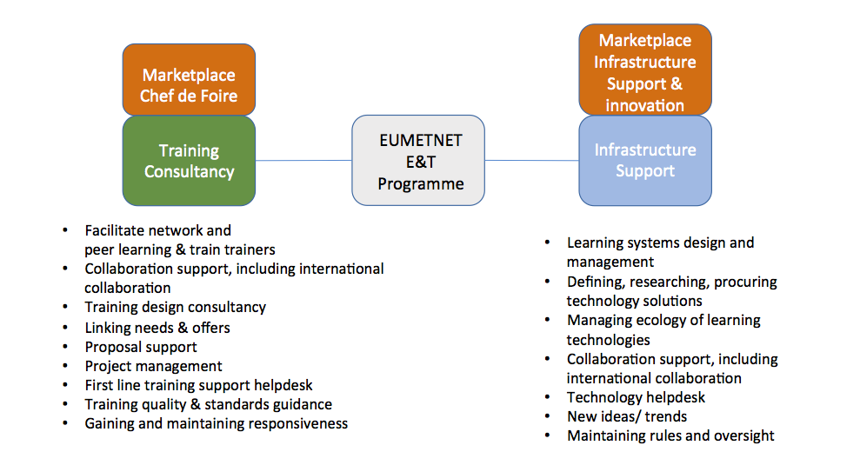
It is understood that an increase from 1,25 to 3 FTE is a large step and may be unaffordable so WGET has created a 2 FTE version of option 4, herewith known as option 5.
Assumptions done for this option 5 are:
- Project management will be quite intense in the initial stages but will be less intense throughout the year, ramping up again towards the end of the year or STAC meetings.
- All members will be committed to being proactive in supporting the project, minimising the amount of time required to gain and maintain responsiveness.
- New ideas and trends will be shared across the two posts, but will primarily sit with the infrastructure support post.
- International collaboration and collaboration support will be required from both posts.
- Maintaining rules and oversight of the marketplace can be done by either post once the rules have been established.
- Course and workshop management and support will be embedded within a number of activities rather than a separate activity in its own right. For example, training trainers, peer learning, collaboration support and international collaboration. It will also be shared across both posts.
This option 5 has variations in the amount of time spent on each task. The table below illustrates how time could be differentiated over the tasks of a future EUMETNET E&T Programme.

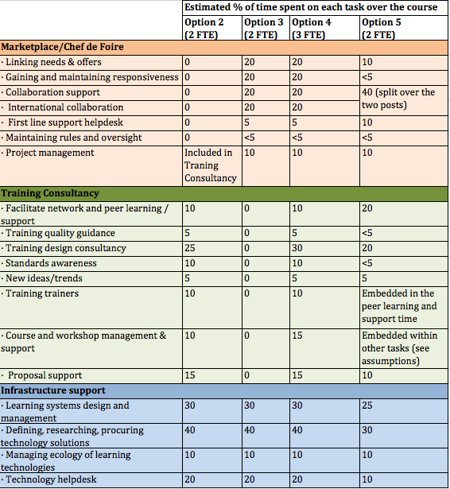

The option 5 strengths:
- All E&T within Europe (Eumetcal, EUMeTrain, EUMETSAT, WMO Global Campus) is fully integrated and presented through one window and you have one point of contact for all E&T related contacts.
- It has the very needed European wide coordination, facilitate partnership, advice within the European E&T world
- Having solidarity and help to solve your own E&T problems.
- Saving time and money for each country
- Wider audience for your courses. (Save money)
- Wider than forecasting - all operational areas of EUMETNET members.
- Efficient utilisation of resources will be paramount

The option 5 weaknesses:
- The pace of delivery of some aspects of the programme may be slower.
- There is a risk that expectations of all members will not be met as some specific member activities may need to be refused or receive lower priority.
- Less time available for innovative free time, cost recovery activities and managing unforeseen events.

Summary

The full programme, who will serve the full EUMETNET Programme, requires a modest implementing budget comparable with the current Eumetcal budget (minus the salary) and 3 FTE. This modest implementing budget, minus the salary, will be used for the maintenance of training infrastructure, the basic support tasks in the Training Consultancy and help with the start-up of new collaborations projects. The programme management like monitoring, reporting and planning is included in these 3FTE.

In the following table you will find an overview of option 2, 3, 4 and 5.

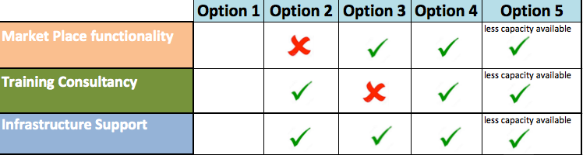

WGET considers infrastructure as one of the main and necessary pillars of the EUMETNET Education and Training Collaboration and therefore present in every available option and as the WGET really believes in the need for training consultancy within EUMETNET therefore Option 3 is not a feasible option for WGET. This option may suit the countries with larger training institutions but will make life harder for the smaller institutions.

Option 2 is “Eumetcal 2.0” solution intended for the full EUMETNET programme you will find a training consultancy and infrastructure to standards for 2 FTE, but no Marketplace and therefore it will not the most desired solution.

As you may understand after reading all put in this document so far option 4 is the most desirable option and option 5 will follow closely after. With option 5 it should be kept in mind that the pace of delivery of some aspects may be slower, that there is a risk that expectations of all members will not be met and that there is less time available for innovative free time, cost recovery activities and managing unforeseen events. The benefits of this “full” approach will be elements of cost efficiency through the provision of training resources which fulfil the needs of multiple stakeholders, the facilitation of coordination in work taking place in other international organisations and EUMETNET members’ training bodies or activities, (unexpected) collaboration between members, innovation of the training process and through more efficient procurement processes

Business Cases

In this document WGET has added all the business cases that came on her way since WGET has touched the subject future of the EUMETNET E&T within Europe. Together with the penportaits on the marketplace part of the plan these business cases show how collaborating as EUMETNET partners in the area of education and training will pay off.

The WIGOS and WCRP Example

During a WGET meeting at WMO headquarters in June 2016 we found out that there are lots of programs within Europe, who work together with the EUMETNET community, who want to use education and training (E&T) to be more effective. This time we came across WIGOS and WCRP programme. They would love to have some assistance for the education and training part of their programme and somehow these programmes don’t know where to find Eumetcal or us, WGET. Assistance is asked in the area of instructional design (eg. help to compose a good training by asking the right questions at the right time) and train the trainers courses for their people. After the WGET meeting Eumetcal jumped into this hole.

A short time ago WIGOS and WCRP reported to WGET that very good work was done by Alessandro and Lisa from the Eumetcal project in support of the WMO RA-VI training event they organized and this has led to some very good outcomes and lasting resources for the future.
Four lessons can be learned:
- One central point for all E&T questions within Europe is needed with a helpdesk to answer questions.
- To be effective it is needed to look to the EUMETNET E&T future strategy from a wider perspective than only from the forecasting area
- Training Consultancy is needed
- Collaboration within all E&T projects and initiatives within Europe will pay off.

The Met Eireann Example

Shortly after WGET created the marketplace requirements we, as WGET, got an email from our WMO colleague with a question from Met Eireann about who could train 6 novice forecasters before the end of the year. This event showed that members should not look only at UK Met Office College, Meteo France and DWD to increase the market of European E&T opportunities. Members should also look for solidarity and cooperation with other members within EUMETNET and be committed to help each other out in challenging situations. Next to that the case showed that so many organisations (Met Institutes, Universities, and other Meteorological related organisations) are puzzling with the same issues and inventing the same wheel several times. Because the discussion dropped completely dead after it was clear that none of the WGET members had the full answer to this training questions the WGET Chair took the role of broker/moderator/animator/facilitator and because of her knowledge she was able to break this question up in bits and pieces and to point Met Eireann to the different available solutions which they could use to solve their training question.
Met Eireann was happy because this meant that Met Eireann didn’t need to send their people to a WMO Regional training Centre in an exotic place and that they will most probably have their people trained around the end of the year. In the end the answer to Met Eireann’s request of help was not one training in one place but a patchwork of different training solutions with different training providers that will fulfil the training request and it might be the answer to the training request for other countries too.

The lesson that can be learned:
- A marketplace needs to be facilitated to work.

The Hirlam/Harmonie Consortium Example

A few years ago the Hirlam/Harmonie consortium explored to develop a Massive Open Online Course (MOOC) together with Heleen ter Pelkwijk (KNMI). This course was created to train all the forecaster of the members for a new model product called GLAMEPS. This course was time and place independent. For all of us this was a real experience in which we have learned a lot.
Recently Heleen asked the Hirlam/Harmonie consortium whether this course was still useful for training. As it turned out the developments of the model moved on; parts were still very useful and parts needed to be updated. A new short-term ensemble based on the older one is being introduced soon and the Hirlam/Harmonie consortium expressed the need to update this module. The Hirlam/Harmonie consortium has the content knowledge to do so but needs help on the instructional design side of developing the training material to create an effective course for their members.

Lessons to be learned:
- Help from the training Consultancy is needed to develop this training
- A fresh new innovative view on how training can be done is very welcome. EUMETNET has a lot to learn in the area of fully self directive courses and other new developments.

The US Example
In the US the Federal US bodies have set up a similar system as the plans made by STAC for a future EUMETNET Education and Training Programme. The difference is that our aim is to look for the solidarity and cooperation with other members within EUMETNET to solve the E&T demand and the US has put a performing body, called COMET, in place who contributes significantly to the training in the US. The US situation:

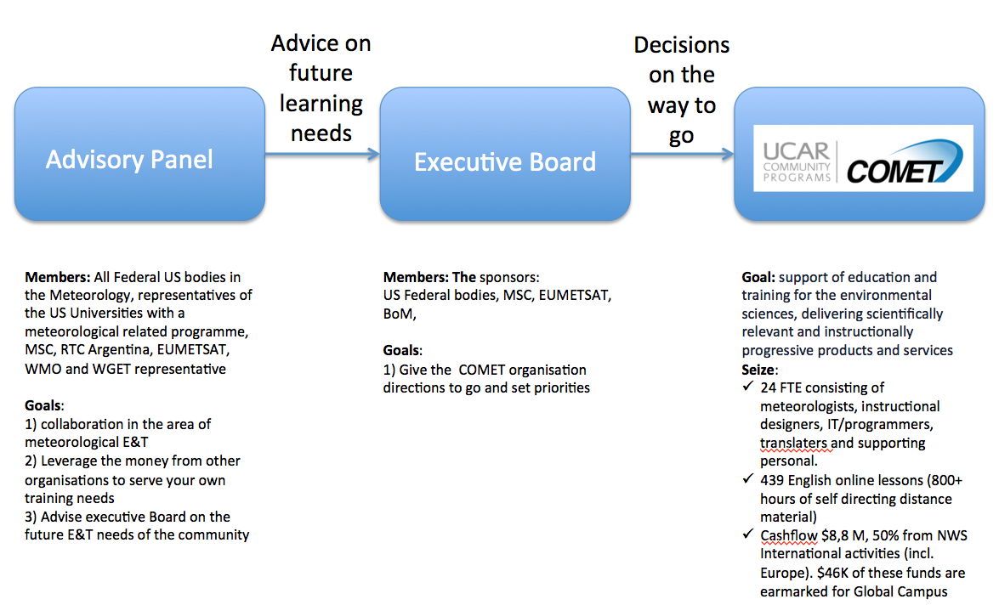

The Advisory Panel is a crossing of WGET and the marketplace. The executive Board brings the advice further to a decision of priorities for the nearby future. This system now works for 26 years.

The last Advisory Panel meeting we found that during the last 6 years we have lost the collaborative way of thinking in the Advisory Panel. After some discussing we realised that this had consequences for a very important aim of the Advisory Panel being the leverage of money from organisation to other organisations and less could be done with the available money. We made the appointment to meet (online) more often because getting to know each other and knowing from each other’s challenges we are facing is a very important factor for success in this.

Lessons learned:
- Collaboration in the field of education and training pays off
- Meeting once a year is not enough. Real energy needs to go in there to keep real cooperation and collaboration going.

The Level 0 Requirements for a future EUMETNET E&T Programme

The EUMETNET E&T Programme in general

1 | People working for this programme shall have understanding of the meteorological operational service delivery context
2 | People working for this programme shall be diplomatic and have a good communication skills, working well across European cultures, openness, willingness to communicate and travel
3 | The programme management shall improve the use of resources and impact of international projects by making it easier to know what people are doing internationally (outside of EUMETNET) to enable development assistance cooperation
4 | The programme management shall be developing needs assessments in the whole EUMETNET community

The Marketplace

1 | Providers of training can present their offer (capability, courses, resources, teachers) to the community
2 | Managers of training can see what is offered that suits their needs and are able to evaluate the potential return on the investment
2.1 | Training managers have enough information to reasonably assess the offers (what quality standards does the delivery organisation meet / not meet).
2.1.1 | The offers presented on the marketplace are shaped in the same standard format
2.1.2 | Use the standard format that matches the format of the WMO Global searchable Calendar i.g. Name, description, duration (incl. start/end dates), location, delivering institutions, Regio/Area, delivering format, delivering language, fees if applicable, application deadline, learning content and links to qualifications or competency framework, expected learning outcomes, awards (diplomas and certificates) associated with the course, how learning is assessed, additional quality management processes used by the institution, intended audience, prerequisites and whether this offering is part of a larger offering.
3 | Pace: Training managers deliver within their time constraints
4 | The marketplace should be responsive (few working days) to questions, needs and offers
4.1 | The marketplace should provide a broker or helpdesk where it is possible to facilitate queries
4.1.2 | The marketplace should provide animation, moderation, enabling constraints, rules and procedures to support efficient functioning
4.1.3 | The marketplace should provide guidance on reuse
4.1.4 | The marketplace should provide a negotiation mechanism to solve problems or to get things started or changed, manage the tensions between the different agendas, sizes aspirations and mandates of participants
4.1.5 | In the case there is no straight solution available the future education and trainings body has the obligation to task the project manager to find a solution to this training need with the help from trainers from the institutes against a cost effective rate
4.1.6 | Every EUMETNET Member has the obligation to also look into solidarity among us in EUMETNET environment and will have the commitment to help each other out in difficult situations.
5 | Training managers / managers can let the provider community and other training managers know what their needs are.
6 | Training managers and providers can work together to refine user needs, gather wider interest and deliver a course that is affordable and meets the actual needs.
6.1 | Training managers and providers can articulate and hear perceived needs for the future, the marketplace is also informed about the needs coming from the groups such as heads of forecasting and ... (not just HoF - but we hear what people are saying - the market place pulls information from these groups and well as having perspectives pushed from these groups).
7 | Training providers can identify needs and make offers to meet these needs
8 | Training providers and managers can leverage the investment of other organisations - reusing resources, courses, design, technologies ...
9 | Consumer feedback is available on the quality of the courses
10 | Providers are stimulated to maintain / increase the quality of their courses
11 | WMO ETR get information for and about the providers (desirable)
12 | The rules and functioning of the marketplace needs to suit the members of EUMETNET
12.1 | EUMETNET approves and validates rules of the marketplace (owner)
13 | The marketplace monitors, reacts, and informs about quality aspects of the offered E&T services
14 | The marketplace should be financially efficient
15 | The marketplace gives opportunity to reduce duplication (through cooperation)
16 | The marketplace shall use competence across the EUMETNET members
17 | Training managers, providers, and others will have information and intelligence to guide planning and decision making (learning organisation)
18 | The marketplace serves first the EUMETNET members and then the wider community
19 | The marketplace should integrate with and not duplicate work from the wider ETR community
20 | One place for all ETR needs - i.e. the market place should pick up information from other places (Global Campus etc.)
21 | The marketplace should support shared procurement (providers, infrastructure, )
22 | The marketplace should facilitate discussion, group building, negotiation and problem solving
23 | The marketplace should be the go to place / reference body to share and get information on training
24 | People should be able to contribute, adapt, and reuse tools / resources (that they wish and are able to share and under what IPR conditions) easily, knowing what versions exist. (there is interoperability with GC here) tools such as a simulator framework or course planning template, resources all the PowerPoints etc. - with a range of IPR conditions/constraints. People don’t have to share everything they have. (This needs careful and thoughtful implementation - no rushing!)
25 | The marketplace is able, after developing knowledge, to give advice on strategic HR management issues (competency and stands evolutions, workforce planning challenges ... )

Training Consultancy

It shall:
1 | facilitate the teaching (train the trainer) network within EUMETNET to make sure that it can deliver state of the art training
2 | deliver instructional design consultancy - across instructional design areas, standards in our community, new ideas/ trends from in and outside our community, train trainers in training, get people talking about quality
3 | facilitate a trainers network
4 | support the briefing of training managers (making sure that they know what is available and how the whole system works including competency assessment)
5 | facilitate peer learning and support
6 | organise training of trainers (including subject matter experts) within RA-VI together with WMO ETR
7 | share knowledge and support the development and innovation of the used training methods
8 | encourage the reuse of training resources
9 | deliver a yearly conference or workshop for trainers
10 | share success stories
11 | support quality assessments and help members to meet and prove training quality standards
12 | have a strong network/forum so we are able to solve problems big and small
13 | support the WMO ETR train the trainer work in WMO Global Campus
14 | when needed, have the possibility to provide the management, design and implementation of courses on a cost recovery basis

A joint EUMETNET E&T Infrastructure with accompanied support

It shall
1 | provide a western European /RA-VI dedicated front-end or portal with an easy option to go to the WMO Global Campus coordination and communication system
2 | capture and write the user needs definition for the infrastructure
3 | do the research finding technical solutions (learning technologies and collaboration tools) for the community
4 | enable shared contract placement & procurement, and the contact once in place
5 | manage the ecology of learning technologies and be aware of what is needed and what is the best solution for the problem at hand.
6 | provide a state of the art Learning Management System (LMS; for instance the present Moodle)*
7 | provide a state of the art conferencing tool (for instance Webex as done now. This can be done in conjunction with other EUMETNET activities)*
8 | provide a calendar of the E&T activities within Europe*
9 | provide a state of the art repository and sharepoint or something similar to facilitate collaboration (can be joint with the other EUMETNET activities)*
10 | enable the sharing of others’ infrastructure within Europe (examples: the simulator building tool from UK Met Office and the option to get help to build a MOOCs from EUMETSAT)
11 | provide support and training in how to use the shared tools and infrastructure
12 | provide communication to contributors and users such as a newsletter
13 | have a first line training and Helpdesk: provide 1st line support
14 | support the TSO network
15 | keep up a list of free and open source software (FOSS) tools that the E&T community may find useful
16 | have the possibility to give additional support with the use of the shared infrastructure on a cost recovery basis
17 | Partners who use the named tool for work outside of EUMETNET work can buy additional capacity

Annex

The Proposal for the EUMETNET strategy discussion in the area on Education & Training (E&T).
Produced by WGET in September 2016 and approved by Assembly

Considering the great diversity of situations in Europe about Education and Training in Meteorology and Climate, WGET points out the importance of a good level of co-operation between European training institutions, to match the identified global needs that can be summarised as follows:
- Initial and professional training of agents of the different National Met Services
- Exchange of good practices and increasing a good mutual knowledge, to consolidate the European meteorological and climate community
- Optimized use of resources (efficiency, specifically for activities outside of Europe)

At a first level, WGET suggests to focus the objectives on matching the training needs, training quality evaluation and management and efficiency of international activities.

To strengthen and animate the co-operation and to reach the objectives, WGET clearly underlines the interest of a centrally placed European body in the field of Education and Training that would have a co-ordination role as first priority, and strongly recommends to establish one. Eumetcal could become this body, if, as suggested by WGET, EUMETNET is ready to shift the focus of the future EUMETNET education & training body from a performing role to a more coordinating one.

Effectively, in the current EUMETNET phase, as mentioned on its web site, Eumetcal acts as the European Virtual Organization for Meteorological Training. Its objective is to facilitate training activities at European level through the provision of training in Meteorology, the exchange and delivery of online material, the creation of lessons, and help on Computer Assisted Learning (CAL) techniques.

Matching the above mentioned objectives would need a new orientation for Eumetcal program. The future EUMETNET education & training body will have to act essentially as a facilitator. At the current step, its future activities can be seen at various levels:
- Coordination,
- Recommendations and advising,
- Technical support,
- Realisation.
In addition, the funding of this new version of the EUMETNET education & training body should be done in a flexible manner with different levels of E&T services from the basic, which are compulsory for all EUMETNET members, to more comprehensive services.

In this document, WGET aims to be more precise on how this could work, with the underlying motivation.

Coordination
For a future education & training strategy WGET proposes to first look within the members’ community whether unsatisfied training needs can be satisfied. In case these training needs cannot be satisfied within the European society we can look in the WMO Global Campus Area or a future EUMETNET education & training body can organise the training event herself together with the help of its member trainers.

In our view, the future EUMETNET education & training body will collect all unsatisfied E&T needs from its members and will create a marketplace where the E&T demand and supply can be brought together. In this new approach this framework will involve all the European partners in the E&T field, like National Training Institutions and Training departments of international organisations as EUMETNET, EUMETSAT, ECMWF when looking for the most adapted E&T solutions. This can also be open to non-European offers, such as Comet or WMO-Global Campus.

Note that if, in the current situation, some members with their own training institutes are having the feeling that, with Eumetcal, they pay for the membership of an organisation they hardly benefit from, the new approach, may be more profitable, in giving a broad visibility to every European training offer.

Next to that, WGET advices STAC to broaden EUMETNET’s scope on education and training to all disciplines that exist within the member NMHSs.
Eumetcal now concentrates mostly on the forecasting area but we see a large need for assistance with education and training matters in other European programmes and projects. We think that EUMETNET should provide an education and training infrastructure centrally based in the EUMETNET organisation because this can help to increase the effectiveness for most of the EUMETNET programmes. We imagine the future EUMETNET education & training body being the point of contact for all organisations with education and training questions related to Europe.

Nowadays quality assurance plays an important role in the business plan of the EUMETNET members. With a mix and match of parts out of basic and continuing professional development (CPD) training at different providers to be properly educated, the EUMETNET members who send their people away for their training will need proof that the training and training material is up to the applicable standards.
On request of STAC, WGET has written a proposal to organise this aspect of quality assurance within the EUMETNET community. Organisations that are not in a position to follow the proposed recommended practices may have benefit from adopting the WMO-RTC self-assessment and/or review process. A future EUMETNET education & training body could have a role in facilitating this process on behalf of EUMETNET. Please see WGET progress report STAC 13 for further background information on the WGET advice on quality assurance for training and training material.

As the “train the trainer” network, the “train the trainer” training facilities and the available E&T tools within Eumetcal are unique and very important to most of the Eumetcal members, WGET advices STAC to continue these facilities within the future EUMETNET education & training body.
An active trainers network improves the quality of our trainers and makes that research to new innovative education and training methods and tools will be done. The future EUMETNET education & training body should play a major role in training and continues development (CPD) of the European trainers. They should also maintain a trainer’s network by facilitating the discussion between training actors and keep up a database of experts in education and training that can be consulted in case of questions.
Next to it, this organisation should play an important role, together with the other players within in the international E&T community, in the identification of new innovative and possible E&T methods and tools. The gained knowledge will be tested among and shared within the trainer’s network.

WGET thinks that the future EUMETNET education & training body should also play a role in maintaining global coherence of training activities, which is related to global efficiency. An example we found is that many EUMETNET members are delivering training in developing countries. In our view there should be exchange of information, more efficient use of resources and coordination for the training outside of Europe. The aim is that the training delivered by EUMETNET Members outside Europe is coherent and not redundant to be able to use our available training capacity in the most optimal way. This coordination task can be done by the future EUMETNET education & training body in connection with the GLOBAL Campus Commonalities.

Recommendations and advising
When all above works out well, the future EUMETNET education & training body has a lot of knowledge and expertise on all education and training related subjects, has an excellent network and knows exactly what is going on in the worldwide Meteorological education & training area. This makes this EUMETNET education and training body an excellent sparring partner for all meteorological E&T issues. This future EUMETNET education & training body will give advice when needed, can help to find solutions and can be asked to make proposals regarding for instance recommended standards in this area.

Technical support
As mentioned earlier, WGET proposes to have a set of education and training tools centrally available for the EUMETNET members. This set of tools will be proposed by, hosted and maintained by the future EUMETNET education & training body and will include at least a learning management system, online conferencing tool, a dedicated surrounding for calendars/catalogues, a library for training material and a database with people with industrial design skills for members who need help to develop a training. Because this body has also an innovative and networking role this set of tools will be state of the art and matches the wishes of its members. The future EUMETNET education & training body will also deliver basic technical support on the tools hosted by this organisation. When needed more advanced technical and industrial support for instance to build a training can be offered at cost recovery based prices.

Realisation
In some cases it is impossible to match the training needs with the available training offers or the training is not available in the market. Also it can be decided that a training or continues development activity will be done in regional consortia or within one of the EUMETNET programmes. In those cases the future EUMETNET education & training body can be asked to coordinate or help with the conception and implementation of the training solution to help their members.

Finances
WGET advices STAC to create a flexible framework for education and training within Europe with different levels of E&T services from the basic, which are compulsory for all EUMETNET members, to more comprehensive services.

Under the basic level, WGET groups a basic coordinating task consisting of the collection of the unsatisfied E&T needs of its members, managing the market place to satisfy these training needs, managing the training and continues development (CPD) programme for trainers and maintaining the trainers network which is connected to it, maintaining the global coherence, hosting and maintaining the centrally stored set of education and training tools and the offering of a basic level of technical support. All these services are more or less of interest to all EUMETNET members. Additional services described above can be delivered at extra costs either on cost recovery basis or it can be decided that WGET defines different levels of services with corresponding prices where the individual NMHSs can choose from.

The basis for this financial framework is that every EUMETNET member is responsible for its own training and education costs. That means that every member who has a successful match for their unsatisfied training needs will pay a fee to the institute that will organise the training. The future EUMETNET education & training body will not be part of this deal. This body will only do its best to solve the unsatisfied training needs within the community. This all doesn’t mean that especially the poorer and smaller EUMETNET members are completely left alone to solve their NMHS education and training problems. The cost of the basic education and training facilities needed to produce good education and training opportunities will be shared within the full EUMETNET community and it is possible to purchase extra service when needed on a cost recovery basis.
It is like providing good tools for fishing for everyone who wants and leave the way how to do it to the individual fisherman

Pen Portraits to support the marketplace concept

These pen portraits show what the WGET members expect from a marketplace and how their organisations would benefit from having a marketplace on E&T related matters within EUMETNET. These pen portaits were used to draft the requirements for the marketplace.

Aristotle, KNMI
Looking for a short course at the EUMETNET E&T Marketplace, 1 or 2 days, on “world meteorology”, i.e. primarily tropical meteorology for a group of forecasters involved in a project Aristotle to support European Civil Protection Coordination Centre ERCC in Brussels in cases of meteorological hazards all over the world. Questions:
- Who could offer such a course
- Combination (?) live and on-line
- Duration: 1-2 days
- When could it be organized?
- Costs
- More countries (5 or 6) could be interested (ZAMG, FMI, IMO, IPMA, KNMI, SMHI)

KNMI training on the use of dual-pol radar products for forecasters
KNMI is installing two new duo pole radars in The Netherlands. This gives a lot of new possibilities for the use of radar data in for instance the forecasting office and the forecasters in the Netherlands needs to be trained to use this new material.

Training is not only needed on how duo pole radars work, but also on what products are available, what circumstances it is useful and in what circumstances it is not and how to use the products in for instance extreme conditions. This course needs to be a mix of theory and practice (exercises/cases) and because we are training a large group of forecasters from different services we want it done multiple times in a blended format.

As coordinator training I know that a lot of training on the various subjects in the radar domain has been done within the international community and because of efficiency I will go to the market place to find out:
- Are there any training courses available that can of any use to train the forecasters in our countries?
- If not, is there any training material available that can be used as a start for developing our course with maybe some small adaptations to our situation?
- Are there any other countries dealing with the same training needs to work together with?

FMI
FMI has organized several face-to-face training courses in radar meteorology, at both basic and advanced level, for countries where weather radars have been or were going to be installed (usually the assignment was carried out in connection with the procurement of weather radar(s) from VAISALA, which subcontracted the radar meteorology training component to FMI). The courses have been designed mainly for operational forecasters, but in some cases also for developers of weather radar products.
Insofar FMI has the the capabilities (material, trainers, training programs) to deliver weather radar courses to any organization or institution which might require; in addition the course structure can be adjusted to customer’s wishes.
FMI post into the Bazaar its capability to provide on-site courses on radar meteorology for forecasters and also for weather radar products developers: time, duration, costs, etc to be negotiated.
KNMI needs training in weather radar and becomes aware of FMI training capabilities in this area: they contact them and manage to organize a residence course in De Bilt given by one/two FMI radar experts, after negotiations.

DWD
- Under the umbrella of EUMETCAL and EUMeTrain training seminars are being offered at DWD. However, we need training capacity and programming power from other training bodies or services for replacing trainers (e.g., after their retirement) and for creating learning modules of high quality. The marketplace is a powerful concept for the DWD to overcome these issues and to find partners for cooperation and for exchanging experiences;
- The DWD is presently using E-learning for training only partly. However, we do not have the personal to adapt and to create learning material or even seminars without cooperation. We expect from the marketplace help to produce more E-learning modules of high quality yielding more efficient training due to E-Learning;
- The DWD is able to offer scientific expertise for the marketplace and skilled trainers. However, we assume benefit from the marketplace by enabling us to offer more training because they will run in cooperation;
- At DWD, we expect from the marketplace that we could learn from other training institutions, both in pedagogical (e.g. train the trainers) and also in relation to the training process (e.g. assessment and evaluation);
- Students at the University of Applied Science (Diploma in Meteorology (FH)) and forecasters of the central and regional forecasting services of DWD visit sometimes other NMSs. However, the DWD is interested to broaden this to more NMSs. We expect from the marketplace that more internships could be initiated.
- The marketplace will support the DWD to deliver training according to the WMO-requirements.

UK Met Office
- The Met Office has a number of existing, scheduled courses on its prospectus. These are currently promoted/marketed through our website and using existing relationships with other NMHS’s that often attend/complete this training. The marketplace/bazaar would promote these opportunities centrally, bringing efficiencies for those with a training need (being able to see and compare opportunities in one place - learning outcomes, length, cost, feedback, location/online/blended, language) whilst helping Met Office by reaching those beyond the website and existing relationships we currently use to capture their requirements.
- The Met Office is keen to operate efficiently and aims to be the global partner of choice. Having a marketplace/bazaar where opportunities to collaborate can be highlighted and taken forward would enable us to see efficiencies and partnerships by working together for mutual gain, whether it’s a saving in time/money (sharing out the development) or accessing specialist expertise (for example universities, ECMWF, Eumetsat) to use within our training offering (content, delivery methods/design etc).
- As with other user stories given in this document the Met Office has its own training need. Before developing it from scratch it would be useful to have easy access to existing offerings through marketplace/bazaar. What is on offer/learning outcomes/competencies, when, language, how long, cost, online/blended/location etc.

Serbia - RHMSS (2)
RHMSS has started to develop an internal EPS course in Serbian language for interpretation of EPS products in weather forecasting (mainly derived from the WMO EPS reference guide ).

They are able to get advice on the most up-to-date materials and what is changing as the broker puts them in touch with an expert peer in this case at ECMWF who provides some up-to-date materials (in English).

RHMSS decides to let the community know they are develping training material in Serbian language on this topic and posts this initiative in the Bazaar. Bosnia-Herzegovina, Montenegro and Croatia have need to get training in this area, and since their language is very similar to Serbian, they contact RHMSS to develop a joint training.

IMGW
IMGW would like to use market place to find information about all courses in Europe and to find services that have or had the same problems and training needs and to find somebody who can organise and deliver training. Moreover, it would be useful to talk with others who have more experience in some particular problem or topic. It should be also a place where we can find links to training resources, informations about new tools, projects, contacts to different organisations and people responsible for trainings. It should be a place where we can ask for advice in e.g. organising courses or finding financial support from international organisations.

ESTEA
ESTEA would use training marketplace for finding upcoming courses (preferably in nearby countries). As well as for finding trainers and cooperation opportunities for planning specific courses. As an example: we are looking for a course in the field of maintenance of automatic weather stations. What we find from marketplace:
option 1 - there will be a course in Europe (eg in one of the WMO RA VI centres);
option 2 - Sweden is preparing similar course for its own technicians, they are ready to host some foreign participants, we are welcome to join (could be partly in swedish, partly in english);
option 3 - got some hints from Finland, they have a great trainer who has done internal and external trainings, we could call him/her to Estonia (and pay) for special training.

Malta
I run the Malta Met Service and I need to find courses for the Initial Training of my aviation forecasters. The marketplace would help me to browse through the offers and I could decide what is most suitable.

ECMWF
Users of my data have expressed interest in new courses for NWP data in applications. The marketplace would allow the training coordinator to find a network of interested parties to build the evidence base that would support legitimacy and mandate for the course or to find partners to put together the course itself.

EUMETSAT
- The EUMETSAT training manager uses the database of needs alongside conversations with member states and the heads of forecasting to define the training activities of EUMETSAT for the next 5 years. The training manager hopes that by doing this the activities of EUMETSAT are closely linked to the needs ot the member states. The training manager uses the community of the marketplace to deliver the needs in a collaborative and integrated ways.
- We have created resources, paid for by the member states. Member states are more able to access and use the resources without asking.

Collaboration on developing components for a multilingual, blended-learning BIP-M course
Several universities intend to respond to an ERASMUS+ call for proposals with a proposal to collaborate on developing materials to make possible the delivery of a complete BIP-M curriculum through an extensive online component, combined with critical face-to-face components offered by the partner institutions. The partnership seeks others who have expertise in delivering the BIP-M, and that reflect language diversity. An important goal is to support developing countries that have fewer opportunities for offering this critical requirement based on WMO standards and ICAO requirements. The initiators of the proposal go to the marketplace to identify the additional partners to make a valid initiative. Up to 15 universities and NHMSs are desired to partner, and the rapidly approaching deadline requires fast coordination.

European Countries
Based on new WMO guidance on Nowcasting, the countries want to develop a state-of-the-art nowcasting course. The marketplace/Bazaar helps a consortium of countries come together to develop the course using international guidance, leaving space for national customization.

WMO Regional Office Europe/WMO ETR
Countries in south-eastern/eastern Europe have requested guidance and support from WMO to have stronger, consistent, high-quality forecaster development programmes available, both initial training and advanced training. They are willing to collaborate to share resources and expertise amongst themselves to get it done. They are guided to the EUMETNET E&T Marketplace/Bazaar for infrastructure support (Web tools, collaboration tools, simulation tools, project management tools), resources (existing training resources, course outlines, cases and simulations to use for examples and as templates), and guidance (project management, pedagogical, meteorological expertise, training management, collaboration mechanisms).

WMO ETR
ETR gets a request from a small middle eastern country in RA-VI for in-country training of a set of staff who need to upgrade their skills to the BIP-M level. WMO looks to the EUMETNET E&T Marketplace/Bazaar (for no fee to explore the bazar) for providers who can provide cost effective training based on an existing programme, but who can also collaborate on a needs assessment for this particular country to ensure their needs are targeted.

WMO ETR
RA-IV or III Latin American country is asking for radar training to help them take advantage of the new radars about to be installed. We go to the EUMETNET E&T Marketplace/Bazaar, as part of the WMO Global Campus, looking for Spanish language resources and experts who can consult with them on their needs and strategies for meeting them.

A country
A small non-ECMWF member wants to upgrade the NWP forecast usage skills of at least a subset of their key staff. They want to participate in a course, but have very limited funds for travel and tuition. The EUMETNET Marketplace/Bazaar helps them to find willing support to receive the training at a reduced cost consistent with their GNI.

Region II Country
A RA-II country wants to learn about modernizing service delivery from some of the advanced met services in Europe as models, even though they might also use Asian models as well. The Marketplace/Bazaar provides a source of countries willing to provide high level consultation, and eventual training, if this is decided.

Cameroon
Cameroon wishes to establish a meteorology department in their university to provide a source of educated persons to enter their met services. They are not able to staff their service sufficiently with the graduates from foreign institutions studying on grants. Some of these do not return to Cameroon also after receiving their education. Cameroon can use some African models, but they are limited. They would like a partner institution or institutions to guide what would be needed to develop a successful programme.

Wageningen University
Sometimes students are interested in courses on specific meteorological subjects for their curriculum that are not available at Wageningen University or have a gap in their training program. In those cases the (assistant) professors would be very interested to see what courses are offered at other universities to see whether that suits the need of the student. In case there is something useful available then it is a serious option for Wageningen University to send those students to that other university to fulfill part of their curriculum.

A Commercial Weather Provider
Also Commercial Weather Providers have a large interest in well-trained staff. At this moment these companies have a huge interest in easy accessible and tailored training solutions for both initial and recurrent training for their forecasters.

