A. MEENAKSHI SUNDARA ARASU
HYDROLOGICAL CONDITIONS OF PONNANIAR IRRIGATION SYSTEM

HYDROLOGICAL CONDITIONS OF PONNANIAR IRRIGATION SYSTEM
- MEENAKSHI SUNDARA ARASU

Option B
The assignment will cover the hydrological variability of Ponnaniar irrigation system, a reservoir functioning from 1974. it will cover the rainfall pattern, how it changes, whether there is any shift in the monsoon pattern, the occurrence of flood and how it was routed. the drought conditions prevailed in the system and how it was tackled etc will be discussed. Data will also be shared with the assignment.

Key words : Ponnaniar Irrigation System – history – rainfall distribution – analysis – SWAT – hypothetical climatic conditions

Ponnaniar Dam
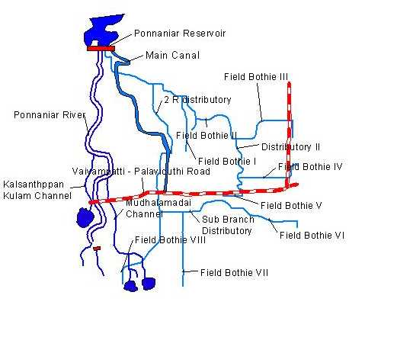
The river Ponnaniar originates from Kadavoor hills and it is one of the tributaries of river Ariyar. Ponnaniar reservoir is situated in Mugavanur village of Manapparai Taluk across river Ponnaniar River. The site of the reservoir is located in between Sommalai hills and Perumal malai hills. The jungle stream originates from Kadavoor hills and traverses through east in Manapparai Taluk for a distance of 32 km and joins with river Ariyar. The river finally in falls into river Cauvery. In order to fulfill the demands of this area the scheme was taken up for execution after detailed investigation.
Since the flow in Ponnaniar is not perennial it is proposed to impound 120 Mcft with two fillings totaling to 240 Mcft.
The project comprises a Reservoir of 120 MCft. capacity across the Ponnaniar River D.Edayapatty Village of Kulithalai Taluk in Tiruchirapalli District and a left-side contour canal of about 3.5 km. long, to irrigate about 1,830 acres of dry lands to be converted in to wet lands. In addition, about 271 acres of existing wet lands will get stabilized by the waters of Ponnaniar Reservoir. The entire new ayacut lies in Mughavanur village of Manapparai Taluk.
The Ponnaniar dam is an earthen dam with masonry spillway. The construction of the dam was started in 1970 and completed in 1974. The purpose construction of this dam is for irrigation but fish culture is catching up in the recent years. The reservoir with a catchment area of 33.60 sq. miles is designed for a design discharge of 7028 Cusecs. The length of the dam is 247 m with a maximum height of 51 feet.
Rainfall distribution
The Drainage Basin of Ponnaniar Dam is mainly in Plain Areas of Mugavanur and Chekkanam Village. There are two rain fall stations in the catchment area viz. Kadavoor and Dam site.
The rainfall received from 1975 to 2011 is plotted and shown below. The rainfall received is showing a downward trend and this causes great concern when it comes to matching the supply and demand.

The number of occurrences of rainfall of a particular quantum also exhibit interesting figures. The lowest range and the highest range occurs 5 times. As per the flow duration curve, the 75% probable inflow will be 750 mm.
Rainfall range in mm | Number of occurrences | 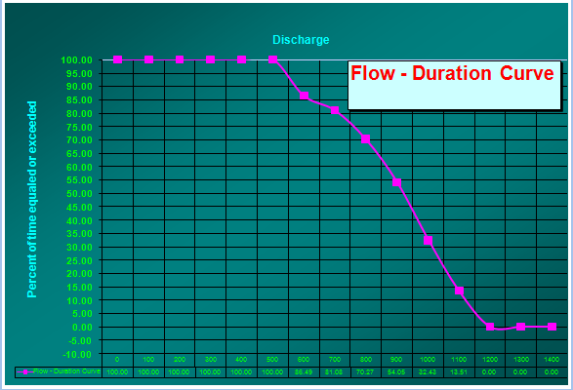
500 - 600 | 5
600 - 700 | 2
700 - 800 | 4
800 - 900 | 6
900 – 1000 | 8
1000 – 1100 | 7
1100 - 1200 | 5

The rainfall distribution of South West Monsoon and North East Monsoon is given below for 39 years. It is very clear from the graph that the North East Monsoon is predominant than the South West Monsoon and expecting an active North East Monsoon the reservoir is thrown for irrigation from 1st September to 31st January.

The rainfall revealed many interesting result.
- Out of 39 years of the data collected, 11 years experienced normal rainfall, 12 years had excess rainfall and 13 years received deficit rainfall.
- No definite periodicity is observed, but, raising and falling epochs are observed in the collected data.
- After 2000, in a span of 12 years (from 2000 to 2012,) deficit rainfall is experienced in 7 years.
- Worst drought hit was experienced during 1980, 1990, 2000 to 2003, 2006, 2012 and 2013.
- For 12 years, the rainfall was more than 1000 mm.
- The South West monsoon is having a declining trend and especially after 2000, the contribution of South West Monsoon to agricultural activities has considerably reducing.
- The North East Monsoon at the same time is having an upward trend there by contributing to the agricultural activities.
- These are also established in the number of rainy days of the irrigation system.

Climate Change and its effect on Water availability in Ponnaniar Reservoir System
Climate change is a phenomenon we can no longer deny as its effects have become increasingly evident worldwide. The impacts of climate change on water availability and water quality will affect many sectors, including energy production, infrastructure, human health, agriculture, and ecosystems. Water resources are among the most vulnerable sectors to be affected by the climate change. In order to minimize the adverse impacts of climate change on water resources and attaining its sustainable development and management, there is a need for developing rational adaptation strategies.
A hydrological model Soil and Water Assessment Tool (SWAT) was used to simulate runoff in the Ponnaniar basin for current climatic conditions, and for prescribed hypothetical climatic conditions that represent a range of possible climate changes that is likely to be expected in the current century.
Annual summary of hydrological outputs of Ponnaniar basin for the year 2008 (representing 75% dependability of rainfall) as simulated by SWAT model has been worked out and the monthly hydrology of Ponnaniar basin has also been calculated.
The model was run for two climatic conditions, i.e. 1⁰ incremental change in temperature from the base temperature and changes in precipitation with -40%, -20%, and +20%, +40%. Totally eight scenarios were considered for the study to assess the impact of climate change in Ponnaniar Reservoir System. The model executed for Ponnaniar Basin current climatic conditions, and for prescribed hypothetical climatic conditions that represent a range of possible climate changes. The hypothetical changes in climate included changes in mean seasonal and annual temperatures of +4°C, upto 1°C and changes in precipitation of -40%,-20%, and +20%, +40% (a total of eight scenarios) .These changes in climate were computed by uniformly changing current values of daily temperature and precipitation by the specified amounts for all months of the year (2008). The current and altered time series of daily temperature and precipitation were input to a hydrological model to simulate changes in components of surface flow, lateral flow, ground water flow, percolation, soil water, evapotranspiration, potential evapotranspiration and water yield are presented in Table.
Results of Annual Hypothetical changes in Temperature
Parameters | 1⁰C | 2⁰C | 3⁰C | 4⁰C
Precipitation (mm) | 967 | 967 | 967 | 967
Surface flow (mm) | 136.1 | 134.27 | 132.51 | 130.1
Lateral flow (mm) | 85.22 | 84.76 | 84.54 | 84.14
Ground water flow (mm) | 99.59 | 94.71 | 89.53 | 84.41
Percolation (mm) | 217.64 | 212.62 | 207.26 | 201.21
Soil water (mm) | 52.06 | 51.73 | 51.42 | 51.1
Evapotranspiration (mm) | 513.23 | 520.87 | 528.52 | 537.71
Potential Evapotranspiration (mm) | 1980.77 | 2036.98 | 2094.07 | 2152.06
Water yield (mm) | 324.40 | 317.1 | 309.78 | 301.66

Results of Annual Hypothetical changes in Precipitation
Parameters | Base (2008) | +40% | +20% | -20% | -40%
Precipitation (mm) | 967 | 1284.36 | 1160.92 | 773.6 | 582.28
Surface flow (mm) | 137.69 | 284.82 | 208.27 | 78.69 | 35.55
Lateral flow (mm) | 85.69 | 113.73 | 103.89 | 66.4 | 46.5
Ground water flow (mm) | 103.49 | 214.07 | 153.46 | 52.88 | 13.68
Percolation (mm) | 221.81 | 345.36 | 293.47 | 147.06 | 78.14
Soil water (mm) | 52.38 | 61.41 | 52.45 | 52.25 | 50.63
Evapotranspiration (mm) | 506.67 | 514.51 | 540.03 | 466.5 | 408.83
Potential Evapotranspiration (mm) | 1925.4 | 1925.4 | 1925.4 | 1925.4 | 1925.4
Water yield (mm) | 330.48 | 619.59 | 470.81 | 200.03 | 96.61

Summary
The above two tables clearly shows that there will be appreciable changes in the Water availability in the coming years due to climate change and more precautionary steps both structural and non-structural are to be planned now itself.

