Checklists for Organising Webinars

When asking a group of technical support officers what would be the main activities one should perform when organising online seminars – most commonly called Webinars – they identified 5 main steps in the process. These steps represent different phases of the organisation process, from start to end. Each step comes with its own set of activities, which in turn, supports the next step.
The diagram below shows each step and includes short videos prepared by the support officers to help webinar organisers to think what activities they would consider for each specific step. These videos were used in a training session in 2014, which resulted in the collaborative writing of the checklists that are presented in the next pages.
1
Plan
Define goals, outcomes and audience
2
Organise
3
Design
4
Deliver
5
Wrap up
Support speaker to prepare and test an engaging session
Collect feedback, share recording, prepare report
Check the system, support speaker and participants
Contact speaker, advertise event, open registration
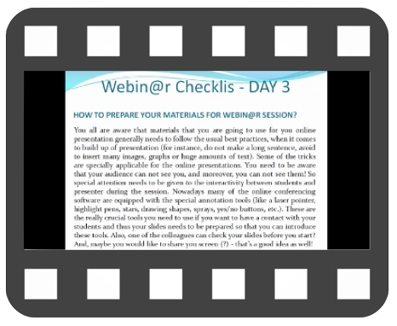
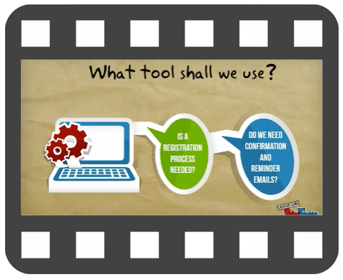
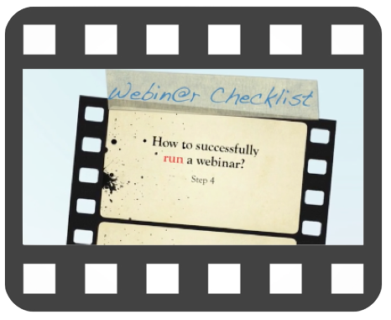
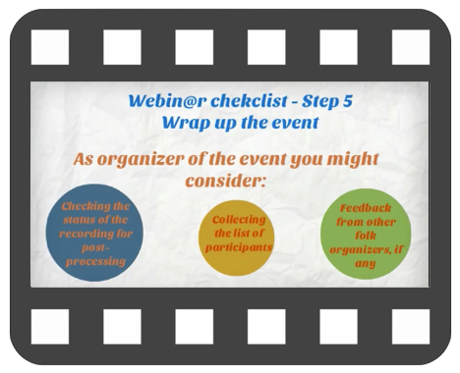
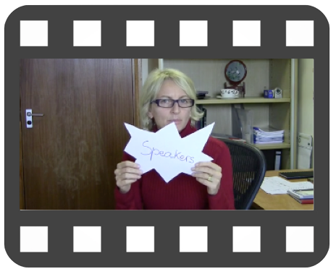
1. Plan
Topic |  | Define list of topics
 |  | Define how to integrate webinar into wider training programme (if existent)
Goals |  | List goals
 |  | List expected outcomes
Partners |  | List potential providers of training who could help or be interested in collaboration
Audience |  | Map the audience (adult/children/managers/technical people/level of expertise in the topic/etc.)
 |  | Language (do you require translators?)
 |  | Time zones
Time Frame |  | Establish the time frame (i.e. how much time do you have before the due date of the webinar?)
 |  | Identify any time constraint
Speakers |  | List candidate speakers
 |  | Identify experts in the field who could advice you
Tech |  | Identify technical experts to advice on tools and provide technical support
Advertise |  | Identify advertising channels
 |  | Draft advertisement (using the above defined goals and outcome)
Risks |  | List risks (add level of risk: high, medium, low)
Additional notes:

2. Organise
Select date |  | Check presenter(s) availability
 |  | Check for major/local holidays
 |  | Check for conflict of dates with other events of interest to same audience
Language |  | Make sure information and support is available in the language to be used
 |  | Check if the conferencing system supports the language to be used (e.g. menu bar and text chat)
Manage Registration |  | If registration is to be required, decide if it will be managed manually or via conferencing system
 |  | If registration is not required, decide if event is to be "open to all" or require preparations to deal with a "restricted audience" (e.g. password protected events)
 |  | Make sure confirmation of registration (if registration required) and email reminders of webinar are sent to the audience and contain all relevant information to attend the event (e.g. webinar link and main point of contact in case of any problems)
Web Conferencing System |  | Make sure the 'main point of contact' for the event has access to all information needed to support participants (audience and presenter) using the conferencing system
 |  | Plan to support presenter on the use of conferencing system (e.g. bookings induction and test sessions, upload material, distribute training material prior and after session if required)
 |  | Plan to support audience on the use of the conferencing system (e.g. book induction sessions, make information and FAQ available)
 |  | Be considerate that participants (audience and presenters) will most certainly be using different devices to attend the webinar, in different environments (e.g. bandwidth, institutional security firewalls) and also will have different levels of technological skills and experience
Certificate |  | Agree on design and basic information (logos, signatures, etc.)
 |  | Decide on methods of production and distribution (printed or electronic format?)
Evaluation survey |  | Decide on methods of production and distribution for a post-event evaluation survey (this should be conducted after the event)
 |  | Decide which tool to use for the survey, making sure the decision is based on accessibility by the audience (and may provide an alternative format if accessibility problems are foreseen)
 |  | Write survey questions to collect feedback related to content, technology used in the event, speaker and support received (prior and after session)
Assessment |  | In cases where subject assessment is required, make sure this is explained to the audience well in advance of the session (and before the registration, if registration is planned)
 |  | Plan the assessment format with the presenter in order to fulfil the learning outcomes established for the event
 |  | Decide which tool(s) to use for the assessment, making sure the decision is based on accessibility by the audience (and may provide an alternative format accessibility problems are foreseen)
Advertising |  | Advertise the event well in advance in order to make sure participants have time to plan the attendance
 |  | Use a variety of communication channels (e.g. relevant newsletters, mailing lists, online calendar of events, websites, social media)
Additional notes:

3. Design
Support speaker’s planning and preparation |  | Inform speaker about the system requirements of the web conferencing to be used
 |  | Inform speaker about engagement functionalities available in the web conferencing system (e.g. poll, chat, questionnaire, break out rooms)
 |  | Provide a list of document formats that can be uploaded to the web conferencing system (if applicable)
 |  | Advise on the pros and cons of using animations, videos and application sharing during the online session. Remind speaker that the quality of internet connection of the participants can affect the use of these features
 |  | Agree on the length of the webinar
 |  | Check with speaker what web conferencing permissions the participants will need to engage in the webinar (e.g. annotation tools to draw on screen, chat, microphone, etc.)
Test |  | Book a test session for the speaker to test the quality of his audio, and how the material displays in the system (slides, animations, videos)
Confirm |  | Agree on a deadline for receiving a copy of final versions of all resources that will be used in the webinar (slides, animations, videos, etc.). This is a backup procedure, in case of technical problems
 |  | Check with speaker if any resource should be shared with participants prior the session, as part of preparation to attend the webinar
 |  | Confirm if facilitation support is needed during the session and agree on a strategy (e.g. would the speaker want help to monitor the chat, open and close polls, distribute participants in break out rooms, etc.)
 |  | Obtain confirmation from speaker that the webinar can be recorded and the recordings shared after the event
Additional notes:

4. Deliver
Audio |  | Test microphones of speaker and participants
 |  | Solve audio issues using the web conferencing system (as possible, depending on settings available for system administrators)
 |  | Disable/enable microphones as needed during the session
Whiteboard |  | Test display and loading time of images and animations. Plan to do this before participants log in
 |  | Test functionalities that will be used (e.g. poll, drawings, cleaning drawings). Plan to do this before participants log in
Backup |  | Make sure to have the backup files of all resources handy, in case there is need to upload it again
 |  | Be prepared to call a speaker replacement if needed
Chat |  | Post a welcome message
 |  | Answer technical questions (and content questions, if applicable)
Manage the flow of session |  | Introduce topic, speaker and acknowledge participants at the beginning of the session
 |  | Set the rules for communication, informing the preferred time for questions (if participants should interrupt speaker to ask questions or let the questions to be asked at the end), and preferred functionality (use microphone for questions or type in the chat)
 |  | Keep track of time and remind speaker
 |  | Have an extra person as chat moderator, if applicable. This is advisable when having a large number of participants, so the organiser can dedicate its full attention to attend technical issues that arise during the session
 |  | Support the facilitation of the session if previously agreed with speaker (e.g. open/close polls, distribute participants into break out rooms, clear drawings, initiate questionnaires, etc.)
 |  | Add more “seats” for additional participants. Note: not all web conferencing systems allow this change after session started.
 |  | Eject misbehaving participants
 |  | Change participants’ permissions or roles within the system when needed
 |  | Record the session (if applicable)
On-site |  | Prevent interruptions (e.g. turn mobile phone off, inform office colleagues you should not be interrupted)
Additional notes:

5. Wrap up
Record attendance |  | Save the registration data of the event. This can be useful to identify prospect participants for future events you may organise
 |  | Distinguish between those who attended and those who missed the event. Most web conferencing systems will indicate this in the attendance report. You will need this information to send post-event messages and certificates
 |  | Prepare certificates to those who attended the event (if applicable)
Post-event messages |  | Send a “Thank you” message to those who attended the event. Include the link to access recording and certificates (if applicable)
 |  | Send an “Event missed” message to those who registered but not attended the event. Include the link to access recording, if applicable
 |  | Send a “Thank you” message to the speaker. Share a short report of attendance and the link to access recording, if applicable
Recording |  | Download and save recording. Check the quality of the recording and edit if needed (e.g. cut unwanted audio tests and other irrelevant parts)
 |  | Save all related material, for instance the chat discussions, shared files, poll results, etc.
 |  | Convert recording file to appropriate format (e.g. mp4, wmv or other) to use in a website or selected platform for sharing (e.g. YouTube, Vimeo, etc.)
 |  | Share the recording
 |  | Follow the statistics of the recording playback. This can provide you useful insight regarding the audience and needs for similar training resources
Feedback |  | Distribute post-event survey to collect feedback
 |  | Analyse survey results and share with managers, speakers, support officers and participants (if appropriate)
Report |  | Write a report. Make sure to include the outcome from the feedback survey, lessons learned and ways to apply it when organising future events
 |  | Share the report with appropriate partners
Additional notes:

Videos used in this resource:

Step 1 – Plan
https://player.vimeo.com/video/109318168?color=c9ff23&amp

Step 2 – Organise
https://youtu.be/ofAjW72TtOg

Step 3 – Design
https://player.vimeo.com/video/109671598?color=c9ff23&amp

Step 4 – Deliver
https://player.vimeo.com/video/109761952?color=c9ff23&amp

Step 5 – Wrap up
https://youtu.be/6y-7mDm9mPo

Adapted from the session “Webinar Checklist” offered at CALMet Online 2014 by Anna Ghelli (ECMWF), Ivan Smiljanic (EUMeTrain), Lu Veeck (WMO/VLab), Alessandro Chiariello (EUMETCAL/FMI) and Maja Kuna-Parrish (EUMETSAT).
Videos are linked to respective diagram pictures. If you have problems accessing the videos, please see full URLs listed at the end of this document

