Assessment Principles

Many trainers would say that assessment is the part of training about which they are least confident. Assessment is stressful for both trainers and for learners. However, it is an ESSENTIAL part of learning. Without it, learners do not know how well they are learning, and trainers do not know if their training is successful. This resource looks at the fundamental qualities of assessment—both simple parts and also at what makes it complex.
In some ways, learning assessment is simple. Look at this training cycle diagram from the WMO Guidelines for Trainers (WMO-No. 1114).
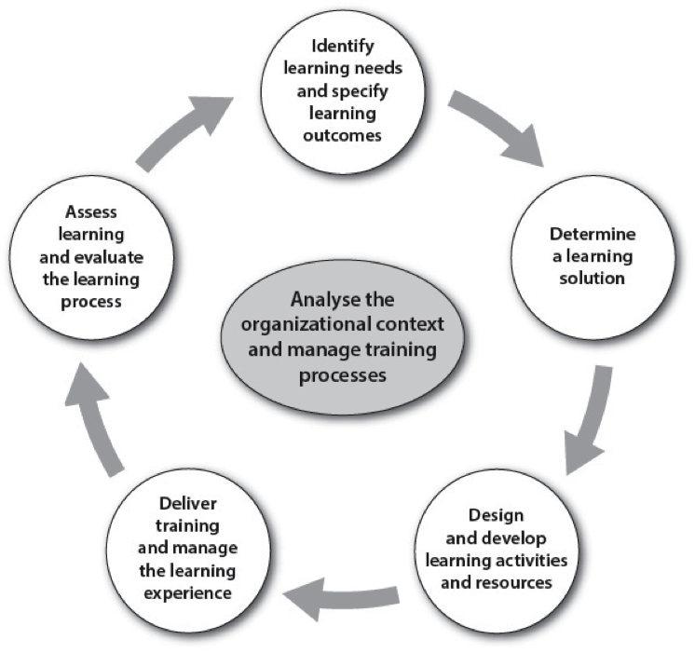
It shows that assessment is embedded as part of a learning system. It is not a separate set of decisions. What we need to assess is actually decided right from the beginning, when we determine the required learning outcomes. If you have defined learning outcomes in terms of job tasks, as we do in training, then you know what you have to assess. That part is easy.
What is difficult is finding effective and practical ways to assess job tasks in a training environment. It is hard to recreate realistic conditions outside the job environment. However, this can be approximated through simulations and case studies that use standard work equipment and real data. But due to the time to create them and the time to administer them during training, these assessment formats will always only be able to selectively measure what has been learned.
Job competencies are best assessed on the job, particularly if the assessment has implications for the certification of the person to perform that job. However, job tasks are composed of many smaller actions and based on a large amount of background knowledge, and simpler assessment methods can assess these smaller tasks and background knowledge to make a contribution to a more complete assessment of how someone will be able to perform on the job.
Consider the excerpt at the end of this resource. It describes part of competency and knowledge requirements from the Aeronautical Meteorology Forecaster competencies (which can be found at http://www.wmo.int/pages/prog/amp/aemp/index_en.html). While the ability to perform a job in realistic conditions requires a complex assessment or on-the-job observation over long periods of time, the building blocks of this performance can be assessed in less complex ways. For example, we can more easily assess the ability to analyze data and make forecasts of specific parameters. With even more reliability, we can assess knowledge of the formation mechanisms of weather phenomena. We can use many forms of assessment to discover if learning has occurred. Well-constructed objective test questions in quizzes can go a long way to help you (and learners) gauge learning before, during, and immediately after a course as well. But of course, discussions and simulations can probe more deeply and diagnose what learners know.
A list of many forms of assessment is presented below. How many of these have you used in your training?
- Quiz items, including: Multiple choice, True/False, Matching, Fill-in-the-blank, Short- or long-text answer, Clickable hot spot
- Contributions to discussions
- Papers, reports, or projects
- Problems and exercises
- Student-created diagrams/illustrations / concept maps
- Interviews
- Observation of practice or work tasks
- Peer-assessment
- Self-assessment
- Role play
- Simulation or case study
- Real-time (actual) event
- Portfolio of collected student work

The WMO Trainer Resources Portal contains other resources that focus on assessment in the training environment. This includes resources on developing good assessment test questions, which can be difficult to create, but worth the effort. Other resources are available on using case studies and simulations for assessment purposes, and one resource covers competency assessment techniques. Yet others address peer assessment practices and formative assessment.

______________________________________________________________________

Competency 2. Forecast Aeronautical Meteorological Phenomena and Parameters
Competence description: Forecasts of meteorological parameters and phenomena are prepared and issued in accordance with documented requirements, priorities and deadlines.
Performance criteria
1. Forecast the following weather phenomena and parameters:
- temperature and humidity
- wind including temporal and spatial variability (wind-shear, directional variability and gusts)
- QNH
- cloud (types, amounts, height of base and vertical extent)
- precipitation (intensity and temporal variations, onset/cessation and/or duration, amount and types), and associated visibilities
- fog or mist, including onset/cessation and/or duration, and associated reduced visibilities
- other types of obscuration, including dust, smoke, haze, sand-storms, dust-storms, blowing
- snow, and associated visibilities
- hazardous weather phenomena listed in Performance criterion 3.1
- wake vortex advection and dissipation, as required.

Background knowledge and skills
- the generation mechanisms of low-level jet-streams, boundary layer turbulence and gusts, and their effects on aircraft
- the formation and dissipation, characteristics, occurrence and effects of fog and other forms of obscuration, and low-level cloud, and associated diagnostic and prognostic parameters
- mechanisms for generating different types of cloud and precipitation, and local enhancement mechanisms for cloud and precipitation
- volcanic ash cloud displacement and dispersion
- formation mechanisms and characteristics of other aeronautical meteorological phenomena, such as dust-storms, sand-storms, dust devils, waterspouts.
- Etc. …
____________________________________________________________

