**ADV FlowTracker gauging – summary procedure**

The use of ADVs is not detailed in current ISO standards. However there are **best practice** **guidelines** from the manufacturer and the USGS that are detailed below:

1. Routine Quality Assurance checks

* Beam Check. A beam check is required when (1) a new instrument is received, (2) if physical damage (e.g. dropping) may have occurred, (3) a firmware upgrade or repair was made, and (4) after any QCTest failures. The beam check procedure is carried out in a bucket of water and is outlined in the FlowTracker Technical Manual. The results are to be stored so that the history of the instrument can be checked.
* Tow Tank Test. New FlowTrackers must be tested in the rating tank and then every 3 years following this. The test must include the meter’s ability to:
  + Measure 3 velocities 10.0 cm/s, 50 cm/s, and 150 cm/s within the manufacturer’s tolerances for accuracy and precision.
  + Measure temperature within +/-2 oC
  + Pass peak signal position and signal noise difference (beam check) tests.

1. Field Quality Assurance checks

The following checks should be performed at each site prior to the discharge measurement. Instrument functions are available under the System Functions Menu on the data recorder.

* Vent the Handheld Controller: The handheld controller should be vented prior to every data run. To vent, loosen the dummy cap on the external communication connector a few turns, wait a few seconds, then retighten the cap.
* Recorder status: The data recorder can hold up to 64 files (4Mb version), or 32 files for the older 2 Mb version. Make sure there is enough room on the recorder to store the site discharge information. Delete the oldest file on the recorder if necessary.
* Temperature data: Temperature is an important component of the velocity estimate. Check that the meter is recording an appropriate temperature compared to an independent measurement.
* Battery data: This function tells the operator how much battery life is remaining. Fully charged alkaline batteries should have a life span of 25 hours. The FlowTracker requires eight AA batteries and a set of new batteries should be carried in the case.
* Display raw data: Set the probe in the water and check the SNR value. It should be > 10 dB, but the FlowTracker can operate properly with an SNR as low as 4 dB in very clear water.
* Run the Auto QC Test.
* System clock: Verify the clock is set correctly.

1. Site Selection

Where available, select a straight reach with a minimum of turbulence, irregularities and weed, etc.; with sufficient depth for the meter and velocity method; and sufficient velocity for the meter to register accurately. Improve the section by removing boulders or debris if practical.

1. Vertical spacing – as for current meter gauging

With a regular bed profile, verticals shall be made at intervals no wider than 1/15 of the total width, and with an irregular profile, no wider than 1/20. In addition, no less than 20 verticals shall be used, and no partial section shall contain more than 10% of the total discharge. This shall be checked by recording the partial section discharges during calculation.

The position of the sampling volume is 10 cm from the transmitting face and the normal wading rod offset is 5 cm; the effect of this 5 cm velocity measurement offset is summarised below:

* In cases of large streams no adjustments are typically made.  The influence on discharge is insignificant.
* In shallow, narrow streams, an adjustment will be made if there is a relatively large change in depth in relation to the total depth.
* If there is a big change in channel depth (like the edges of a small trapezoidal channel) the user will first measure the depth, then physically offset the rod such that the FT sample volume will be placed directly in the vertical station and then adjust the measurement depth accordingly (to sample at the correct depth in the vertical).  This is a little bit cumbersome but again, it’s not commonplace for this type of adjustment to be made and at most it will happen for a few stations along the edges.

1. Velocity measurement

Use the 2 or 3-point methods, and the 0.6 method only if too shallow or there is documented evidence that it is accurate at that site and flow. Measure the velocity over at least 40 seconds where the velocity is regular, and 50 seconds where it is pulsating.

1. Technique guidelines

After the checks are completed, the procedure to collect verticals is outlined in the quick start guide at the end. Important details in this process are:

* Always hold the FlowTracker perpendicular to the tagline as it will calculate the correct flow angle (cosine angle) and use it in the discharge measurement automatically. (By holding it thus, “angle of current” corrections are not necessary.)
* Water’s edge assessments are applied using the correction factor key (CF). The default value of CF is 1.00, any value from -1.00 to 1.00 except 0.0 is allowed. A uniform deceleration from the last velocity reading to the W.E or Effective W.E. suggests a CF of 0.5. The CF can also be used at internal islands and other method = None stations to scale the velocity from the adjacent station(s). One possible use is near the edges where a boundary may interfere with the sample volume, in these cases the FlowTracker probe can be reversed 180° and a CF of -1.00 used to correct the X velocity.
* Quality code parameters are reported after each vertical measurement. Table 1-1 from the Technical Manual outlines the expected values and these may indicate the need to repeat or check some verticals.

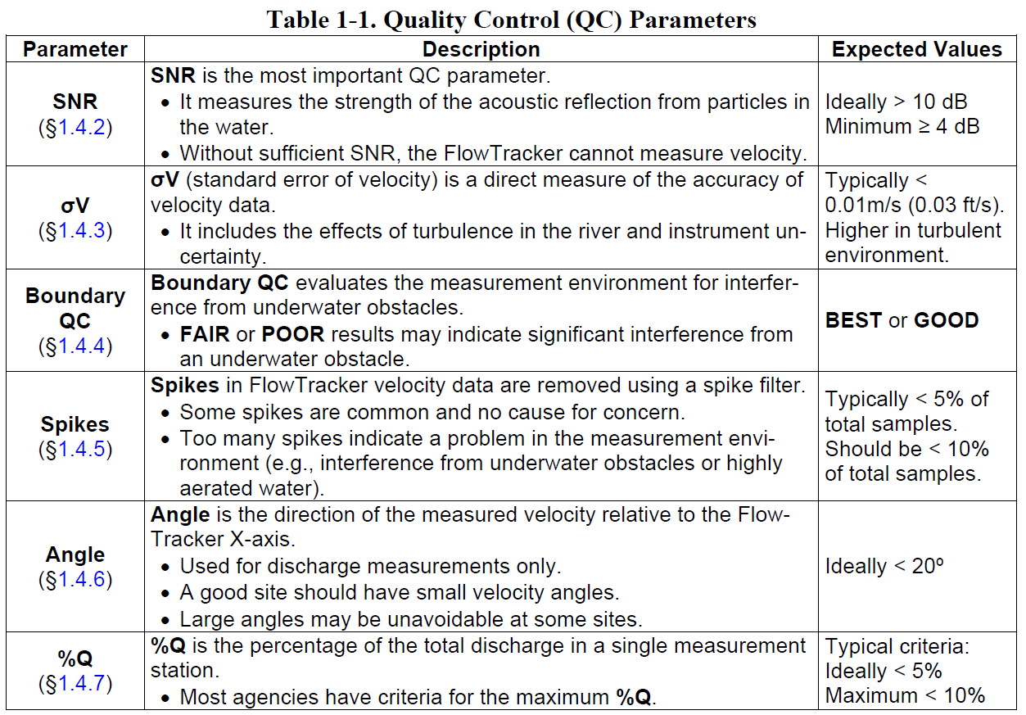

1. FlowTracker specifications:

* Velocity

Range ±0.001 to 4.0 m/s (0.003 to 13 ft/s)

Resolution 0.0001 m/s (0.0003 ft/s)

Accuracy ±1% of measured velocity, ±0.25 cm/s

* Depth

Can measure velocity in water as shallow as 2 cm.

**FlowTracker Quick start guide from the Sontek manual**



