### Battery charging procedures

Most current instruments can be powered by one or more rechargeable 12v sealed lead‑acid batteries of 7.5 ampere‑hour capacity. Solar‑powered installations normally have a larger, low‑loss battery of a similar type but with a capacity of around 80 ampere‑hours. Battery charging, in particular of the non‑solar powered ones, is a crucial operation in ensuring the reliability of instruments. The team shall have a system of identifying:

* Whether a particular battery is charged or discharged (this is to avoid installing a discharged battery at a site). A simple method is to only take batteries directly off the battery charger into the field, and to keep them separate from any discharged ones.
* The age of a battery; i.e. its date of entry into service.
* The condition of batteries with respect to their history of discharge tests, and any power failures or capacity rejuvenation.
* Possibly, the last site the battery was used at.

These requirements will normally require a written record, either attached to each battery or in a book kept at the battery charger. It is recommended that separate areas of bench or shelving be dedicated to charged and uncharged batteries. White vinyl adhesive signwriting sheet (obtainable from almost any signwriter) or paint can be used to cover one end of a battery, and then a black indelible pen can be used to mark the record on the battery.

Batteries should be stored and transported in the field in containers and conditions such that they are protected from accidental contact across their terminals, for reasons of battery health, recorder reliability and fire danger from arcing.

### Power supply

Consider whether this is adequate, test the voltage during a reading, and check whether the wiring is tidy (there is a correlation between tidiness and reliability) and free of corroded terminals, unsoldered connections, and potential breaks. Check for tension in the wires due to movement. Check for diode protection between different batteries on the primary and backup systems.

Batteries should have recorded on them their date of entry into service, and there should be a record of charging, discharge testing, conditioning, etc. as appropriate for the type and duty of the battery. For smaller batteries under 65ah use a 5 year life span as a rule of thumb.

# Power supply diagnosis

If power supply is totally lost and the logger/sensor stops, check the whole system looking for where you do and don’t have power? A systematic check is required, this is best accomplished by measuring the voltage at various points with a suitable voltmeter.

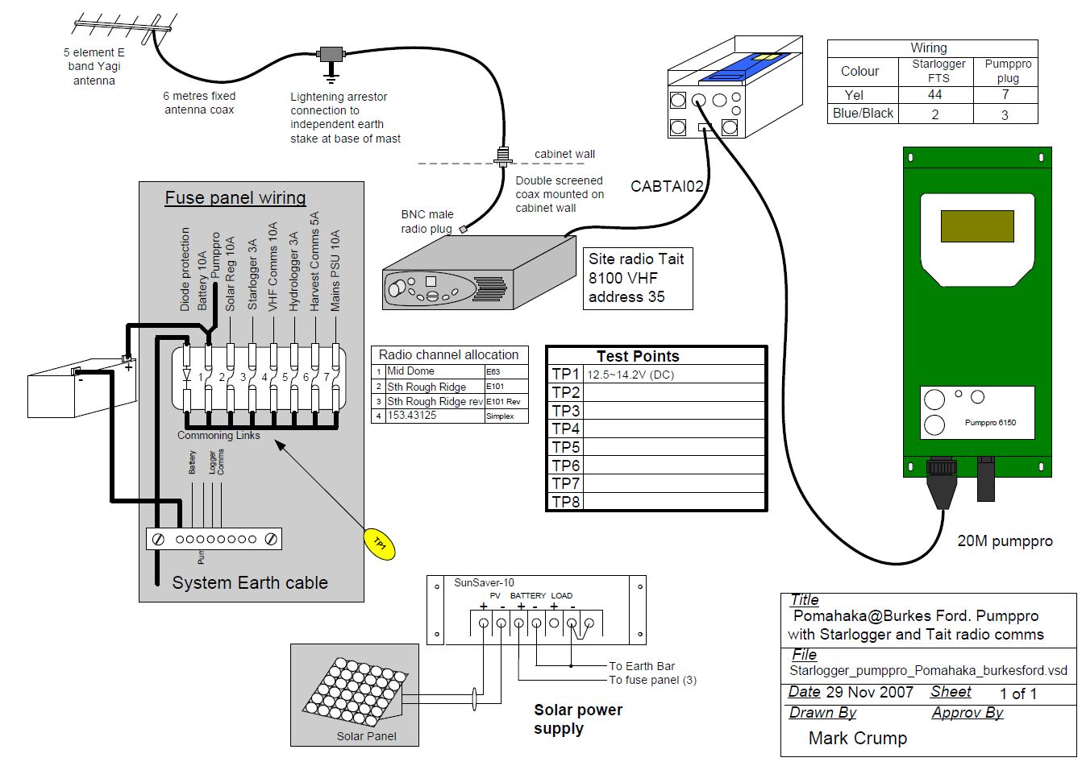

Station power supplies are all different but most stations have a similar structure, the above design follow a standard proven construction and fusing concept so the diagnosis would follow a structure as below. This means diagnosis follows standard processes for isolating problems i.e a standard process may be:

1. Check relevant outputs to devices from fuse panel (blown fuse?)
2. Check voltage from power supply source – Solar/Mains etc
3. Check charge current from supply into regulator
4. Check voltage out of regulator
5. Check charge current out of regulator into battery
6. Check battery, is it holding charge
7. Check solar panel capacity/orientation if charging is insufficient
8. If battery is being run down, check individual device currents to find the culprit – there could be a fault causing a sensor to draw too much power?

Power supply check list example:

|  |  |  |  |  |  |
| --- | --- | --- | --- | --- | --- |
| Power at: | Voltage (v) | Current (A) |  |  |  |
| Battery direct | 12.8 | — |
| Battery at fuse | 12.8 | — |
| Battery at Regulator | 13.2 | — |
| Solar/mains at Regulator | 13.8 | 1.5 |
| Power at fuse 1 | 12.8 | — |
| Power at fuse 2 | **12.8** | — |
| Power at Cell modem | **12.8** | — |
| **Power at PumpPro** | **12.8** | **0.2** |
| **Power at Starlogger** | **12.6** | **0.5** |
| **Power on Din Rail** | **12.8** | — |

*The next page has a printable table for writing down your station power findings.*

|  |  |  |
| --- | --- | --- |
| **Station power supply check list:** | |  |
|  |  |  |
| Item | Voltage (v) | Current (A) |
| Battery direct |  |  |
| Battery at fuse |  |  |
| Battery at Regulator |  |  |
| Solar/mains at Regulator |  |  |
| Power at fuse 1 |  |  |
| Power at fuse 2 |  |  |
| Power at fuse 3 etc… |  |  |
| **Power at sensor 1** |  |  |
| **Power at sensor 2 etc…** |  |  |
| **Power on Din Rail** |  |  |
| **Extras** _____________________ |  |  |
| **Extras** _____________________ |  |  |