# Equipment Deployment

Once a site has been selected, the design and construction of the installation type and deployment of equipment follows.

### In this Section

This section contains information on:

acceptable installation types and components

deployment of equipment and instruments to measure water level, and

basic accuracy requirements.

It primarily covers two factors that influence deployment. These are:

the site-related variables that determine the type and installation of equipment, and

the degree to which the equipment is:

* fit for purpose, and
* operated to minimise errors and maximise accuracy.

### Functional Requirement

All equipment used to measure water level must be deployed and maintained to ensure:

stationarity of record

appropriate resolution of time and recorded stage, and

the overall accuracy of water level data.

## Station Planning

Planning a station requires consideration of a number of factors that can affect the quality, availability and long-term usefulness of the data that is collected.

These factors are:

site access

materials

design, and

construction method.

Note: Where practicable any construction work shall be preceded by a site survey.

### Site Access

Safe and convenient access to recording stations is crucial for data collection.

Permission shall be obtained for access over and installation of equipment on land, whether private, local authority, corporate or government owned.

Construction work on a site shall begin with work on the access itself, including foot tracks and steps to the work site.

### Site Survey

It may be useful to precede construction work with a site survey for the purposes of design. At the least, a station history form should be filled out for the site as soon as records begin, updated following changes, and checked during the annual site inspection (see site factors above).

### Materials

All materials used in installations shall be of adequate strength, thickness and durability for the purpose, and conform to the New Zealand Building Code and Regulations.

Note: Remember that many temporary works can become permanent, or be re-used for another purpose.

Generally:

timber should be treated against rot to an appropriate specification (or better)

exposed and structural steelwork should be hot-dip galvanised or stainless steel

wire ropes shall be galvanised, and

bolts and nuts shall be galvanised or made of stainless steel.

### Design

The design, deployment and installation of systems shall comply with the relevant clauses of the:

New Zealand Building Code and Regulations, and

Health and Safety Act and Regulations

#### Signage

Where relevant, signage shall be installed to warn of any hazards.

A sign that briefly explains who operates the station, contact details and its purpose, is recommended.

#### Security

Where relevant, security gates or systems shall be installed for the safety of anyone who visits the vicinity, and to protect the station from vandalism. Protect installations where practicable from interference and damage, including deterioration resulting from the presence of flora and fauna.

### Construction Method

#### Rivers and Lakes

Where used, concrete footings shall be built in accordance with the New Zealand Building Code to ensure the stability of hydrological structures.

Generally, recorder stilling wells require concrete foundations to:

key them to bedrock, or

to form a broad and substantial footing in alluvium to prevent subsidence or movement.

Generally, weirs require deep cut-off walls to prevent:

leakage, and

overturning of the structure.

Cleaning and preparation of the foundation is essential.

Note: Rock bolts can be useful methods of fastening equipment to bedrock, large rocks or concrete structures. These can range from substantial bolts grouted into holes drilled in bedrock by a compressor-powered drill, to masonry fasteners driven into holes in concrete.

#### Groundwater

Generally groundwater sites are mounted on a sturdy steel bore pipe. If this is not the case, ensure that the datum will remain stable and structural strength is adequate by using suitable construction methods and materials. Allow for easy access to recording equipment.

#### Sea Level

Because of the coastal location of sea level sites, the following should be considered:

The use of Grade 316 stainless steel components

Time construction around the low cycle of a ‘king’ tide

The use of an epoxy that sets underwater

Consider the use battery-powered tools when working around salt water

## Station Documentation

### Site Identifier Allocation

All stations shall be allocated a unique identifier such as a site number or name.

Note: It is the responsibility of the recording agency to catalogue and register the site ID.

The index to hydrological recording sites in NZ can be used to allocate site identifiers.

Note: New Zealand has a system of water-level recording station numbers based on river numbers. NIWA, some regional and district councils, and various other companies use this system. Stations are listed in a site index publication ( Refer: Walter, K. 2000: Index to hydrological recording sites in NZ. NIWA Technical Report 73).

### Station History

#### Station History Record

As a minimum, a station history record shall be established for all water-level stations as the main part of their metadata and be:

filled out for the site as soon as records begin

checked and updated during the periodic site surveys

updated whenever there are changes to site parameters

updated whenever there are changes to what is recorded on the form, and

any updates of an existing record should be in the form of an additional record rather than an overwrite. This will ensure that the station history is maintained.

Note: The Station History form provides a record of, for example, installations, equipment types, data collected, benchmarks and levels, location, the sites initial purpose (e.g., low flow and flood) ownership of land and history for each station. For more information, see ‘Annex C – Hydrological Station History Form’.

# Sensing Devices, Wells & Recording Requirements

### In this Section

This section contains information on devices that:

have direct contact with the water, or

take an indirect measurement of water level

It also provides information relevant to the selection and maintenance of stilling wells and recorder housings and instruments.

### Direct Contact with Water

Devices that have direct contact with water include:

shaft encoders

pressure transducers, and

gas purge sensors.

### Indirect Measurement of Water Level

Devices that indirectly measure water level include:

acoustic instruments with sound path in air

acoustic instruments with sound path in water, and

radar instruments.

Note: Each of these direct and indirect methods have differing accuracies, and in choosing a sensor, the appropriateness to the site must be considered. There are other sensing devices available; some of these don’t meet the standards. Price may also be a consideration.

## Sensor Selection

Selecting a sensor can be complex, however to assist in the correct sensor being selected, consideration should be given to:

whether it is fit purpose, and

compatibility.

### Fit for Purpose

To be fit for purpose the sensor shall cater for the following where required:

Alignment with this standard

Client requirements

### Compatibility

The sensor shall:

be easily interfaced with existing hardware, and

have common industrial output protocols.

### Site Characteristics

Every water level site is unique.

The maximum and minimum measuring range at the site shall be determined. This will ensure the sensor covers the full range and hence no loss of data results.

When selecting the appropriate sensor, the site characteristics shall be considered in conjunction with the following factors:

Seasonal conditions

Environmental conditions

Power budget assessment

#### Seasonal Conditions

Seasonal conditions can influence or damage the sensor, for example:

heat

weed and algal blooms

frost and ice

recreational activity

sediment flushes

floods, and

flood debris build up.

#### Environmental Conditions

Environmental conditions can influence the performance of the sensor, for example:

wind

waves

bank stability

movement of bed materials

river works

water turbulence, and

migrating channels.

#### Power Budget

When used with a particular logger and telemetry system the power budget and maximum demand shall be considered to cover mains power outages.

Items to consider include:

low solar charge

Winter periods

temperature conditions at the site, and

Below freezing over periods

battery capacity.

Will this sustain the power requirements through the worst conditions?

Note: Backup systems and equipment isolation (separate backup data-logger batteries) also need considered.

## Shaft Encoders

A shaft encoder:

is an electro-mechanical float and counterweight gauge

consists of a pulley rotated by the float and counter-weight system

converts pulley rotation to millimetres of rise and fall, and

Records the stage, or relative rise or fall from a start point

Shaft encoders are precise measuring devices that usually have a resolution of ±1 mm, but with some models this can be ±0.1 mm.

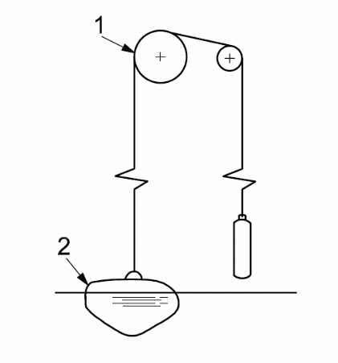Key: 1 driven pulley

2 float

Figure 6 – Float and counterweight configuration

Source: ISO 4375 (2008) Hydrometry – Water Level Measuring Devices

Used on its own, a float gauge can provide a direct readout of stage height without requiring an external energy source, however most encoders are now electronic, link to a separate data-logger, and require constant power to operate. It provides almost uniform resolution throughout the range and good accuracy at low stage.

Note: A float gauge is a mechanical device and is therefore subject to errors from change in temperature, hysteresis and friction. It requires a stilling well, which can be expensive to construct and maintain.

## Submersible Pressure Transducers

#### Theory

Pressure transducers convert the pressure acting on a sensing element into an electrical signal. The signal varies in proportion to the pressure.

The pressure transducer will measure the pressure head of the system but in most cases will report to an equivalent head of water. It is important to understand this relationship and the effects that it will have on given measuring situations. The relationship is:

h = P/(ρ.g )

where P = pressure, g = gravitation constant and ρ = density

The international standards used in deriving the equivalent head of water are:

g = 9.80665 m/sec2

ρ = 1000 kg/m3 derived at 4oC

When comparing the pressure transducer against a body of water this relationship needs to be considered. In most situations the error involved is small and proportional to the head of water over the sensor.

Note: For groundwater systems and deep lakes the ability to effectively validate a system is dependent on these factors and especially the temperature of the water as this will determine the density.

For artesian groundwater systems the temperature effect can be further influenced with exposure of inspection tubes to radiant heating. Purging the tube prior to inspection or direct comparison to another pressure reference is required in these systems.

When verifying the performance of the pressure transducer a direct pressure comparison is preferable as this will check the sensor independent of gravity and density variations that are found with water measurements. The system can be validated against external references to monitor the overall site performance.

There are two main categories of pressure transducer used in the measurement of water level, submersible and gas purge

#### Submersible Sensors

Submersible pressure transducers are mounted directly in the water and can have vented, (open to atmosphere), or non-vented cable to provide a gauge reading. They can be used in a range of applications from surface water and lakes to deep groundwater and can be used with well head adaptors to measure artesian groundwater systems.

Note: Vent tubes must be kept clear or measurements will be affected by barometric changes. Non vented transducers are available and have their advantages; however measurements from these require compensation for barometric pressure. Even if barometric pressure is measured in conjunction with water level, compensation rarely produces results that meet the accuracy required of this standard.

Submersible pressure transducers require a relatively simple installation, hence lower costs, due to no stilling well being required.

Note: It is not normally possible to set the sensor at the recording zero, so an offset is usually needed. It must be recorded in the logbook at the time of installation and applied to the record either in the logger or when processed. In any case transducers must be checked frequently for drift; an offset or change in offset may subsequently be required.

## Gas Purge Sensors

Gas purge sensors differ from a submersible pressure transducer by having the transducer located well above water level, normally within the recorder housing.

The transducer senses water level at an underwater orifice that is connected to the transducer by small diameter tubing. This in turn has a small feed of gas from a cylinder bubbling out through the orifice. The backpressure in the tubing is proportional to the water pressure over the orifice and hence the water level.

When measuring groundwater levels, there may not be sufficient space to install a pressure transducer, or the risks of not being able to retrieve it may be high. In this case, gas purge sensors are frequently used.

Note: In some situations there are considerable advantages in having only small diameter tubing exposed to the stream rather than an expensive transducer. There is, however, additional cost associated with the use of the gas purge system.

These systems must be installed correctly, with regard to manufacturer’s instructions on bubble tube length, avoidance of dips in the bubble line, and a suitable orifice system that prevents under-reading in surging waters and will enable the measurement of a fast rate of rise or fall.

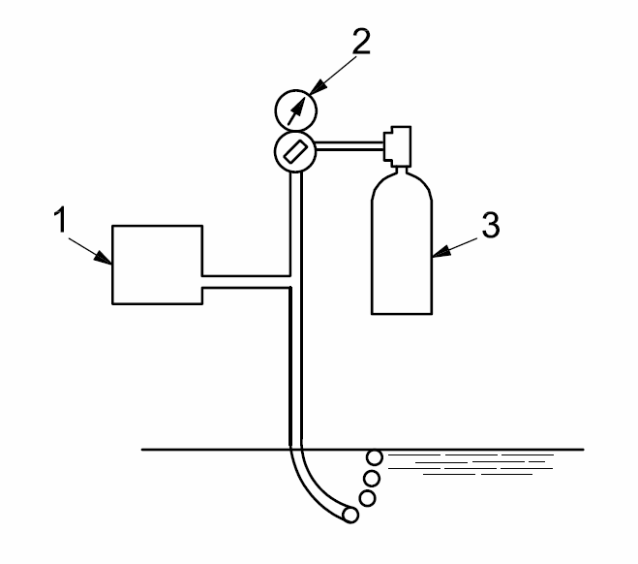

**Key**

1 pressure sensor

2 regulator

3 compressed gas

Figure 7 – Gas purge system

Source: ISO 4375 (2008) Hydrometry – Water Level Measuring Devices

### Accuracy Requirement for Pressure Transducers

The accuracy requirement for water level measurement follows the USGS framework for sensor and site accuracy.

The sensor shall have an accuracy of ± 3mm or 0.2% of effective stage, whichever is greatest.

Note: This gives a high degree of accuracy at low levels with a proportional decrease over the sensor range.

Manufacturers state sensor accuracy in differing formats and can include linearity and temperature errors. The total error should be considered when selecting a pressure transducer.

Accuracy may be in terms of full-scale error ( % FS ) which states error as a percentage of maximum sensor range, or as a percentage of measured value, which gives a proportional error over sensor range.

For example:   
A sensor with a range of 10mH2O and accuracy of 0.1%FS has an error of 10mm over the entire 10m range whereas a sensor of the same range and accuracy of 0.1% of value has an error of 10mm at full range but only 5mm at half range.

A sensor with a stated accuracy of 0.1% FS can be used if the calibration relationship is known and falls within the accuracy tolerance of ±3 mm or 0.1% of effective stage, this can be requested on purchase or can be determined and scaled with a portable calibrator.

For sensors with an error greater than 0.1% FS then the range of the instrument must be selected to ensure that the error does not exceed 3 mm; i.e. for a 0.2% FS sensor the maximum range is 1.5 metres.

A calibration certificate showing the relationship of the sensor to a traceable reference shall be supplied on purchase detailing the sensors accuracy

### Installation and Commissioning

The most important component of installing a pressure transducer system is applying the correction to gauge zero. This requires an offset to be derived and applied to the raw signal on the data logger.

Note: The sensor output may require additional scaling to return the correct engineering units for the water level measurement; this is most important on voltage and milliamp outputs but can be important for digital signals as well.

Where possible the orifice or sensor mount should be surveyed to the datum to provide the offset, and monitored for stability over time.

Alternatively the sensor can be set to a suitable primary reference gauge. It is important to adequately record the offset information and ensure that the reference gauges are correctly aligned to recording zero.

## Stilling Wells

### Usage

Stilling wells shall be used to:

dampen the fluctuations present in open water

protect the sensors, e.g., float and counterweight sensors, and

provide, within the well, an accurate representation of the water level in the channel.

### Stilling Well Design

Stilling wells are generally made either of spiral-welded pipe or standard rolled sections 1200 mm in length.

A steel recorder housing bolts to the flange of the top section.

The following diagram shows one design that consists of a number of sections; each section being 600 mm in diameter and 1200 mm in length.

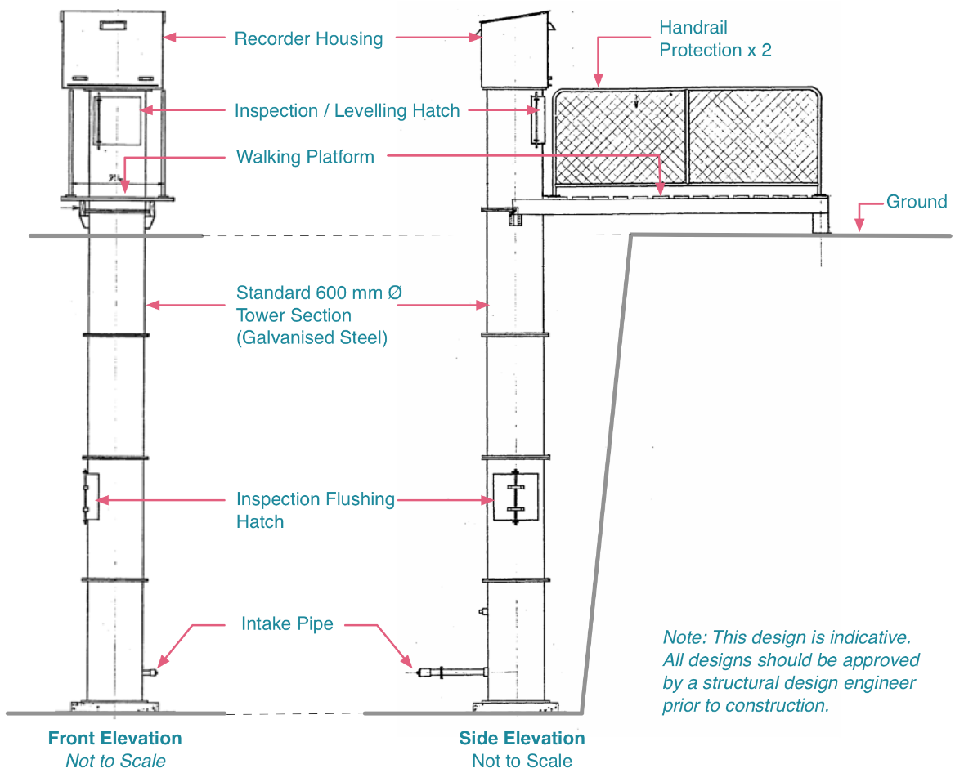

Figure 10 – Typical Stilling Well and Housing Setup

Source: NIWA Field Manual

Note: Other designs and materials may be as good or better in certain situations. Alternatives include pipes of concrete, plastic (PVC), spiral-welded steel, fibreglass and corrugated culvert pipes.

### Connection to Open Water

The well shall be connected to the lake or river by means of suitably sized intake pipes.

Where velocity past the river end of the intake is at times high (i.e. above 1.5 m/s) drawdown of the water level in the well may occur. To reduce this, a capped and perforated static tube shall be attached, oriented parallel to the direction of flow (± 10°).

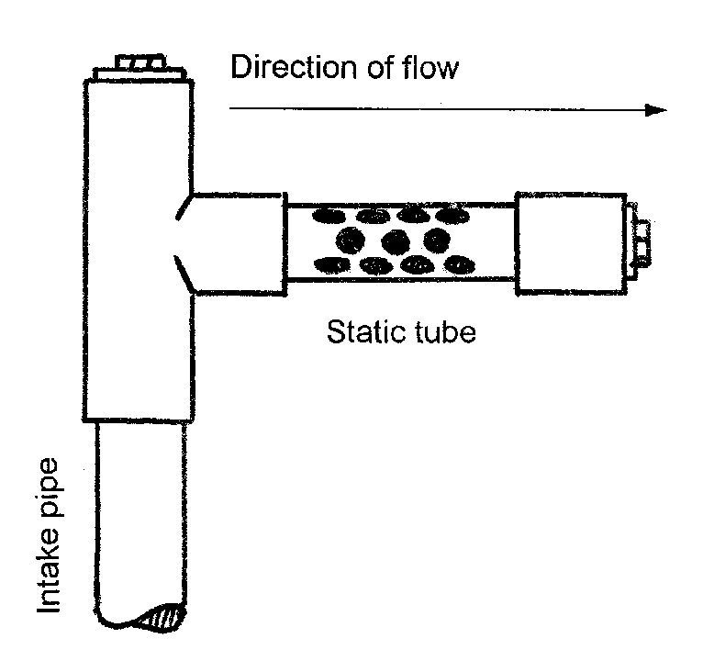

Figure 10 – Typical Static Tube Setup

Source: NIWA Field Manual

### Cross-Sectional Area

The cross-sectional area of an intake pipe shall be large enough relative to the diameter of the well to follow rapid changes in the external water level without significant lag.

For more information, see ‘Annex I – Intake Pipe Dimensions’.

### Site Requirements

#### Intake Pipes

Intake pipes shall be laid:

on firm material that will not subside, and

at a constant gradient; normally horizontal.

The lowest intake pipe shall be at least 150 mm below the lowest anticipated water level (but considerably further if degradation of the bed is possible).

Note: This is a very important decision that may impact considerably on the usefulness of the structure over time.

The lower intake pipe shall be at least 300 mm and preferably 1m above the bottom of the stilling well, to avoid blockage by sediment.

The intake pipes’ diameters shall be large enough to keep lag within acceptable limits, but not overly large so that surging is not damped.

For more information, see ‘Annex I – Intake Pipe Dimensions’.

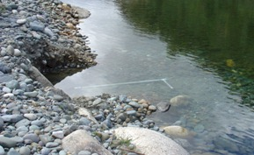

Figure 11 – Example of Intake and Static Pipe

Photographer: Evan Baddock

#### Stilling Well Construction

The stilling well shall:

be vertical within practicable limits

not allow the float and counter-weight systems to come in contact with the walls.

have sufficient height and depth to allow the float to freely travel up and down the full range of water levels, and

be firmly founded so that subsidence will not occur.  
*Note: Foundations that sit directly on bedrock are preferable; otherwise a substantial concrete mass poured into hard alluvium is required.*

All construction joints of the well and intake pipes shall be watertight.

Note: Watertight joints ensure that water can only enter and leave through the intake.

A means of access to the well and intakes for cleaning and other maintenance reasons shall be provided.

### Silting Management

Sites with known sediment problems shall be carefully checked at each visit, and if there are any indications of a siltation problem, the stilling well must be flushed as soon as possible.

Note: Indications of a blocked or partially blocked stilling well are usually apparent on the recorded hydrograph. It may show up as uncharacteristically flat or stepped recessions, rounded peaks or a slow response to changes in external water levels.

For more information on flushing techniques for cleaning silt from stilling wells, and methods for checking the amount of silt in a stilling well or intake pipes, see ‘Annex F – De-Silting Stilling Wells’.

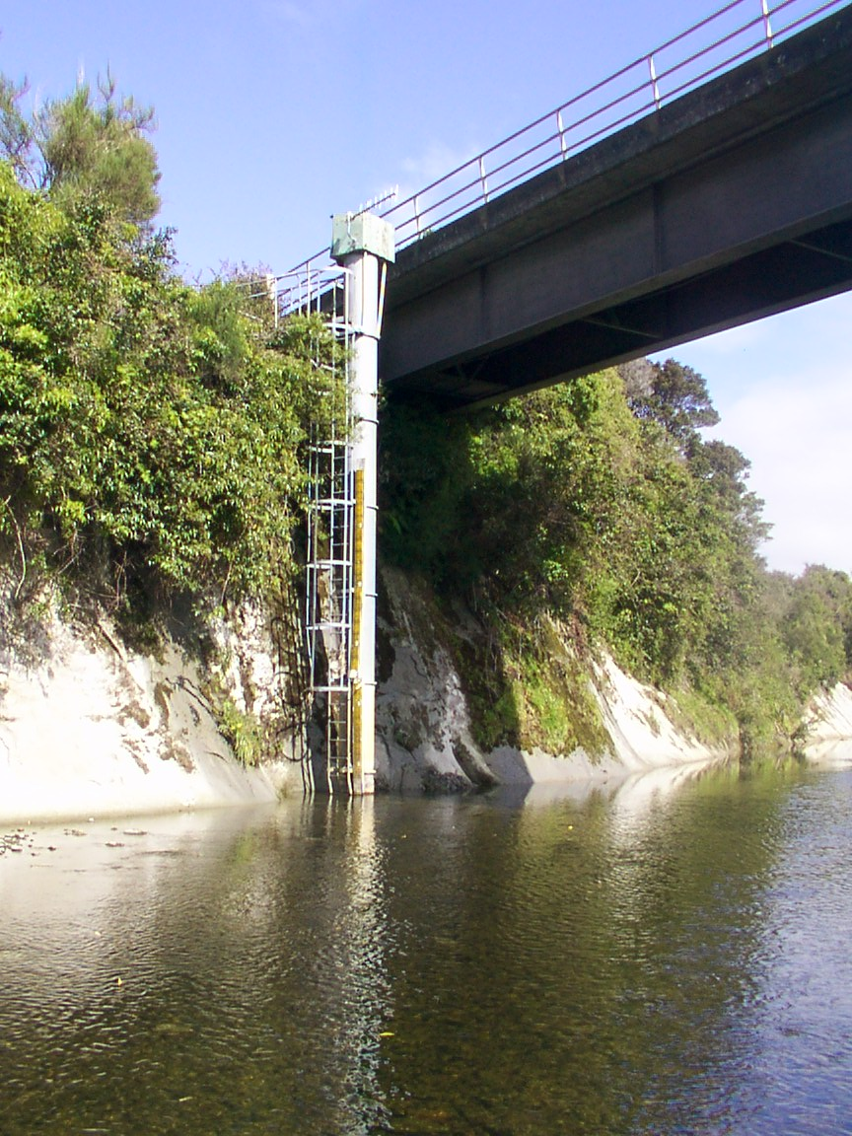

Figure 12 – Water Level Station Showing Multiple Sections and Housing

Photographer: Evan Baddock

## Recorder Housing

The recorder housing shall:

be installed above maximum possible water level

fully protect the equipment from:

* all inclement weather
* spray
* condensation
* insects
* vermin, and
* the general public.

provide sufficient room for:

* equipment
* field books
* telemetry equipment (if applicable), and
* downloading loggers.

be clean and dry on the inside, and

have an exterior appearance that blends in with the landscape as much as possible.  
*Note: The appearance can protect the recorder and associated equipment from the elements and from interference by the public and wildlife.*

All equipment within the housing shall be installed in a secure and orderly manner.

Note: For example, wires, cables, pulleys must not interfere with operation and servicing.

#### Walk-in Types

A ‘walk-in’ housing may be:

a small shed or

the top of a large diameter concrete stilling well that is mounted:

* above a stilling well, or
* separately on the ground nearby.

#### Chest Height Types

A ‘chest height’ recorder housing may be a smaller design mounted:

at chest height on the recorder stilling well, or

if the sensor is connected only by cable or tubing, in a suitably protected location.

Note: Exposed cabling and tubing also requires protection from the elements and interference.

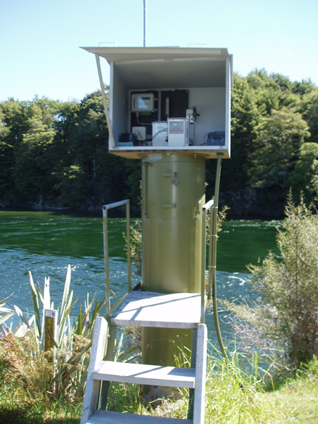

Figure 13 – Typical Stilling Well Housing design

Photographer: Evan Baddock

## Recording Instruments

### Electronic Data Loggers

An electronic data-logger shall be able to store at least the equivalent of four digits per reading. Where a data logger includes the sensing device, the resolution and uncertainty shall relate to the stored value.

There are many data-loggers on the world market with a large range of price and capability. Generally they all have the capability to interface to several different types of sensors, vary the recording interval and output the data in various electronic formats to computers.

Chart recorders shall not be used.

The main capabilities and factors to consider when choosing a data-logger are the:

ability to interface to relevant sensors

digital resolution (how many bits) and accuracy

telemetry capability and compatibility

adequacy of set-up and downloading software

With digital devices, there can be poor on-site access to the data without specialised equipment or software.

the ability to average and record other statistical information such as standard deviation

recording of data at some distance from the sensor

reliability, compactness, and cost

power requirement

The power requirement should be low.

storage capacity

clock accuracy, and

scan rate.

This is the frequency a data-logger is able to measure and process signals then recieve data.

## Site & Station Maintenance

All stations shall be maintained in good order so that they are:

reliable and operate effectively

fit for carrying out their intended task, and

sufficiently tidy for efficient work practice.

Note: A well-maintained station will project the impression of a professional operation.

To maintain a station and the site in good order, the following tasks shall be carried out on a regular basis:

The recorder housing shall be kept tidy.  
*Note: Bare galvanising is often acceptable, particularly once weathered.*

Hinges and locks shall be kept lubricated   
*Note: Use graphite powder on locks; not oil but keep it away from electronic and electrical components and aluminium surfaces that may become wet. Use sparingly or it may bind locks.*

Signage relating to hazards shall be maintained

Access tracks shall be maintained in a safe condition, including being clear of vegetation.

The visual effect of the station on the environment shall be minimised.