## Primary Reference

### Local Datum

Any water-level measurement shall be referenced using a local datum that is established on site using at least three benchmarks (BM’s).

Note: Three benchmarks are essential to resolve the cause of any discrepancy in levels that may occur over time, by the movement of one or more parts of the installation.

A survey grade GPS can be used to establish the approximate level of a primary benchmark. However the vertical accuracy is unlikely to be adequate for levelling between benchmarks and staff gauge(s).

All components shall be levelled in from the primary datum, using traditional survey methods.

### Assumed Datum

When establishing an assumed datum, an assumed level shall be conferred, for example, 100.000 metres to the most immovable of the site's benchmarks, and level in the other benchmarks and installations to this.

100.000 metres is a useful assumed level to choose, unless the site is at a comparable elevation above mean sea-level (M.S.L.), in which case it may at some time be confused with M.S.L. datum, and thus an alternative value should be used.

Note: An assumed datum may be used instead of one established to a proper surveyed datum, as in many cases stage height is measured only to determine flow, and the level itself is not the information required. A common exception to this is the case of reservoirs or groundwater stations where levels may be well defined in terms of a local or regional datum.

### Adopting a Recording Zero

The recording zero of a station shall:

be placed below the lowest level to which the water surface will fall, and

take into account possible degradation at the site that may lower the water level below the recording zero.

When adopting the recording zero, choose one that is:

a sensible number where possible, e.g., 100.000 metres, and

below the anticipated minimum water level.

Note: An important factor is that the water level will not be likely to fall to negative values over the life of the station.

### Equipment for Reference and Measuring

#### Basic Requirements for Collecting Water Level Data

The collection of water level data, either manually or automatically, requires a range of instruments, or components, to be deployed at a site.

For water level data to be useful, a permanent datum shall be maintained and specified accuracy limits shall be met. These details are documented in the station history file and metadata for individual sites.

#### Reference Gauges

The reference gauge is the means by which an instrument is referenced to the recording zero. At least one reference gauge shall be installed at each site.

The reference gauge shall be:

referenced to benchmarks

of robust and stable construction

readable to within 1 mm, and

cover the full range of anticipated stage.

#### Primary Reference Gauges

The primary reference gauge and the measured water levels are used to determine the stage height. The following are examples of primary reference gauges:

Staff gauge

Sloping staff gauge

Electric plumb bob

Electronic water level indicators

For example: A groundwater probe.

#### Equipment Selection

Any of the following devices may be used to measure water level:

Shaft encoder

Pressure transducer

Gas purge sensor

Acoustic transceiver

Radar

When establishing a station the sensing device and datalogger shall, where practicable, be selected to meet:

the accuracies and resolution required by this Standard

the full range required

any present and future (anticipated) data needs, and

the time interval required to measure the fluctuations occurring at the station.

## Staff Gauges

A staff gauge:

is a graduated staff that is mounted either vertically or inclined, and

provides an inexpensive, simple, robust and absolute method of determining water level.

At a site equipped with an automatic recorder, the staff gauge provides an independent check on recorded water levels.

Generally, with a stilling well this external staff gauge is an essential check on whether the intake pipe is blocked by silt.

Generally, with a transducer or gas bubbler orifice directly in the river, the staff gauge is the only easy direct check on its performance.

Where the range of water levels exceeds the capacity of a single vertical gauge, other gauges shall be installed, as much as practicable in line with the recorder cross-section.

The scales on a series of stepped staff gauges should overlap by not less than 15 cm.

### Usage

A staff gauge shall only be used for spot measurements and shall include an estimate of uncertainty.

Note: It can be difficult to obtain readings in the field with a true resolution better than ± 3 mm. Floods cause surges and standing waves which can introduce a bias.

### Vertical Staff

The most common form of gauge is the vertical staff. It normally consists of a series of   
1-metre long plastic plates that are graduated at ten-millimetre and 1-decimetre (100 mm) intervals fixed to a secure mount, e.g., treated timber board or concrete wall.

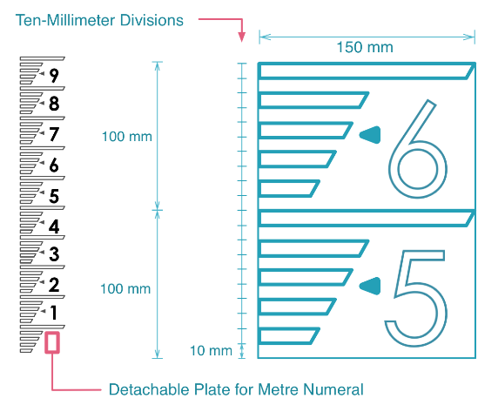

Figure 3 – Staff Gauge Plates

Illustration: Chris Heath

### Sloping Staff

Sloping staff gauges can be used where:

there are no suitable anchorages for vertical staff gauges

vertical staff gauges are too prone to be damaged by high velocities and debris, or

a better resolution is required.

Note: A sloping gauge will achieve a better resolution than a vertical staff gauge because distance up the slope is greater than corresponding vertical height.

Gauges, e.g., a plank or concrete pad (Figure 4) shall be set at a known angle.   
30˚ is recommended, as staff plates exist for this angle*.*

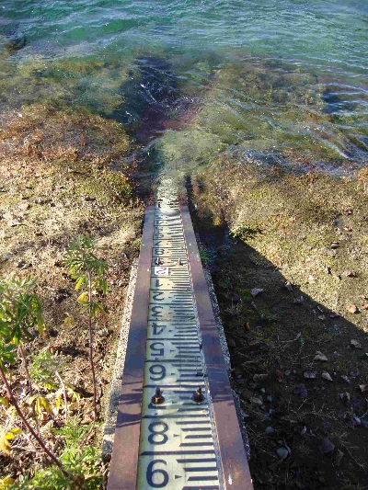 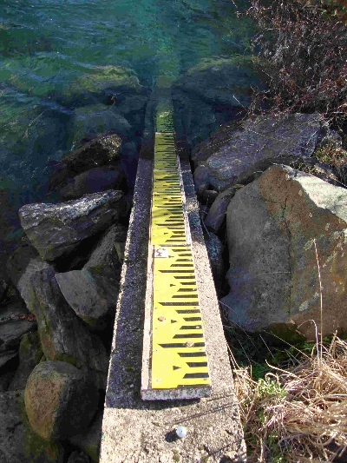

Figure 4 – 30° Sloping Staff Gauge

Photographer: Evan Baddock

If standard vertical plates are used at 30˚, the values read off the sloping staff gauge can be halved to obtain the actual water level.

Note: At 30˚, the slope distance is twice the vertical height.

### Installation

Staff gauges shall be installed so that:

the zero of each gauge is at the recording zero.

The R.L. level should be below the lowest possible water-level, given that the bed may degrade significantly over the life of the station.

there is overlap between the top of the one gauge and the bottom of the next

the staff gauge mounts are immovable and not prone to settling

the method of fastening the timber to the mount is positive   
*Friction should not be relied on to prevent slippage.*

the water-level is easily and accurately read at any time

the gauges are protected from high velocities, and   
*If high velocities are unavoidable, keep the gauges short and have more of them, or glue plates to a concrete face.*

the gauges are on the same river cross section as the intake pipes or sensor orifice.  
*Especially with low flow gauges, staff gauges shall be as close to the intake pipe or orifice as possible.*

## Electric Plumb Bob

### Introduction

The electric plumb bob (EPB) is a non-recording gauge that is normally used to measure the water level in a stilling well.

*Note: It gives an independent check on the internal water level and therefore provides a check on the recorder.*

It consists of a plumb bob connected to a graduated steel tape, wound on a brass reel (Figure 5). This forms part of a low voltage electrical circuit that is completed when the plumb bob is wound down to, and touches, the water surface. The contact is registered on a milliammeter, or buzzer/light, and thus the plumb bob can be raised or lowered so that it is only just touching the water surface, and a reading taken from the tape graduations.



Figure 5 – Electric Plumb Bob Schematic Diagram

Source: ISO 4375 (2008) Hydrometry – Water Level Measuring Devices

In Groundwater applications, electronic water level indicators are used. These consist of a spool of dual conductor wire with a probe attached to the end as an indicator. When the probe comes in contact with the water, the circuit is closed and the meter light and/or buzzer will signal contact. Measurements should be made and recorded to the nearest 10mm.

*For details on the installation and set-up of an electric plumb bob, see ‘*Annex B – Procedures*’.*

### Usage

An electric plumb bob (EPB) shall be used to provide an accurate indication of water level in situations where access and visibility are impaired, i.e., within a stilling well or a borehole.

An electric plumb bob can provide acceptable accuracy when the distance to the water surface is of the order of tens of metres.

Note: Electric plumb bobs may not work in waters of very low conductivity.

Due to their accuracy, electric plumb bobs are generally used as the primary reference check at stations where they are installed. Although they are the best check of the instruments in a stilling well, they are prone to the same intake silting. Each electric plumb bob reading should be paired with an external staff gauge reading to identify possible silting.

### Mounting

Electric plumb bobs shall be mounted in a manner that prevents vertical movement. Any vertical movement will shift the gauge zero with respect to the recording zero.

### Precision

Fixed pointers shall be installed to ensure that readings can be taken to 1 mm precision.

### Deployment

An electric plumb bob shall be installed at each stilling well site.

Note: Discrepancies between the recorder and the electric plumb bob will sometimes occur. For more information, see ‘Annex B – Procedures’.