Learning Action Maps∗

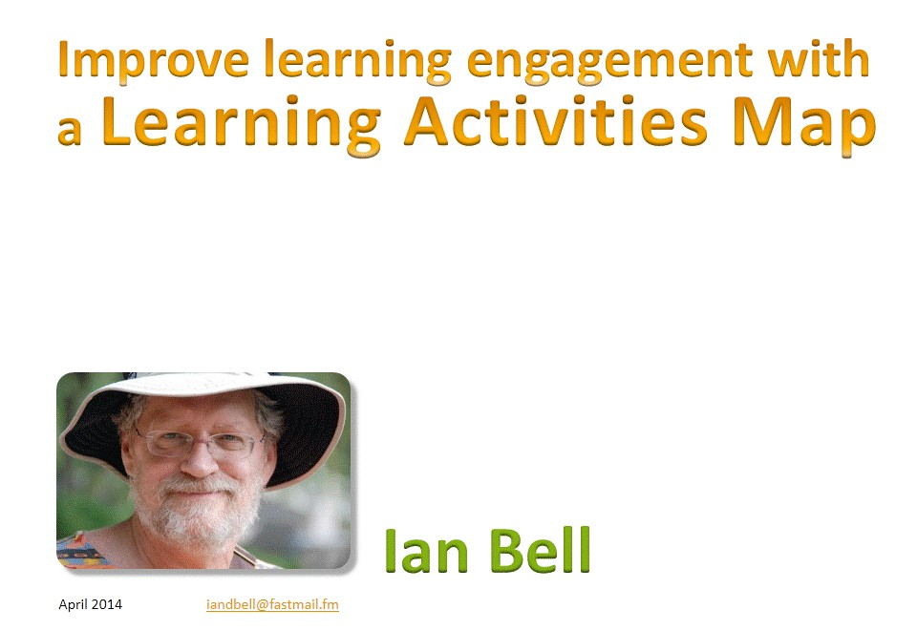
Once you know what it is you want to teach, based on the competencies and training needs analysis, and may have used the “Think-Do-Feel Table” to analyse factors affecting your learners’ desires to learn and what might help or hinder the process; the next step is to plan learning activities that will engage the learners.
Training is frequently centred on the trainer attempting to transmit their knowledge to the students. This generally means that their audience is passive and so little, if any, learning takes place. Being exposed to a topic doesn’t guarantee learning. For example, you have seen bank notes (currency) thousands of times, but if I asked you to draw a note, how well would you do it?
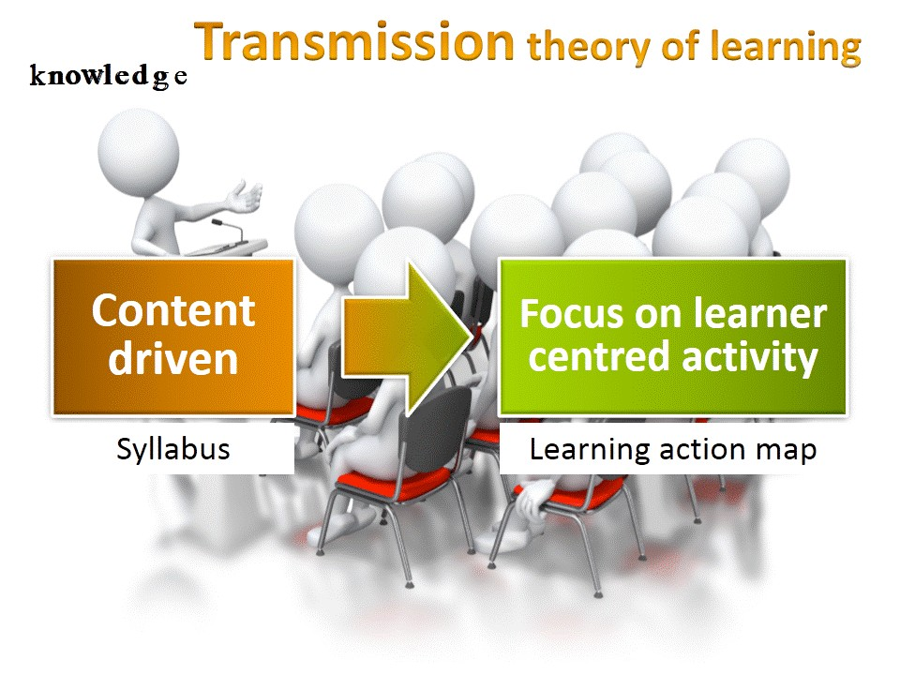
We need to move away from a content-driven, syllabus based approach to one centred on learner activity. Identifying the tasks learners need to be able to perform and mapping the learning activities that will help them to practice these tasks can help us to make the move from content-driven to learner-centred activity approach.
The use of Learning Action Maps (LAM) was suggested by Ian Bell and has evolved from his previous approaches and experience using mind (concept) maps plus the work of Cathy Moore. You can read more about Cathy Moore’s ideas on action mapping in her blog post at http://blog.cathy-moore.com/2008/05/be-an-elearning-action-hero/ (available in English only).
There are four basic steps to follow when creating learning action maps, and they need to be performed in this order. We shall look at each in turn.
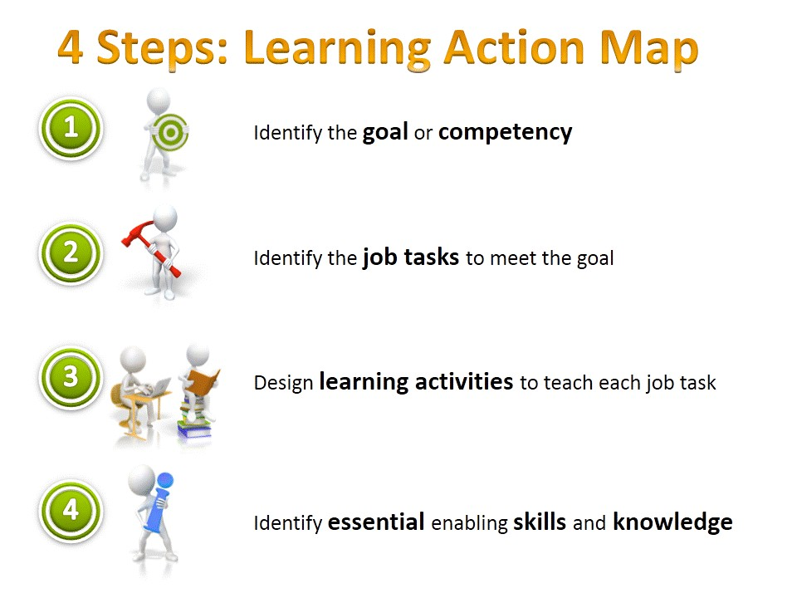
- Identify the goal or competency
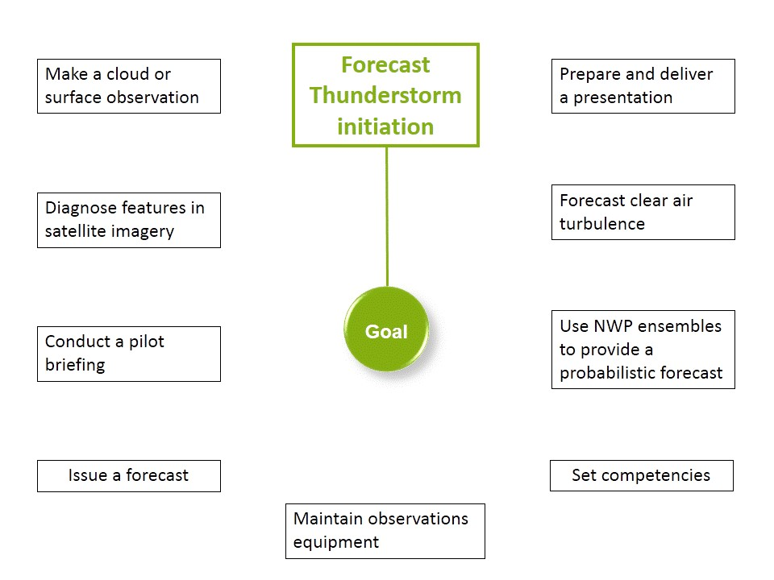
This is the purpose of your session or training topic. It should be active and authentic. You may have identified this through the use of a competency framework and training needs assessment. Place the goal or competency in the centre of your map or link it to the central point.
The illustration on the right shows some examples of goals. We will use the example of forecasting thunderstorm initiation (highlighted in green) to follow the process of four steps. Don’t worry if it isn’t something you teach. We are only looking at the principles here and additional examples are available in another resource.
LAM Step 1 – Forecast Thunderstorm Initiation
- Identify the job tasks to meet the goal
This is what the learner should be able to do on the job. If someone is competent to perform the job tasks they will be able to do the required work, so the goal in the centre of your learning action map is met.
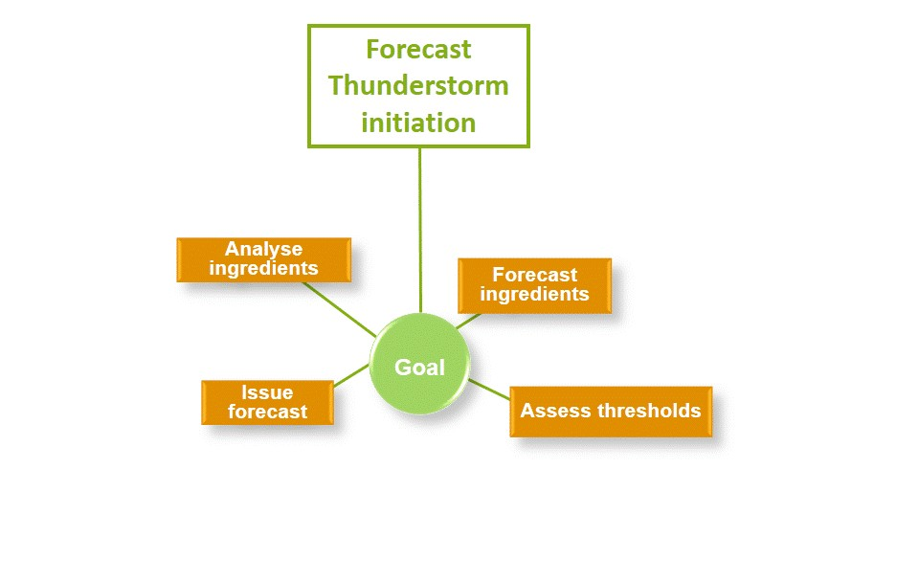
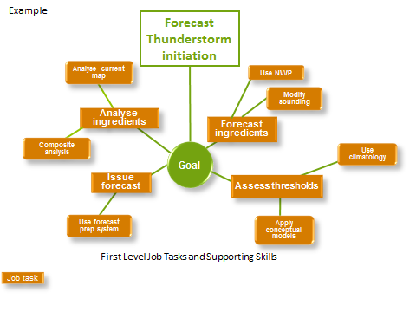
If your job tasks are at a level too high to fully analyze the training needed, you may need to further break them down into subtasks or supporting skills. See the example below.
Subtasks added
LAM Step 2 – Forecast Thunderstorm Initiation
Now, with more details, you have what you need to plan your learning activities. If you have too many job tasks and subtasks it may be better to separate them into individual maps, assigning the more complex job tasks to the position of “Goals” on separate maps.
- Design learning activities to teach each job task
Now it is the time to think about what sort of activities will help to teach each job task. If the activities are well chosen, we can be confident that when successfully completed, the learner will be able to perform the job tasks.
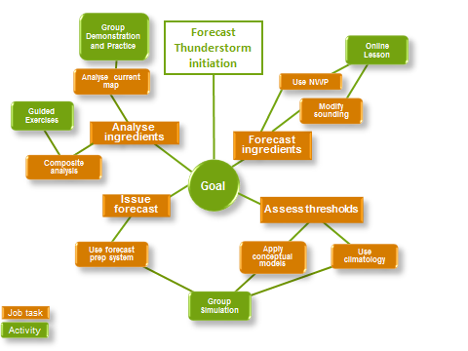
Remember to connect the learning activities to each job task, so no task will be taught without opportunity for practice.
LAM Step 3 – Forecast Thunderstorm Initiation
- Identify essential skills and knowledge
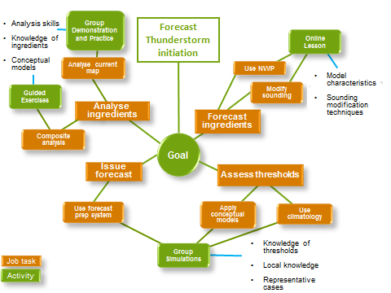
Unlike in the conventional approach, only now do we identify the knowledge and skills that are required to enable someone to perform the activities. Note that these are essential knowledge and skills only. Any extra content that is in the “nice to know” category, or that we think they might need one day, might negatively impact learning. Do not include them.
LAM Step 4 – Forecast Thunderstorm Initiation

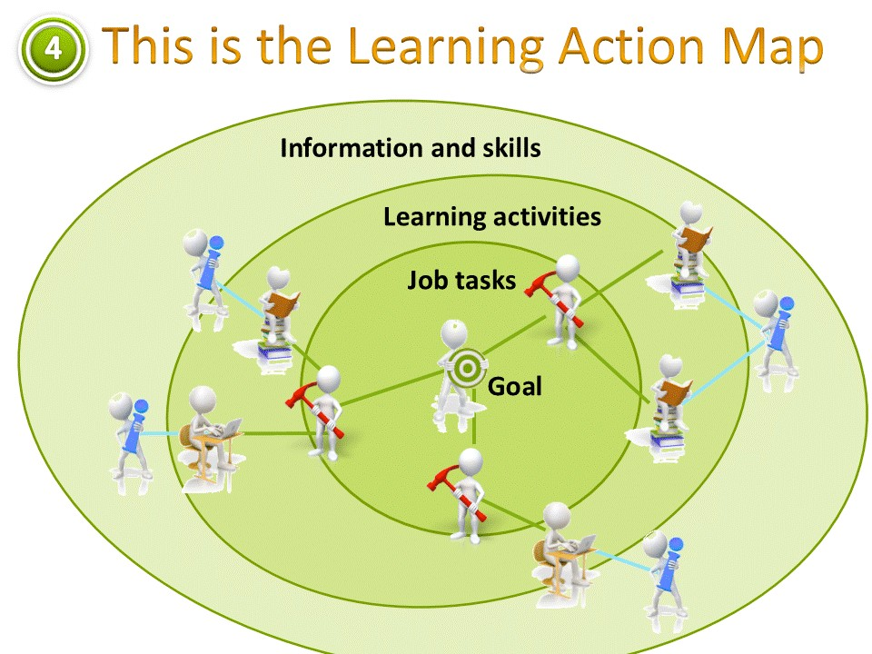
You can think of the learning activities map as a series of shells, each contributing to the one inside it, until the goal has been met.
In summary, only the essential information and skills should be presented in the outer shell to support the core of learning, which are the learning activities. The job tasks are the components that you will need to assess, as these are the tasks you want the learners to be able to perform to show they met the goal established for the training.
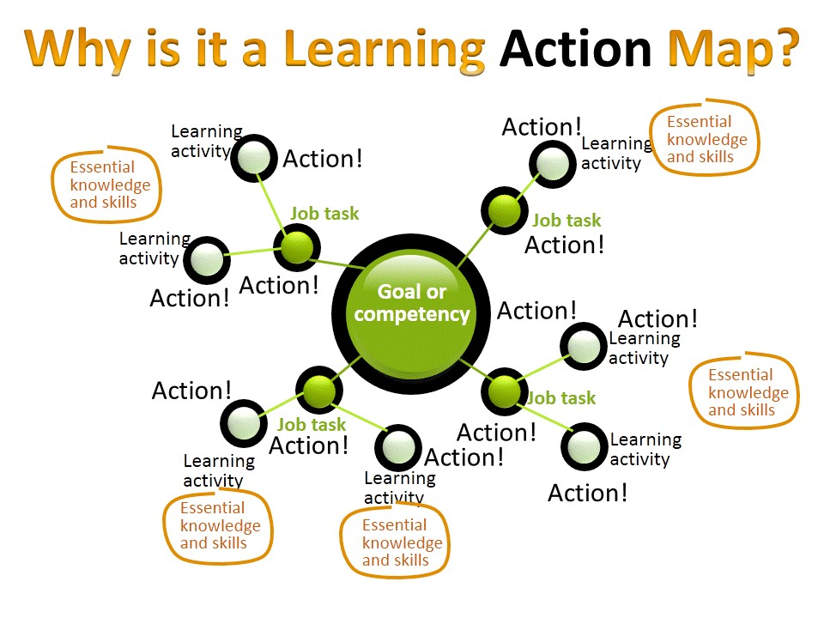
As you can see, the emphasis is on action so that, with this approach, learning is, by default, active rather than passive.
Consider how a traditional syllabus-driven course is often delivered. The learning activities map provides a much more useful document than the syllabus. You can still have a syllabus but develop it only after you have created the map and provide guidance on how the two relate.
A note about assessment of learning
The LAM provides a nice foundation for deciding your assessment. You need to ensure learners have mastered the required job tasks that you have designated in your LAM. You can also display the assessment requirements to your learners by including the assessment tasks in the map.

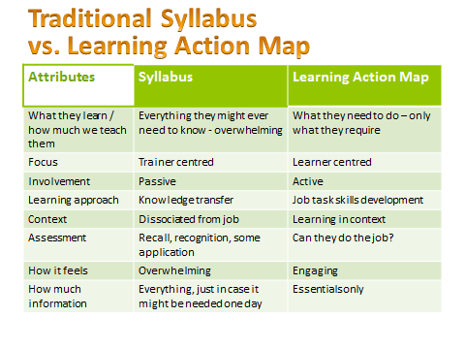
As a final example, the following presents a situation when Ian Bell used learning action maps to support trainers organising a course for climatologists.
Ian’s experience – Advanced Climate Course
In 2000 I was helping to organise an Advanced Climate Course for climatologists from our regional offices. I was meeting with staff from our National Climate Centre to discuss what would be in the course.
At one point they said, “We need some lectures on climate change”. We had access to some of the IPCC lead authors. I asked, “Why do we need lectures on climate change?” they replied, somewhat exasperated, “Ian, this is a climate course and they are climatologists.”
I persisted, “Yes, but what are they going to do with the knowledge?” The answer was that the regional climatologists are the people the media will contact when they are doing a story on climate change.
This meant that our goal changed from “tell them about climate change” to “enable them to respond to media interviews on climate change”. This immediately changed the focus of the topic and led the way to activities rather than passive listening.

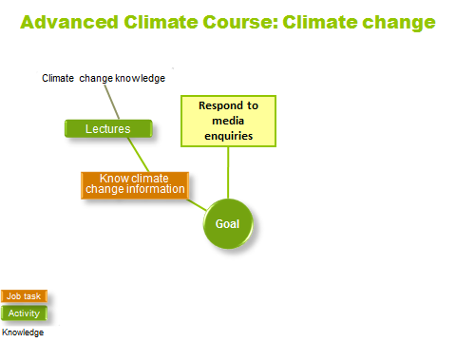
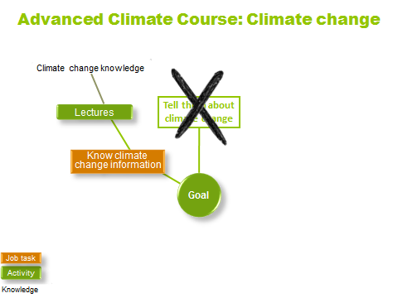

Firstly, they required information. As they already knew a lot, they needed answers to questions on topics they were unsure of, plus any new data or policies. For our needs analysis, I asked each participant to provide 2 or 3 questions they would not like to be asked. I passed the consolidated list to the presenters and asked them to add anything else they thought was important. This formed the basis of their presentations.
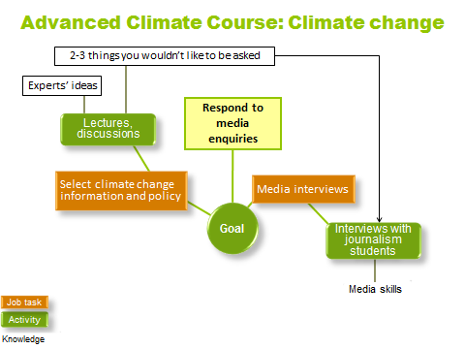
Secondly, they needed to respond in a media interview situation. This suggested an activity. We contacted the school of journalism at a nearby university. They agreed to provide students armed with the list of possible questions, so their students would come to interview our climatologists. This was a good experience for the journalism students and introduced them to climate change ideas too.
By focusing on authentic goals and activities, the session became active and the learners were engaged and attentive.
Now it’s your turn. Try creating a learning action map for your training.

∗ Adapted from a presentation by Ian Bell (2014).

