Tideda Comments:
Associated with the Tideda database is the Comment database. This provides the facility for text comments to be filed for a station against a date/time stamp. Comments are an essential part of any database. They are sometimes referred to as “meta-data”. They provide information about aspects of the data that cannot be easily quantified, such what conditions are like at the measurement site.
Tideda provides several ways to build a database of comments. Comments can be entered into an unstructured file of text. However, if the comments are entered into an ODBC (Open DataBase Connectivity) database they can be accessed by other special database programs such as Microsoft Access. Therefore this method has been followed.
For instructions on adding comments to the Comment database, see Appendix B.
The comments filed can be read directly from the database, but Tideda also has the ability to display relevant comments and indicate, for example on plots, that comments are filed at specific date and times.
Comments are very useful to explain unusual features or events in the record that users of the data should be aware of. In addition, routine comments are required for key information. These include:
- All recording stations require an initial comment detailing station information and parameters measured.
- “Recorder comments” are required for both water-level and rainfall stations, giving instrument and sensor types and their resolutions and accuracy
- Flow stations require a “rating comment”, to provide information on the ranges covered by flow gaugings.
- Comments relating to gaps, missing record, synthetic record, or any specific time-related event, are also required in a standard format. They should be filed one time interval (e.g. 15 minutes) into the missing (gap) or synthetic record period or at the time the specific event takes place.
Comments covering the accuracy of data and gaps in records should be informative, coherent and identify the period(s) for which the data are suspect or missing. Examples of these types of comment formats are given in Appendix A.

Comments
Concise, informative and understandable filed comments on site history and data quality are essential for users not familiar with the site to assess the quality of the data and be informed of site peculiarities, (e.g. flow affected by upstream water extraction). Although the filing of concise yet descriptive comments may seem pedantic detail at the time, their relevance and importance grows with the passage of time.
A listing of comments should be produced and read critically for accuracy and clarity. This should be done in conjunction with plots and summaries of the data.
The comments that must be filed are:
(a) An initial comment for each site which should include information on parameters measured, instrumentation types, and characteristics of the catchment, location, flow regime, etc as applicable. Include information on other stations which could be of interest to a data user for correlation, cross-checking, etc. The initial comment must precede all other filed data for a site. The comment starts “INITIAL COMMENT for ....”.
(b) A rating comment, which follows the initial comment, and states the maximum gauged flow (and gauge height), the maximum recorded flow (and gauge height) and the mean velocity for the maximum recorded flow, which is to be calculated from the rating curve. This allows the user of the flood data to identify the number of floods on the extrapolated section of the ratings, and assess the reliability of their calculations. The date on which the comment was written (i.e. as at date ...) should be filed at the beginning of the comment and updated on the production of the Annual Station Data Review. The comments should read as per the following example:
RATING COMMENT as at 1-Jan-2009
Maximum gauged flow is 35.2 m3/s (stage height 2.468 m)
Maximum recorded flow is 71.1 m3/s (stage height 3.119 m)
Minimum gauged flow is 1.25 m3/s (stage height 0.745 m)
Minimum recorded flow is 1.05 m3/s (stage height 0.680 m)
Mean velocity at maximum recorded flow = 2.8 m/s

(c) The type of recorders, installation dates, and the resolution information should be filed, e.g.
RECORDER INSTALLED on 17-Sep-1997 (13:45) is a DAA 500XL datalogger with a recording interval of 15 minutes. The level sensor is a Unidata Encoder with Tait 8110 radio telemetry. The recorder has a water-level resolution of 1 mm.

BACKUP RECORDER INSTALLED on 17-Sep-1997 (13:45) is a Hydrologger 2001 with GPRS telemetry and the same resolution of 1 mm.

(d) Sites which have been closed or the controlling authority changed should have this date and change identified by a comment. The comment starts “SITE CLOSED” or “SITE TRANSFERRED ...”
(e) Periods of missing record or backup record should be identified by a comment ‘MISSING or BACKUP RECORD from ...’ and followed by sites that could be used to synthesise a continuous record if required by a user.
MISSING RECORD from 15-Sep-2008 (02:15) to 7-Oct-2008 (10:15) due to failure of the Hydrologger. The Hydrologger stage values are erratic and not sensible over this period and have not been included in the data.
BACKUP RECORD used from 18-Nov-2000 (12:15) to 7-Dec-2009 (14:15) due to failure of the primary Neon datalogger.
(f) Periods of synthetic record (if allowable according to the conditions detailed elsewhere in this manual) should be identified by a comment ‘SYNTHETIC RECORD ...’ which should include a brief description of how it was constructed and what sites were used in its construction. Confidence levels must be identified if they can be expressed specifically, (e.g. regression equation = .. , coefficient of determination = .....). If they can only be expressed in non-specific terms (i.e. good, fair, etc.) then the synthetic record should be omitted.
(g) Any change in the data that cannot be explained without communication with the hydrological team. (If you get questions from confused users regarding the state of the data then the comments are obviously inadequate.) Informative filed comments are essential.
Further examples of standard comments such as initial and gauging are given in Appendix A.

Rainfall Comments
All raingauge records must have the following comments on the data archive:
(a) An initial comment giving details of the station location, recording authority, and additional information covering the gauge exposure in case something may affect the record sometime in the future (e.g. trees growing, new structures, etc.).
(b) An instrument comment should be filed for each type of raingauge installed at the station (i.e. separate comment for check gauge), covering instrument type, orifice size, height above ground-level and capacity/tip size.
(c) When the exposure of the gauge changes (e.g. a tree grows or is felled, building erected, etc.), or anything else that could affect the catch, a comment giving details should be filed, and the affected periods identified.
(d) “Site closed” or “site transferred” comment if applicable.
(e) Missing record comments should state:
- The period not recorded (from/to);
- The reason why the raingauge did not function correctly;
- The information on adjacent gauge totals which assist in filling gaps could, if desired by a user.
(f) When a gauge has been damaged in a way which may have affected the record.
(g) If correlation work has been done, a comment indicating correlative gauges, formula and correlation coefficients will help the user fill gaps.
(h) File any comments on the overall record or portions of it which will enable the user to assess the quality and consistency of the record. (e.g. vandalism in summer, trees growing/trimmed).
(i) Use a consistent format for the comments, modelled on those for flow data as given in section 4.2.4. above and in Appendix A.
Appendix A: Example formats for filed Comments
INITIAL COMMENT for ***** River at *****
Site number ***** on river *****
The site is situated *** km from the mouth at grid reference (Specify coordinate type here – NZMG/NZGD – eastings/northings WGS84 Lat/Longs etc….)
Drains ***** km2 and controlled by *********
Additional information: NIWA installed the recording sites for TrustPower to monitor flows for resource consent requirements. (Example)
The local recording authority is NIWA,****

INITIAL COMMENT for the GAUGING STATION:****
On the **** River, river number *****
The station is situated at grid reference *****
Gaugings above stage height **** mm are carried out by slackline cableway
Units, unless otherwise stated, are
1) Mean stage height in mm
2) Discharge in l/sec
3) Area in square cm
4) Mean velocity in mm/sec
5) Maximum depth in mm
6) Water surface slope in mm/1000m
7) Water surface width in mm
8) Hydraulic radius in mm
9) Wetted perimeter in mm
10) Sediment concentration in mg/l
11) Water temperature in degrees Celcius times 1000
12) Stage change code
13) Gauging method code (ccnn) where cc = method and nn = number of verticals
14) Number of verticals and sample points
15) The gaugings theoretical uncertainty (%*10)
16) A flag to indicate a comment was filed
17) A code number for the agency that carried out the gauging
18) Gauging number
The format changed from 15 items to 18 items in 2005; most gaugings prior to 2005 will not have gauging uncertainty (item 15) or a comment flagged (item 16).
The gauging is filed at the time of mean stage height.
-1 indicates missing data.
The local recording authority is NIWA,****

RECORDER INSTALLED on 17-Sep-1997 (13:45) is a DAA 500XL datalogger with a recording interval of 15 minutes. The level sensor is a Unidata Encoder with Tait 8110 radio telemetry. The recorder has a water-level resolution of 1 mm.
BACKUP RECORDER INSTALLED on 17-Sep-1997 (13:45) is a Hydrologger 2001 with GPRS telemetry and the same resolution of 1 mm.

RATING COMMENT as at 1-Jan-2009
Maximum gauged flow is 35.2 m3/s (stage height 2.468 m)
Maximum recorded flow is 71.1 m3/s (stage height 3.119 m)
Minimum gauged flow is 1.25 m3/s (stage height 0.745 m)
Minimum recorded flow is 1.05 m3/s (stage height 0.680 m)
Mean velocity at maximum recorded flow = 2.8 m/s
MISSING RECORD from 15-Sep-2008 (02:15) to 7-Oct-2008 (10:15) due to failure of the Hydrologger. The Hydrologger stage values are erratic and not sensible over this period and have not been included in the data.

BACKUP RECORD used from 18-Nov-2000 (12:15) to 7-Dec-2009 (14:15) due to failure of the primary Neon datalogger.

------------------------------------------------------------------------------------------------------------------------
Comment Program “Pulldown boxes” options are:

Comment type: Site
Equipment
Data
Rating
Miscellaneous

Data type: All
Series
Gauging
Rating

Site Type: Flow-Level
Rainfall
Water Quaility
Groundwater
Climate
Sediment
Air Quality, Misc
------------------------------------------------------------------------------------------------------------------------

Appendix B: Entry of Comments

Comments are an essential part of any database. They are often referred to as “meta-data”. They provide information about aspects of the data that cannot be easily quantified, such what conditions are like at the measurement site. Tideda provides several ways to build a database of comments. Comments can be entered into an unstructured file of text. However, if the comments are entered into an ODBC (Open DataBase Connectivity) database they can be accessed by other special database programs such as MicroSoft Access.

A.1. Initial building of Access Comment database
In the example below an ODBC database compatible with Microsoft Access will be built. As starting an ODBC database from nothing is difficult and tedious, Tideda provides a template file in its working directory to help users start the process of building a comment database. The first thing to do is find out where the template file is, and then to make copy of it. To find out what directory is your Tideda working directory go:
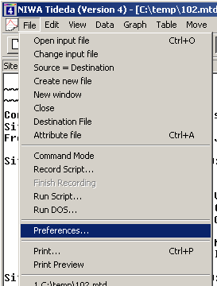
and then
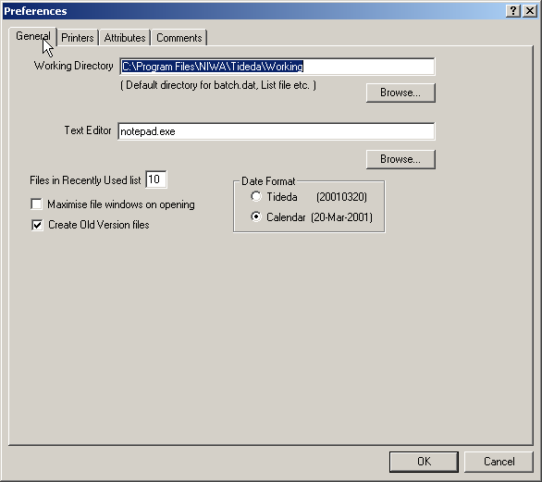

The directory given in the “Working Directory” above defines the Tideda working directory which is where the comment template files will be found. Use Windows Explorer to copy the file “Tideda_Comment_Template.mdb” to “Tideda_Comment.mdb”. The template file contains a wide range of comments for a site in New Zealand, but they can be readily adapted for use in most situations. To access the Tideda Comment facilities go:

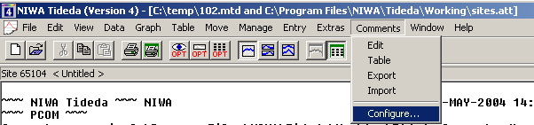

and choose the “Configure” option to open this window:

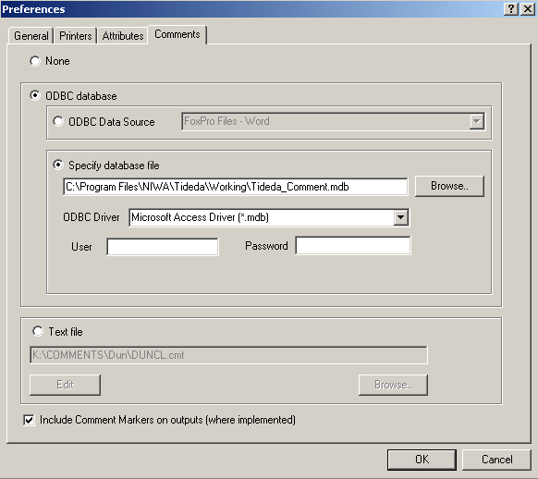

The window should open at the “Comments” tab, but if it does not, then click on the “Comments” tab to see the above window. Select the “ODBC database” option and within that option the “Specify database file” option. In the first box enter the name of the file in which the comments will be filed, in this case the file “Tideda_Comment.mdb” which has just been created through the copy operation, or use the “browse” button to find the required file. In the second box select one of the drivers that is appropriate for your comment file. In the case above the “Microsoft Access Driver (*.mdb)” is suitable. If the database has had a user and password set from the driver, then enter them under “User” and “Password”.
In the bottom left hand corner of the screen is a tick box with the words “Include Comment Markers on outputs (where implemented)” alongside it. It is recommended that this box be ticked. If ticked, those Tideda processes that can access the comment database will automatically display a symbol or the relevant comments to the data that are being processed and so draw the users attention to relevant meta-data.

Once you have completed the screen, click “OK”.
A database has now been set up, but so far it contains no data relevant to your hydrological database.
To enter data use
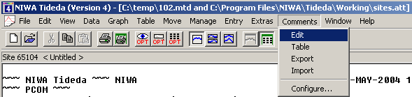
to get a screen similar to this:

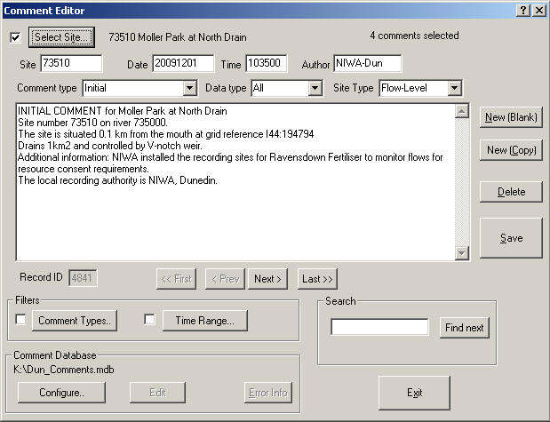
The easiest way to get started with entering new comments is generally to copy those from another site and then edit them. To do this, click on the “New (Copy)” bottom. The first thing that must be done is to select the site number for the new comment. If you do not do this, any edited comment will be saved for the existing site whose number and name are shown alongside the “Select Site …” button. The number and name of the site for which any comment will be saved is always displayed alongside the “Select Site …” button. To select the site to which a comment is to be copied click on the “Select Site …” button, to get:
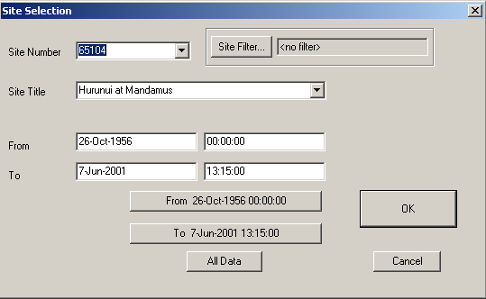
and in the “Site Number” box type the new site number and press “enter”, and then click “OK”. Do not type anything into the other boxes or the results of your save may be unpredictable. Once you have clicked on the “OK” button you will be returned to the main Comment Editor screen, and you can edit the text of the comment.
Then, using these panels, enter the date and time of the comment and comment author, and then the “Comment type”, the “Data type”, and the “Site type” panels (use the drop down boxes to select the most appropriate type. To save the comment, click on “Save”.

A.2 Entry of Comments
The above section describes how to set up a Comment database and enter the first data. This section has some repetition, but sets out how to routinely enter Comments to the existing database.
To enter data use
to get a screen similar to this:

The easiest way to get started with entering new comments is generally to copy those from another site and then edit them. To do this, click on the “New (Copy)” bottom. The first thing that must be done is to select the site number for the new comment. If you do not do this, any edited comment will be saved for the existing site whose number and name are shown alongside the “Select Site …” button. The number and name of the site for which any comment will be saved is always displayed alongside the “Select Site …” button. To select the site to which a comment is to be copied click on the “Select Site …” button, to get:

and in the “Site Number” box type the new site number and press “enter”, and then click “OK”. Do not type anything into the other boxes or the results of your save may be unpredictable. Once you have clicked on the “OK” button you will be returned to the main Comment Editor screen, and you can edit the text of the comment.
Then, using these panels, enter the date and time of the comment and comment author, and then the “Comment type”, the “Data type”, and the “Site type” panels (use the drop down boxes to select the most appropriate type. To save the comment, click on “Save”.

A.3 Deleting Comments
To delete a comment, select the site and the comment you wish to delete, and press the delete button.

A.4 Navigating
Underneath the panel in which the comments are displayed, is this line:
The “Record ID” panel is for information only and displays information about where the comment is stored in the database. The buttons labelled “<<First”” etc. enable the user to move backwards and forwards between comments for the selected site. If any of the buttons are “greyed” out it is likely that you are either at the front or the end of the comments. So, in the case above, the comment in the panel above was the first one for the site in question, hence the editor is already at the first comment and cannot go back to a previous comment, as there is none.

A.5 Comment types
The box labelled “Filters” enables the user to select comments of a particular type:
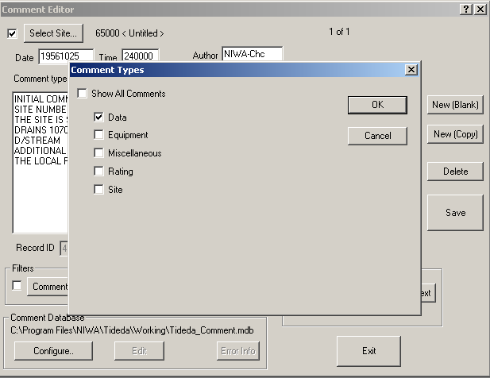
Note: always make sure that if you tick the “Show All Comments” box that one of the other five boxes is also ticked.

or within a particular time range:
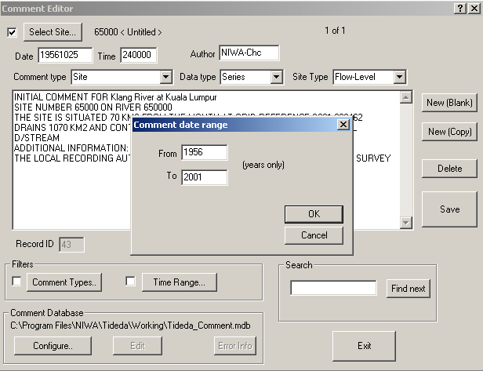
or to look for comments containing particular text use the “Search” box.
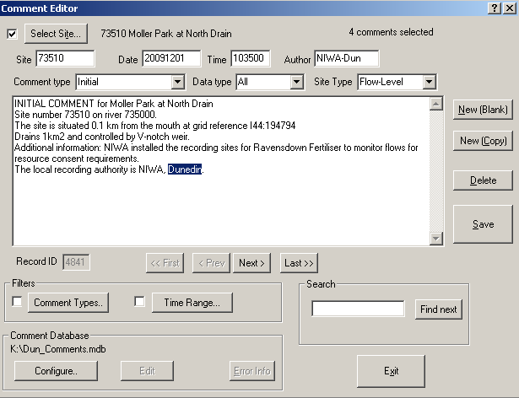

The Comment Database box allows the user to use the “Configuration” facility already described without having to leave the Comment editor. The “Edit” button is activated when the comment database is a text database. The “Error Info” button is activated if an error occurs.
Use the “Exit” button to leave the Comment Editor.

A.6 Import and export
There are other facilities under the “Comment” item on the main Tideda menu bar. These allow the export of comments (Export), the import of comments from text files (Import) and the listing of comments by site, date range, and comment type. If comments are being imported from text files, the comments must be formatted from in the same way that Tideda would export them. Thus if you want to use an external editor to make, say a global change to the data, the comments could be exported, modified and then imported back into the database.

A.7 Displaying Comments
Outside of the comment editor, comments can be displayed in several ways:
(Table → Other → Comments) prints comments for the selected site and time range.
(Graph → Graph and Zoom) shows comments as triangular markers on the bottom time axis. If there are comments in the selected time range the “Comments” option will appear in the zoom menu. If you select this option you can display the comment text in a window by clicking near to one of the triangles. There is an option in this window to copy the comment text to the Windows clipboard so it can be transferred to another application.
(Graph → Graph over time) shows comments as triangular markers on the bottom time axis.
(Table → Calendar → Daily) indicates where comments are filed by displaying an exclamation mark beside the value.
(Manage → Graph scan) has an option to show the time of comments with a triangular marker.

Entry of Comments

Comments are an essential part of any database. They are often referred to as “meta-data”. They provide information about aspects of the data that cannot be easily quantified, such what conditions are like at the measurement site. Tideda provides several ways to build a database of comments. Comments can be entered into an unstructured file of text. However, if the comments are entered into an ODBC (Open DataBase Connectivity) database they can be accessed by other special database programs such as MicroSoft Access. In the example below an ODBC database compatible with Microsoft Access will be built. As starting an ODBC database from nothing is difficult and tedious, Tideda provides a template file in its working directory to help users start the process of building a comment database. The first thing to do is find out where the template file is, and then to make copy of it. To find out what directory is your Tideda working directory go:

and then

The directory given in the “Working Directory” above defines the Tideda working directory which is where the comment template files will be found. Use Windows Explorer to copy the file “Tideda_Comment_Template.mdb” to “Tideda_Comment.mdb”. The template file contains a wide range of comments for a site in New Zealand and can be easily adapted for use in most situations. To access the Tideda Comment facilities go:

and choose the “Configure” option to open this window:

The window should open at the “Comments” tab, but if it does not then click on the “Comments” tab to see the above window. Select the “ODBC database” option and within that option the “Specify database file” option. In the first box enter the name of the file in which the comments will be filed, in this case the file “Tideda_Comment.mdb” which has just been created through the copy operation, or use the “browse” button to find the required file. In the second box select one of the drivers that is appropriate for your comment file. In the case above the “Microsoft Access Driver (*.mdb)” is suitable. If the database has had a user and password set from the driver, then enter them under “User” and “Password”.
In the bottom left hand corner of the screen is a tick box with the words “Include Comment Markers on outputs (where implemented)” alongside it. It is recommended that this box be ticked. If ticked, those Tideda processes that can access the comment database will automatically display a symbol or the relevant comments to the data that are being processed and so draw the users attention to relevant meta-data.

Outside of the comment editor, comments can be displayed in several ways:
(Table → Other → Comments) prints comments for the selected site and time range.

(Graph → Graph and Zoom) shows comments as triangular markers on the bottom time axis. If there are comments in the selected time range the “Comments” option will appear in the zoom menu. If you select this option you can display the comment text in a window by clicking near to one of the triangles. There is an option in this window to copy the comment text to the Windows clipboard so it can be transferred to another application.

(Graph → Graph over time) shows comments as triangular markers on the bottom time axis.

(Table → Calendar → Daily) indicates where comments are filed by displaying an exclamation mark beside the value.

(Manage → Graph scan) has an option to show the time of comments with a triangular marker.

Once you have completed the screen, click “OK”.

A database has now been set up, but so far it contains no data relevant to your hydrological database. To enter data use

to get a screen similar to this:

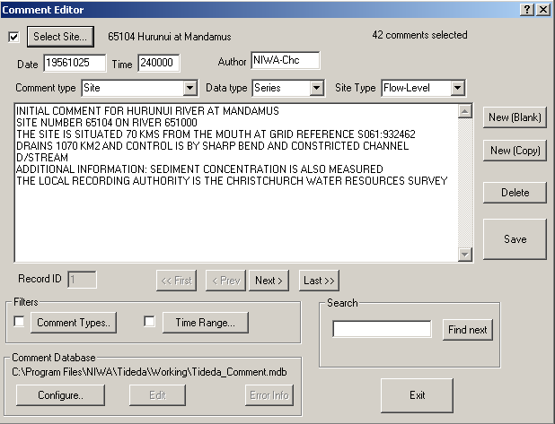

The easiest way to get started with entering new comments is generally to copy those from another site and then edit them. To do this, click on the “New (Copy)” bottom. The first thing that must be done is to select the site number for the new comment. If you do not do this, any edited comment will be saved for the existing site whose number and name are shown alongside the “Select Site …” button. The number and name of the site for which any comment will be saved is always displayed alongside the “Select Site …” button. To select the site to which a comment is to be copied click on the “Select Site …” button, to get:

and in the “Site Number” box type the new site number and press “enter”, and then click “OK”. Do not type anything into the other boxes or the results of your save may be unpredictable. Once you have clicked on the “OK” button you will be returned to the main Comment Editor screen, and you can edit the text of the comment.
Then, using these panels, enter the date and time of the comment and comment author, and then the “Comment type”, the “Data type”, and the “Site type” panels (use the drop down boxes to select the most appropriate type. To save the comment, click on “Save”.

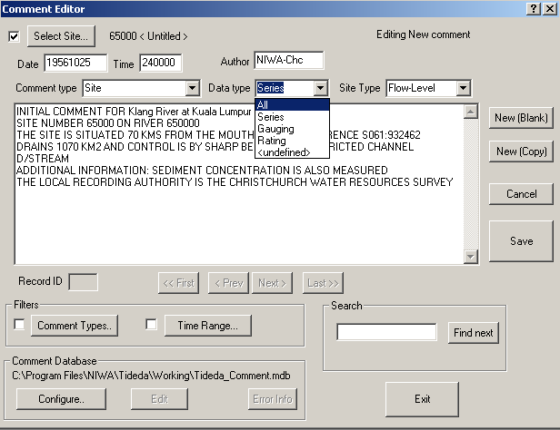

To delete a comment, select the site and the comment you wish to delete, and press the delete button.

Underneath the panel in which the comments are displayed, is this line:

The “Record ID” panel is for information only and displays information about where the comment is stored in the database. The buttons labelled “<<First”” etc. enable the user to move backwards and forwards between comments for the selected site. If any of the buttons are “greyed” out it is likely that you are either at the front or the end of the comments. So, in the case above, the comment in the panel above was the first one for the site in question, hence the editor is already at the first comment and cannot go back to a previous comment, as there is none.

The box labelled “Filters” enables the user to select comments of a particular type:
Note: always make sure that if you tick the “Show All Comments” box that one of the other five boxes is also ticked.

or within a particular time range:

or to look for comments containing particular text use the “Search” box.

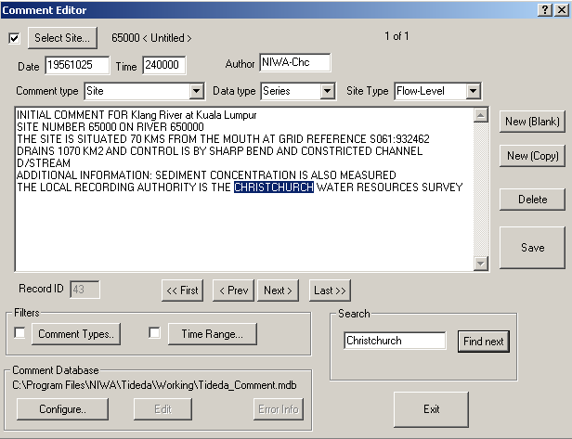

The Comment Database box allows the user to use the “Configuration” facility already described without having to leave the Comment editor. The “Edit” button is activated when the comment database is a text database. The “Error Info” button is activated if an error occurs.

Use the “Exit” button to leave the Comment Editor.

There are other facilities under the “Comment” item on the main Tideda menu bar. These allow the export of comments (Export), the import of comments from text files (Import) and the listing of comments by site, date range, and comment type. If comments are being imported from text files, the comments must be formatted from in the same way that Tideda would export them. Thus if you want to use an external editor to make, say a global change to the data, the comments could be exported, modified and then imported back into the database.

